
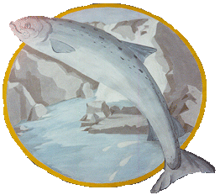
ROSS-SHIRE GUIDE ASSOCIATION

Unit:

INCOME and EXPENDITURE ACCOUNT FOR THE YEAR ENDED 30th June 20……………

INCOME |  |  |  | EXPENDITURE
 | £ | £ |  |  | £ | £
Balance Brought Forward |  |  |  | Hall hire/upkeep (or donations in lieu)
Subscriptions |  |  |  | Materials and Equipment
Donations and Grants |  |  |  | Postage, Telephone & Stationery
Fundraising for Unit Funds |  |  |  | Fundraising expenses
Fees for Camps, Holidays, & Outings |  |  |  | Costs of Camps, Holidays, & Outings
Bank Interest |  |  |  | Badges and Uniforms etc.
 |  |  |  | Donations raised
Sale of Uniforms, Handbooks |  |  |  | Gifts and Presentations
Funds raised for Other Causes |  |  |  | Bank Charges
 |  |  |  | Census
Census |  |  |  | Other Expenditure
Other Income
 |  |  |  | Total Expenditure
Total Income |  |  |  | Balance Carried Forward

I have examined the books and accounts of the ……………………….….. Unit and have verified that the above summary gives a true and accurate view of the accounts of the unit. | Signed: Unit Guider/Treasurer  Date  Noted: (Commissioner)  Date
Signed: (Auditor)
Date

