Abstract

Simplified theories of the convective boundary layer under clear skies suggest a temperature profile that changes from an approximate isothermal to adiabatic state in response to surface heating. This assumption is used by some forecast models to predict convective boundary layer evolution. The performance of two forecast techniques is assessed by comparing the model predictions to observations. The first technique uses an empirical method to predict the maximum daytime temperature from a pre-dawn temperature profile. It was found to give a mean forecast error of 0.06ºC, which verifies the underlying assumptions are of practical use. The second technique examined was a numerical model used to predict the vertical extent of the convective boundary layer. The results were of the same order of magnitude as the observations, but no definite conclusions could be made due to large error associated with the implementation of the model.

1) Introduction

The atmospheric boundary layer

The atmospheric boundary layer (ABL) can be loosely defined as “the layer of air directly above the Earth’s surface in which the effects of the surface (friction, heating and cooling) are felt directly on timescales of less than a day…” (Garratt, 1994). It is the part of the atmosphere that is of interest to all, as processes within it affect everyone living on the surface. Within the ABL there are large fluxes of heat and momentum, which have important consequences on the weather and climate. The ABL is characterized by turbulent motions, which are a combination of mechanical turbulence (generated by surface friction) and turbulence generated by buoyancy effects (i.e. convection). The structure of the ABL is highly variable in both space and time, as the underlying surface and surface heating dictate its structure.
There are several categories of boundary layer that are observed, such as the convective boundary layer (CBL), nocturnal boundary layer (NBL) and internal boundary layer (IBL). Each of these boundary layer types have different properties, and we must understand how each of these work in order to assess each of their effects on the surface conditions. A boundary layer in which buoyancy generated turbulence is dominant is called the CBL. Over land surfaces and under clear skies, we can observe the daily growth and decay cycle of the CBL and NBL and it is these processes that this study is concerned with.
During a clear night, emission of long-wave radiation cools the air at the surface and creates a stably stratified NBL. After sunrise, solar radiation heats the surface, which creates an unstable layer and triggers convection. This convection breaks down the NBL typically within a half-hour of sunrise (Stull, 1988). After which, the convection reaches the remnants of the previous days CBL in the so-called residual layer. The air in this layer is typically adiabatic or slightly stable, as it remains largely uninfluenced by the nocturnal surface cooling. This means upon convection reaching the residual layer, the CBL can grow rapidly. Often a well-defined stable layer called the capping inversion marks the interface between the top of the CBL and the free atmosphere. Due to their momentum, the individual convective elements overshoot the top of the CBL, cross the density interface between the CBL and free atmosphere, and penetrate a short distance into the capping inversion. The cumulative effect of the continual overshooting by the convective elements is that the CBL penetrates further into the free atmosphere and due to mass continuity, stably stratified (high θ) free atmospheric air is entrained into the CBL. Due to adiabatic processes, the forced descent of this high θ air acts as an extra heat source in the CBL and acts to increases its depth.
Observations show that the CBL reaches its maximum extent during the mid-afternoon (i.e. After the daily heating maximum) and any heat input after that time maintains the CBL depth rather than increasing it (Garratt, 1994). After the cessation of heating by solar radiation, the convection generated turbulence within the CBL starts to decay due to viscous dissipation. A change in the sign of the sensible heating at the surface creates a low-level temperature inversion and re-establishes the stable NBL. Above the NBL, the remaining daytime CBL air resides in the residual layer, where it cools slowly due to not being in contact with the surface. At sunrise the next morning, the process begins again. It can frequently be observed that convection within the boundary layer results in the formation of clouds, which have important effects on the dynamics of the CBL. It must be noted that this study focuses only upon dry convection within the CBL.
The evolution of the CBL is most apparent in vertical temperature profiles, such as those measured by radiosonde. Before sunrise, a strong temperature inversion can be seen near the surface, which is indicative of the stable NBL. At the same time, within the residual layer, an adiabatic or slightly stable profile is typically observed. A short time after sunrise, a shallow (of order 10-100 metres deep) superadiabatic layer called the surface layer begins to form in response to surface heating. As the surface heating becomes more intense, the instability created within the surface layer causes convection. During the day, after the breakdown of the NBL, convective mixing within the CBL carries heat and moisture throughout its depth, resulting in an adiabatic temperature profile above the surface layer, in a region called the mixed layer. The interface between the free atmosphere and the CBL is clearly marked by a sharp inversion within a shallow layer called the interfacial layer. It is by monitoring the height of this inversion that the depth of the CBL can be inferred. Figure 1 shows a schematic of the evolution of the CBL under clear skies, with potential temperature profiles shown for indicated times.

CBL forecast techniques

In general, if a mean temperature profile is drawn through the NBL plus the residual layer on a pre-dawn sounding, up to the approximate maximum height of the daytime CBL, then this line approximates to an isotherm. Similarly, if a mean temperature profile is drawn through the depth of the daytime CBL, this line approximates to a dry adiabat. This implies that in very basic terms, the CBL goes from a pre-dawn isothermal to a daytime adiabatic state. By exploiting these simple ideas, some techniques have been developed to forecast the evolution of CBL properties on clear days, this study looks at two such techniques.
The first technique that is examined is a method of predicting the daily maximum temperature using a tephigram (an atmospheric thermodynamic diagram), which was formulated by E.Gold in 1933 updated by Johnston (1958) then by Inglis (1970) and is included in the Forecaster’s Reference Book (Met. Office, 1997). Gold’s method involves a simple construction on a pre-dawn tephigram, which predicts a daytime maximum temperature by assuming the idealised temperature profile evolution (see methodology for details). Although Gold’s method is very old and simple it is still included, mostly unaltered, in the UK Meteorological Office Forecaster’s Reference Book, which is issued to the present day.
Secondly, the study will look at the Carson model of the CBL by D.J.Carson in 1973. This is a simple one-layer model of the CBL, which grows in response to surface forcings. This model also assumes a pre-dawn isothermal state within the lower atmosphere, which becomes adiabatic due to surface heating. It determines the height of the CBL using the sensible heat flux integrated over time, along with a simple parameterisation of the heat flux arising from entrainment at the top of the CBL (see methodology for details).
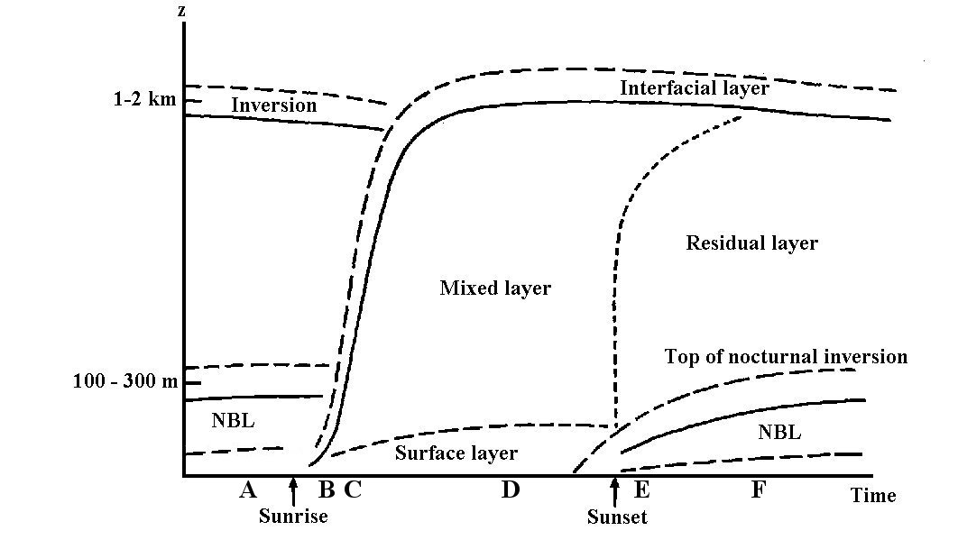
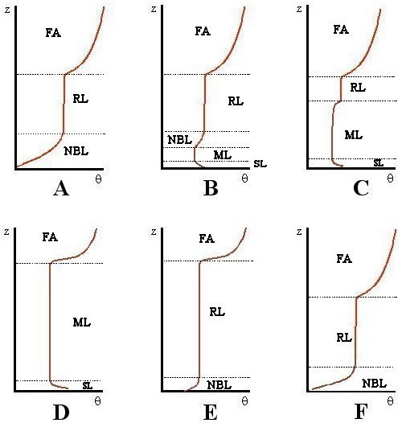
Figure 1 – (Top) Schematic of CBL evolution throughout the course of a day, under clear skies. Adapted from Garratt,1994. (Bottom) Vertical potential temperature profiles for the times A-F, relating to the times shown on the top half of the figure. Abbreviations as follows: FA = Free Atmosphere, NBL = Nocturnal boundary layer, RL = Residual layer, SL = Surface layer, ML = Mixed layer.

The main objectives of this study are to evaluate the performance of the techniques, and also to explore the usefulness that the assumption of the idealised temperature profile evolution provides is when used in practice. Section two describes the method used to come to the main conclusions of the study, section three presents the main results of the project and section four discusses the significance of these results. The overall conclusions from the study, plus ideas for future work are presented in section five.

2) Methodology

(a) Maximum daily temperature from the tephigram (Gold’s Method)

Gold’s method requires that a mean isotherm be drawn through a pre-dawn ascent up to a predetermined pressure level on a tephigram. From the point where the mean isotherm meets this pressure level, another line is drawn down a dry adiabat (line of constant θ) until this line intersects the surface pressure value. The temperature value at this point is the forecast daytime maximum temperature. This construction is illustrated in figure 2. The depth of the layer in which this construction is performed (Δp) varies according to time of year, and the source gives a Δp value for each month. These Δp values were derived from observations of the real CBL, but as the method was formulated in the United Kingdom the Δp values are only valid for this area. The success of this method is governed by how well the atmosphere approximates to one that undergoes a change from an isothermal to adiabatic state.
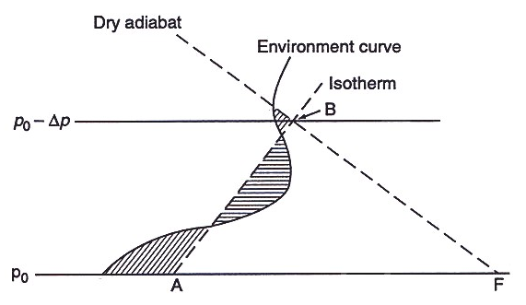
Figure 2 – A diagram depicting the pre-dawn tephigram construction required to implement Gold’s method of forecasting maximum daytime temperature. Line AB shows a mean isotherm drawn through the environmental temperature curve. p₀ is the surface pressure and Δp is the depth of layer that changes from a pre-dawn isothermal to daytime adiabatic state. Line BF is a dry adiabat drawn from where the mean isotherm intersects the p₀₋Δp pressure level back to the surface pressure. Point F represents the forecast maximum daytime temperature. Figure adapted from Forecaster’s Reference book (Met Office, 1997).

In order for the method to give realistic results, Gold stresses the fact that the sky must remain cloud free during the day. To assess the performance of this method, cloud free days from the summer of 2001 were picked and this tephigram construction was made on pre-dawn ascents from Larkhill upper-air station to determine a maximum daytime temperature. These forecast temperatures were then compared to the maximum surface temperature recordings at the Reading University field site in Reading, which is approximately 75 km to the northeast. This data was sourced from two sites because neither site could provide both the radiosonde and surface temperature data. The graphical nature of the tephigram construction was responsible for large errors in the estimation of maximum temperatures, since plotting the data on a tephigram by hand was inaccurate (±1ºC for the temperature co-ordinate, ±5hPa for the pressure co-ordinate) and the positioning of a mean isotherm by eye is subjective. By positioning isotherms at the limits of feasibility on the pre-dawn ascents and combining the plotting error, on a number of ascents, the maximum error in the forecast temperature was found to be ±1.55ºC. By comparing the forecast maximum to the recorded maximum temperature, an appraisal of the method and its underlying principles could be made.

(b) Estimating daytime temperature rise using Gold’s method.

Gold’s tephigram construction can also be used to forecast the hourly rise in temperature from a pre-dawn ascent, in a similar fashion to the estimation of the maximum temperature. In this case, different Δp values are given by the source for each hour of the day during each month of the year, so that a temperature forecast can be made for anytime during the day using only a pre-dawn tephigram. This study looked at an example that demonstrated how well the Gold method captured the evolution of the surface temperature during the day, by comparing the pattern of predicted temperature rise with the continuous temperature readings taken at the Reading University field site for the same period.

(c) The Carson Boundary layer model

The second boundary layer forecast technique under scrutiny in this study is the Carson model of an inversion-topped boundary layer, by D.J.Carson (1973). This technique also uses the simplified CBL temperature profile evolution to forecast the depth of the CBL. The model assumes a pre-dawn isothermal state in the lower troposphere that becomes adiabatic in response to sensible heating (H) at the surface, at that the depth of atmosphere that undergoes this change is proportional to the time integrated sensible heat flux. Carson takes account of the overshooting convective elements (as discussed in the introduction) in an adiabatic overshoot layer. Immediately above the overshoot layer, the Carson model assumes a jump in temperature profile at the top of the CBL (in the interfacial layer from figure 1) where the profile rejoins the environmental isothermal profile. A schematic diagram of the CBL profile as used by the Carson model is shown in figure 3. This type of model is often referred to as a zero-order jump model as a consequence of this temperature profile.
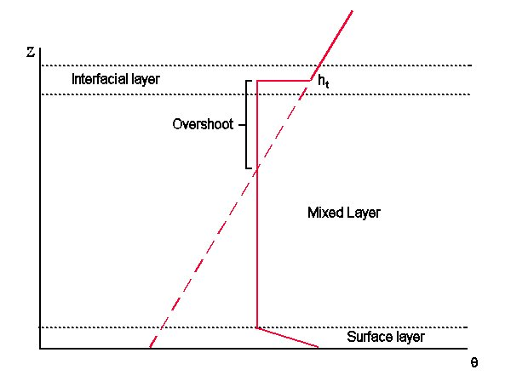
Figure 3 – The simplified CBL temperature profile used by the Carson model, shown from the surface to the top of the CBL. The point h_{t} marks the top of the CBL as defined by Carson.

The Carson model parameterises the entrainment heat flux (heating caused by entrainment of free atmospheric air into the CBL) simply by assuming that it is a fixed fraction (A) of the surface sensible heat flux (H(0)). The physical reasoning behind this is the belief that a larger surface heat flux will generate more vigorous convective plumes, which will penetrate further into the capping inversion and increase the amount of entrainment by mixing. By assuming that the sensible heat flux through the depth of the CBL followed a flux-gradient relationship, Carson formulated an equation (see Appendix A) that specifically predicts the top of the CBL. This equation is:

$h_{t}=\sqrt{\frac{2(1+2A)}{{ρc}_{p}γ}\int_{0}^{t}{H(0)\text{dt}}}$ (1),

where h_{t} is the depth of the CBL at a time ‘t’ from the onset of heating, A is the entrainment heat fraction, ρ is the air density, c_{p} is a thermodynamic constant (1004 Jkg⁻¹K⁻¹), H(0) is the sensible heat flux at the ground and γ is the environmental lapse rate (which can be measured using a pre-dawn tephigram). Carson gives the value of the parameter A as 0.2, which was derived from comparison with observations. This equation shows that the Carson model essential treats the CBL as a single layer that grows and decays in response to surface forcing, and because of this it is sometimes called a ‘slab’ model.
The Carson model was run for an entire day using parameters that were approximated from measured daily conditions (see below). The resulting predictions of CBL depth from this model were then compared to the CBL depth as sensed by an afternoon radiosonde ascent from the Larkhill upper-air station, which is shown in section 3. The observed CBL top was taken to be the point at which the temperature profile deviated significantly from an adiabat. This point is subjective in nature, and is a potential source of error. It was assumed that the afternoon ascents corresponded to the maximum extent of the CBL due to ascents only being made 3 or 4 times a day. This assumption meant it was possible to compare the Carson model results to some form of observations, even if the observations were not entirely representative of the true CBL depth.
The practical difficulty came from the modelling of the sensible heat flux at the ground (H(0)), since this is not a variable that is recorded. In order to get around this problem, this study used the surface energy balance equation:

R_{N} – G = H + λE, (2)

where R_{N} is the net radiation, G is the ground heat flux, H is the sensible heat flux and λE is the latent heat flux. Since the ground heat flux is small (typically less than 10% of the net radiation (Garratt, 1994)) the surface energy balance approximates to:

R_{N} ≈ H + λE. (3)

Net radiation data was recorded at the Reading University field site by the automatic weather station. Analysis of the data shows that in general, under clear skies, it approximates to the positive half of the sine curve during the day and a constant negative value during the night (see figure 4). The positive net radiation values lasted of order 15 hours during the summer 2001 period. In this study a sensible heat flux was used that was also sinusoidal, but lasted 12 hours and had an equal negative flux for another 12 hours, the amplitude of which was equal to the value of the peak of the net radiation recorded at the Reading University field site. Figure 4 shows the net radiation measured at the Reading University field site on the 30th May 2001, along with the heat flux used in the Carson model for the same day. It is clear that the area under both curves is approximately the same, which implies that the model made the very crude assumption that the majority of the net radiation is translated into sensible heat that was then available for CBL growth. This means that the Carson model in this form ignored the effect of latent heat on the surface energy balance and hence the derived CBL depth given by the model is the maximum theoretically possible, if all available energy was put into CBL growth. More about this simple approximation is given in the discussion section.

Figure 4 - Net radiation data from the Reading University automatic weather station for 30th May 2001 with modelled sensible heat flux as used in the Carson model shown for the same occasion.

Because the Carson model treats the CBL as a single layer, it does not capture the true structural evolution of the CBL as shown in figure 1, but instead predicts a layer of air that expands and contracts in response to the heating. Since equation 1 predicts the CBL to depend on the cumulative heat flux, the Carson model predicts the maximum CBL depth to occur at the point at which the heating switches to cooling (i.e. at or around sunset). This unrealistic behaviour means that the Carson model is unsuitable for forecasting the time-dependent evolution of the CBL. Figure 5 shows the depth of the CBL from the Carson model versus time when using a sinusoidal heat flux, which illustrates the maximum depth occurring at the cessation of heating. In this study, the maximum extent of the CBL forecast by the Carson model for comparison with observations was taken to be the peak given by the model at the end of heating.
Figure 5 – The Depth of the CBL derived from the Carson model. The graph shows the depth of the CBL as a function of time. Sinusoidal heating starts at time 0 hours and finishes at time 12 hours. The model used an entrainment heat flux fraction (A) of 0.2 and a heat flux of maximum magnitude 200 Wm⁻².

3) Results

(a) Forecasting maximum temperature by Gold’s method.

Gold’s method was used to estimate daytime maximum temperatures (T_{max}) at Larkhill, based on near-dawn ascents during the summer of 2001 (see Appendix B). The maximum temperature at Reading was estimated by adding a constant increment (ΔT) to T_{max} to allow for the difference in station heights. The increment ΔT was calculated assuming an adiabatic lapse rate within the sampled environment below the height of Larkhill, so that

$ΔT=−\frac{g}{c_{p}}ΔZ$,

where ΔZ is the height of the Larkhill station above Reading (66 metres). Although assuming an adiabatic profile in surface temperature might be a crude approximation in practice, this correction (+0.65ºC) nevertheless reduced the average forecast error on T_{max} at Reading to less than 0.1ºC (see table 1).
Results are summarised in figure 6 and table 1. In figure 6, error bars correspond to prediction error limits associated only with uncertainty in the graphical estimation of a representative mean isotherm on the dawn tephigram (see methodology). It is clear that most forecast values of T_{max} are within 1ºC of their observed values at Reading, and that observed forecasts mainly lie within the limits of prediction error. These conclusions are supported by the forecast error statistics presented in table 1. The statistics show the forecast error had a mean of 0.06 ºC and a standard error of the mean of 0.25 ºC. The median and quartile values suggest that the data was slightly skewed toward positive values. This is consistent with a method that predicts maximum temperatures, which might not be reached. The observations (see Appendix B) had a mean temperature rise between the pre-dawn ascent and the time of maximum temperature of 11.1ºC, which was an order of magnitude larger than the standard deviation of the forecast error. This implied the forecast method was giving meaningful predictions of the maximum surface temperature.
Figure 6 – Main results from using Gold’s construction to forecast the daily maximum. This figure shows the forecast temperature (based on the Larkhill ascent) minus the observed temperature at Reading. A positive value denotes that the forecast temperature is higher than that observed.

Number of observations | 25
Mean Error | 0.06ºC
Standard Error of Mean Error | 0.25ºC
Median Error | 0.10ºC
Minimum Error | -2.40ºC
Maximum Error | 3.70ºC
Error Standard Deviation | 1.24ºC
Lower quartile | -0.65ºC
Upper quartile | 0.75 ºC
Table 1 – Statistical summary of results from Gold’s construction

Although most forecast values of T_{max} match the observed maximum temperature within the limits of prediction error, there are two obvious outliers. The first corresponds to day number 207 (26th July 2001) where the difference between the forecast and observed temperature is -2.4ºC (i.e. the observed temperature is higher than the forecast maximum). This result highlights an important deficiency with Gold’s technique. The modernised version of the technique, from the Source book to the Forecasters Reference Book (Met. Office 1997), notes that it is necessary to add 2ºC to account for superadiabats in calm conditions. On this particular day (which was cloud free), the Reading University field site reported a mean wind of variable direction at less than 1 knot. Under these conditions, operational forecasts would add 2ºC to the forecast maximum temperature predicted using Gold’s method. Doing this would bring the prediction to within 0.4ºC of the observed T_{max} on day 207. This method of adding 2ºC to account for superadiabats in the surface layer is empirical and acts as a ‘quick fix’ to a forecast rather than a correction derived from a physical model.
A second outlying point can be seen at day number 227 (15th August 2001) where the difference between forecast and observed temperature is +3.65ºC, i.e. the forecast temperature is much higher than that recorded. This sample provides a good example of how spatial variations in synoptic cloud cover can lead to large errors in Gold’s method of forecasting maximum daytime temperature. The synoptic observations at midnight the night before shows a trough stretching from the Channel Islands to the south of France. During the course of the day, satellite imagery shows that the trough moved toward the Reading area. Infrared imagery taken by a NOAA polar orbiting satellite at 1352 UTC shows a large region of high-level cloud (possibly the cirrus anvils of cumulonimbus cloud associated with the trough) covering a broad region from London to Swindon. Consequently, some solar radiation would not have reached the surface and been available to heat it, such that the surface temperature was unable to rise as much as predicted assuming clear sky conditions. Although the trough passed through the Reading area in 3 hours or so, it passed through at the time when the solar heating would have been its greatest, and would have had the largest effect on the surface temperature. This brings into the question whether or not this sample should strictly be included in the study, as it does not fit the clear sky assumption. Nevertheless, the sample does illustrate effectively how vital it is to Gold’s method that the sky remains cloud free.

(b) Estimating daytime temperature rise using Gold’s Method.

Gold’s method can also be used to forecast the increase in surface temperature between dawn and the time of maximum temperature (typically around 1400 local time (LT)).
Figure 7 illustrates how the temperature rise forecast from the pre-dawn ascent follows the temperature rise at the observed at a surface. The data is taken from the 30th of May 2001, which was chosen because it was typical of the days sampled in this investigation. The Reading University field site reported 2 oktas of cumulus and cirrus at 9 UTC and a wind speed of 2 knots. This figure shows that the tephigram construction predicts the temperature trend accurately by an almost constant offset between the predicted and observed temperatures. The offset arises from the misplacement of the initial surface temperature, which is due to the uncertainty in the graphical estimation of a mean isotherm on the pre-dawn tephigram.
Figure 7 – Comparison of hourly temperature predicted using Gold’s method with the observed temperature at the Reading University field site.

(b) Numerical Modelling of CBL Depth.

The Carson model used to determine the maximum depth of the CBL. The results from this were compared to the top of the CBL as measured by the mid afternoon ascent from the Larkhill upper air station for a selection of days during the summer of 2001.
The results are shown in figure 8 and table 2. As mentioned in the methodology, the sensible heat flux was modelled as a 24-hour sine wave, with magnitude equal to the largest value of the (smoothed) net radiation recorded at the Reading University field site. This assumption meant that the latent and ground heat fluxes were effectively ignored. Even with this terrible assumption, figure 8 shows that the CBL depths predicted from both models are the same order of magnitude as the observation for all samples.
From the statistics in table 2, it can be seen that the Carson model predictions have a large spread, shown by the standard deviation of order 250 metres. Although this standard deviation is large, it is an order of magnitude smaller than the observation values, which indicates that in statistical terms, the Carson model produces meaningful results. Even with the crude assumption regarding the sensible heat flux, the Carson model results had a mean difference from the observations that was not significantly different from zero.

Figure 8 – Results of comparison of CBL depth Observed by radiosonde ascent at Larkhill and predicted by Carson model (with A = 0.2). The Carson models show maximum possible values as this case assumed that all net radiation was translated into sensible heat. Note error bars absent from measurements due to small size and largest error arising from CBL structure (see discussion).

 | Measured depth – Carson prediction
Number of observations | 12
Mean | -3.5m
Standard Error of mean | 75.3m
Median | 15.1m
Standard Deviation | 260.7m
Minimum value | -341.4m
Maximum value | 409.2m
Upper Quartile | 210m
Lower Quartile | -285.9m

Table 2 – Statistical summary of Carson CBL model results. Table shows the statistics of the measured boundary layer depth minus the predicted depth from the Carson model. A negative value denotes the prediction is larger than the observed.

4) Discussion

(a) and (b) Gold’s method of temperature forecasting from the Tephigram.

One major consideration in all aspects of this study is the that Larkhill and the Reading University Field Site are approximately 75 kilometres from each other. Trying to match data from the two sites will introduce errors if the two sites were experiencing differing synoptic conditions. This error is reduced somewhat by the fact that the days sampled were chosen so that the weather was predominantly anticyclonic with clear skies over a large area of the British Isles. However, it is not possible to say that the conditions at both sites were identical for every day chosen, due to a lack of sufficient data.
Interpretation of the results must take into account the possibility of local effects at each of the sites. The Larkhill upper-air station is located on Salisbury Plain in Wiltshire, an area that is predominantly rural. This is in contrast to the Reading University field site, which is located on an open campus, within the town of Reading. The semi-urban location of the Reading field site means that the field site could, under certain conditions, experience an urban heat island effect. Melhuish and Pedder (1998) conducted a study of the urban heat island effect in Reading, and found that in the summer months, the town centre was an average of 2.5ºC (and under extreme conditions was greater than 5ºC) warmer than the surrounding countryside.
Although the campus is in a position away from Reading town centre, it is likely that observed temperatures at the field site are affected by the urban heat island effect, due to the horizontal advection of surface layer air, originating over the urban canopy upwind of the field site.
It is plausible that a heat island effect could be giving misleading results regarding the accuracy of Gold’s method. The urban location could push the field site maximum temperature up by a few degrees, which coincidently matches the maximum forecast temperature for a rural location. Without maximum temperature information from a station similar to Larkhill, this possibility cannot be explored.
A limitation of Gold’s method in the form presented in the Forecaster’s Reference Book (Met. Office 1997) is that the method only works within the United Kingdom region. The method cannot be applied in other locations, since the depth of atmosphere that undergoes the change from an isothermal to adiabatic state (Δp) is dependant on a myriad of factors, which vary according to location. This method is site specific, and to apply it to a particular region would require climatological observations of the CBL temperature profile in order to produce Δp values.

(c) Boundary layer Modelling.

Observations of the CBL show that the interface between the CBL and free atmosphere is undulating and in state of constant flux. For example, figure 9 shows a section of the 94-Ghz Cloud radar image on the 26th July (day number 207) from the Chilbolton radar station, 50 km south-west of Reading.

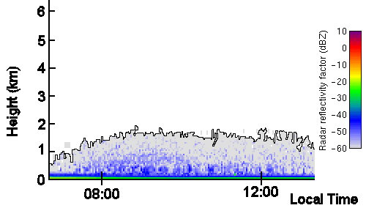
Figure 9 – Section of Chilbolton 94 GHz cloud radar image on 26th July 2001 from the surface to 6km. Lidar observations from the site showed that no cloud was present. In this image, the colours indicate the power of return from atmospheric particulates in the boundary layer. The cloud radar is used primarily for the remote sensing of clouds, but it is possible to see some of the boundary layer features, particularly in the summer months. layer, with grey shades being the least powerful return. The solid black line is included to outline the top of the aerosol layer.

In this example, anticyclonic subsidence over the proceeding few days have trapped aerosol particles (such as dust) within the boundary layer. These have built up to such a concentration that they have a low power radar return. This image illustrates that the top of the boundary layer is not a smooth interface. The reason for this undulating character of the interface is that convective plumes overshoot the top of the CBL and push up into the capping inversion. At the same time air is pulled down into the CBL (subsequently to because the source of the entrainment heat flux). Observational studies (e.g. Crum at al. 1987) and numerical models (e.g. Deardorff, 1974,1980) also show this undulating nature of the CBL top. Because this interface is in a state of constant flux, it is not possible to determine whether a single radiosonde ascent passed through a plume of CBL air intruding into the capping inversion, a region of entrainment or a region representative of the average boundary layer. It can be seen from figure 9 that the CBL top can vary by several hundred meters with in few minutes due to the convective plumes.
The radiosonde ascents were taken from times that were not dictated by this study, since Larkhill is part of the upper-air network. The data used in this section was mainly from a 14 UTC (13 LT) ascent, which is important because it may not represent a time when the CBL was at it maximum extent. This factor, coupled with the subjective nature of defining a CBL top and the undulating nature of the interface means that the observations are subject to large (of order several hundred metre) sampling errors.
The apparent accuracy of the Carson model as shown by table 2 is surprising for a method that in principle derives a maximum possible CBL depth. From figure 8 it can be seen that there are approximately 4 days around day number 210 where the measured CBL depth is in excess of 200 metres greater than the CBL derived from the Carson model. These points add a bias to the statistics which makes the Carson model appear more accurate than it actually is. There are a number of possible reasons for the observation being greater than the theoretical maximum. Firstly, the observed data is subject to large sampling errors as detailed above. Secondly, the net radiation data recorded at Reading may not correlate to the net radiation (and therefore maximum sensible heat flux) at Larkhill due to synoptic variation or local effects such as urban pollution in the Reading area. Another possibility could be the effect of boundary layer clouds, which have important implications on the CBL dynamics, rudimentary observations in connection with this study (Appendix C) noted that small quantities (less than 3 oktas) of shallow cumulus were observed on all of these outlying days.
The parameterisation of the Carson model surface heat flux was dubious due to the assumption of a 24-hour sinusoidal heat flux, with magnitude equal to the maximum net radiation recorded at the Reading University field site. Figure 4 shows the net radiation data from the Reading University field site follows an approximately sinusoidal pattern during the day. Stull (1988) suggests that boundary layer growth begins approximately one half hour after sunrise and ceases one half hour before sunset. In the mid-latitude summer the day length is between 14 and 16 hours, which implies a growth period during the sampling period (summer 2001) greater than 12 hours. Due to this extra heating, the boundary layer could of grown to be larger than predicted assuming a day length of approximately 12 hours.
It was assumed that the majority of net radiation at the surface was given to the atmosphere as sensible heat, which contributed to the growth of the boundary layer. It would have been more realistic to include a latent heat flux term, since over vegetated land surfaces it is an important contributor to the surface energy balance. The division of the net radiation between sensible and latent heat is very difficult to measure. A non-dimensional number called the Bowen ratio (Bo) is the ratio of the sensible to the latent heat flux and can be used to side step this problem somewhat. Studies (e.g. Priestly and Taylor, 1972) have noted that over a saturated surface, the Bowen ratio is strongly a function of temperature, such that at 20ºC the Bowen ratio is approximately 0.5. When this factor is included in the Carson model, (ignoring the ground heat flux) the maximum boundary layer depth is predicted to be a third of the depth of the boundary layer predicted using the Carson model that ignores the latent heat flux, this is shown in figure 10.
Figure 10 – The time dependent depth of Boundary layer derived using the Carson model in two cases: (i) With Bowen ratio equal to infinity (i.e. neglecting latent heat flux) in red. (ii) With Bowen ratio of 0.5 in blue. Both cases use an entrainment heat fraction of 0.2 and a net radiation of 200 Wm⁻².

This new estimate of maximum depth including the Bowen ratio is unrealistic when compared to the overall observations from the Larkhill ascents, where are no observed boundary layer depths less than 900 metres, in fact CBL depths of 400 metres are commonly observed over the sea (Stull, 1988). The reason for this very large discrepancy is that the studies of the Bowen ratio assumed that the surface was saturated. The data was collected during the summer months on specific days during periods of dry weather that lasted a week or more. This implies that the ground was very dry and plants would retain moisture strongly due to a soil moisture deficit (Garratt, 1994), so the Latent heat flux would not of contributed as much to the surface energy balance as this consideration of the Bowen ratio suggests. The problem still remains that the contribution of the latent heat flux to the surface energy balance remains an unknown for the entirety of the sampling period due to lack of sufficient data. It is probable that the Bowen ratio was variable not only over the course of the sample period, but over the course of any particular day as the moisture at the surface was evaporated. It is possible to use anecdotal evidence to speculate about the surface conditions, but without supporting evidence, the latent heat flux remains a problematic unknown in this version of the Carson model.
Operational numerical weather prediction (NWP) models general use similarity theory or high-order closure schemes to determine the surface fluxes (Thuburn, 2001), these methods use variables from within the NWP model to estimate the surface fluxes. Such methods utilize iteration techniques, which are computationally intensive.
Including a factor to account for the latent heat flux in the Carson model reduces the estimate of the maximum boundary layer depth, which acts in the opposite sense to the effect to a period of extra heating. This implies some degree of cancellation between the two effects, but the net effect remains un-quantifiable with the available data.
From comparison with observations, Carson (1973) derived an entrainment heat fraction (A) of 0.2. Stull (1976) bought together other estimates of the entrainment heat fraction from different studies (which used either pure thermodynamic considerations or numerical models) in one paper, which shows entrainment heat fractions ranging from 0.1 to 0.3. Sullivan et al (1998) suggest that in zero-order jump models, the entrainment heat fraction is also a strong function of the Richardson number. VanZanten et al (1998) quantified this by using a large eddy simulation (LES) model to evaluate the parameterisation of entrainment in zero-order (and other) convective boundary layer models. From the LES, the authors found an entrainment heat fraction of 0.25, but using the Richardson number consideration within they found an entrainment heat fraction of 0.42. This variation in the entrainment heat fraction has large effects on the estimation of the boundary layer depth using the Carson model. Figure 11 shows the depth of the boundary layer derived from the Carson model when the entrainment heat fraction is set to the two extreme values (0.1 and 0.42), as well as 0.2 as given by Carson (1973).
From figure 11, it can be seen that changing the entrainment heat fraction (A) from 0.1 to 0.42 modifies the estimated boundary layer depth in the Carson model by approximately 600m. If this parameter is variable according to the conditions, as suggested by Sullivan et al, the entrainment heat fraction was different for each day sampled. This reveals a limitation in the Carson model that simply uses a set value to parameterise the entrainment process.
Figure 11 – The effect of changing the Entrainment Heat fraction (A) on the predicted depth of the time-dependent CBL using the Carson model with sensible heat flux of 200 Wm⁻² in each case.

5) Conclusions

(a) and (b) Gold’s method of forecasting temperature from the tephigram.

The forecast maximum temperatures obtained by using Gold’s method on pre-dawn ascents from the summer of 2001 have been shown to match the recorded maximum temperature very closely, such that the mean forecast error is 0.06ºC. This illustrates that the on sampled days the lowest layers of the atmosphere did undergo a change from an approximate isothermal to adiabatic state. It was also shown that the Gold method accurately predicts (within the limits of prediction error) the temperature rise on a clear day.
The approach used in this study can be improved in a number of ways. Firstly, the radiosonde ascents and maximum temperature observations should take place at the same location. This will eliminate the errors due to synoptic variation, which this study was potentially liable to. Secondly, the main source of error associated with Gold’s method is the error due to hand drawing and subjectively placing a mean isotherm. To reduce this error, a computer program could be implemented to carry out this technique and place a mean isotherm more accurately; therefore predicting a more precise forecast maximum temperature.
This study was limited to ascents taken at just one location during the summer, an extension to this would be to do the same for a number of sites on clear days throughout the year, in order to build up a larger dataset with which to re-appraise the technique.
If this were done, it would be of interest to compare the accuracy of the forecast maximum temperature using Gold’s method to the accuracy of the forecast maximum temperature derived from an operation numerical weather prediction model e.g. From the Met Office or ECMWF.

(c) Boundary Layer Modelling.

Comparison of the results from the Carson model with observations of the CBL depth show that the model predicts CBL depths that are consistent (in terms of order of magnitude) with those observed. The approach taken in comparing these is subject to a large amount of uncertainty, mainly due to lack of sufficient data (as mentioned in discussion).
The uncertainty regarding the assumptions and sampling errors from the observations means that it is difficult to bring forward any irrefutable conclusions regarding the performance of the Carson model. This uncertainty arises mainly due to the crude assumptions regarding input variables such as the surface energy balance and entrainment parameterisation. From the investigation into Gold’s method, it is apparent that the underlying principle is a useful approximation to the real atmosphere. This therefore suggests that if the input variables could be derived correctly, the Carson model would give sensible results.
What this study has shown is that even with the poor assumptions, the Carson model gives realistic estimates of the CBL depth compared to those derived from radiosonde observations. However the error range is so large on both the predictions and observations, the results are not very meaningful.
In order to improve the evaluation of the Carson model the number and quality of the observations would also have to increase. The best way to do this would be to make use of high quality research instrumentation. To obtain realistic sampling of the CBL a tethered balloon, with electronic temperature sensors mounted at a number of different heights, could be used to allow for good quality observations of CBL evolution. It would also be sensible to make use of data from different sources, such as the cloud radar, LIDAR or MST radar, in order to corroborate these observations.
In order to test the Carson model more rigorously, it is essential to quantify the surface energy balance terms realistically. The main discrepancy with the method as used here is the division of the net radiation into ground, latent and sensible heat fluxes. It remains a challenge to estimate both the sensible and latent fluxes in practice, but there are methods that are better than simply using the Bowen ratio over a saturated surface. For example, an eddy correlation measurement technique could be used to estimate the sensible heat flux or a Lysimeter could be implemented to estimate surface evaporation. All of these techniques are expensive and require constant maintenance, but would result in more rigorous assessment of the Carson model.
Secondary to this, it would be crucial to correctly parameterise the entrainment heat fraction in order for a complete investigation of the Carson model. However, this is still an issue that is unresolved as there is no consensus regarding the best method of parameterisation. An extension to this study would be to use the Carson model and observations to work ‘backwards’ as a simple way of deriving an entrainment heat fraction for differing conditions.
The next obvious step would be to compare the forecast maximum CBL depth from the Carson model to the maximum CBL depth forecast from a hierarchy of different models, ranging from similar zero-order CBL models to operational models such as the Met Office mesoscale model.

Carson, D.J  Crum, T.D., Stull, R.B. and Eloranta, E.W.  Deardorff, J.W.  Deardorf, J.W., Willis, G.E. and Stockton, B.H.  Garratt, J.R.  Gold, E.  Inglis, G.A.  Johnston, D.W.  Met. Office.  Stull, R.B.  Stull, R.B.  Sullivan, P.P., Moeng, C.H., Stevens, B., Lenschow, D.H., Mayor, S.D.  Thuburn, J.T.  VanZanten, M.C., Duynkerke, P.G. and Cuijers, J.W.M. | 1973  1987  1974  1980  1994  1933  1970  1958  1997  1976  1988  1998  2001  1998 | The development of a dry inversion-capped convectively unstable boundary layer. Quart. J.R. Met Soc., 99, 450-467  Coincident lidar and aircraft observations of entrainment into thermals and mixed layers. J. Clim. Appl. Meteor., 26, 774-788  Three-dimensional numerical study of turbulence in an entraining mixed layer. Bound-layer. Meteor., 7, 199-226  Laboratory studies of the entrainment zone of a convectively mixed layer. J. Fluid. Mech., 100, Part 1, 41-51  The Atmospheric Boundary Layer. Cambridge atmospheric and space science series.  Maximum day temperatures and the tephigram. Prof. Notes. Met. Off., London, 63  Maximum temperature on clear days. Meteorological magazine., 99, 355-363  The estimation of maximum daily temperatures from the tephigram. Meteorological magazine., 79, 33-41  Source book to the Forecaster’s reference book. Met.O.1024, Crown Copyright, Met. Office College  The energetics of entrainment across a density interface. J. Atmos. Sci., 33, 1260-1267  An introduction to boundary layer meteorology. Kluwer academic  Structure of the entrainment zone capping the convective atmospheric boundary layer. J. Atmos. Sci., 55, 3042-3064  Numerical Weather Prediction. Lecture course notes., unpublished  Entrainment parameterization in convective boundary layers. J. Atmos. Sci., 56 813-828
References

