Dear Sir,

I am very interested in Information Technology (IT), Marketing & Accounting System and Strong experience in project management & system implementation and would like to have the opportunity to prove that I am qualified in those sectors.

I have a successful work history in IT in Pharmaceutical Industries sector and government sector, IT Marketing Activity in Pharmaceutical Industries & Accounting System.

I hold a government excellence award, category of Individual Award 2006.

I hold a Bachelor of Commerce (English Section) from Tanta University, Egypt.
I hold a Microsoft Certified Systems Engineer (MCSE) in windows server 2003
I hold a Microsoft Certified Systems Administrators (MCSA) in windows server 2003 & Microsoft Certified Database Administrator (MCBDA) in SQL 2000.

My experience and skills would make me voluble assets to your company.
I am available to start work immediately.

Attached is my resume, I look forward to having the opportunity to be accepted by your company.

Best Regards,

Sameh Hablas
Mobile: +97150 5390406
E-mail:sameh_hablas@hotmail.com





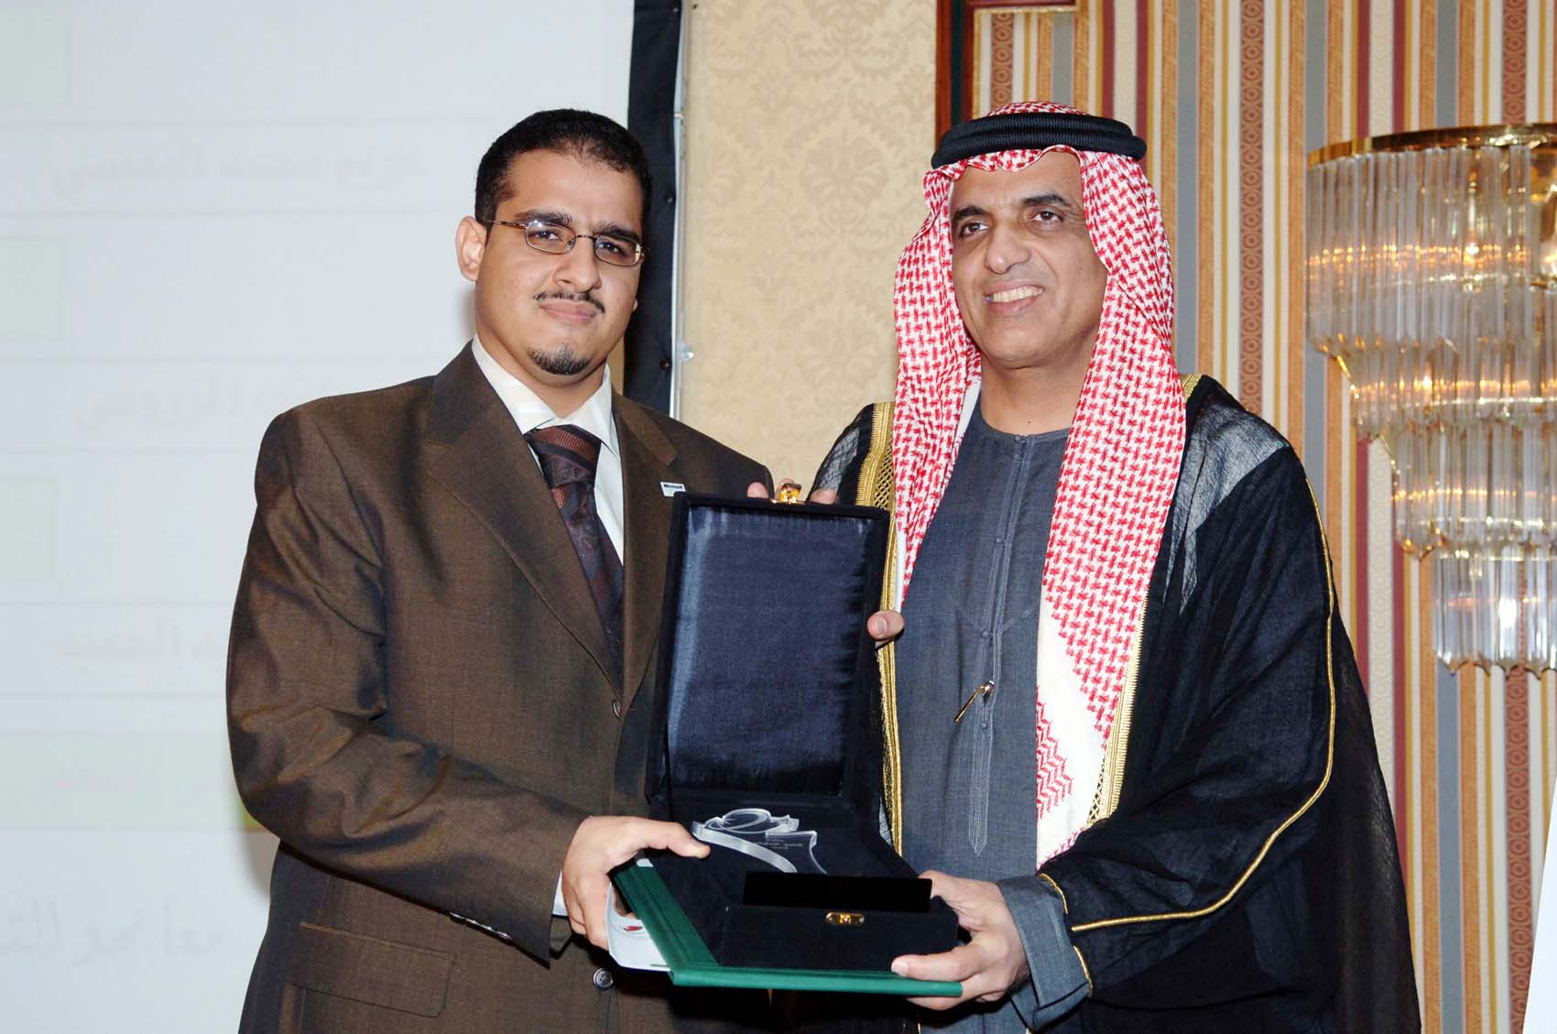
Curriculum Vita

SAMEH ABDEHAMID HABLAS
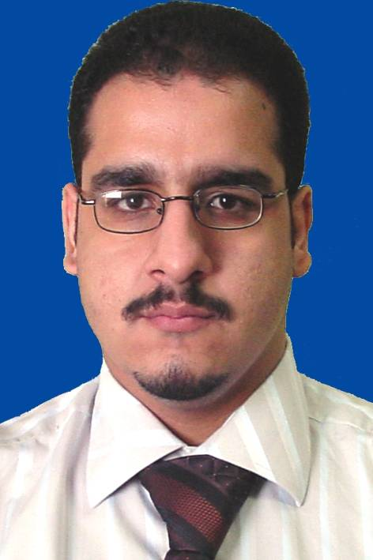
Mobile: +97150 5390406
E-mail: sameh_hablas@hotmail.com
Online CV: www.samehhablas.s5.com

Personal Data:

Date of Birth: 07/08/1980
Place of Birth: U.A.E.
Nationality: Egyptian
Gender: Male
Religion: Muslim
Marital Status: Single
Driving License: U.A.E. & Egypt

Objective:

To obtain a Senior or Management position in the Information Technology or computer Management establishing a competitive and challenging career in a multinational or International organization.

Summary of Qualifications:

• 8 years experience (4 years in UAE & 4 years in Egypt) in the field of IT Infrastructure Library (ITIL), Support, Implementing, Securing, System Analyst and Training & Managing.
• Strong experience in project management & system implementation.
• Clear Understanding of current IT systems, applications & Networks.
• A sound grasp of general business principles.
• Database & Systems design & architect Capability.
• Problem Solving approach, Excellent Communication & Presentation Skills, Proven Performer, Strong work Ethics and Very good leadership skills.

Computer Skills (Professional Experience):
- Windows "9x, NT4 Server, 2000 (professional & server), Me, XP, 2003 server", ISA & Exchange Server ,Active Directory, Microsoft Office 2000, XP, 2003 with front page.
- Designing and Implementing Web Sites with Microsoft Front page & Flash.
- Adobe Photoshop (5 to 7), Flash, SWISH, Ulead Cool 3d, Gif animator, 3D Flash Animator, Flax, Ulead Gif Animator 5, Xara & other multimedia application.
- Surfing the net and have an advanced to getting information from searching web site.
- Programming language in Delphi 3 level 3 & Programming language in C with grade good.
- Accounting Application System (ERP).
- Knowledge of Operation Systems such as: Linux, Mac & UNIX.
- Encrypt and decrypt all file extinction by using professional software.

Award:

Sheikh Saqr Program for Government Excellence.
The category of Individual Award 2006 - New Employee.
Certificates of appreciation and souvenirs by H.H. Sheikh Saud bin Saqr Al-Qasimi,
Crown Prince & Deputy Ruler of Ras Al-Khaimah.

Work Experience (U.A.E.):

Job title: IT Manager – IT Project Manager
Employer: Town Planning & Survey Administration – Ras Al Khaimah Municipality
Employer Country: U.A.E. – Ras Al Khaimah
From: 06/2008 till now.
Job description:
- Manage overall information technology infrastructure, applications, database and security in order to support critical business and process requirements
- Manage the IT Project (archive, ERP, GIS).
- Management of regional 3rd party supplier contracts
- Controlling the security aspects of IT systems
- Increase the productive for the staff in the project from 60 transaction daily to 200 transaction daily in archive system.
- Besides strategy development and planning, the role is also responsible for managing the performance of the division through program management, service measurements and staff development.
guide, and train selected project team members in the planning, organization, execution, and service delivery of the final project. Upon project start-up.

Job title: IT Manager
Employer: VirgiTech Corporation FZE (Microsoft Golden Partner)
www.virgitech.com/uae
Employer Country: U.A.E. – Dubai Knowledge Village, Block 11
From: 01/04/2008 to 6/2008
Job description:
- Manage the IT function on a day-to-day operational basis .
- To ensure maximum availability of computer systems throughout the Company.
- Responsible for the provision of IT infrastructure services including desktop applications, Local and / or Wide area networks, IT security and telecommunications.
- Development and implementation of new systems.
- Working with senior management to propose, agree and deliver IT service to defined Service Level Agreements.
- Responsible for the IT Budget.
- Manage the IT department include staff appraisals, disciplining, pay reviews and career development.
- Responsible for IT hardware, software and maintenance procurement.
- To develop and maintain a disaster recovery plan.
- To develop and control the IT security policy.
- To maintain and develop the company website.
- Provide a monthly written report to the Regional Manager on all aspects of the IT Department

Job title: Head of IT Section
Employer: Government of Ras Al Khaimah / Finance Department.
www.rak.ae
Employer Country: U.A.E. – R.A.K.
From: 07/11/2005 to 31/03/2008.
Job description:

- Responsible for overall operation of IT Section, including budget authority, hiring, training, and retaining of qualified people, and alignment of IT as a service organization, to ensure that department can meet strategic objectives and operational goals.
- Administer the Windows Server 2003 (create backup\restore system , user right , install the exchange & ISA server , create group policy system for the domain user , install Active Directory …etc).
- Administer the antivirus server (Symantec Corporate Edition) & the firewall system (Sonic wall firewall device).
- Administer the E-payment gateway by monitoring & administer the e-payment service that made via RAK E-Gov. website, receive the encrypt e-mail, print out the transaction and send it to internal auditor to compare & audit it.
- Administer the Archiving system (Logical Access) as windows server administrator (NT4) & database admin (SQL2000), create user, user access right, and delete transaction, backup\restore the SQL database.
- Create a backup system for the servers & user files (normal backup & incremental backup per week using tape backup).
- Administer the Oracle Financial Application & Human Resource application based on oracle database 8i.
- Database administrator for the oracle 8i that is using by Financial application (delete the transaction, create user , user right , backup for the database, editing for the transactions ,close the monthly transactions to prevent editing by any user.
- Administer the Archive system that used SQL 2000 Server and grant the access for users and mange their operation.
- Lead the team in strategic planning and development of those systems and services.
- Manage IT operations including computers, network & communication operations, technical support, financial applications evaluation and Implementation.
- Update the financial application infrastructure to be more easy to use by end user.
- Design a new IT system in the department to reduce paper use & minimize the office expense and hand working.
- Update the IT section infrastructure to meet the new technology and requirement.
- Replaced the old servers for the financial application with new one and upgrade the operating system from Windows NT 4 & Unix to Windows server 2003.
- Update the network infrastructure to 100/1000 to increase the speed of data transfer.
- Coordinate with the Ras Al Khaimah e-government authority to supply our need.
- Managing Database, inserting items, categorizing items.
- Prepare monthly reports for the government expense to send it to the Chairman of the Finance Department.

- Design & Deploy wireless network.

- Team Leader for the operation process in Sheikh Saqr Program for Government Excellence.

- Human Recourses Deputy:
- Checking the payroll of all RAK government department
- Issuing annual leave forms.
- Auditing the over time of RAK government employ by using special software.

Note: Award from Sheikh Saqr Program for Government Excellence

Job title: IT Support in the IT Department.
Employer: Gulf Pharmaceutical Industries (Julphar) --- FDA approval
www.julpahr.com
Employer Country: U.A.E. – R.A.K.
From: 25/07/2004 to 22/10/2005.
Job description: -
- Handle all daily computers problem & solving it.
- Responsible for all marketing department activities in IT Solution (sales, tender, budget applications…..etc) and edit the new product for the database.
- Create demo movies for presentation by using various multimedia applications such as flash, swish, ulead & etc………..
- Set up, install, configure, and troubleshoot hardware, software& networking.

- Solve problems using recognized problem-solving methods.
- Prepare training materials and train end-users.
- Administer and support computer network in marketing department.
- Assist in network infrastructure for the company and backup and create user account.
- Administer the mail server for marketing department.
- Assess user needs and recommend computer solutions.
- Perform computer facilities management tasks.
- Collect and display data as lists, tables, and charts using computer software.
- Provide quick solution of problems at a centralized point of contact for technical support services for staff.
- Provide support on the phone, via e-mail as well as in person.
- Create E-book for different product.
- Assist in building the company security system for the main gate, visitor & staff and be the coordinated person with the company which executive the project and take training about this system.
Note: 2 thanks letter for:
1- Prepare presentation movie for Julphar symposium in Aswan for mebo product.
2- Decrypt files for biotech department to be using in specific device.

Work Experience (Egypt):

Job title: Hardware Technical Support.
Employer: Tanta Computer System Company (RAVAN).
Employer Country: Egypt.
From: June 1999 to October 2003.
Job description:

Hardware Technical Support:
- Have a broad base of knowledge and competency in core hardware and operating system technologies including installation, configuration, diagnosing, preventive maintenance and basic networking.
- Understanding of hardware systems and how they are constructed.
- Understand the purpose of common computer peripherals such as disk and tapes and appreciate the significance of their different performance characteristics.
- Understanding of basic technologies of the hardware and also how the hardware functions and the purpose of controllers or adapters and interface standards such as PCI used in PCs to allow peripheral devices such as disks drives to be connected.
- Understanding the network system Peer-to-Peer Networks & Server Client Networks.
- Install, configure and operate Simple-Routed LAN, Routed WAN in Windows Environment.
- Plan, administrate and troubleshoot LAN, WAN connectivity issues.
- Responsible for the purchase, installation, maintenance and personnel training of all office equipment (phone systems, computers, printers, copiers, fax machines, and shredders).

Certificate:

1-Microsoft Certified Systems Engineer (MCSE) Server 2003

2-Microsoft Certified Systems Administrator (MCSA) Server 2003

3-Microsoft Certified Database Administrator (MCDBA) SQL 2000

4-Microsoft Certified Professional (MCP) ID number is 3363057

1-Installing, Configuring and Administering Microsoft Windows XP Professional.
2-Installing, Configuring and Administering Microsoft SQL Server 2000 Enterprise Edition.
3-Designing and Implementing Databases with Microsoft SQL Server 2000 Enterprise Edition.
4- Managing and Maintaining a Microsoft Windows Server 2003 Environment.
5- Implementing, Managing, and Maintaining a Microsoft Windows Server 2003 Network Infrastructure.
6-Planning and Maintaining a Microsoft Windows Server 2003 Network Infrastructure.
7-Planning, Implementing, and Maintaining a Microsoft Windows Server 2003 AD Infrastructure.
8-Designing Security for a MS Windows Server 2003 Network.

(ITIL Foundation V3 under study)

Education:

University Degree: Bachelor of Commerce English Section.
University: Tanta University.
Faculty: Commerce English Section.
Major: Accounting English Section.
Grade: Pass.
Graduation year: September 2002.

Spoken Languages:

Arabic: mother tongue.
English: Very Good spoken, written & reading.

Membership:

1-Microsoft Partner Registered Member ID number is 953615.
2-Arab Information Technology Council.

Conferences Attended:

Date | Description
5/2008 | Windows Mobile Enterprise Briefing 2008 - Dubai
4/2008 | Microsoft Dynamics 4 - Dubai
4/2008 | Simplifying Excellence-Strategic Project Management – Dubai Knowledge Village
4/2008 | Leadership Development Channel‏ - Dubai Knowledge Village
4/2008 | Sustaining Performance under Pressure‏ - Dubai Knowledge Village
3/2008 | Microsoft 2008 Launch Wave‏ - Dubai
06/2007 | Best Practice for Government Excellence – Ras Al Khamiah
04/2007 | Microsoft Business Intelligence Tour – Dubai
12/2006 | Information Technology Governance Assurance Forum - Dubai (VIP)
03/2006 | Microsoft Be the first to know: 2007 Office System & Windows Vista Readiness Tour - Dubai
02/2006 | Microsoft Gulf Partner Summit: Together, We Build Success - Dubai
01/2006 | Microsoft Dynamics Great Plains 9.0 Event - Dubai

Training

Geo Learning LMS –Learning Management system
Presentation Skills.
Professional Selling Skills.
Information Marketing.
Julphar Sales Viewer application.
Julphar Budget application.
Oracle Financial – Government of Ras Al Khaimah
Oracle Human Resource – Government of Ras Al Khaimah
E-Payment gateway administer & monitoring

References can be furnished tailored to your request and inquiry

