EASTERN STATE LIBRARY LINE

IMAGE SEARCH

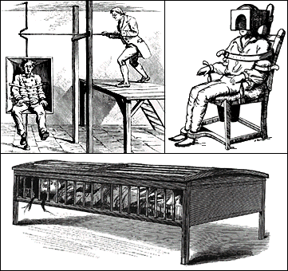
Need a picture or two for Power Point presentations or handouts ?
Check out these Image sites.

Google Image Search
http://images.google.com/

Google’s Image Search is the most
comprehensive on the Web, with more than

425 million images indexed and available
for viewing. Enter a query in the image search
box and click on the “Search” button. On the
results page, just click the thumbnail to see
a larger version of the image, as well as the
Web page on which the image is located.

Health Education Assets Library
(HEAL)
http://www.healcentral.org/
The Health Education Assets Library (HEAL)
is a national repository of multimedia
instructional materials designed to support
all levels of health sciences education.

Images from the History of Medicine
(IHM)
http://wwwihm.nlm.nih.gov/

This system provides access to the nearly
60,000 images in the prints and photograph
collection of the History of Medicine

Division of the U.S. National Library of
Medicine. The collection includes portraits,
pictures of institutions, caricatures, genre
scenes, and graphic art in a variety of media,
illustrating the social and historical aspects
of medicine.

Public Health Image Library (PHIL)

http://phil.cdc.gov/phil/Created by a Working Group at the Centers
for Disease Control and Prevention (CDC),

PHIL TM offers an organized, universal
electronic gateway to CDC’s pictures. The
content is organized into hierarchical
categories of people, places, and science,
and is presented as single images, image
sets, and multimedia files.

The system is written and edited by nearly
3,000 physician experts in each medical
specialty and a new, peer-reviewed version
Eastern State Hospital Staff Library

Issue 1 Spring 2006
is issued every four months. The expert
faculty synthesizes and summarizes the latest
evidence and provides specific, practical
recommendations for diagnosis and
treatment. More comprehensive than any
other individual resource, UpToDate contains
the equivalent of over 50,000 pages of
original text.

UpToDate’s topic reviews contain links to
other related topics and are fully illustrated
and referenced. Users can view related charts,
x-rays, photographs, movies and MEDLINE
abstracts by clicking on the associated links,
and also have complete access to UpToDate’s
extensive drug databases.

UpToDate’s online drug information
database was recently enhanced by the
addition of the Lexi-Intereract drug
interactions program. Lexi-Interact allows
you to review all potential interactions for a
selected medication. You may also enter
specific patient regimens with multiple drugs
for analysis or potential intereractions and
the severity of the interaction. Additionally,
you can select a drug interaction result to
obtain detailed information on patient
management.

UpToDate also offers category 1 CME
credit to physicians while they use the system.

Time spent using the service is automatically
tracked both on the CD-ROM and online.

For additional information, contact the
Norris Reference Desk, (323) 442-111, or
medlib@usc.edu.
Public Health Image Library (PHIL) Photographs, Illustrations, Multimedia Files
http://phil.cdc.gov/phil/home.asp
Much of the information critical to the communication of public health messages is pictorial rather than text-based. Created by a Working Group at the Centers for Disease Control and Prevention (CDC), the PHIL offers an organized, universal electronic gateway to CDC's pictures. We welcome public health professionals, the media, laboratory scientists, educators, students, and the worldwide public to use this material for reference, teaching, presentation, and public health messages. The content is organized into hierarchical categories of people, places, and science, and is presented as single images, image sets, and multimedia files.

http://www.pubmedcentral.nih.gov/

PubMed Central (PMC) is the U.S. National Institutes of Health (NIH) free digital archive of biomedical and life sciences journal literature.
PubMed Central is a digital archive of life sciences journal literature at the U.S. National Institutes of Health (NIH), developed and managed by NIH's National Center for Biotechnology Information (NCBI) in the National Library of Medicine (NLM). With PubMed Central, NLM is taking the lead in preserving and maintaining unrestricted access to the electronic literature, just as it has done for decades with the printed biomedical literature. PubMed Central aims to fill the role of a world class library in the digital age. It is not a journal publisher. NLM believes that giving all users free and unrestricted access to the material in PubMed Central is the best way to ensure the durability and utility of the archive as technology changes over time.
PubMed Central follows in the footsteps of other highly successful and useful services that NCBI has developed for the worldwide scientific community: GenBank, the genetic sequence data repository, and PubMed, the database of citations and abstracts to biomedical and other life science journal literature. GenBank, and the tools provided by NCBI for searching and manipulating its contents, have been a boon to molecular biologists and have helped advance developments in the field. PubMed (which encompasses Medline) is the database of choice, for researchers and clinicians alike, to locate relevant articles and, in many cases, link directly to a publisher's site for the full text.

 | Literature Database

Look for background information or research new topics with freely accessible, online biomedical textbooks. The growing NCBI Bookshelf can be searched directly or accessed via PubMed abstracts by clicking
the "Books" link. The database can also be searched by choosing "Books" from the Entrez pull-down menu.
PubMed - NCBI
Through PubMed, anyone can access MEDLINE's 15,000,000 biomedical journal citations to research biomedical questions. Clicking the "Related articles" link for each abstract can expand your search. Click here for the PubMed tutorial.
For all resources offered in NCBI go to:
http://www.ncbi.nih.gov/Sitemap/ResourceGuide.html

My NCBI.
Now you can not only store your search strategies indefinitely,but you can get automatic email updates of the most
recent articles retrieved with your search. My NCBI will also have a feature allowing you to group retrieved articles by
topic and see which articles are available in full text format. Although My NCBI is free, you must register the first time you
use it and login to access your saved searches. On the upper right-hand corner of the PubMed heading, click on Register.
Fill in the form to create your username and password. Startsaving the searches you want to reference in the future!

What’s New in the Staff Library?
Books:
Crazy: A father’s search through American’s mental health madness.
Nursing made insanely easy:
Pharmacology made insanely easy.
Best of the incredibly easy.
Geropsychiatric and mental health nursing.
Monday morning leadership:
Monday morning communication:
Nursing against the odds:
Pain management at the end of life:
Faith and mental health:
Dementia and lewy bodies and Parkinson’g disease dementia.
Asylum: Patton State Hospital…
Seven habits of highly effective people:

College of Direct Support Update

State and Local Service and Advocacy Leaders Are Saying:

“The College of Direct Support is an important national initiative that provides validated, competency-based training in the specific knowledge, skills and abilities needed by direct support professionals. The College of Direct Support has important features such as the scientific analysis of the content of the direct support role; its engagement of national experts in all courses; its platform that provides interactive, multi-media content; the permanency and portability of its training records; the articulation of its training into college credit; and its adherence to the principles of adult learning.”
--James Reinhard, M.D., Commissioner, Virginia Department of Mental Health, Mental Retardation and Substance Abuse Services

The College of Direct Support is an exceptional curriculum to enhance one of our most valuable human resources, the direct support professional. With the College of Direct Support we can finally provide quality, consistency, innovative training at any time, any day, while continuing to improve the quality of life for our consumers.”
--India Sue Ridout, Virginia Department of Mental Health, Mental Retardation and Substance Abuse Services

Direct Support Professionals and Supervisors Are Saying:

“I feel I have bettered myself and will be able to use what I learn at work to help others better themselves.”
--A Wyoming DSP quoted in Wyoming’s DDD News, December 2004

"Our staff is really excited about it and is not only enjoying the learning but also, for many, they are beaming over their newly developed computer skills. Again, our staff is embracing CDS with great enthusiasm and is excited about the potential career ladder that is proposed in conjunction with this learning opportunity."
--Sally Garrett, Chief Nurse Executive, and Lori Carter, Nursing Staff Development Coordinator, Northern Virginia Mental Health Institute, Falls Church, VA.

“I love how the College of Direct Support taught me about how to support people; you heard the stories of experiences from both consumers and direct support staff, you took a test, you were able to print out documents you felt were important to keep.”
--A DSP student at LaGuardia Community College, New York

Eastern State has 54 staff members enrolled in the College of Direct Support. Two hundred forty lessons have been completed and 186 hours of CDS credit earned.
Two staff members have completed all the courses! Congratulations!!

If you have questions or would like to enroll in CDS contact Sandy Kochersperger x5457, Building 3 Staff Library.

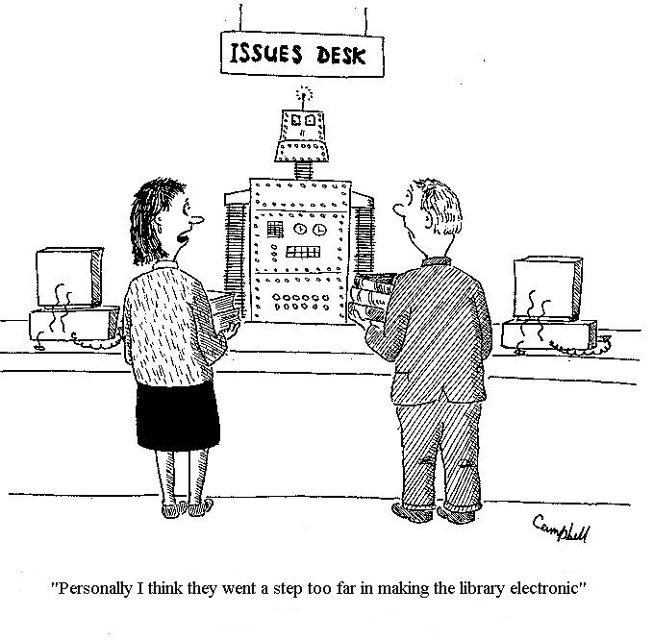

UPCOMING CHANGES IN DATABASES

Ebscohost Databases changes beginning
July 1, 2006:
Healthsource will be dropped.

Will continue PsychINFO, Psychology and Behavior Science Collection, MEDLINE, and CINAHL.

These databases are always available 365 days a week 24 hours a day.
To access these Databases connect to the Internet-http://search.epnet.com
From home or off campus: User ID: ESH,
Password is Eastern.

STAT!REF http://online.statref.com Username: mentalhealth

Password: galt

Changes
The following full-text items will be dropped:
Delmar’s Fundamental & Advancing Nursing.
Merck Manual of Diagnosis & Treatment.
Nursing Diagnosis in Psychiatric Nursing.
Treatments of Psychiatric Disorders. (Most of these can be found in print in the library.)

New Items Added and Renewed
Delmar’s Geriatric Nursing Care Plans- To be added.
- DAVIS'S DRUG GUIDE FOR NURSES 9th ed. (2005)
- DELMAR'S GERIATRIC NURSING CARE PLANS - 3rd Ed. (2005)
- DIAGNOSTIC AND STATISTICAL MANUAL - TEXT REVISION (DSM-IV-TR™, 2000)
- GERIATRIC MEDICINE: AN EVIDENCE BASED APPROACH - 4th Ed. (2003)
- REVIEW OF GENERAL PSYCHIATRY - 5th Ed. (2000)

 National Guideline Clearinghouse
A public resource for evidence-based clinical practice guidelines.

MedCalc 3000
MedCalc 3000 is a unique computerized medical reference and tool set.

 STAT!Study
Free Tools and Resources for Medical Students and Residents

 Pub Med
PubMed, a service of the National Library of Medicine, includes over 15 million citations for biomedical articles back to the 1950's.

