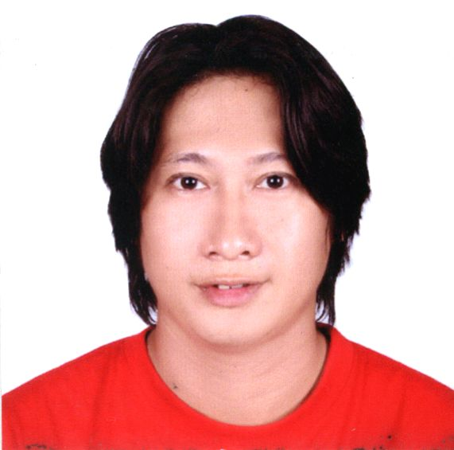
R E S U M É
Personal Information:

Name: Alexander “Sandy” San Miguel Tecson

Age: 37 Years Old Height: 5’8”
Weight: 135 lbs. Birthday: August 31, 1969
Sex: Male Place of birth: Valenzuela
Civil Status: Married
Address: 007 Edelweiss St., Sanville Homes, Malhacan Meycauayan, Bulacan
Wife’s Name: Ma. Lagrimas O. Tecson
Mother’s Name: Teresita M. Tecson
Father’s Name: Reynaldo U. Tecson

Educational Attainment:

Name of School / University Degree Earned Year

University of the East, Caloocan BFA, Advertising Major 1988-1994
Marisyl School, Malanday, Valenzuela Secondary 1985-1987
Meycauayan College Secondary 1983-1985
Marisyl School, Dalandanan, Valenzuela Primary 1981-1983
Malinta Elementary School Primary 1977-1981

Other Courses Attended:

Guzman Institute of Electronics Basic Electronics June 1987
Hands On Computer School, SM City Basic Computer Graphics July 1994

Job Experiences:

IDNet Consulting, Inc. / (Freelance) Web Designer #4 Garfield St., Greenhills West, San Juan,
July 14, 2004 – August 14, 2004 Metro Manila

Vignet Inc. / (Freelance) Graphic Designer Vignet Factory T.L.R.C. Building, Tama,
March 2002 – April 2004 Hermosa, Bataan

Vignet Inc. / Graphic Designer Vignet Centre, E. Rodriguez Jr. Ave.,
Nov. 1998 – March 2002 Libis, Quezon City

Cyberia Café / Web Designer / Computer Graphic Artist 13 – 138 Jupiter St., Bel – Air Vill.,
Sept. 1997 – Nov. 1998 Makati City

Inkworks, Inc. / Graphic Designer Unit T-2B 3F Mile Long Bldg.,
Aug. 1996 – Sept. 1997 Amorsolo St., Makati City

Viva Records / Graphic Artist 3F Crispina Bldg. 1589 Quezon Ave.
Nov. 1995 – Aug. 1996 Quezon City
Primer Group of Companies / Sr. Manual Artist J A Tan Bldg. 2317 A. Luna St.,
May 1995 – Sept. 1996 Pasay City

Adroit-Huntington Comm. Inc. / Asst. Sr. Artist 3F Seddco 1 Bldg., Rada St.,
May 1994 – Mar. 1995 Legaspi Vill., Makati City

Concept Tree Inc. / Artist Kintanlad St., Quezon City

Rebisco / Jr. Artist [summer job] Novaliches, Quezon City

Santos Ceramics / Artist [summer job] Rincon St., Valenzuela City

Some Achievements:

Worldbex Exhibit, World Trade Center, March 16-20, 2004, Roxas Boulevard, Manila
Worldbex Exhibit, World Trade Center, April 2003, Roxas Boulevard, Manila
Worldbex Exhibit, World Trade Center, March 14-17, 2002, Roxas Boulevard, Manila
Converge @ Comddap Expo2000, World Trade Center, October 4-7, 2000, Roxas Boulevard, Manila
Participated in the exhibit “AdverEastment” Feb. 15 – 27 1994, Shangri-la Plaza, Edsa
Batman Forever Fashion Shows; July 1995, SM Shopping Malls (Metro Wide)

Other Skills:

• Knowledge in some outdoor advertising & photography
• Knowledge in trouble-shooting and repairing pc computers, software installation & configurations
• Web Site Design; knowledge in understanding HTML, Style-sheet and some Java Script

Software Knowledge:

Adobe Photoshop, CorelDraw, Microsoft Applications, Allaire Homesite, Macromedia Dreamweaver / Flash, Microsoft PhotoDraw, (Video Editing Software “Pinnacle Studio”) and more.

Reference:

Jing Staple Joji Hodges Ian Selby
Manager Businesswoman Businessman
Nike Philippines Pure Sense Race Rock Bar / EasyStop
Shaw Boulevard, Q.C. Makati City (SBMA), Subic Bay, Olongapo City


____________________________
Alexander “sandy” M. Tecson

Mobille: 0921 8298954
E-mail: sandytecson@yahoo.com Website: http://www.geocities.com/smtecson

