
Lil Lily Chan at 778-388-9158
y Llyi Chan at 778-

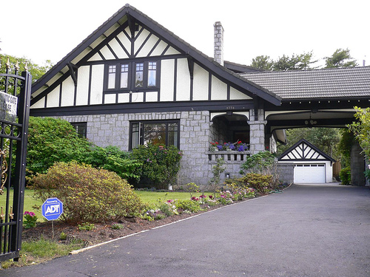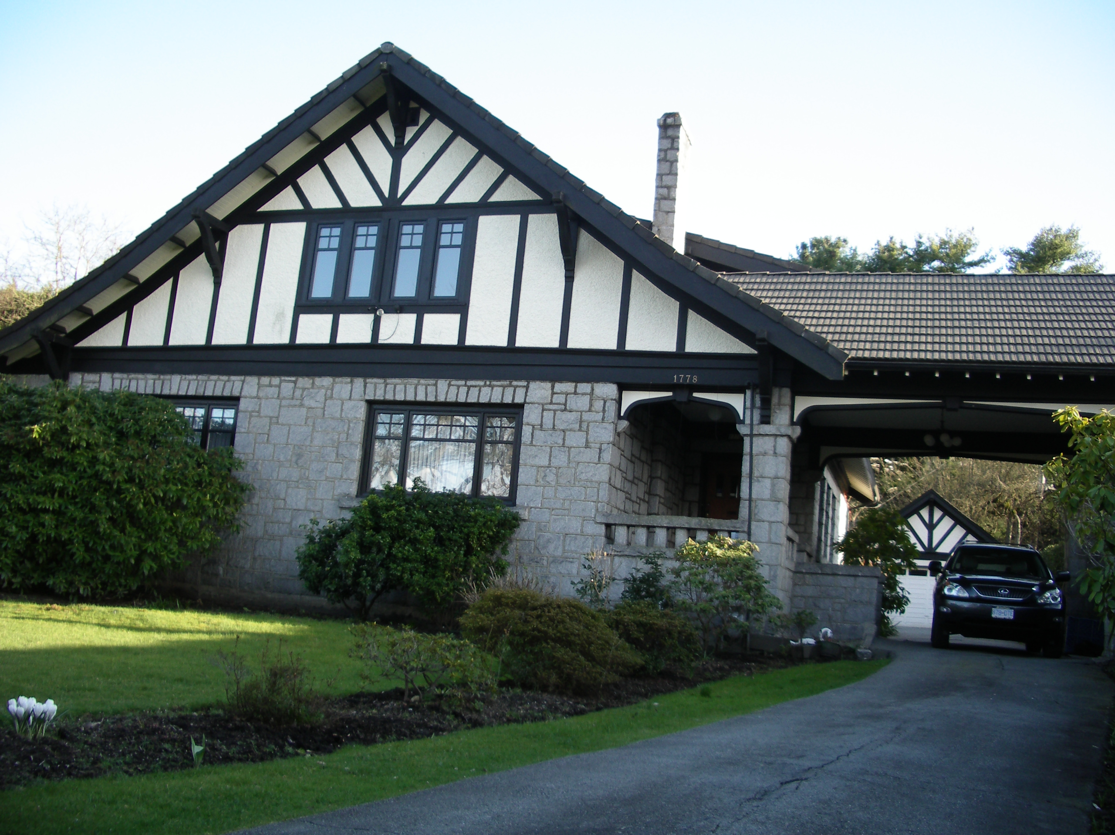
$3,280,000 3,3,8000,000.00

SUTTON GROUP – WEST COAST REALTY

- A 110’ X 200’ corner lot
- Total over 4,000 sq.ft on
The main & 2nd floors
- 4 spacious bedrooms
and bathrooms
- A huge elegant living
room and dining room,
perfect for entertaining
- A cozy bright kitchen
- Double glazed windows
Character masonry Tudor home. Well situated on a 110’ X 200’ corner lot in First Shaughnessy. Spacious bright high ceiling bedrooms and den with entertaining size living room and dining room. All rooms overlook the garden. The house has kept its original charm with some updates. Basement is low & requires further development.
To view more pictures: http://www.flickr.com/photos/89598305@N00/

Please call: Lily Chan at 778-388-9158

JUST LISTED!

1778 Cedar Crescent
AN INDEPENDENT MEMBER BROKER
Tel: (604) 267-3800 Email: clily688@yahoo.com Website: www.sutton.com

The above information is deemed reliable but not guaranteed. Not intended to solicit current listed properties.

