Haven Storm Fundraising Order Guide

Package #1: $25
Choice of keychain or starter bracelet and all 6 charms
Package #2: $18
Choice of keychain or starter bracelet and 2 charms (1 & 2)
Package #3:
Charms only... 1 & 2… $14
Each additional charm (#3, #4 or #5) $1
Personalized Charm (#6) $4

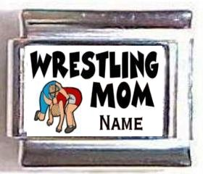1A. Wrestling Mom | 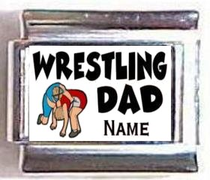1B. Wrestling Dad | 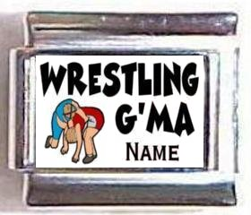1C. Wrestling G’ma | 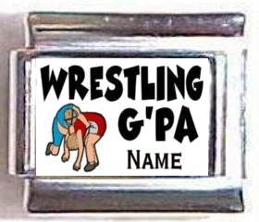1D. Wrestling G’pa | 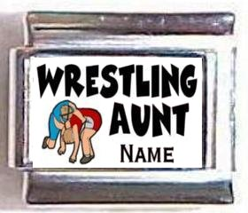1E. Wrestling Aunt
Choose one form above row – your name OR wrestler’s.

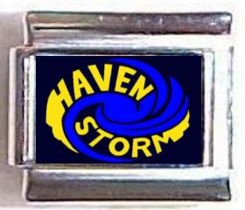  2. Haven Storm | 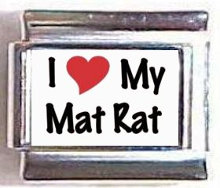  3. I Heart My Mat Rat  $1 | 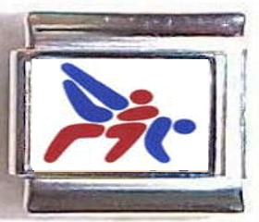  4. Red and Blue Wrestlers  $1 | 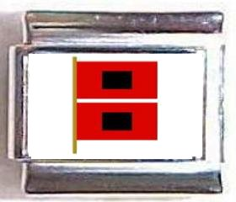  5. Hurricane Warning  $1 | 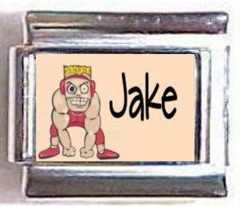  6. Personalized Wrestler  $4

Bracelet / Keychain choices
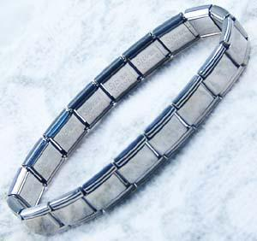S1 | 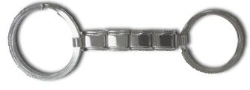  K1 | 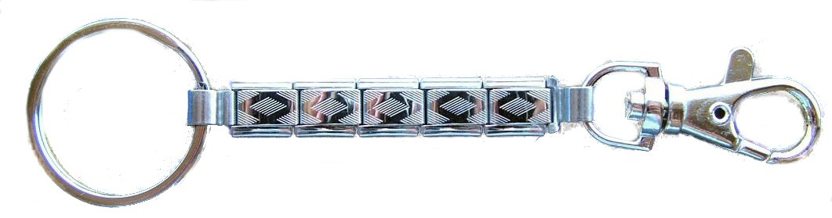  K2

