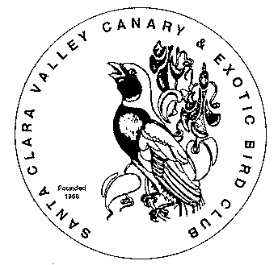
Santa Clara Valley Canary and Exotic Bird Club’s
48th Annual Open Bird Show
December 12, 2009

Judges

Colorbred Canaries: Rado Pagac from Ontario, Canada
Type Canaries: Robert Wild from Illinois
American Singer Canaries: Ella Galik from California
Don Taylor from California
Spanish Timbrado Canaries: Sebastian Vallelunga from California
NFSS Finches & Softbills: Brian Mandarich from California
ABS English Budgerigars: Leon Saad from California
NCS Cockatiels: Roland Dubuc from California

Show Location
Show Hall: Temple Emanu-El, 1010 University Ave., San Jose, CA

Show Lodging
You and your birds are welcome at the Red Roof Inn, 1440 N. First St., San Jose, CA
Phone: (408) 453-7750, ask for special rate for "Santa Clara Bird Show”

Show Banquet
Harry's Hoffbrau, 390 Saratoga Ave., San Jose, Saturday 6-8 p.m., no RSVP, just show up

Registration Schedule
AS and Timbrado canaries must check-in at Temple Emanu-El, December 11, 5-8pm.
All other birds check-in December 12, Saturday morning only, 8-9 a.m.
For pre-registration information, call Ginger at (408) 739-3995
or visit our club web site at http://santaclarabirdclub.org/

