Geography Notes
Sec 3 Express/ Sec 4 Express [Revision]
Impacts of Tourism
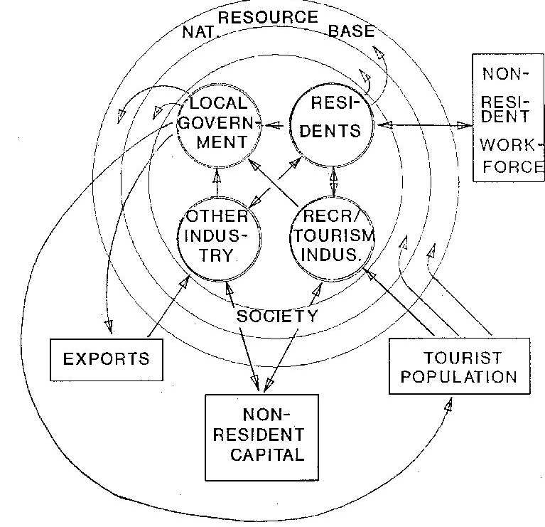
Type of implications | Good | Bad
Social | - A force for peace  - Tourism brings people into contact with each other and, has an educational element.  - It can foster understanding between peoples and cultures and provide cultural exchange between hosts and guests.  - Because of this, the chances increase for people to develop mutual sympathy and understanding and to reduce their prejudices. | - Pseudo culture  Example: Paper lantern → Plastic lantern  This will give tourists a false impression of their culture.
Social | - Enjoy higher standard of living  - Tourism supports the creation of community facilities and services  - Benefits can include upgraded infrastructure, health and transport improvements, new sport and recreational facilities, restaurants, and public spaces as well as an influx of better-quality commodities and food. | - Unemployment  Reason: Unstable  Depend on seasons, external threats.
Social | - More equal distribution of wealth  Reason : The developed country go to the developing country to spend and thus distribute their wealth | - Intimate bad habit  - Tourist behaves in a way that is different in the local country. (e.g. clothing)  - Local people that come in contact with these tourists may develop a sort of copying behavior, as they want to live and behave in the same way
Social | - Preserve culture  Reason: Tourists will go to the places of interest like China Town, Little India, Kampong Glam, Geylang Serai
Social | - Encourages civic involvement and pride  - Tourism also helps raise local awareness of the financial value of natural and cultural sites and can stimulate a feeling of pride in local and national heritage and interest in its conservation. | - Economic inequality  - Tourism-related jobs generally generate more income than primary and even secondary industries.  - Resentment may arise from those who are unemployed or in primary and secondary industries due to uneven distribution of income.
Social |  | - Irritation due to tourist behavior  - Some tourists fail to respect local customs and moral values.  - When they do, they can bring about irritation and stereotyping.
Social |  | - Crime generation  - The presence of a large number of tourists with a lot of money to spend, and often carrying valuables such as cameras and jewelry, increases the attraction for criminals and brings with it activities like robbery and drug dealing.
Economic | - Earn foreign exchange  - Tourism expenditures and the export and import of related goods and services generate income to the host economy.  - This increases its GNP per capita. | - Rising prices  Example: The tourists would buy things (food, necessities) in that country and the local would also want to buy things (food, necessities) too. Thus, there will a high demand and shortage of food. Thus, they will raise price to solve the shortage of food.
Economic | - Build infrastructure  Example: Build roads for ease of transport network for tourists.
Economic | - Improves the standard of living  Reason: Due to the above amenities
Economic | - Encourages other industry  Example: Tourist will need to board taxi, go to restaurant to eat. Thus, these industries are set up.
Economic | - Diversify economy  Example: If agricultural and industry are not doing well, tourism is another resource of getting income.
Environment | - Preserve natural environment  - Tourism can make pristine sites and natural areas are identified as valuable and the need to keep the attraction alive can lead to creation of national parks and wildlife parks.  - Example: Eco-tourism has been one of the attractions for tourists. The government of that country will restore the environment by imposing fines for those destroying the environment to attract tourists. | - Deforestation  Example: Forests are being cut down for building resort for the tourists. This causes deforestation.
Environment | - Preserve a clean environment  - Tourism increases public appreciation of the environment and spread awareness of environmental problems when it brings people into closer contact with nature and the environment.  - Example: Due to tourism, Singapore established a ‘green country’ and imposes fines for those flouting the above rules (e.g. littering, spitting) | - Soil erosion  Example: Due to deforestation, the soil will seep to the ground. Thus, it causes soil erosion.
Environment | - Clean river  Example: The Singapore River used to be extremely dirty but Singapore’s government decided to make it as tourist attraction due to the fact that it has a rich history and had to make it clean | - Pollution  Example of air pollution: Traffic jams  Example of water pollution: Oil leakage when transporting tourist.  Example of land: The garbage thrown by the tourists.
Environment |  | - DEPLETION OF NATURAL RESOURCES (Water)  - Water is one of the most critical natural resources.  - The tourism industry generally overuses water resources for hotels, swimming pools, golf courses and personal use of water by tourists.  - This can result in water shortages and degradation of water supplies.

