aimsFax®
Ready-to-run desktop Fax Management
Solution for the Windows Environment
– From the maker of AIMS Enterprise Solutions®

• A complete desktop fax management solution
• One solution for the fax & option e-mail integration
• Support for all Windows-based workstations

Reliable Windows-Based Fax Management  aimsFax® by Accede provides a robust means of managing fax traffic throughout day-to-day operation. It allows end users to send, receive, view, edit, monitor, and archive the fax documents that flow through your organization every day. Accede continue to aim to be the proven leader in telecommunications management reliability, you can assure that aimsFax strive to provide the performance, features, and compatibility require to support your present and future operating environment. | aimsFax Manager Makes it Easy for Users to  Manage their Fax Activity  Whether you want to send a fax or review recent fax activities, aimsFax Manager makes the faxing process easy for any user. When sending faxes, users can automatically add recipients to their phone book/groups from the SEND FAX dialog box. The aimsFax Manager Activity log enables users to view recent fax service activity at a glance
Automatic Conversion of File Attachments to  Faxes  You can fax directly from an application using the  aimsFax printer driver. Or attach application files  to outbound fax messages. These native application  files are converted to faxes in the background by the  fax engine. aimsFax supports the most popular  Windows applications, including:  Corel Office (including WordPerfect), Microsoft Office,  Lotus SmartSuite, Microsoft Project, Visio,  Adobe Acrobat (PDF) and HTML.  Edit, Annotate and Forward Multiple Faxes  Simultaneously  With the generic Window versatile image viewer, end users can now expedite the manual filing document. And also, by incorporating with the popular Windows XP’s image  viewer, user can displays either single or multiple fax  documents on one screen, enabling users to view  documents in a thumbnail format. | 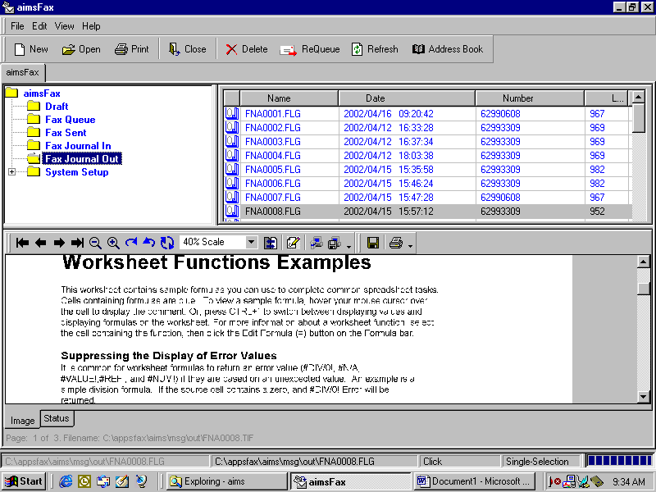  aimsFax Manage Fax Activity Efficiency

Perform bitmap editing; organize documents by  eliminating or adding pages from another document;  and send a fax that has been annotated, rotated, filled out,  and signed directly from the desktop.  Achieve a Return on Investment in Months  & Lower Total Cost of Ownership  Reducing your reliance on stand-alone fax machines  should provide ROI in a short amount of time. However,  when you include the cost associated with installing  software and hardware that have not been designed and  tested together, the ROI timeframe extends while the  Total Cost of Ownership (TCO) increases. Because  aimsFAX is designed and developed exclusively for you  to drastically shorten your time to achieving ROI and  minimize your TCO. | 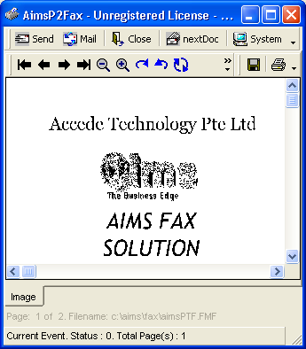  aimsFax Print2Fax Driver convert  all popular Windows applications

Major Benefits  - Low Cost Investment / Setup  - Incoming fax line distribution / print to designated printer  - On-screen diagnostic and management capabilities  - Monitoring via Event Viewer and Performance Monitor  - Real time fax monitoring  - Native file translation of most popular documents:  - Lotus SmartSuite  - Microsoft Office  - Microsoft Project  - Corel Office  - Visio  - Adobe Acrobat (PDF)  - HTML or Rich Text Format  System Requirements  - Any PC running Windows 2000, Windows NT Workstation 4.0 and Windows XP | Product Features  - Support for any Windows 2000, Windows NT and Windows XP desktop  - Queue manager for pending faxes  - Fax status monitor  - Fax broadcasting with option to filter unwanted number  - Phonebook import capabilities  - Support most popular desktop scanners and document management technology  - Support for sending multiple attachments  - Detail Log Traffic Activity for Analysis  - Multi-User Sharing Environment  - Option to integrate with e-mail  - Option to integrate with telex  - Return Delivery Notification via e-mail  - Support Class 1, 2, 2.0 fax modem


Accede Technology Pte Ltd

Blk 104 Boon Keng Road, #03-07
Kallang Basin Ind. Estate,
Singapore 339775
Tel: 6299 9013

Fax: 6299 3309
Web: www.accede.com.sg The Business Edge
E-Mail: aims.sales@accede.com.sg

