A Long and Winding Road
(Progress on the Road to a Software Engineering Profession)

Tan Siang Cheng
Student of Nanyang Technological University (NTU)
javier090@yahoo.com.sg

Introduction

The paper [1] which I am assigned to has nothing to do with the techniques or processes of Software Engineering. Interestingly, the paper talks about Professionalism in Software Engineering. This made me instantly recall the time whereby everyone had to memorize the Professional Engineers Act [2] as to fulfill the requirements of SC131, Engineers and Society.

Related Lecture Topics

Basically speaking, there is no relation to the topics discussed in lectures.

Contribution to Field of Software Engineering

The new contribution to Software Engineering described by the paper [1] is that effort has been made by international bodies to establish Software Engineering as a profession.

Why establish professionalism in Software Engineering?

Software Engineers bear heavy responsibilities for the software system that the world relies on more and more.

Examples would include critical systems controlling life support functions in medical science and flight and launch control software for manned missions.[3]

Mechanical Engineering shaped the 19th century and Electrical and Electronics Engineering the 20th. It would be imperative that the products of Software Engineering will shape the 21st century.

Developments made to establish SE as a profession

- Adoption of Software Engineering Code of Ethics and Professional Practice [4]

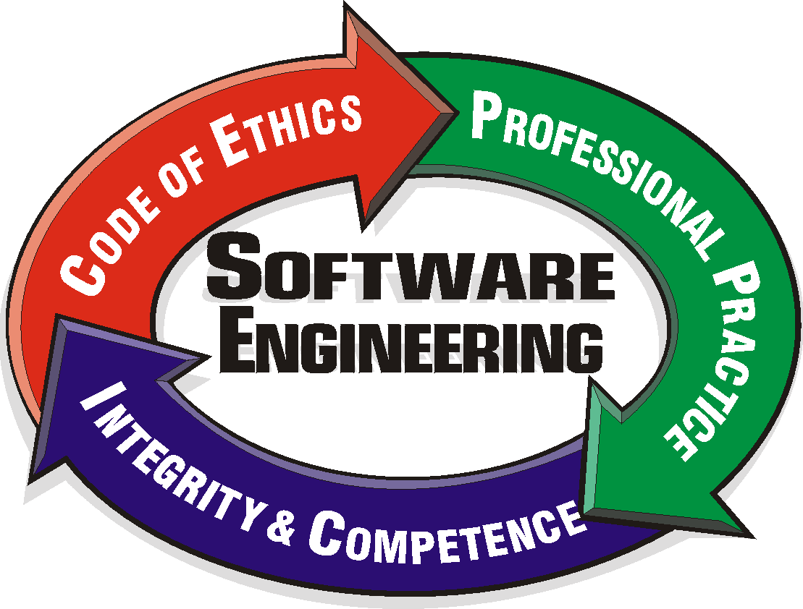

Figure 1, Logo of the SE Code of Ethics and Professional Practice

It is jointly approved by the ACM (Association for Computer Machinery) and IEEE-CS (IEEE Computer Society) in 1998.

Because some people wanted a concise, relatively high level, inspirational code and others wanted a more detailed document that would guide practitioners in making technical decisions ethically, the code comes in two versions:

- The short document: Preamble fulfills the desire for conciseness
- The longer document offers more details

- The Software Engineering Body of Knowledge [5]

The Body of Knowledge (BoK) represents and defines the scope of SE. It must exist if educational institutions, professional bodies and licensing organizations are to produce meaningful curriculum and examinations.

Its development is aimed at achieving a consensus view by the SE community on a core body of knowledge for the SE discipline.

- The Harmonization of Professional Standards document [6]

It has been produced under the auspices of the International Federation for Information Processing
IFIP) [9]. Essentially it provides a framework for professionalism with sections that address:

- Ethics of professional practice

- Established body of knowledge

- Education and training

- Papers promoting areas related to SE professionalism

An increasing number of papers related to SE professionalism are being published in major computing journals such as IEEE Software and IEEE Computer.

Problems faced

- Major parts of software industry uninterested

The whole area of professionalism tends to be neglected by major parts of the software industry which appears to be mesmerized with technological aspects to the detriment of human related areas and issues

- Bias

The SWEBOK project faced major problems as a close inspection of the contents of the trial version of the guide has a bias towards the North American continent.

The demographics presented on the project website also cast doubts as to whether the reviewers of the project represented a reasonably balanced international population across all the various designated sectors.

This is a huge limiting factor in my opinion as for any work to be recognized globally, consensus has to come from professionals from all over the world.

Quoting the author from [7], “I have great concerns that many of SWECC’s current projects are likely to produce a model for Software Engineering Professionalism that is primarily centered on industry structures and educational models that reflect the situation in North America”

It can be seen that the author shares the concern that for SE to shape the 21st century, a much broader view is needed.

- Serious Limitations

ACM believes that there are serious limitations within the SWEBOK project. They believe that this has impacted the later stages of it. These problems appear to have been partly instrumental in ACM’s withdrawal from SWECC.

ACM’s withdrawal is a big blow to the cause.

Positive, Successful Aspects

Despite the problems faced, the several developments mentioned above have been well received by national professional bodies for computing.

The SWEBOK project is also used to support teaching and demonstrate to students the disparate views that exist across the community

Related Works
Author (s) | Year | Article | Description | Relation to Main Article
Don Gotterbarn | 1999 | How the New Software  Engineering Code of  Ethics Affects You [8] | A thorough investigation to the immediate and long-term implications of the code | The code is one of the major development in establishing SE as a profession
Don Gotterbarn | 1997 | The Professionalization of Software Engineering and its significance for Ethics Education [10] | Discussions on ethics and details of the draft copy of the SE code | Same as the above
J.B. Thompson | 2000 | Knowledge, Professionalism and Free Movements of Labor (Visions of the Software Engineering Future) [11] | Reflection on non-technical aspects of Software Engineering and its relation to the harmonization of professional standards within IFIP | Almost the same article as [1] with the exception that emphasis was placed in explaining the different developments in greater detail
J.B. Thompson | 2000 | Time to go back and think again[7] | Talks about the after effects of ACM withdrawing from the Software Engineering Coordinating Committee(SWECC) | Highly related to the analysis made of the problems which cropped up during the developments

Relation to Lab Project

I think there wouldn’t be much of a relation between this topic and the lab project as it does not demonstrate any technique that can be applied directly to the project.

However, since we are “playacting” ourselves as developers for the project, it is possible for the lab manual to direct us to the code of ethics and have us read only the preamble (short version).

As the preamble is essentially a concise and inspirational code, hopefully it can inspire more students to take the lab project more seriously.

Suggestion for inclusion of Preamble to the lectures

Although it was stated earlier that there is no relation between the content of the paper and the lectures, an additional slide can be included in the introductory lecture of the course.

This can impress the students that Software Engineering has its own code of ethics.

Possible extensions to the article

Suggestions to solving the major problems presented in the article are possible extensions.

Although the successful aspects and major problems are elaborated in the paper, little was mentioned on how to overcome them.

Demographics and statistics can be shown in the article to make it even more convincing and interesting.

Comments on notations and diagrams

Although there are no diagrams to be found in the paper itself, I found a highly relevant diagram in a related article [7].

The diagram (Figure 2) can be found in the appendix.

The diagram is supposed to show the cumulative levels of professional obligation.

In my opinion, Level 1 Humanity should be presented at the base of the pyramid instead of the top. This is because most people can adopt the familiar ethical values such as integrity and justice.

But fewer professionals are able to proceed to the second level which obliges them to more challenging obligations than those required in the first level.

So, the area of the levels in the diagrams can now effectively represent the number of professionals who can reach that particular level.

Comments on results presented in paper and its relevance to the immediate future

It was an eye-opener reading how the major computing bodies are trying to establish SE as a profession.

I think there is no question that the community must proceed to evolve towards further professional status for software engineering given the critical role software plays in just about everything the nations of the world do these days.

References

[1] Thompson, J.B., A long and winding road (Progress on the road to a software engineering profession), 25th Annual International Computer Software and Applications Conference. COMPSAC 2001, Page(s): 39-45

[2] Professional Engineers Act. Available at http://www.peb.gov.sg/peb/html/pea.html

[3] Definitions Factors contributing to the consequences of software. Available at http://ivvcriteria.ivv.nasa.gov/Documents/Definitions.pdf

[4] Software Engineering Code of Ethics and Professional Practice (SECEPP) Available at http://csciwww.etsu.edu/gotterbarn/secepp/default.asp

[5] SWEBOK Project Web Site. Available at http://www.swebok.org

[6] Mitchell I., Juliff P., and Turner J. (1998): Harmonization of Professional Standards, pub. International Federation for Information Processing, web site: http://www.ifip.or.at also available at http://www.cet.sunderland.ac.uk/ssep/

[7] Thompson, J.B., Time to go back and think again, in Forum for Advancing Software engineering Education (FASE), Volume 10, Number 09 September 2000, available at http://www.cs.ttu.edu/fase

[8] Gotterbarn, D, How the New Software Engineering Code of Ethics Affects you, IEEE Software, Vol. 16, No 6, pp58-64, November/December, 1999

[9] International Federation of Information Processing (IFIP) Web site. Available at http://www.ifip.or.at

[10] Gotterbarn, D, The Professionalization of Software Engineering and its significance for Ethics Education. Frontiers in Education Conference, 1997. 27th Annual Conference. 'Teaching and Learning in an Era of Change'. Proceedings. , Volume: 1 , 5-8 Nov 1997 pp484 -489 vol.1

[11] Thompson, J.B.;
Knowledge, professionalism and free movement of labour (visions of the software engineering future)
Computer Software and Applications Conference, 2000. COMPSAC 2000. The 24th Annual International , 2000
Page(s): 28 -37

Appendix

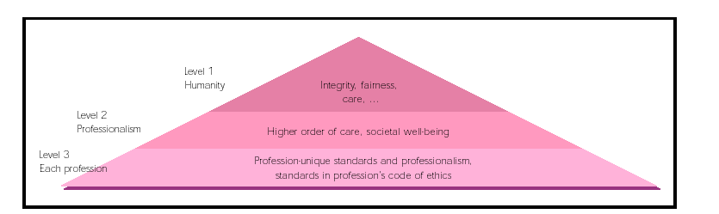

Figure 2 The cumulative levels of professional obligation. While all people share the obligations at Level 1, professionals
also carry the responsibilities expressed in Level 2. A member of a particular profession might have additional, unique
obligations, as articulated in Level 3.

