AOPEN

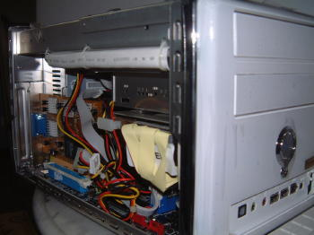

AOPEN XC-cube EZ65 PENTIUM 4

SUPPORT: FSB800/533MHZ (socket 478)

220WATT AOPEN POWER SUPPLY(shielded power cable)

2*SATA/2*IDE/2*DDR 400 up to 2GB/intergrated onboard 128mb Intel Extreme 8X VGA/Realtek AC97 5.1/Intel Broadcom gigabit Lan/1xPCI expansion slot/1x AGP (8x)

USB 2.0 Front , Rear x2 /IEEE 1394 Front & Rear x 2 /optical Front & Rear 1 each/Sound in& output at Front & Rear respectively/Printer port, Serial port each.

Check URL review at:
http://www.pcstats.com/articleview.cfm?articleid=853&page=2

