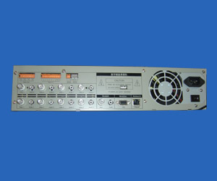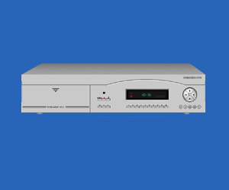
● Top advanced arithmetic: H.264 (MPEG4 Part 10) video compression.
● Powerful chipset: adopt Philip-Tri-media Chipset that has 16 DSP means one channel each.
● High stability: absolute Hardware compression and professional embedded operating system.
● Real time: up to 16ch video and audio synchronized display and record real time.
● 8 grade image level adjustment from 32k to 1152k depending of your existing network transmission provided by local ISP.
● Good network transmission: It can transmit on PSTN, ISDN, ADSL, WAN, LAN.
● Built-in 8 HDD: for industrial configuration up to 2,000 gigabyte.
● Individually working: Each channel compresses the signal at real-time individually, the parameters of resolution, frame, and record time can be set up separately.
● Support real watermark technology so that compressed image file can’t be juggled.

Item | Parameter | Specification
Video | Compression | Hardware H.264 (MPEG4 Part10) compression
Video | Frame speed | Max. PAL 400F/S NTSC 480F/S for display and record
Video | Input | 1,2,4,8,16 CH
Video | Output | 1CH BNC (1.0V pp 75Ω), 1CH VGA
Video | Signal format | PAL: CCIR625 Line 50 Field NTSC: EIA525 Line 60 Field
Audio | Compression | G.722, Video and audio synchronized
Audio | Input | 1,2,4,8,16 CH Line level，None-equilibrium , mono
Audio | Output | 1CH Line level，None-equilibrium , mono
Audio | Signal to Noise Ratio | ≥80dB
Audio | Deformation &  Noise | ≤-30dB
Storage | Image Format | Display：D1 (PAL 704×576 NTSC 704×480 )  Record: CIF（PAL 352×288 NTSC 352×240 ）
Storage | Video bit rate | 32kbit/s ~ 1152kbit/s (Namely 0.16~ 5.76Kbyte/f)
Storage | HDD consume | 20M-500Mbyte/h
Storage | Storage HDD | Max. 8HDD
Storage | Image quality | 8 grade adjustable：32kbps、64kbps、128kbps、256kbps、384kbps、512kbps、768kbps、1152kbps

