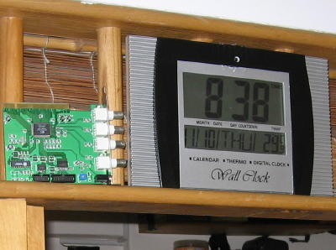

Package Deal (A): $450 inclusive of installation
(1) 4-cam PCI DSR capture card 25fps (install into your own PC);
(2) 1 pc Wall hanging LCD clock with pin-hole cam 1/4” CCD/ 380 tvline/2lux;
(3) HDB 3-4room area cabling with power 12vdc run. (5-room/Executive additional charge will be based on site determination).

Package Deal (B): $350 inclusive of installation

Item 1 and 3 same as above except camera is DOM type ¼” Sharp CCD/420tvline/1 lux.

Additional camera range from $85 to $200 with 12vdc regulated power adapter depends on individual requirement (*installation charges apply)

All inquiry are welcome and Call me @ (+65) 90056049 for Philip( SINGAPORE).

