Adding Chinese input
1. Go to Control panel, select Regional and Language Options and click on Language tab.
2. Check on "Install files for East Asian Languages" under Supplemental language support.
3. Click Ok and you may be prompted to insert the Windows CD-Rom. Insert the Windows XP CD. 4. After the files are installed, you must restart your computer.
5. After restart, repeat Step 1.

6. Click on Details button. Under Installed services, click Add and select the input language as
and keyboard layout as below. Keyboard layout should be Chinese(Simplified) – Microsoft
Pinyin. Click OK.
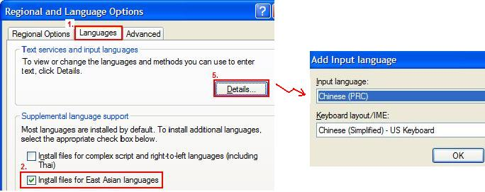
7. Highlight "Chinese (Simplified) - Microsoft Pinyin IME3.0" and select Properties, check on
Prompt step by step. Click OK.
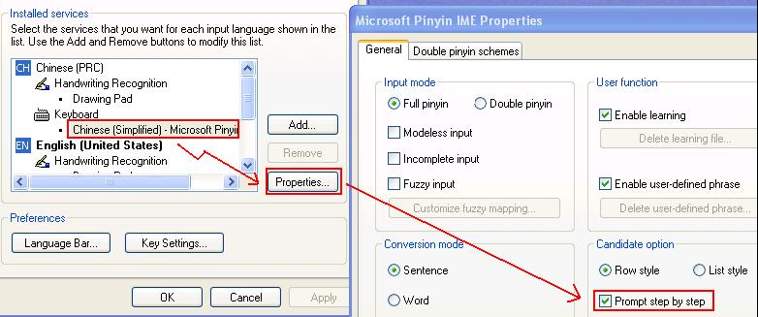

8. You should now see a language indicator in the System Tray (located at bottom right hand corner). Alternatively, you can toggle between different input methods by pressing ALT + SHIFT keys.

