- Related Work
Before discussing the creation of the virtual humanoid, there is a need to have a look at related topics, such as humanoid body animation, kinematics techniques, use of Cal3D and vjAvatar toolkit and current software packages for putting virtual humans in applications, to fully understand the elements of implementations in the coming next section.

  - Humanoid Body Animation
In humanoid body animation, there are basically two ways to achieve the desired interactivity: using motion capture [1] and similar additional techniques to animate the humanoid to its required motion, or write procedural code [2] to allow program control over important movement parameters.

Although using motion capturing allows the animator to achieve the most natural movements possible (i.e. they are carried out by real life human actors), several problems arise from the implementation of such motions in virtual reality applications. These include maintaining environmental constraints such as solid foot contacts and proper reach, grasp and interactions with the agent’s own body parts and other objects. For example, the humanoid may be seen as floating above the ground when the humanoid model is incorporated into a virtual reality application. These motion capture data are also difficult to reuse [3], as they cannot be transferred to a different model or scene easily.

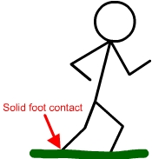
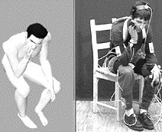

Fig. 2-1 Picture showing humanoid having solid foot contact with the ground in the virtual environment and an example of a motion captured animation

Thus, to alleviate these problems, procedural methods are able to make use of target locations, motion qualities and other movement constraints to achieve a convincing movement directly. One of these methods will be the use of kinematics techniques, such as the forward and inverse kinematics algorithm (refer to section 2.2).

On top of all that, animating a humanoid using a skeletal animation system consists of other aspects such as intelligent movement strategies and soft deformable surfaces like the skin and clothing. Movement strategies are motion paths along which each section of the whole body will move or turn from one position to another to achieve a desired motion. For example, when a hand is moved from one location to another, each section of the whole limb (upper arm, forearm and hand) will move in their own natural instinctive way such that the desired position of the hand is reached. This is often achieved with the use of goal-directed inverse kinematics. Soft deformable surfaces are important due to the fact that the muscles of human beings deform in some way or another by internal muscle actions when the body skeleton moves, and also by external contact with the environment. This will be done with the “skinning” technique in 3D graphics software (refer to section 3.1.3).

  - Kinematics Techniques
2.2.1 Hierarchy Basics
The use of hierarchical bone structure has been very prevalent in present 3D software packages. The bones are linked together by means of parenting to form the movable joints in a body. The thighbone is the parent node of the shinbone. The shinbone is parent of the foot bone. The foot bone is the parent of the toe bones, and so on. This is called serial linking, and it establishes the hierarchy of the bones in a character model. When you rotate an object (like a thigh bone), the child objects linked to it (shin, foot and toe bones) will follow along. This is the essential principle of hierarchical motion.
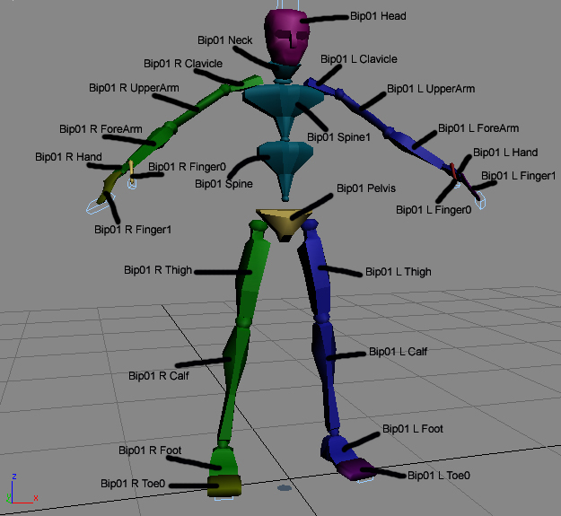
Fig. 2-2 Hierarchical Bone Structure in 3D Studio Max®
    - Forward Kinematics
Using the workings of a hierarchical bone structure, Forward Kinematics is the "straight forward" individual keyframe definitions made between parent/child relationships, that is, for every movement made, a keyframe is established for each individual bone/object along the chain. This kind of keyframe animation is based on a technique developed by the likes of Walt Disney when animation was a young art form. A master animator would draw the important images (the keyframes) and a junior animator would draw the images that fill the gaps between the key images. Similarly, the bones can be rotated, positioned, or even scaled at specific points required and we use this ability to animate the whole character. For each keyframe, we store the values of the parent bone's position and orientation properties. Each keyframe occurs at a user-defined time after the animation starts, so, by using a technique called interpolation, the computer can calculate the in-between transformation values required so that the parent bone (and its children) can be moved smoothly between keyframes.

Therefore, FK requires the positioning of each joint in a skeleton independently when it comes to character animation to achieve the desired movement. The animator provides joint angles from the parent object down to its children and the co-ordinate positions of the individual joints down the hierarchy are derived as a result. While FK offers more control over the positioning of joints, it requires a lot more experimentation to obtain the desired position and is not of much use when creating animations that involve the motions of many joints at once. Thus, it is usually used only when fine-tuning of the bones needs to be done.

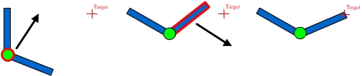
Fig. 2-3 Steps taken using FK technique to move a limb (2 steps)

    - Inverse Kinematics
Inverse kinematics (IK) is a goal-directed (known as IK handle in 3D Studio Max®) procedure that is commonly used in character animation to ease the difficulty associated with accurately positioning an articulated skeleton. The task of repositioning a skeleton with, say, ten or fifteen joints into a different configuration, joint by joint is no mean feat, especially considering that the skeleton in its rest pose must appear natural. With the help of an IK algorithm, the animator can set up the structure of the skeleton in such a way that when a joint at the end of a limb (such as the wrist) is moved, the IK algorithm automatically works out the required joint angles for the joints further up the chain. In this way, the articulation is maintained, and the animator has one less thing to worry about. The joint at the end of an IK chain is known as the end-effector, while the joint at the other end of the chain is called the terminator. There can be any number of links in the IK chain between the terminator and the end-effector. However, the greater the number of links, the more unwieldy it becomes for the animator to achieve the desired articulation.
IK effectively allows an entire arm or leg to be posed by moving only one object: an IK handle (or ``goal'' in other programs). As the IK handle is moved around, the extremities follow it and the joints above it in the hierarchy readjust accordingly. In order for the joints to readjust appropriately, constraints or ``degrees of freedom'' have to be assigned to the joints, so they don't bend beyond a realistic range of motion. Thus in IK, motion is inherited up the hierarchy, from the extremities to the more proximal joints (closer to the body) which are their parents.

Consider, for example, the articulation of the human arm. If the requirement were for the arm to be raised, using IK would mean simply moving the wrist to the desired IK handle position. On the other hand, as said earlier, FK would require each joint in the arm, such as the forearm, hand and fingers, to be individually positioned so as to achieve the required position.

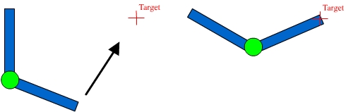
Fig. 2-4 Limb can be moved directly to its desired position in 1 step using IK

  - Use of Cal3D and vjAvatar toolkit
With regards to using the humanoid modeled and animated in 3D Studio Max® in virtual environments, the original plan was to develop a software interface to export the data in the 3D Studio Max® scene in formats whereby it is possible to deploy them and also a functional API (Application Programming Interface) to control and determine the real-time motions of the humanoid in the virtual environment. However, through literature review, it was discovered that there has already been much research and work done in such areas, and the Cal3D library [6] was reviewed to be one of the best of such interfaces. Thus, there was no need to re-invent the wheel and the Cal3D library was chosen for exporting the models out from 3D Studio Max®.

    - Cal3D Character Animation Library
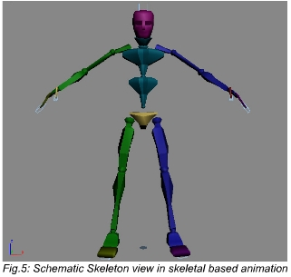
The aim here is to create realistic motions of avatars in virtual environments. Presently, the most promising and flexible technology for character animation was the skeletal-based approach as it gives developers a lot of freedom over the animation process. Skeletal animation mainly consists of the skeleton, mesh, materials and mapping of texture onto the mesh. This is a core feature of the Cal3D library. Cal3D is a free (open source) skeletal-based 3d character animation library written in C++ in a platform/graphic-API independent way. It is a stand-alone library that can be used in many different kinds of projects. Cal3D works by use of keyframe skeletal animation, which is a key feature of animation done using 3D software packages such as 3D Studio Max®. Other features of Cal3D include material and texture handling and automatic generation of level-of-detail of models, which make Cal3D a suitable library to be used for avatar creation in virtual reality applications. With the use of the library, models can be created using 3D software packages like 3D Studio Max® using the wide variety of modeling and animation tools to create the most realistic humanoid possible and then export them out for use with the vjAvatar toolkit in VR Juggler [7] applications.
Fig. 2-5 Schematic Skeleton view

    - vjAvatar Toolkit
The vjAvatar toolkit is an extension of Cal3D and the VR Juggler application. Having tools specific for human-controlled avatars and a simplified coding interface, it serves as a perfect bridge between the Cal3D character animation library and the VR Juggler application. In the configuration of avatars, one only needs to instruct the avatar factory (API function class) on where the components of the avatar are located, such as the Cal3D skeleton, mesh, material and animation files of the avatar. It can then be added to any VR Juggler application to further develop the engine for the control of the virtual avatar’s movements.
  - Current Virtual Humans Software Packages
DI-Guy™ is one of the leading software for adding lifelike human characters to real-time simulations. DI-Guy™ allows the adding of humans to simulations rapidly while achieving high levels of visual realism and real-time performance. It provides an integrated module that includes features required to populate real-time simulations: photorealistic human models; an extensive library of behavior; a high-performance real-time motion engine, and an API that is both simple and powerful. Despite all these, the use of DI-Guy™ will have several disadvantages as compared to the approach of creating the virtual human described in this report.
Comparing the two methods of virtual human creation, by using the approach of first modeling and animating the virtual human in 3D Studio Max®, then exporting them into Cal3D data files, the developer will have greater flexibility in creating the specific model required, the desired number and type of animations and the control of the virtual human as the Cal3D animation files can be easily exported one by one as compared to using DI-Guy™. Despite the fact that DI-guy™ provides approximately 100 models, they may not cover everything the developer wants. Although it is possible to create and input OpenFlight models into DI-Guy™, it is more cost effective to be using only 3D Studio Max® as the sole software package for creating the virtual humans required here. Furthermore, the animation feature or Motion Editor comes with extra costs and not as a single whole package.

