- Implementation
Using the tools and techniques as discussed earlier in this report, a 3-step strategy is employed in the creation of a virtual interactive humanoid. The following figure summarises the process of the implementation:

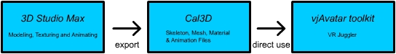
Fig. 3-1 Process of Implementation

  - Use of 3D Studio Max® 5.1 & Character Studio 4.0
3D Studio Max® 5.1, the world’s most widely used professional 3D modelling, animation and rendering solution, offers the ultimate professional 3D tools required for creating near-realism humanoids for use as avatars in virtual environments. With the wide variety of modelling and animations tools available in the software package, as well as the use of the Character Studio 4.0 plug-in, 3D Studio Max® 5.1 proves to be a very useful tool in human avatar creation.

    - Polygonal Modeling
The polygonal mesh of the avatar is done from scratch using the modelling tools available in 3D Studio Max®. Tutorials found on the Internet regarding modelling techniques are a great help to this section of the project. Below are the steps taken to model the virtual casualty:
- Starting from a box, convert the box to an Editable Mesh and create the rough shape of the soldier with reference to image planes of human images found on the Internet. The main tool used here is the Extrude Face tool. Vertices are also fine-tuned to shape the casualty.
- Following that, the mesh is then further modified in the sub-object level (vertices) to shape the details such as clothing, pockets and collar of the shirt.
- Once the main body has been done, much effort was then put into the creation of the face so as to achieve the most possibly realistic face of the soldier. The details of the face were also essential for future work regarding facial animation.
- The last step involved merging the scene with a helmet mesh found on the Internet and by combining the polygons and merging vertices, the helmet was attached to the casualty mesh properly. Tools such as Editable Poly and Edge Cutting are also important in determining the level-of-detail and smoothness of the surface of model.
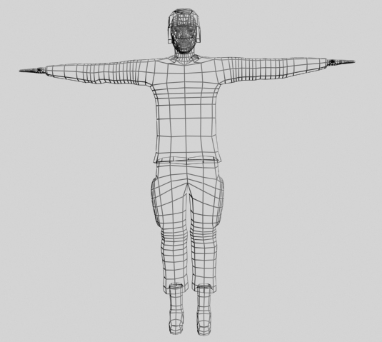
Fig. 3-2 Mesh of the model after modelling process
    - Texturing
When modelling of the mesh is completed, the Unwrap UV Modifier is used to edit the texture mapping coordinates of the model. Planes are selected for planar mapping and the UV coordinates are then moved and organised into a proper texture map template, which is then exported into Adobe Photoshop to be painted. Subsequently, the texture is then mapped back onto the mesh to complete the modelling and texturing process.

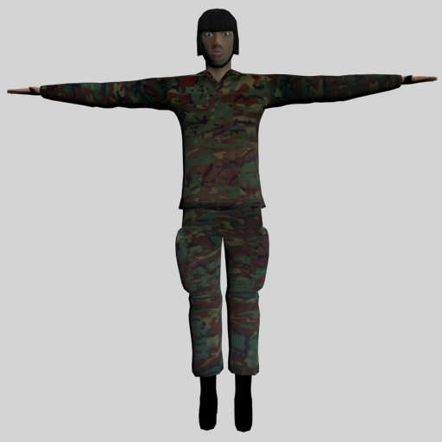
Fig. 3-3 Mesh of the model after modelling and texturing process

    - Skinning
Next, the basic skeleton of the model is created using the Character Studio 4.0 plug-in to fit the mesh of the avatar created earlier. Using the Physique modifier, all the vertices of the mesh are attached to the skeleton, so that when the humanoid is animated, the mesh will deform in one way or another to simulate the deformation of muscles and soft body parts of the human avatar. Objects such as the head and helmet are also attached to the skeleton, except that the vertices of the head and helmet are attached as rigid vertices, meaning that the object will not deform when the character is moving. This method of attaching meshes to a bone hierarchy is the “skinning” method as mentioned earlier.

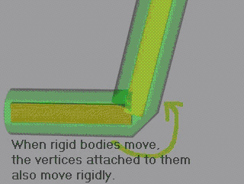
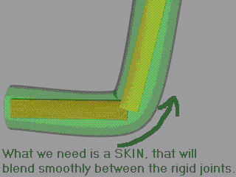

Fig. 3-4 Rigid vertices and Deformable vertices

    - Animation
After the mesh has been fully rigged, that is, set up the skeleton and binding of the mesh properly to the skeleton, individual animations and actions of the avatar are created by use of the keyframe animation in 3D Studio Max®. This includes walking, falling to the ground, and instinctive human movements like slight movement of hands and head and so on. Keyframes are set at each starting and ending position of a motion after moving the ends of the body parts to their desired position. Sometimes, adjustments need to be made in between the parts higher up in the hierarchy, as well as keyframes for the smooth transition of the positions of the limbs for the avatar to move naturally. This is done by use of the Forward Kinematics Algorithm as each individual part of the limbs and body are moved to their desired position and then setting a keyframe at that point of time. The individual animations made are listed as follows:
- Introductory Motion: Walking, feeling hard to breathe, faint and fall
- Slight movement of the hands, legs, body and head
- Movement of the eyes
- Movement showing signs of distress (hand clutching chest/head)
- Seizure and die
- Sitting up
- Get up from the ground
- Face the medic to start a conversation
- Shake head in sitting and standing position
- Staggering walk after recovering

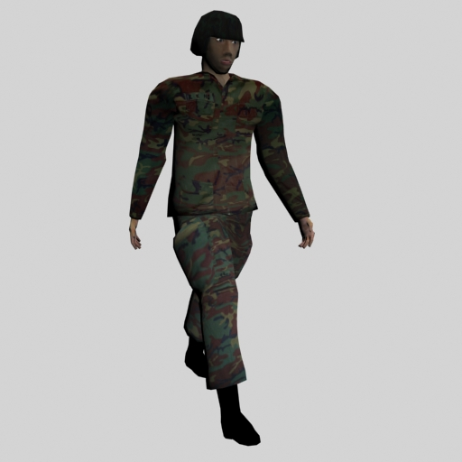
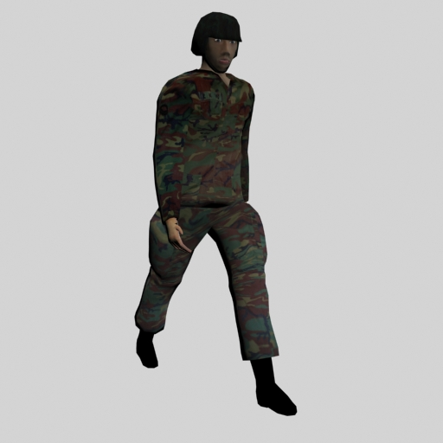
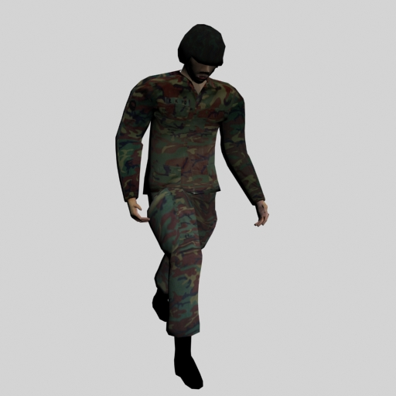
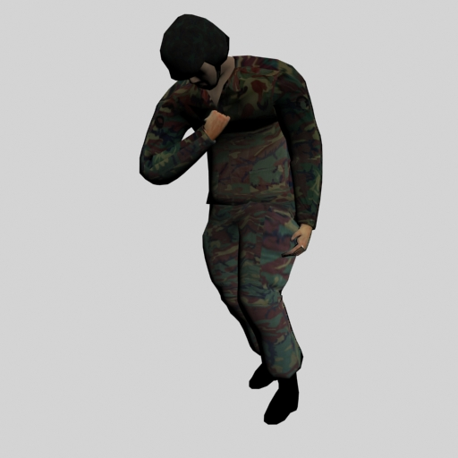
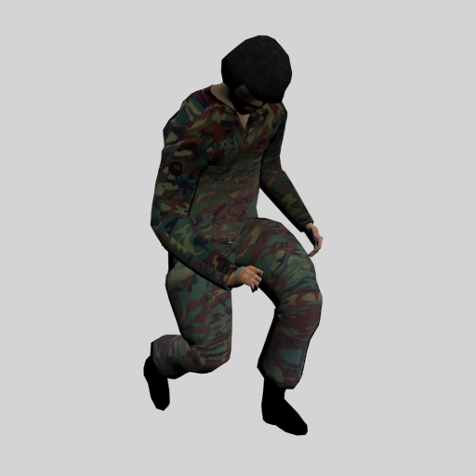

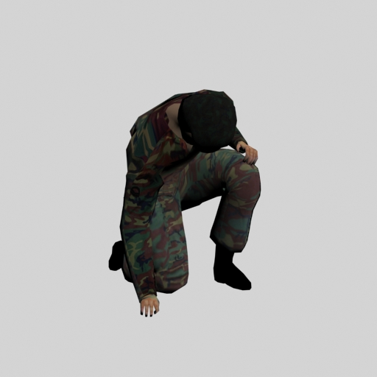
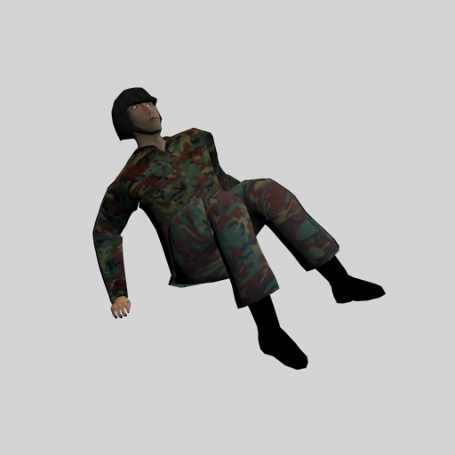
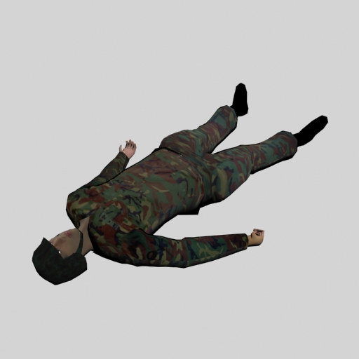
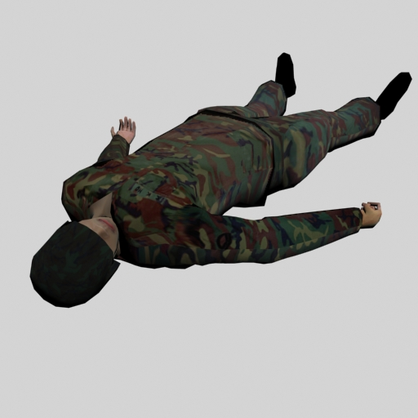
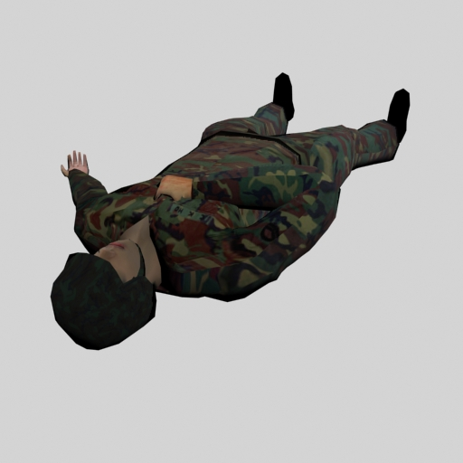

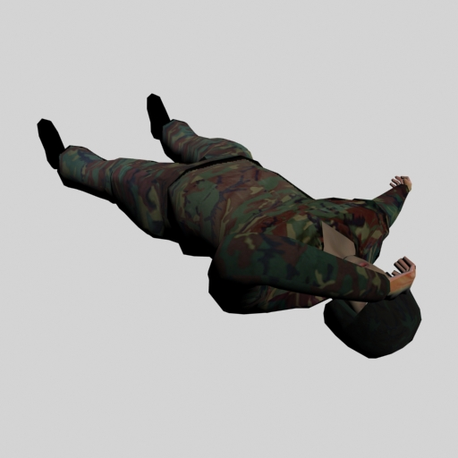
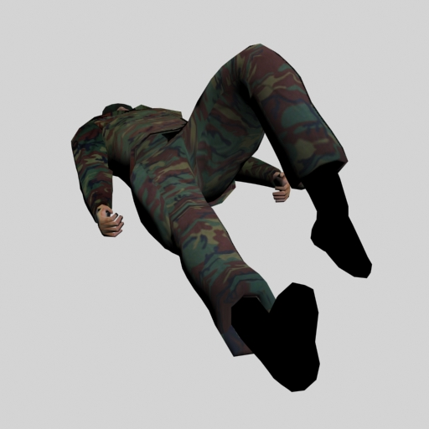
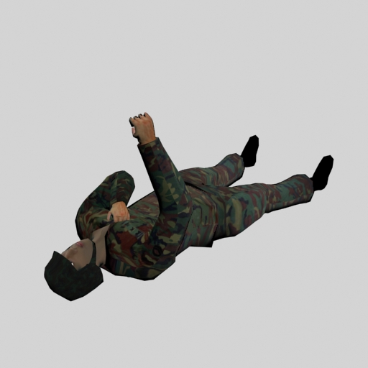
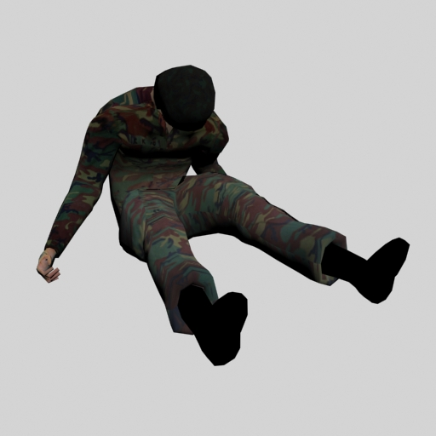

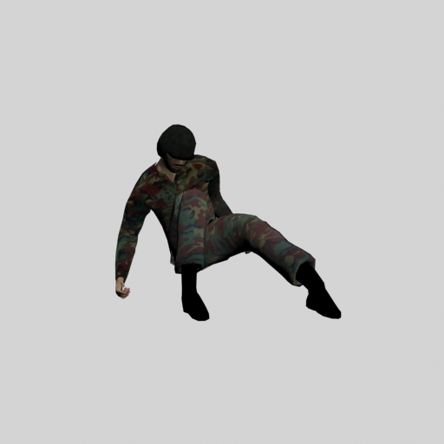
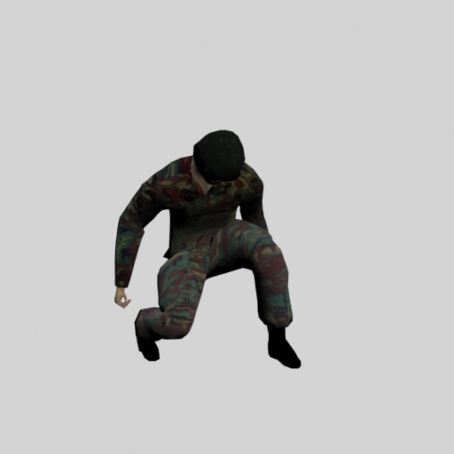
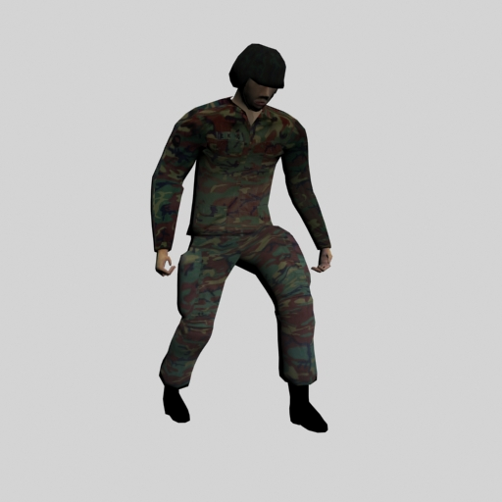

Fig. 3-5 Some screenshots of the various animations

  - Exporting to Cal3D data files
After all the animations are created, the humanoid is then exported from 3D Studio Max® into individual Cal3D data files via the use of the Cal3D plug-in. These files include the skeleton file (.CSF), the mesh data (.CMF), the material data (.CRF) and lastly, the animation data (.CAF). The Cal3D plug-in for 3D Studio Max® is able to convert the relevant information about the skeleton, mesh, material and animation into formats for use in any VR Juggler application via the vjAvatar toolkit. Special attention need to be drawn to the fact that the materials or textures used for the humanoid has to be numbered with a material ID, starting from zero, before exporting the model. This is to allow the Cal3D exporter to identify the individual materials used. The steps taken to export the model are as follows:
- Export the skeleton first. Select one of the biped parts, go to Motion tab and make sure the skeleton is in the Figure mode . Then select the centre of mass (Bip01). Next, under the File menu, click Export. Now select the Cal3D skeleton exporter, and type a name for your skeleton. A dialog box will appear with all of the bones in your Biped checked. Just hit next and finish and the Cal3D skeleton file (.csf) will be exported.
- Export the mesh. Select the mesh of the model and under File menu, click Export. Choose the Cal3D mesh file (.cmf) to export. In the Export dialog, choose the skeleton file exported earlier and click Next. Leave everything as default and finish the exporting. If the model has a few parts, repeat step 2 for the other parts also.
- Export the material. Do the same as step 2 but choose the Cal3D material file (.crf). Select the material of the part being exported, starting with index 0. Repeat step 3 for the other parts if the mesh has a few parts to it.
- Export the animation file. Make sure the Biped is NOT in Figure mode in this step. Using the time configuration button on the bottom right part of the interface, type in the animation start time and end time for the specific animation to be exported. Next, make sure the time bar is at the beginning of the desired animation. Then, choose the Cal3D animation file (.caf) to be exported. Leave everything as default, except that put Displacement to 0.
- After everything has been exported, create a .cfg file that contains all the information about the files that make up your character using any text editor. When writing the list of included materials, it must be done so that the material tagged with [0] appears first in the list, with the second being [1], etc.

  - Using vjAvatar toolkit
Following the exporting of 3D Studio Max® scene file into Cal3D data files, these files can now be directly used as the data files for the vjAvatar toolkit to specify as the avatar data files. It can then be added to any VR Juggler applications for the development of interactive virtual environments.

