 | XINMIN SECONDARY SCHOOL  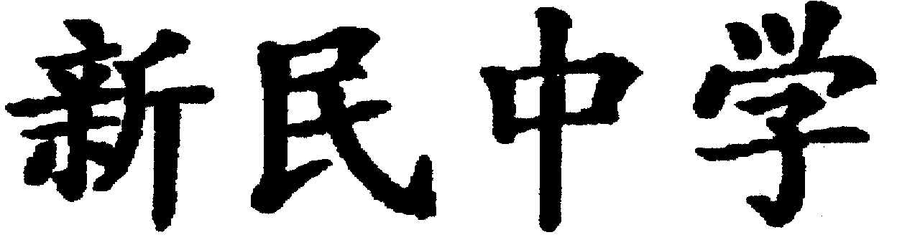  SEKOLAH MENENGAH XINMIN
Mid-Year Examination 2003

Subject : Technical Studies
Level : Secondary 2 Technical
Date : 20 May 2003
Duration : 1 hour
Setter : Mr Jackson Ng
Vetter : Mr Ho Kuan Peng

INSTRUCTIONS TO CANDIDATES:

DO NOT OPEN THIS BOOKLET UNTIL YOU ARE TOLD TO DO SO

This question paper consists of TWO sections.

Section A - Multiple choice questions. [20%]
Section B - Answer all the questions. [30%]
Section C - Graphics. [50%]

INFORMATION FOR CANDIDATES
For Examiner’s Use
Section A
Section B
Section C
TOTAL

Marks for each question is indicated at the end of each question.

NAME [REG. NO.] | [ ]
CLASS
MARKS

This Question Booklet consists of 8 printed pages.
Section A : Multiple Choice (20 marks)

- A ____________ is used for planing curved edges on wood.
a. chisel b. metal smoothing plane
c. spokeshave d. gouge ( )

- We can use a _________ to mark out many workpieces of the same shape and size.
a. steel rule b. protractor
c. template d. try square ( )

- ____________ is a process of cutting thin sheets of metal.
a. Grinding b. Shearing
c. Drilling d. Cutting ( )

- The ____________ holds the auger bit for boring.
a. lathe b. ratchet brace
c. buffing machine d. scroll saw ( )

- A pair of ____________ is used to cut concave edges on sheet metal.
a. scissors b. pop riveting pliers
c. curved snips d. pliers ( )

- Internal screw threads can be cut using a ____________.
a. chisel b. screw
c. die d. tap ( )

- A ___________ file is used to shape the V-shaped edges of aluminium workpieces.
a. round b. half-round
c. triangular d. abrafile ( )

8. A sliding bevel is used to mark out _____________ lines or angles on workpieces.
a. cross b. straight
c. slant d. circular ( )

9. One common way of joining acrylic together is to use _______________.
a. chloroform b. rivets
c. PVA glue d. nails ( )

- A ______________ is used when bending sheet metal.
a. folding bar b. die
c. rod d. bender ( )

Section B : Fill in the Blanks with helping words given (30 marks)

Write the answers for Question 11 & 12 using the helping words given.

Helping Words
Sliding bevel | Hand file | Blade | Triangular file | Wing Nut
Cold Chisel | Acrylic cutter | C-Clamp | Spring Divider | Tenon Saw
F-Clamp | Ratchet brace | Frame | Handle | Protractor
Machine Vice | Strip Heater | Coping saw | Hacksaw | Drilling Machine

- Name the parts of the tool shown in the diagram below (4 marks)

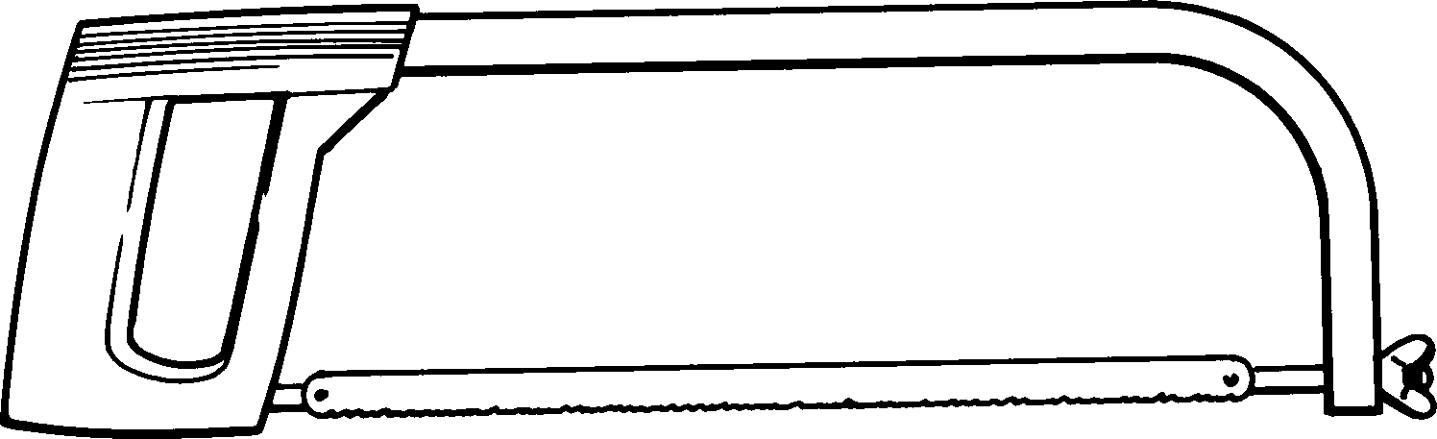

- State the name for each of the tools shown in the diagram below. (8 marks)

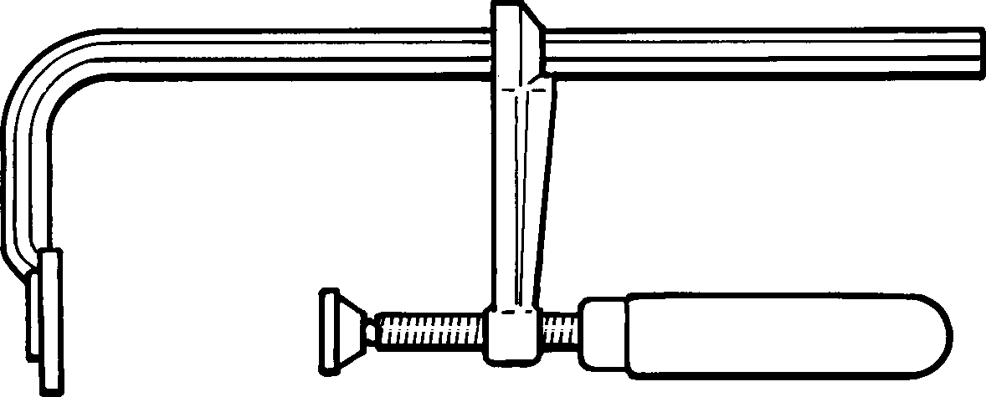  a. ____________________________________ | b. ____________________________________
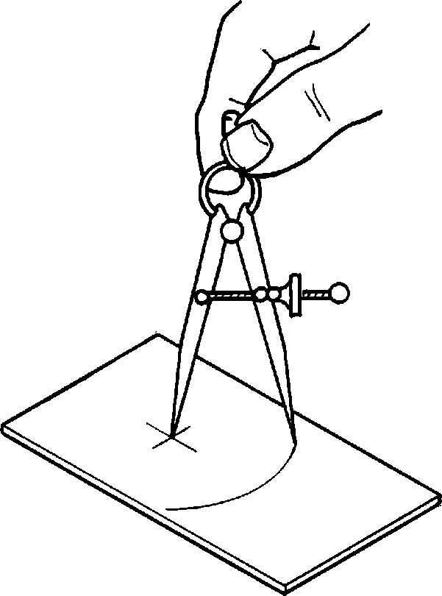  c. ____________________________________ | 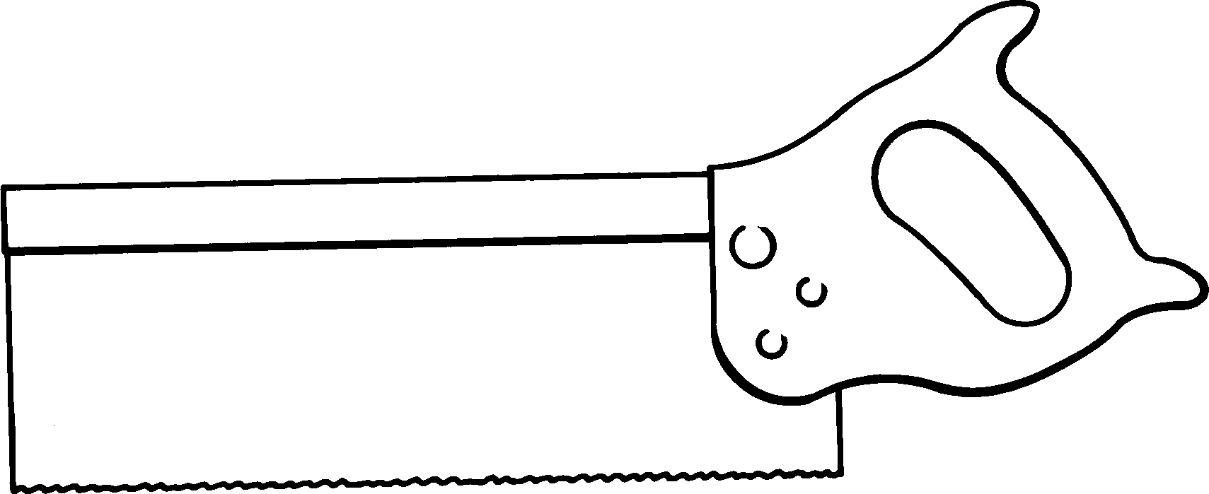  d. ____________________________________
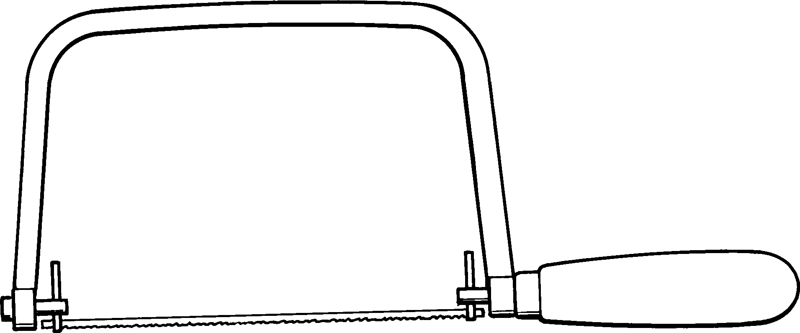  e. ____________________________________ | 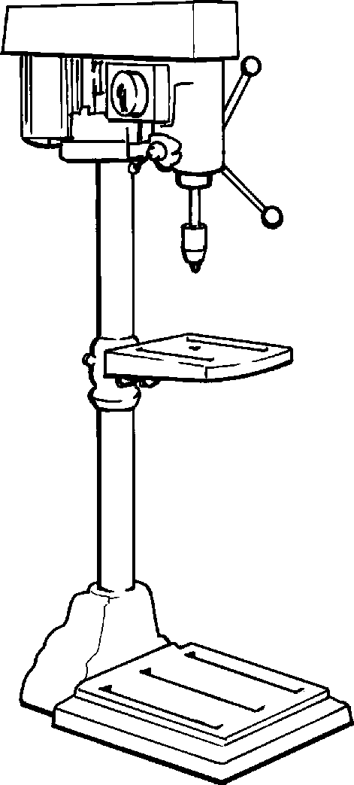  f. _____________________________________
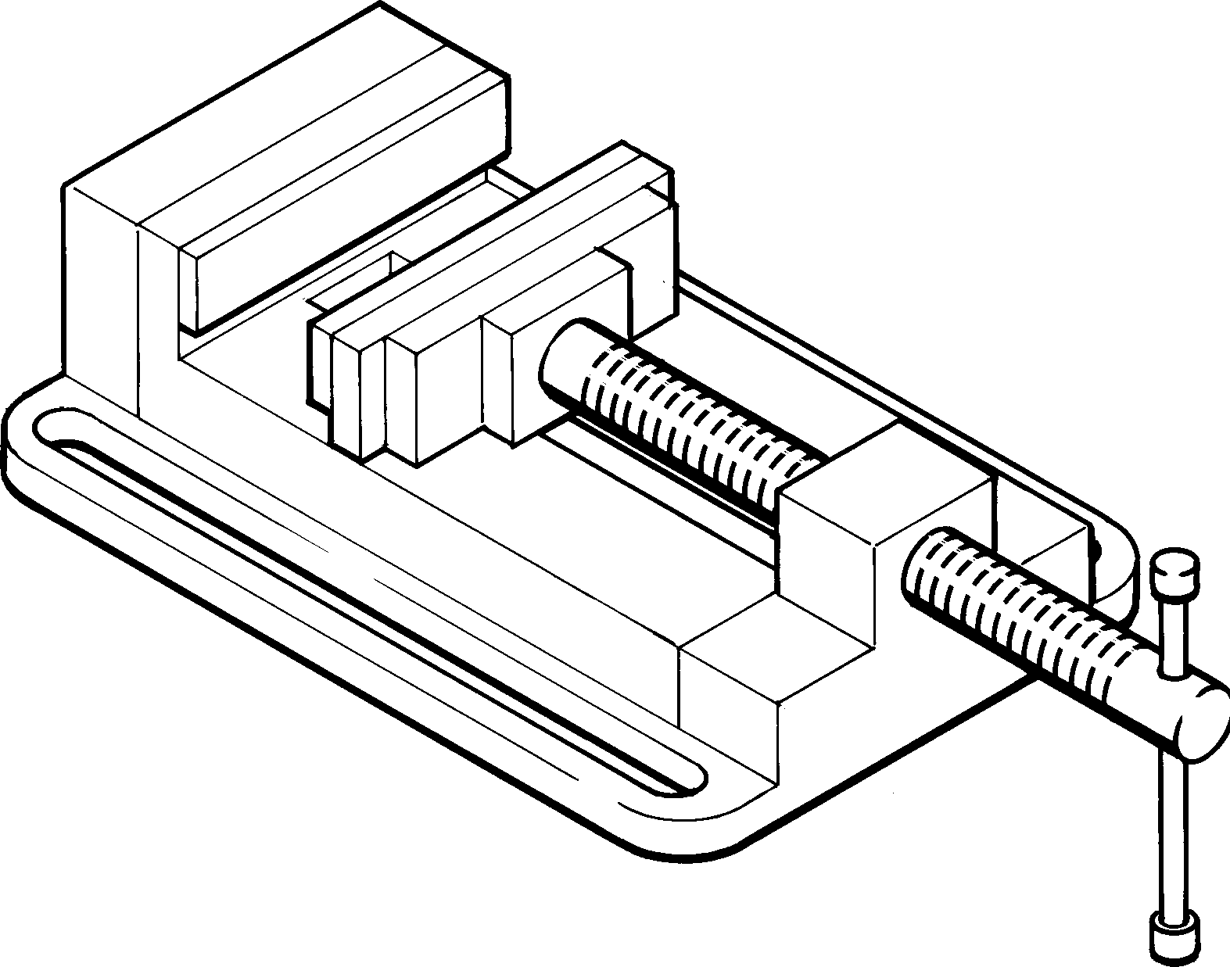  g. ____________________________________ | 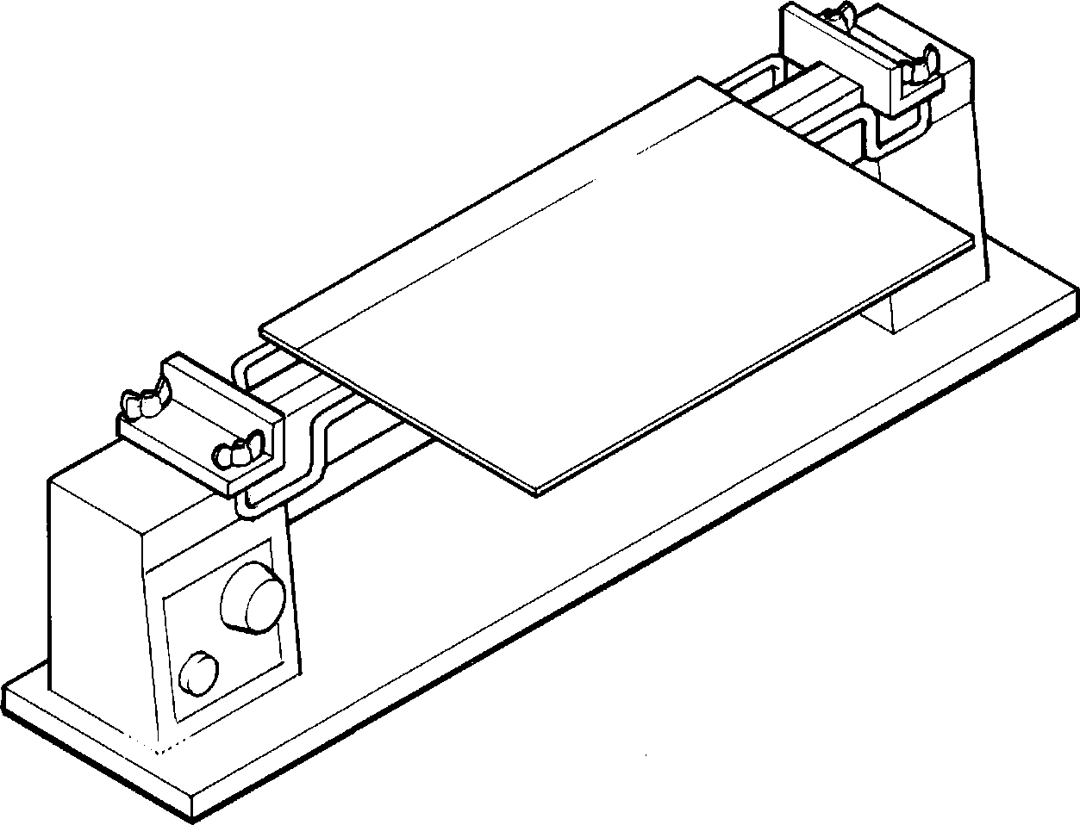  h. ____________________________________

- The diagram shows the procedure of steps in twisting the metal bar. Label the pictures correctly by writing numbers 1, 2, 3 & 4 to show the correct order. (4 marks)

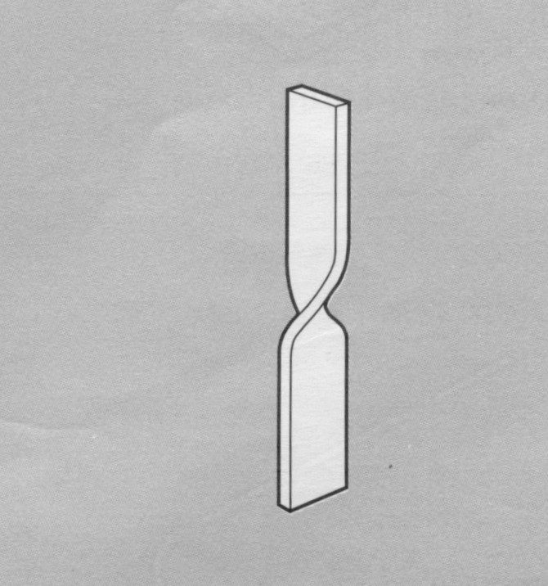  ( ) | 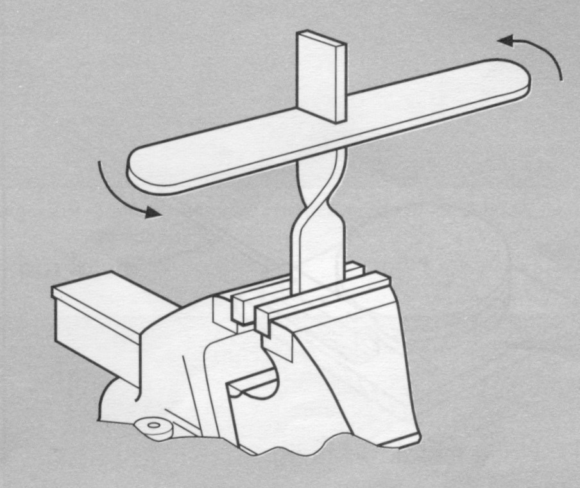  ( )
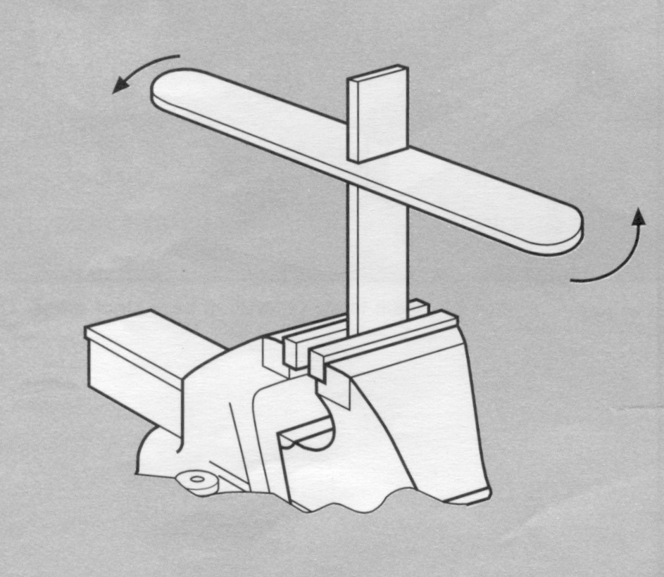  ( ) | 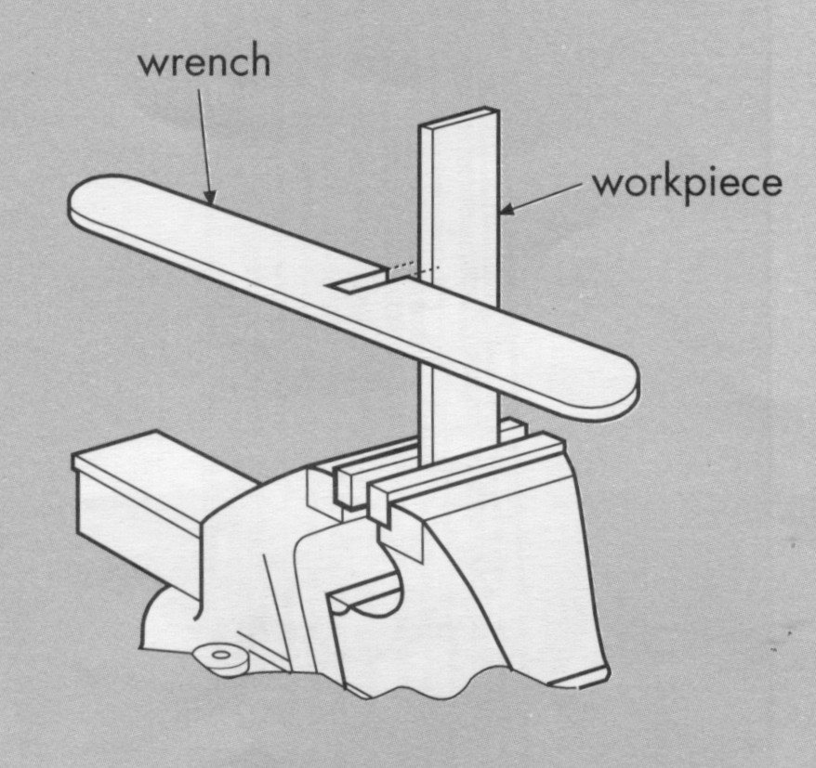  ( )

- Fill in the boxes with the correct type of materials (14 marks)

Helping Words
Melamine | Nylon | Polyethylene | Styrofoam
Glass reinforced polyster (GRP) | Bronze | Teak | Duralumin

Properties | Uses | Materials
Light, strong and flexible | Rope and zip
Strong and durable | Canoe and bus top shelter
Alloy of copper and tin, reddish-yellow in colour | Used to make bells
Hard, strong, durable, very attractive patterns | Expensive furniture, veneers, flooring, carvings
Durable and does not break easily | Plates, cups and bowls
Light weight, heat cannot pass through it easily | Food containers and swimming floats
Flexible and can be squeezed without breaking | Detergent and shampoo bottles

Section C : Graphics (50 marks)
15. Draw the object using the isometric grid provided. (10 marks).

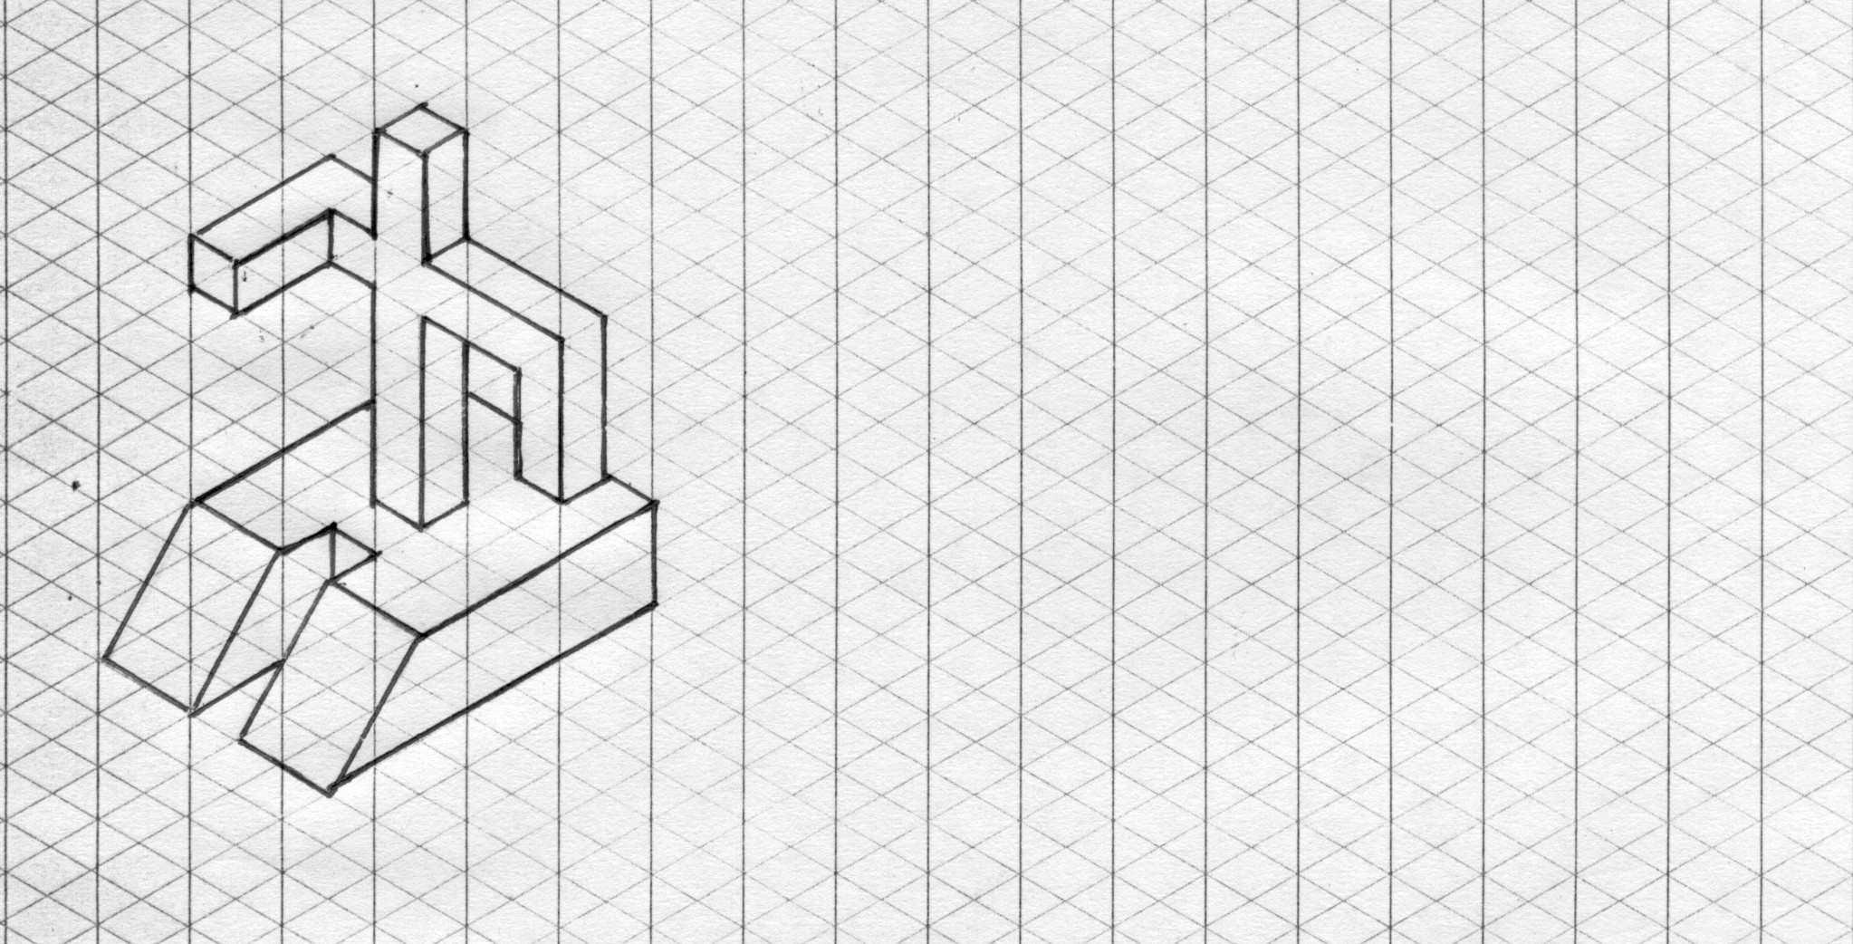

- Study the drawing below and complete the table with the most correct answer (20 marks).

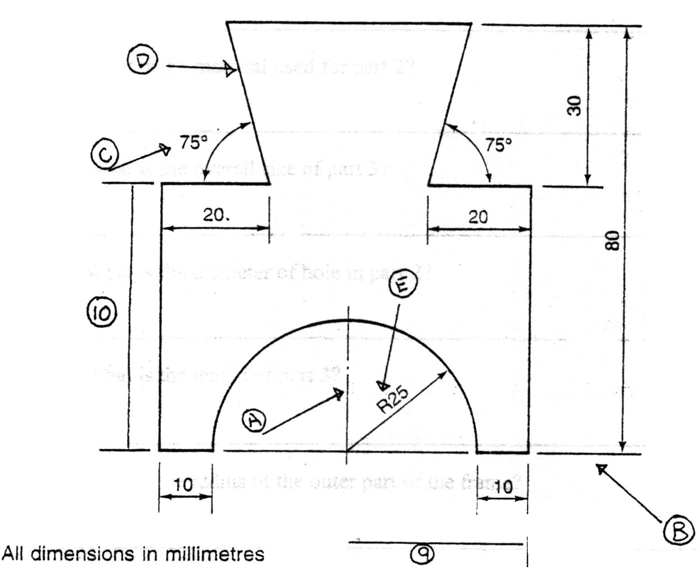

No. | Types of lines and symbols | Answer
1 | Outline
2 | Centre Line
3 | Extension Line
4 | Radius
5 | Angle

No. | Item | Dimension
6 | Overall Height
7 | Overall Width
8 | Radius of Arc
9 | Distance from centre to edge
10 | Distance of base to shoulder

18. Study the drawing and answer the following questions (20 marks)

- What is the name of Part 1?

- What is the material used for Part 1?

- What is the diameter of the hole in Part 2?

- What is the overall size of Part 2?

- What is the length of Part 3?

- What is the radius of the outer part of the frame?

- What is the thickness of the frame?

- How many holes are there in this project?

- How many parts are there in this project?

- What does BDMS stand for?



