

Developed by Susan Gaer and Donna Price-Machado
CATESOL 2004
sgaer@yahoo.com
dpricema@sdccd.net
Agenda
- Introduction

2) What does it look like in the classroom?
(video-binder label outcome)

3) What can you do with a word processor? (pages 11-32)
- Address labels and business cards (pages 11-18)
- Tables—Charts & graphs (supermarket comparison, verb chart) (pages 19-20)
- Directory (pages 21-22)
- Calendar (page 23)
- Student stories (pages 24-30)
- Class Newspaper (pages 31-32)

4) What can you do with the Internet
- Google Images (pages 33-34)
- Color Overhead transparencies (application from Google images)
- National Anthems (page 35)

5) How do you manage it in the classroom? (pages 36-39)

NOTES
________________________________________________________________________

________________________________________________________________________

________________________________________________________________________

________________________________________________________________________

________________________________________________________________________

________________________________________________________________________

Jigsaw Reading

Integrating ESL and Computers

This workshop was designed to fulfill a need felt by ESL instructors who may be new to computer assisted instruction (CAI), especially those teachers with one or two dusty computers in the back of their classrooms. The goal is to help ESL teachers help students use computers as a tool to further their acquisition of English. Student comprehension of ESL competencies and language skills are the top priorities in ESL enhanced computer lessons; however, any acquisition of computer skills is a welcome byproduct. The comprehension of computer skills is, then, a means to an end, and not the end in itself, although computer skills are now fast becoming prerequisite employment and job advancement skills themselves.

ESL computer lessons should deliberately place an emphasis on first teaching ESL competencies and language functions before computer skills, not only because our priority is ESL, but also because it is more pedagogically sound to teach ESL skills in a traditional class setting before practicing them on the computer. With the possible exception of vocabulary skills, the computer is better suited to review and practice language skills than it is to introduce them.

The demonstration lesson is geared toward Adult ESL learners at the beginning-low level. The activities are consistent with those used with students at the Early Production and Speech Emergence stages, as articulated in Steven Krashen’s Second Language Acquisition Theory and practiced in the methods and techniques of the Natural Approach, as developed by Tracy Terrel. Intermediate and higher level teachers should also develop lessons which are consistent with language acquisition theories that correspond to their levels.

Though computer assisted learning is not new, its applications in the adult level ESL classroom are still evolving. There is a short, informative article from the Los Angeles Unified School District’s Technology Guide 2002 called “From the Computer Lab to the Classroom: Integrating ESL Software with Classroom Activities” written by Barry Bakin. Even though it was written for teachers in an ESL computer lab setting, it is worth the time to consider a few of the basic principles it promotes regarding the use of computers in ESL instruction in any setting.

Barry Bakin sees the computer as “a good way to reinforce information, add an interactive element to a lesson, or provide varied activities which meet the learning styles of different students.” In order to achieve those goals, the guide suggests ways to integrate ESL before, during and after computer use. The following is a summary of that article with other suggestions.

Section B: Before Computer Use (in the classroom without students at computers)

- Model tasks students will do at the computer.
- Use visuals that show students what they will see at the computer before they turn on the computer, by using one of the following: an LCD projector (which displays to the whole class the same computer screens the students will see later), overhead transparencies, or handouts and posters.
- Give lower level students a partner with higher language or computer skills.

While Students are at the Computer

- Model the lesson again at the computer with them and let them try it.
- Monitor and assist as necessary, but don’t do it for them.
- Provide enough time and warn them well before their time is up.
- Give pairs a computer task that requires them to orally communicate with each other e.g., one student dictates a web address to the other.
- Provide steps for computer tasks in writing.

Post Computer Use Review

- Use the material studied with the computer in a follow up lesson to check comprehension, reinforce learning, and make them accountable for their time at the computer.
- Review the material as a whole class in a different way than it was practiced at the computer: Computer listening (a story, speech, directions) followed by classroom discussion of the story; computer reading of a story followed by classroom writing about the story etc.
- Use a variety of activities as follow up activities: cloze handouts, group discussions, peer dictations, group writing, jigsaw, mixers and quizzes.

As you can tell, teachers do need to spend some time previewing material and creating follow up activities, just as they would do the first time they use a new text. Hopefully this workshop will clarify the above principles so that you can design effective lessons, which simultaneously teach traditional ESL competencies with the use of one or two classroom computers.

The complete text of The Los Angeles Unified School District’s Technology Guide is available on line at http://adultinstruction.org/administrators/handbooks/index.htm

Integrating ESL and Computers Reading Jigsaw

Directions: Split into pairs in your group. One pair reads, discusses and answers Section A, the other does Section B. Switch partners to share answers.

Section A The first pair of participants (A’s) will write answers for 1-5.

- In addition to second language skills, what other skills do students derive from doing a computer-based lesson? Why are they important skills?

- Is it favorable to introduce language skills before practicing them on the computer? What skill might be an exception to this because of visuals?

- What are some possible challenges of integrating the Natural Approach of teaching ESL with computer-based lessons?

- Would you go online to get information from an Educational Technology Guide such as the one mentioned? Why/Why not?

- Look at the fifth paragraph: How do you think the computer is “a good way to reinforce information”?

Section B The second pair (B’s) participants will write answers for 6-10.

- Considering your skills and/or access to equipment, which visuals would you be able to use to preview material before sending your students to the computer?

- How could you find out if you have any computer savvy students in your class?

- What is one of the ways to make students accountable for their computer time? Can you think of some other ways?

- If your students did a listening exercise on the computer, what would be a better follow up activity: a listening or a speaking exercise?

- How many of the seven follow up activities do you use now?
Video Focus Question Chart How does the video address each question?

1 | a) Which ESL topic or competency is focused on?  b) Which language skills and/or grammar points are taught?  c) Why do you think she chose these language points?  d) What methods or techniques did she use to teach the language?
2 | How did she check comprehension of the language skills?  a) What is the expected outcome of this lesson?  b) How did she communicate this objective to them?
3 | a) What are the prerequisite computer skills required for this lesson?  b) How did she teach these skills?  What methods did she use?  c) How did she check comprehension?
4 | a) What activity was assigned to those students not at the computer?  b) How did she model these activities?  c) What classroom management and grouping methods did she use?

Possible Answers for the Video Focus Questions Chart:
1 | a) Which ESL topic or competency is focused on?  b) Which language skills and/or grammar points are taught?  c) Why do you think she chose these language points?  d) What methods or techniques did she use to teach the language? | a) Personal identification  b) Wh-questions and answers and the be verb.  c) She did a task analysis of the competency.  d) She presented and modeled with lots of repetition, using early production techniques and dialogues.
2 | a) How did she check comprehension of the language skills?  b) What are the expected language and computer skill outcomes of this lesson?  c) How did she communicate this objective to them? | a) She checked comprehension by having students practice with her chorally, by monitoring their peer practice, and by signing off on worksheets.  b) Students should be able to ask and answer personal information questions.  Students should be able to make a computer generated ID label.  c) She showed an ID label to the class.
3 | a) What are the prerequisite computer skills required for this lesson?  b) How did she teach these skills?  What methods did she use?  c) How did she check comprehension of the computer skills? | a) Students need to know basic computer terms; how to use a mouse, and some basic keyboarding.  b) She reviewed the required computer terms and skills; she modeled the skills with lots of repetition, asking yes/no questions and other early production techniques.  c) She checked comprehension of the terms and skills by listening to their answers and by having volunteer students practice before the class used computers.
4 | a) What activity was assigned to those students not at the computer?  b) How did she model these activities?  c) What classroom management and grouping methods did she use? | a) She assigned a board game, which reinforced Wh question formation.  b) Previously, she taught a similar style game, so they would be used to it and she modeled it by asking questions before they did it again.  c) She divided them into groups, using color-coded cards, and placed more advanced students with lower-level students, according to computer literacy skills.

Address Labels

General Process

Step 1: Language is taught
What is your name?
What is your address?
Students practice asking and answering the questions in small groups. Have students draw an address label.

Step 2: Computer is taught

(I have a projection system. If you don’t have a projection system, you would make overheads of the instructions with lots of screen shots.

Buy address labels from a local office supply store. Note the number for use with students. For example, Avery 5160.

With a projector this can be done with the language experience approach in which step-by-step directions are dictated as students write them down. Without a projector, create screen shots to show how to do this.
Using your word processor, show students how to make an address label. Nominate a student to be a secretary. Have the secretary write the step-by-step instructions as dictated by the teacher. (Be sure to have students practice their clarification questions.) Students at desk copy directions in their personal notebook.
Identify your software version and follow those instructions.
Mac Word 2001
Double click on Microsoft Word
Open a new document
Click on Tools
Click on Labels
Click on Options
Find the label type for your labels for example Avery 5160 and select it.
Click OK.
Students type their address.
Click ok and print labels. (File and print)
Mac Word X
Double click on Microsoft Word to open a new document.
Click on Tools.
Click on Labels.
Click on Options.
Find the label type for your labels for example Avery 5160 and select it.
Click OK.
Students type their address.
Click ok and print labels. (File and print)
PC Word XP
Double on Microsoft Word.
Click on Tools.
Click on Letters and Mailings.
Click on Envelopes and Labels.
Click on Labels.
Click on Options.
Find the label type for your labels for example Avery 5160 and select it.
Click OK.
Students type their address.
Click on Print new document
Print labels.(File and print)

PC Word Office 2000
Double on Microsoft Word.
Click on Tools.
Click on Envelopes and Labels.
Click on Labels.
Click on Options.
Find the label type for your labels for example Avery 5160 and select it.
Click OK.
Students type their address
Click New Document
Print labels. (File and print)

Step 3: Project is finished and celebrated

Business Cards

General Process

Step 1: Language is taught
What is your name?
What is your address?
What is your telephone number?
What is your job?

Students practice asking and answering the questions in small groups. Next give students a copy of a simple business card.

This is a business card.

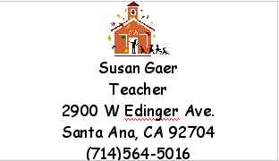
NAME
OCCUPATION
STREET
ADDRESS
CITY
STATE
ZIP CODE
AREA CODE
PHONE NUMBER

Answer the questions.
What is the name on the card?

What is the occupation?
What is the street address?
What is the city?
What is the state?
What is the zip code?
What is the area code?
What is the phone number?

Make your business card here. Put your name, street address, city, state, zip code, area code and telephone number.

Assessment Sheet - Students should sign off each item as it is done.

Objective | Student Signature | Teacher Signature
Your card has your name on it.
Your card has your occupation.
You card has your street address.
Your card has your city and state.
Your card has your telephone number.
Your card has your picture on it.

Glue completed card here.
Have students draw a possible business card.

Step 2: Computer is taught
(I have a projection system. If you don’t have a projection system, you would make overheads of the instructions with lots of screen shots.)

Show students how to open the business card by following the procedure above for address labels, but look for business cards. Be sure to check your business card paper box for the correct number. With a projector this can be done with the language experience approach by you modeling the steps while a student writes the steps on the board. Without a projector, create screen shots to show how to do this.

Step 3: Project is finished and celebrated

Example of Student Work
MARIA SANTOS  HOUSEHOLD MANAGER  210 E SAINT ANDREW PL.  SANTA ANA, CA 92707  (714) 966-3066 | MARIA SANTOS  HOUSEHOLD MANAGER  210 E SAINT ANDREW PL.  SANTA ANA, CA 92707  (714) 966-3066
MARIA SANTOS  HOUSEHOLD MANAGER  210 E SAINT ANDREW PL.  SANTA ANA, CA 92707  (714) 966-3066 | MARIA SANTOS  HOUSEHOL  SANTA ANA, CA 92703  (714) 835-5184
ARACELI CERVANTES  1114 W SANTA ANA BLV.  SANTA ANA, CA 92703  (714) 835-5184 | ARACELI CERVANTES  1114 W SANTA ANA BLV.  SANTA ANA, CA 92703  (714) 835-5184
ARACELI CERVANTES  1114 W SANTA ANA BLV.  SANTA ANA, CA 92703  (714) 835-5184 | ARACELI CERVANTES  1114 W SANTA ANA BLV.  SANTA ANA, CA 92703  (714) 835-5184

Charts and Graphs

Activity
First do an activity which lends itself to a chart or a graph.

In this example, I will do a price comparison.

Step 1: Go over food items and with the class and brainstorm five items to research.

Step 2: Have students write on a piece of paper:
My name is:
My store’s name is:
My store’s address is:

Step 3: On the same piece of paper, have them draw a 2-column table with six rows. Make sure they understand the words, “table, row, column”

Step 4: In the left-hand column have them write Food and in the right-hand column have them write price.
Food | Price

Step 5: Have students fill in the five food items in the left hand column.
Food | Price
1 gallon of regular milk

1 head of iceberg lettuce

I pound of bananas

1 package Mission Tortillas (20 count)
1 liter of Coke

Step 6: Students decide which grocery stores they will research. They go out and research the information.

Step 7: Not all students will finish the activity, so please group the students so that at least one person in each group has finished the activity.

Step 8: Using the “Susan” computer technique, dictate and have students write the steps for making a table. Have each group decide who will type the chart on the computer. It is good for a pair to be assigned. Other students will reproduce the chart on butcher paper. Print enough copies for the entire group. Next display all results by posting the butcher paper on the wall. Have the class decide which supermarket is cheaper.

To further expand this activity, graphs can be produced of the class research. These can be posted on the Internet or used to advertise results to other schools.

Making Directories

You can make a variety of directories including telephone directories, emergency number directories and community directories. Below follows the detailed steps for a community directory.

As a class decide which four agencies it is important to know the hours of operation. This could be for the library, visiting hours at a hospital, etc., the post office, the DMV, child's elementary school etc. Have students write the name of the agency in the grid provided below. For homework, have them find the hours. The next day compare notes and make a master directory including the address and

Name of Community Agency | Address | Telephone Number | Open Hours | Closed Hours

Computer Activity:
To create a computer-generated directory, students need to learn to make a table.
Note: Screen pictures may be slightly different for different software versions and computers.
Here are the directions for Microsoft Word for Mac 2001, Word XP and Word 2000

1. Open a new document  2. Click on Table  3. Click on Insert  4. Click on Table | 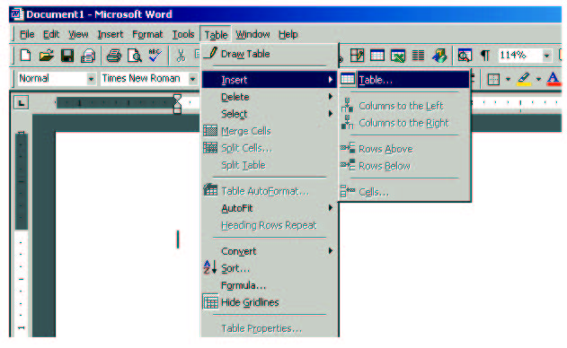

5. Click in the box for number of columns and type the number of columns.  6. Click in the box for number of rows and type the number of rows.  7. Click OK  8. Now you have a table. To type information in the table, use the Tab key, not the enter key. The Tab key moves you around the table. | 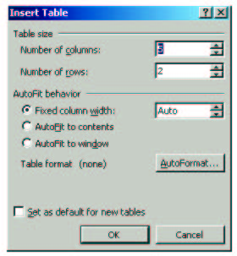
Number of columns here
Type number of rows here.

Calendars
For lower level students, calendars are great activities. Divide students into 12 small groups. With 36 students you would have 12 groups of 3. With 24 students, you can do pairs. Each group gets one month. They create the month with the days of the week and the dates. They also add any holidays that month, using the template below. After students have written in the correct information, each group goes to the computer to type it in. Show them how to use the tab key for each move.

Month Goes Here

Picture goes here

Student Stories
Have students develop stories about themselves and write them.

Ideas for Stories
- About Me
- My Family
- My house
- My job

Prewriting
- Students read a model as a reading activity. A story about the teacher is always a good motivator for students.
- Group students and assign computers for each group.
- Dictate a series of questions for students to answer
- Students answer the questions.
- After students write the answers on their paper, have different students answer different questions on the board. Go over any problems in language structure, vocabulary, etc.
- Interview a partner. Encourage students to ask questions about information they want to know more about.

Writing
- Students put sentences together using the model reading as a sample.
- Those students who finish first can either help others in their group or go to the computer and type their story.
- Once they are done typing, they return to the table to help slower students finish up.
- If you have any pre lits, one of the higher level students can write the story as the pre lit dictates it to them (Peer language experience).

Post Writing or related activities
Group students and have them read their stories to each other. Have students answer the following about each of their group member stories.
- Ask your partner a question about the story. What is something you don’t understand? What more would you like to know?
- Do you see any spelling mistakes?
- Do you see any other mistakes?
Students rewrite stories and give them to the teacher. Teacher reads and comments. I normally comment differently for each student based on his or her level. For example, for a literacy student I would just expect a few sentences. I would not comment at all on structure or spelling and perhaps ask them a question to get more information.

However, for a low beginning student, I might pick one grammatical point for each student, circle their errors in that one point. Show them how to correct that one point.

Continue advising, rewriting, advising, rewriting until the student feels the work is finished.
Publish all student work by either making a class book or posting it on the wall or on the Internet.
Models of many student stories can be found at:
http://www.otan.dni.us/webfarm/emailproject/stories.htm

Question Prompts
Family stories
I divide the students up into two groups; those with children and those without children.

Questions for those with no children:
What is your name? How many brothers and sisters do you have?
Where are you from? Where do your brother and sisters live?
Where do you live? How do you feel about your family?
What is your mother’s name?
What is your father’s name?
Where do your parents live?

Questions for those with children:
What is your name? How old are your children?
Where are you from? How do you feel about your family?
Are you married? What is your husband’s name?
How many children do you have?
What are your children’s names?

Describe your house
Where is your house?
Is it big or small?
How many rooms does it have?
How many bathrooms?
How many bedrooms?
What furniture is in your bedrooms?
What furniture is in your living room?
Does your house have a yard?
Do you like your house?
Why or why not?

Your Job
What is your name? Where are you from? When did you come here?
What is your job?
What are your hours? What do you do at work? Do you like your job?
Why or why not?

Sample Student Handout
What is your name?

____________________________________________________

How many brothers and sisters do you have?

____________________________________________________

Where are you from?

____________________________________________________

Where do your brother and sisters live?

____________________________________________________

What is your mother’s name?

____________________________________________________

What is your father’s name?

____________________________________________________

Where do your parents live?

____________________________________________________

Where do you live?

____________________________________________________

How do you feel about your family?

____________________________________________________

Beginning Writing Checklist

Y N There is a title

Y N The writer's first and last name is under the title.

Y N Every sentence begins with a capital letter.

Y N Every sentence ends with a period.

Y N Spelling is correct.

I have checked this story. Sign your name.

1. _____________________________________________

2._____________________________________________

For more writing checklists, visit http://www.otan.dni.us/webfarm/emailproject/vista/supportmaterials.html
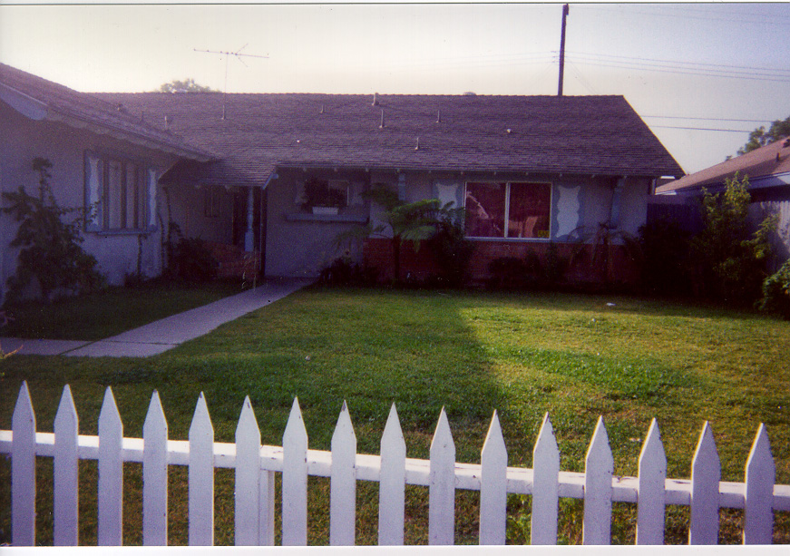

ALMA’S PLACES

By Alma Calderon

My House has four bedroom, two bathroom, one kitchen, one livingroom,
two backyards and a garage.
In My bedroom is big, I have one bed, one dresser, with a mirror, two closet,
bookshelf, Medium TV, two nightstands and a bathroom.
My bathroom has a toilet, shower and tub.
My living room, I have sofa, one love seat a television, a stereo, floor lamp,
Coffee table and I have a big mirror.
My kitchen is big. I have a counter, a stove, two refrigerators a sink and
Kitchen table.

Thanks for visiting my house.
Here’s where I live.

Other Story
BY ALMA CALDERON

I am student at Centenial Education Center. My hours at School are 10am-1pm
Monday-Thursday.
I am a student in Beginning One.my Teachers is Susan Gaer. My teaches is very nice. I Like my school.

In tha afternoons. I am House hold manager. I cook meals, clean tha house,tak care of children, Wash the clothes and budget money.

I enjoy my school and my family and house.
A class newspaper can be developed by having each group write one article and then have a small group of computer literate students use Microsoft Word's newspaper template found under new projects.Here is the Project Gallery in Microsoft Office X.
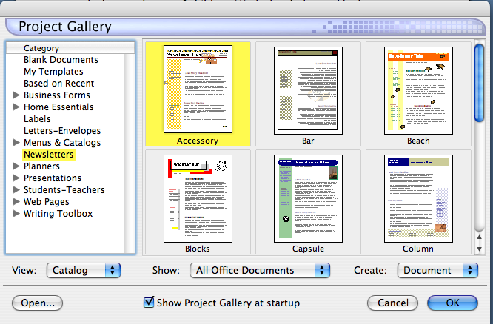

For operating systems other than office X, please go to Microsoft's website at http://office.microsoft.com/home/default.aspx
(Office X is only for Mac with operating system X.)

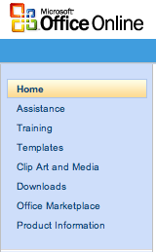
Click on templates

Browse through the templates to pick the one you want. Newsletters are located under Marketing Materials
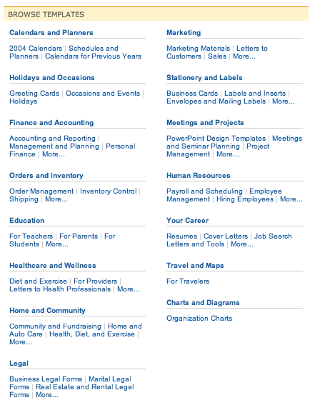
Internet Activities

Grabbing Images off the Internet

1) Go to http://images.google.com


2. Type in the name of an image. For example, let's look for bananas.

3) Click Google Search and you will get many pictures of bananas

4) Click on the one you like. If you are looking for a small picture skip step 5.
5) Click on see full size image.

5) Now we are ready to copy it for our word document.
Right click on the image. And select Copy image.
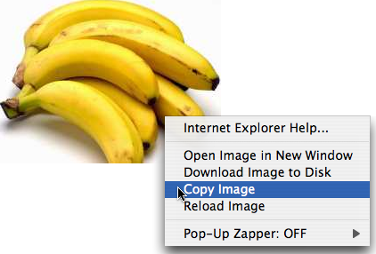

Now open your word document and just click on Edit→Paste. You picture will be in your document.
National Anthems
Visit http://www.thenationalanthems.com/where students can hear National Anthems from 192 different countries.

Activities:
- Teach the meaning of national anthem by playing the anthem from each country represented in your classroom.

- Time the national anthems to find which is the longest and which is the shortest.
Higher Levels
- Have students summarize what their anthem says .
- Teach the Star Spangled Banner. Get the lyrics at: http://www.usa-flag-site.org/song-lyrics/star-spangled-banner.shtml

Problems and Solutions

Question: How do you work with 3 computers and 40 students?

Divide the three computers between the students as best you can. In the case of 3 computers with 40 students I would assign 13 students to two computers and 14 to the third. Amongst this number divide the students into groups of 3. This would be approximately 4 groups of three assigned to each computer.

Each activity is done in groups of three. While three groups are at the computer, the other students are doing a related activity.

Activity | Related Activity
Business Cards | Students interview each other for name, address, telephone number and job and place it on a conversation grid. After interviewing X number of students, classmates write sentences with the information they gathered.  Ex: His name is Raul.etc...
Address Labels | Same related activity as business cards.

Activity | Related Activity
Directory | Students interview each other with the following questions:  Where is your post office? What is the telephone number?  What is the telephone number for your fire department?  What is the telephone number for the police?  Do you have children?  What school do they go to? What is the telephone number  Activity 2:  Have students draw a map and place directory points of interest on the map.
Calendar | Draw the calendar  What day does __________ fall on?  Also, for intermediate and advanced students, they can do web research on what happened in history on a given day or  month. Some suggested sites (from Debbie Kerr, Baldwin Park) are  www.earthcalendar.net/2002/020102.html  www.1728.com/page5.htm  www.anydayinhistory.com  www.sbrowning.com/whowhatwhen/index.php3
Student Stories | - Have students use the questions from student stories and interview five other people in the class.  - Have students read each other stories and use one of the writing checklists to review the story.  - Use conversation starters from the following websites:  http://www.eslpartyland.com

Materials you can purchase:

1. Cathy's Cards  Instant Conversation in the Classroom  Cathy Seitchik Diaz  High Motivation! Low Stress! Easy to use! An ESL teacher's dream! This set of 270 question cards has got the ESOL world talking up a storm! The cue cards are designed to promote natural, spontaneous, and personalized conversation in the classroom. They are ideal for pre-lesson warm-ups, in-between snapper-uppers, and end-of-class cool-downs. The questions are specially created to provoke fun and interesting thoughts on a variety of subjects pertinent to secondary students and/or adults. The adult edition has been newly revised and features durable cards that will last a lifetime and beyond! The included teacher's manual is packed with successful tips and dozens of invigorating activities and ideas for using the cards! Included Free Question cards and available packs of blank cards add extra spice to the set. If you're seeking high-energy, oral interaction in your classroom, look no further! | 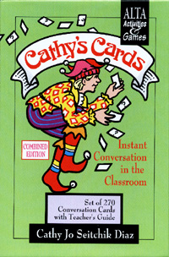  ALT/1997  Order No. ALT-8392-8  $49.50 set

2. Conversation Inspirations
Pro Lingua Publisher
Price: $16.00
ISBN: 0-86647-094-8

3. Schwartz, Eileen A., Gridit Games, published by Schwartz, Eileen A. A book of games can be ordered for $12 plus tax and postage and handling by contacting the author at eileenschwartzusa@yahoo.com

Question: What do you do with a mixed level class? In my class I have students who have lots of computer experience and some with no computer experience at all?

Group students so that there is one computer-proficient student in each group. That student becomes your assistant and helps those with no experience to complete the project. As students become more proficient, change the groupings.
Question: My students can’t type. How can I do an activity with them that involved keyboarding?

When I introduce my students to the keyboard, I teach them these keys: shift, enter, space bar, period and question mark. They hunt and peck to find the letters. They aren’t bothered by this and it doesn’t take that long.

Question: My class is open entry/open exit. How do I handle this in the 1-3 computer classroom?

Handle it just like you do any other activity you do in your classroom. Group students who have experience with those who do not and let them help each other.

Question: Why should we do this?
It enhances and supports language learning, it's motivational for the student, it’s important for family literacy (their children are doing this at school and at the library and they shouldn't be intimidated out), and it increases job skills

OTHER QUESTIONS:

