Joy Luck Catering
3 Course Business Lunch
Handmade delicacies and exotic variety

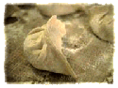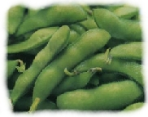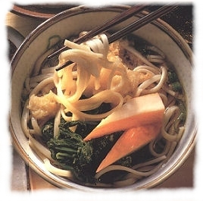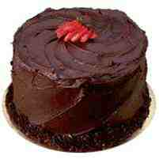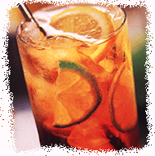

617-201-6943 -The Menus – 617-201-6943

The Corporate Lunch
$13.95 (choose one from each course – does not include beverage and dessert)

Starter Course:
♦ Chicken & Chinese Cabbage Dumplings (4 per serving)
Tender chunks of chicken breast mixed with savory Chinese cabbage.

♦ Vegetarian Harvest Dumplings (4 per serving)
Five spice tofu, bok choy and black mushroom.

Salad Course:
♦ Fresh Tofu
Chunks of fresh, firm tofu with our zesty dressing and crushed peanuts

♦ Edamame
Crisp and crunchy, fresh Edamame – lightly salted.
♣ ♣

The Executive Luncheon

$19.95 (choose one from each course - does not include beverage and dessert)

Starter Course:
♦ Corporate Starters

♦ Premium Blue Crab Meat Dumplings (4 per serving)
Sweet and fresh blue crab claw meat with tangy ginger & scallion

♦ Summer Roll (2 per serving)
Special blend of fresh & tasty greens, shrimp and noodles in a soft rice wrapper.

Salad Course:
♦ Corporate Salads
• Minimum Order: 7 plates. Free delivery with 15 plates or more.
• Minimum of five orders for each Match.
• Bookings require two days notice with 15 plates or more.
Joy Luck Catering –Boston, MA 617-201-6943 info@joyluckcatering.com www.joyluckcatering.com
♦ Cucumber & Calamari
Thin sliced cucumbers tossed with fresh calamari in our white wine sauce.

♦ Wilted Spinach & Blue Crab Meat
Fresh baby spinach with sweet blue crab claw meat in our zesty dressing.
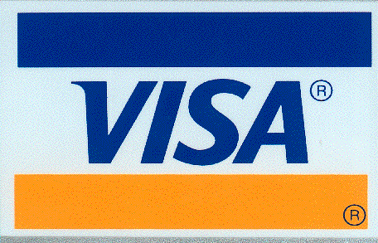
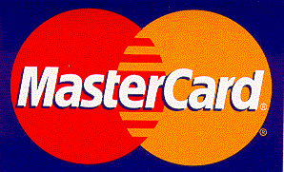
Mix N’ Match Entrée Course

This course applies to Corporate and Executive Menus. Pick one from each sub-category (up to three veggies if no meat selected)

Noodles:
- Flat Rice
- Udon
- Shanghai Wheat

Sauce:
- Spicy Peanut
- Ginger & Soy
- Hoisin
- Curried Coconut

Meat Toppings:
- Beef
- Chicken
- Shrimp

Veggie Toppings:
- Onions
- Tofu
- Mushrooms
- Bok Choy
- Spinach
- Broccoli
- Carrots

♣ ♣ ♣ ♣ ♣ ♣ ♣ ♣ ♣ ♣ ♣

Desserts: Individual Gourmet Cakes $5.25
Homemade Pie (slice) $3.75

Beverages: Canned Soda $1.30
Arizona Iced Tea $2.75
Poland Spring Water $1.30 Pelegrino Sparkling Water $2.75

