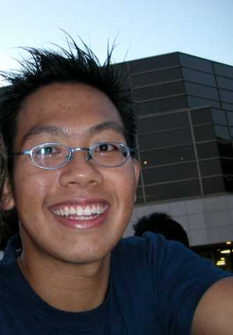

Yeo Kian Kee, Christopher
190 Sarnia Road Apt 303
London, ON, Canada
N6G1M9
Age: 23
Time in SJI : 1993-1996

Honours won for school

-totally forgot-

Overseas Fencing Competitions
O.U.A Fencing 2002 10th place

O.U.A: Ontario University Atheletics

Comments:
Doing political science in UWO
Hobbies:
Reading/Cooking/Music/Clubbing/Drinking/Fencing/Cycling, etc…

http://pbase.com/ksquared
http://www.blurty.com/users/ksquare
http://westernfencingca.tripod.com/

- End -

