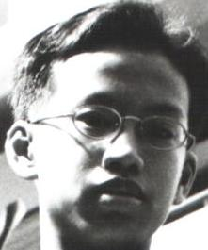Eddie Sng Chong Guo
Bishan Street 23 #06-195 Blk 220
Hp : 98381950
Age: 16
Time in SJI : 1998-2002

Honours won for school
Raffles Junior College Open Team Silver 2001
Novices Fencing Championship (Men’s Foil) Team Silver 2001
Ind & Team Silver 2002
National U-17 Fencing Championship (Men’s Foil) Team Gold 2002
Ind & Team Gold 2003
National U–20 Fencing Championships (Men’s Foil) Team Silver 2002
Ind & Team Gold 2003
Singapore Pools Fencing Championships Team Sliver 2001
Pesta Sukan National Team Championships (Men’s Foil) Team Silver 2002

National Open Championships (Men’s Foil) Individual Bronze 2003

Overseas Fencing Competitions
Asian Juniors Fencing Championships 2002 Poules elimination

Trainer from : 2002-

Comments:
Am presently studying in Saint Andrew Junior College
Hobbies:
Sleeping/slacking/stoning

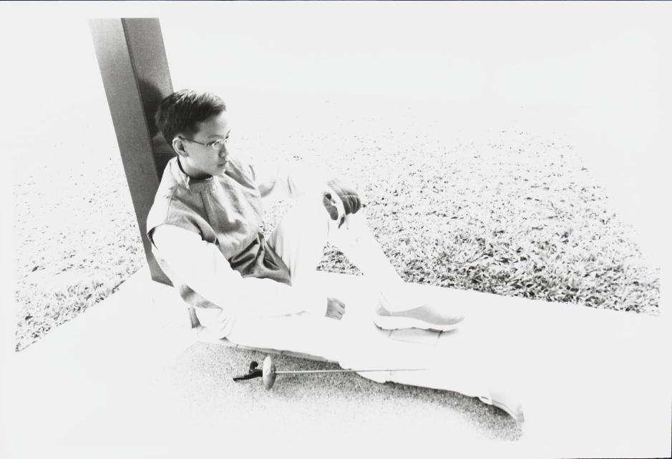
- End -

