

Lee Feng Quan
Blk10F Braddell View #22-24 S(579725)
Age: 17
Time in SJI : 1999-2002

Honours won for school
Raffles Junior College Open Team Silver 2001
Novices Fencing Championship (Men’s Foil) Ind Bronze 2001
Team Silver 2001
National U-17 Fencing Championship (Men’s Foil) Ind Silver 2002
Team Gold 2002
National U–20 Fencing Championships (Men’s Foil) Ind Bronze 2002
Team Silver 2002
Team Silver 2003
Singapore Pools Fencing Championships Team Sliver 2001

Overseas Fencing Competitions
Asian Juniors Fencing Championships 2002 Poules elimination

Trainer from : 2002-
Comments:
Currently doing Interactive Media Design in Temasek Poly
Hobbies:
Jazz/ R&B(Chinese)/ Drawing/ Photo editing/ Surfing/chating

Links: www.angelfire.com/blog/fqphoto/blog.swf

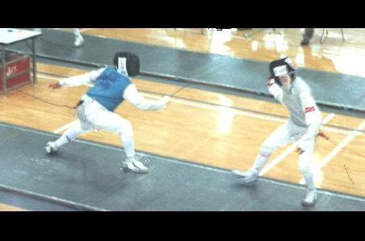

- End -

