

Wee Tze Yi
3 Holland Green
Singapore 276126
Age: 19
Time in SJI : 1997-2000

Honours won for school

Novices Fencing Championships Foil Team Gold 1999,2000
Foil Individual Silver 2000
FS Junior Fencing Championships Foil Team Silver 2003
Foil Individual Bronze 2003
FS Fencing Championships Team Bronze 2002
FM Fencing Championships Individual Silver 2002

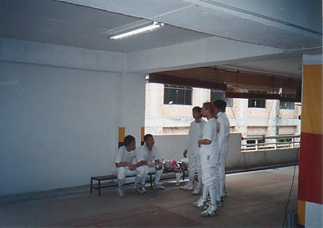

Overseas Fencing Competitions

South Australian Under 17s Foil Individual Silver 2000
Foil Individual Gold 2001
South Australian Under 20s Foil Individual Silver 2000,2001
South Australian School Team Championships Foil Team Gold 2001
South Australian Open Foil Individual Bronze 2001

Comments:

Studied in Adelaide, South Australia from Feb 2000 to May 2002. Did the International Baccalaureate (IB) program which Singapore is going to be introducing amongst their new education reforms. Currently serving NS as an Arms & Explosives Search dog handler. Planning to go to the US to further studies in a business-related field. Boring stuff…

Hobbies:

Currently… only two… Salsa dancing and watching jap anime~!! =P Latest one I’m watching is Samurai Deeper Kyo… damn good! =) Salsa is great fun too, anyone interested in a close contact social dance can look me up. Can talk to D. Chia if you don’t believe its fun! =P

