To Flick or not to Flick, that is the question!
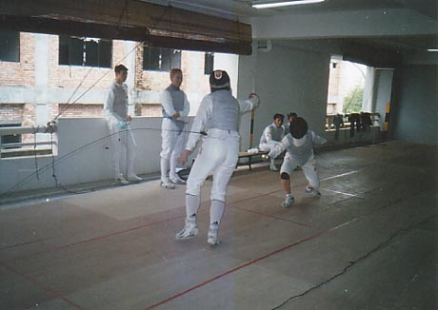

Long gone are the bygone area of the straight blade and the thrust being the sole dominating offensive action in foil fencing. Today, flicks, or whip attacks, are the common denominator for many national and international fencers. Though the trend is picking up and many today, even beginners find the temptation to throw a blade across the back of an opponent intriguing, it is important to understand first the history of the evolution of the flick into its present form and the consequential marketing behind the creation of new and lighter blades to better satisfy this new ‘flicking generation’

The flick was first introduced to the modern art of fencing in the earl 1980s by the Germans. True to expectations, the arrival of a new, faster means of attack and counter attack won them the World and Olympic titles that year.

The flick, contrary to popular belief, actually has a long history which initially evolved form the coupe' (the cut-over) and epeeists efforts to throw their points around the bell before taking their present known form. The idea of attacking concealed targets like the back and the underarm are also not new since the idea of an angulated attack has been around for centuries.

With the advent of modern electronic scoring mechanisms, fencing has evolved into a much faster sport/art form and it is obvious that with this evolution comes the need for a revolution of old techniques and skills. Angulated attacks to the back are now too slow in contrast to the speed of a fencer’s parry and the point of the coupe no longer needs to come under the scrutiny of floor judges. Electricity in a fencing circuit has changed the rules of the game. The advent of the flick was a natural response.

Many have accused the flick for the recent ‘bastardisation’ of the foil game. It is worthy to note however that the evolution of fencing has over the years grown to accept new tactics like the lunge, stop hit, inquarta etc. To merely rule out a move because tradition dictates so is relegating it to being a bane on the spirit of progress and adaptability that the game of fencing itself embodies and strives to train in people. Fencing is no longer a blood sport, it is an ancient art which has found its new roots in modern sport, much similar to the games of chess. Almost nobody complains that the player who dethroned the current world champion in chess is a computer. Even less assert that such matches bastardise the ancient game of strategy.

That being said, those who believe that the key to success on the piste is the flick will be sorely mistaken. Flicking consistently takes months of training and years of practice to perfect. When properly executed and judged, flicks are effective and beautiful attacks; poorly executed and judged, they can be painful and annoying. The flick is not invincible; in fact, it requires more skill to maneuver a whip attack than a direct one. Poor fencing distance, inaccuracy, height, luck all play a part in the flick landing on its target. Those that have yet to master the fencing distance of a straight blade should not attempt a flick so readily.

In total, three elements make the flick a success;

- The how – One must have the requisite skill to actually do the action (incorporated in this is the requite timing, distance, speed and strength)
- The when – Fencers must also have the tactical knowledge when to use the fliock to it’s most devastating effect
- The when not to – When to refrain from it.

Of the three, it is the third option which will prove hardest to master. Yet, the key to understanding this concept usually distinguishes a good flicking fencer, form a poor one.

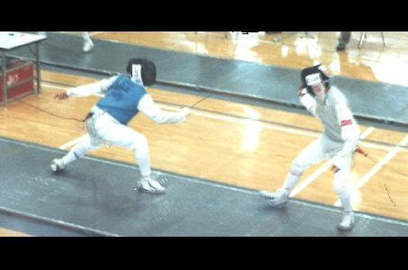 Mastering the ‘when not to’ would be mastering the maturity needed to execute the flick with devastating results. At the end of the day, the flick is merely a tool in a fencer’s arsenal of weapons. A constant flicker on the piste, who relies on the flick on every single endeavor, will surely fall to either the break in time by the step in, or a requisite parry. At the end of the day, the tool must be used in totality with the remainder of a fencer’s skills. Knowing when to switch from flicks mid way, to a direct disengage attack, is very useful because only a wide parry can catch a flick. The flick, used in this way, opens up a whole new dimension to fencing. The opponent fencer now has to contend with small circular attacks as well as large forceful ones. Both require different kinds of parries to neutralize. Knowing which defence to use now will become increasingly important. While the novice fencer happily whips blades over the backs of opponents too ignorant to know how to block a flick, the master skillfully uses the fear of a flick to make a direct attack into the height of his opponent’s defence with a more efficient tool while his opponent is still in two minds about where the attack is going to come from. The end result is more efficient, graceful and will not have to deal with the problem of inadequate priority and presidential interpretation of the preparation.

To flick, or not to flick? That is the question. While many novices feel that flicking would mean the epitome of their learning, it merely opens up a new dimension and new targets to exploit in their opponents chink of armour. As a guide, never make the flick obvious, by doing so you open yourself to a flood of countermeasures your opponent might use to neutralize your efforts. The element of surprise, in this aspect is always important and this should be implemented for all flicking movements whether it is attack, defence or stop hit.

Secondly, it will be important to know when to use the threat of a flick into a successful fake or one two. This confuses the opponent as to the line of attack in which he should expect the point and makes his job of parrying all the more difficult. Done once or twice in a 15 point bout, this will often cause the opponent to panic in later exchanges and makes dealing with his strategies all the more easier.

Lastly, the flick has to be fast. Slow flicks will not give you the result you expect. They lack force for the whip to effectively land the point and they lack purpose. Yet, flicks also need to be accurate, accurate in terms of distance, time and landing. To successfully accomplish this means only one thing: Mastery of distance, and lots of practice.

Blades to use? There are many new blades on the market which might get a would be fencer intrigued with the flick due to their whippy nature. However, it is best to refrain from judging the quality of a blade by their flexibility alone. Whippy blades lack point control and thus, attacks often fall short of their intended target. Stiff blades have the opposite effect of being rigid, brittle and sometimes painful to wield – especially for the opponent. What should be sort is a balance between the two properties: rigid but not brittle, flexible but not whippy. Such blades are highly sort after and brand name alone will tell you little about the quality of the blade you seek.

In conclusion would be flickers, beware the dangers of the flicks for they are legion. However, with proper care, skill and maturity, you will find the flick an effective compliment to your growing arsenal of weapons.

The writer is a resident Coach in the Saint Joseph’s Fencing Academy and presently a law undergraduate at the National University of Singapore.
The views expressed are solely the writer’s own and does not profess to be universal.

