ABOUT K-SEC. . .

PRE-PHASE I DEMO $250,000
- Compile Database 50,000 SF BI-PV Solar Potential Roofing in every Kansas County
- One K-SEC Board Member in each KS County
- 5 KS Counties Incorporate under K.S.A. Ch 17-4651 to 4681 to form twenty-one local K-SEC Renewable Co~operatives
- Locate BI-PV Fabrication/Training Center
PHASE I DEMO $50MM KCC Backing
10,000 SF BI-PV Solar in each KS County by 2012
PHASE II FOUNDATION $3 Billion
1,000 MWp BI-PV Solar in Kansas by 2022
PHASE III MANAGE 50 YEARS 2022-72
1,010.5 MWp BI-PV Solar $.5B
- Monitor + Maintain + Manage

105 KANSAS COUNTIES

EXHIBITS+EVENTS+TESTIMONY
+BI-PV SolarSmoothies™
1.Coffey County Fair 2008
2.Douglas County 2005-2009
- Earth Day 2005 to 2009
- Eagles Day 2007-2008
- Home Energy Fair 2005-2008
- City Sponsored Solar Fair 2008
3.Gove County LibrTourFeb2007
4.Greenwood County/Eureka09
5.JohnsonCounty EarthDay2008
6.Kiowa County, Greensburg
- City Council Testimony Feb2007
7.McPherson County 2005 to2009
- Testimony Zoning Com. 2005
- Marquette factory plans 2006
8. Montgomery County 2009
9.Neosho County Fair 2008
10.Osage County SolarFair 2008
11.Rawlins County 2008
- Renewable Energy Conf.’08
12.Riley County 2005 to 2009
13.Shawnee Co Ks Legislature
- KCC & Legis. Testimony 2005-09
14.Wilson County Fair 2008
15.Woodson County 1998-2009
- WoCo Commission 1998&2008
- Factory Plans 1998 to 2009
- County Fair 2008
- Toronto Days 2009
- Yates Center Days 1998-2009

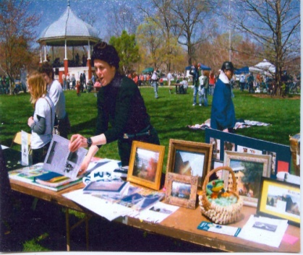
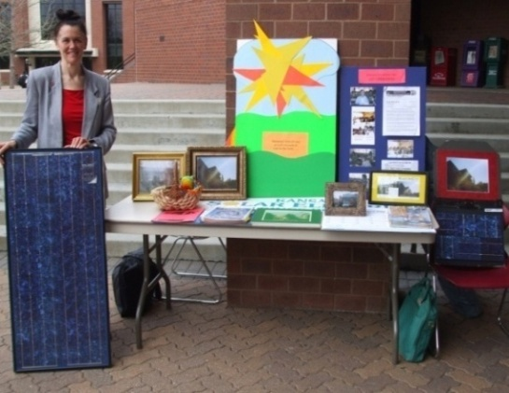
MISSION STATEMENT
VISION STATEMENT
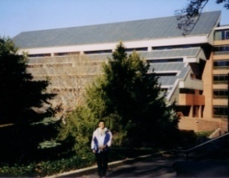

BI-PV
20th BD 2004
30,000 SF BI-PV Solar Roof Installed 1984 Georgetown University Intercultural Center
- K-SEC will provide educational leadership in all areas of The K-SEC Model appropriate to our roles in the lives of our clients, employees, county-based K-SEC Co~operatives and communities.
- K-SEC will always seek to provide world-class technology to evolve teaching and learning opportunities for participants, the public & global community.
- K-SEC will educate and support all constituents in successfully exercising their rights and responsibilities as citizens in a diverse, global society.
- 80% of the electricity presently consumed in Kansas is generated by coal-fired power.
- K-SEC recognizes the importance of uninterrupted electric services and the challenges of blackouts.
- K-SEC will naturally increase
  - Homeland Security
  - Emergency Preparedness
  - Environmental Integrity &
  - BI-PV Technological Expertise
w/1,000 Solar Green Jobs for KS.
The Mission of the Kansas Solar Electric Co~operatives, a statewide non-profit member organization, is to organize and facilitate a three-phase program called The K-SEC Model. K-SEC will provide quality installations for 1,000 MWp Building-Integrated PhotoVoltaic [BI-PV] Solar Electric Capacity in Kansas by 2020. K-SEC will monitor and maintain this solar resource for fifty years. An integral part of this mission is to produce and utilize quality technologically advanced solar systems integrated into buildings (75%) and homes (25%).
K-SEC seeks to evolve a broad spectrum of local and global knowledge in the delivery of our training, installation, management and monitoring producing fifty years of research for development.
It has been clearly revealed in the past 30 years that BI-PV Distributed Solar must have a strong foundation of 10% market penetration to evolve commercially into the energy market. The electricity market is traditionally dominated by a trillion-dollar momentum of fossil fuel commerce. The vital question related to global warming is can we afford to ignore the possibilities? The K-SEC Model will reduce dependency on CO2 and other toxins while we provide many benefits for Kansas as summarized herein. K-SEC will provide a market penetration deployment model for other states and nations around the world.

K-SEC
HIGHLIGHTS

Purchase of 2,000 K-SEC shares, donation(s) and/or grant will allow K-SEC to use this important tool to educate the public about BI-PV Solar. We hope to have it completed soon and to visit each Kansas county by December 31st 2009.
©2008 Eileen M. Smith, M.Arch.
All Rights Reserved
K-SEC IN THE NEWS

HISTORIC ARTICLES

K-SEC Mobile BI-PV Solar Exhibit 2009

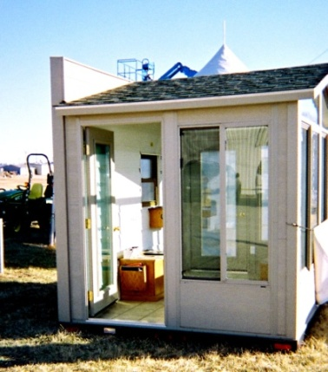
July 2008, K-SEC was sponsored by the Coffey County Economic Development Association to provide an exhibit with Solar Smoothies™ for patrons of the Coffey County Fair. July 4th, I built a 2’x4’ BI-PV Solar Exhibit. The solar half-roof keeps direct current photovoltaic solar electricity flowing to a DC blender to demonstrate how BI-PV works. People of all ages love to stand in front of the solar roof to stop/start the blender. The simplicity of BI-PV Solar technology fascinates everyone.

The first day of the fair it was 110 degrees. A blistering from three other county fairs was not ready for another painful layer of sunburn. About 2 pm, a pick-up pulled in beside my exhibit with an 8’ x 10’ x 8’ high room on a trailer. The driver backed in and within a few minutes the trailer and tongue disappeared w/ hydraulics hiding the wheels in the walls. The little room looked like it had fallen from heaven. After introductions, I indicated how nice it would be to install a BI-PV Solar Roof on his mobile exhibit that was being used to showcase ABC Siding. I could invite K-SEC visitors to enjoy cooled comfort while educating them about how a solar system works via a BI-PV Solar Roof and a wall exhibit of the balance of system components. I immediately designed an exhibit and have been pursuing partners, contractors and/or resources to build a K-SEC Mobile BI-PV Solar Exhibit. The cost is:
- a hydraulic trailer delivered for $5,000,
- the room w/sliding glass doors and BOS display wall for $10,000, and
- a used or leased vehicle for around $5,000.
SOUTH
$20,000 at 0.04% of K-SEC’s $50 MM Phase I Demonstration is a viable investment.
K-SEC President takes RESNET Home Energy Rater/Audit Training
Kansas Building Science Institute in Manhattan

August 2009, the Kansas Corporation Commission provided a scholarship for K-SEC’s President to take the RESNET Energy Rater Training and Certification program at the (1) Kansas Building Science Institute [KBSI] in Manhattan, Kansas. http://www.kansasbuildingscience.com/ During the fifteen years she served as Founder and CEO of the SOLAR DEVELOPMENT COOPERATIVE Ms. Smith provided energy audits to assist clients design renewable energy conservation plans.

Woman crusades for solar energy, by Richard Luken, The Iola Register, Iola Kansas, Thursday May 21, 2009, Front Page, photo page 11 column 1

Solar fabrication and training center proposed for Yates Center, The Chanute Tribune, Chanute, Kansas, June 18, 2008 page 3

Residential Photovoltaics, Building awareness and momentum for an alternative energy source, by Eileen M. Smith, M.Arch., Design/Build Business (magazine), The Resource for design/build professionals, feature article, December 2003, page 20-22

1980’s Energy Crisis Inspired ICC’s Solar Panels; Officials Confirm Panels Productivity, by Charlotte Nichols, The NEWS Hoya, Georgetown University, Washington, DC Tuesday, March 20, 2000 page 8
K-SEC BUSINESS PLAN

PHASE I Demonstration 10,000 SF BI-PV Solar installed in 105 Kansas Counties by 2012
$50 Million

PHASE II Foundation
1,000 MWp/10 WSF
100 MSF/ 100 Counties = 1 MSF/10 Years
= 100,000 SF Yearly

2012 to 2022 ~ 100
Kansas Counties Each
Install 100,000 SF BI-PV Solar Rooftops Yearly:

25,000 SF Residential
Average Home 250 SF
=100 Homes/County

75,000 SF Commercial
Avg. Building 750 SF
=100 Buildings/County

100,000 SF/50 Weeks
= 2,000 SF Wk Installed
In 100 Kansas Counties
2 SOLAR GREEN JOB TYPES
YEARLY SALARIES/HOUR

7 Installers per County x100 Counties =700 Jobs
$3.50SF x 2,000SF=$7,000 WK
$7,000x100CO=$700,000 WK
$700,000x50Wks=$35MMYR
$35M M/700 = $50,000 Yearly Salaries/$25 HR

20 Production Techs
$10 SF x 2,000 SF WK
= $20,000 x 50 Weeks
= $1,000,000/20 = $50,000
Yearly Salaries/$25 HR
K-SEC FULL COST DISPATCH VALUATION TO 2070 IN THE NEWS

Full-Cost Dispatch is Full Costs/Benefits of Technology per Life-Cycle
K-SEC PROJECTED EXPENSES/ INCOME PER PHASE/COUNTY

The K-SEC Model will provide a variety of people stimulating lucrative long-term employment in Kansas and a leadership position in BI-PV. K-SEC seeks stock investors & legislative support of $150,000 to evolve pre-Phase I data for KCC to back $50 MM bonds for K-SEC with ratepayer revenue.
K-SEC seeks to install 1 MSF Building-Integrated PhotoVoltaic [BI-PV] Solar Electric Resource in KS by 2012
Increase Homeland Security + Emergency Preparedness + Environmental Integrity + BI-PV Solar Expertise
Join K-SEC’s Phase I Demonstration to Evolve 10,000 SF Solar in Kansas and 1,000 BI-PV Solar Green Jobs!
December2009.

