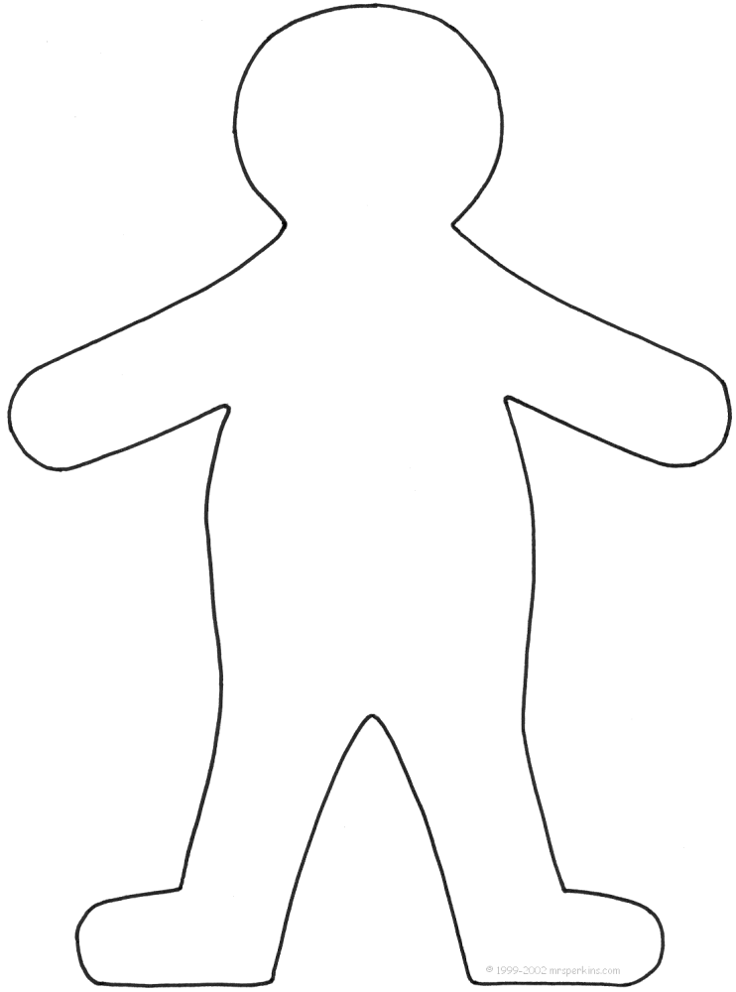
Please send a picture of yourself and Flat Stanley in your hometown, or the place that you visit. Include information about your school or where you visit. If you can’t get a picture taken with him, please send us a picture post card. Include a letter telling us where you took Flat Stanley while he was in your care. Be creative. The sky is the limit. We welcome brochures or souvenirs to display with Flat Stanley. Please return your Flat Stanley to the student that sent him to you, or to me at the address below…
Directions for Flat Stanley:

Cut out Stanley and add things like: hair, shoes, shirt, pants, hat, mittens, etc, etc. Use your imagination as to how Stanley should look. We look forward to seeing what Stanley looks like when he returns to our classroom.
Please return Stanley to us within 2 weeks if possible.

Thank you,
Miss Shields’
ESL Class

Miss Jami Shields
Salyer Elementary
P.O. Box 1307
Guymon, OK 73942

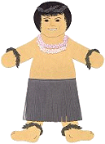
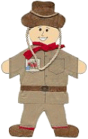

Sample Flat Stanley
(from Hawaii)
Sample Flat Stanley
(from Australia)

