Hello and Welcome to our house. We hope you enjoy your stay. Please remember that this is our house and we hope you will treat it with respect and care as if it were your own.
Here are some pieces of information for you during your stay.

Please be very careful on walkways and deck. You are in a high altitude, mountain environment and it can be very icy and slippery. Garage side of front walkway, asphalt in front of garage and deck can be very slippery. There is snow-melting salt in garage (white box near stairs). Use it as much as needed.

KEYS
- Combination for lock box and garage will be emailed separately ~1 week prior to arrival.
- Enter 3 or 4-digit code, slide black latch down, and then remove faceplate to get key inside.
(To re-lock the lockbox, enter 4-digit code again, slide black latch down, and replace the faceplate on the lockbox.)
Be careful to double-check that the faceplate has been replaced securely or it could fall off.
- One key will be in lockbox on your arrival day.
- After opening the front door LEAVE THE KEY IN THE LOCKBOX AS AN EMERGENCY KEY AT ALL TIMES. 2 keys will be left for your use on the kitchen counter. At the end of your stay please leave all keys where you originally found them.

DIRECTIONS TO HOUSE- enclosed at bottom of this file

PARKING
- Garage is for one car only. Additional parking should be limited to general area in front of house. Do not block neighboring garages.
- Snow Removal is most important close to the building. If your cars are parked in the driveway, please park them away from the house parallel to the street to allow for maximum snow plowing in the driveway. Try not to park on ends of driveway, which is where snow is plowed. (see snow hill)

- **Note – if using a computer we recommend using a surge protector (not supplied)

EMERGENCIES
- Any emergency questions during your stay call (720) 488-3177 or (303) 523-9446 or (303) 523-0711 in that order. There are answering services at all three numbers.

DVD PLAYER
On the main floor is a DVD player. To use it follow these directions.
Change channel to Ext 1, turn on DVD player and play Disc.

FIREPLACE

Be careful, glass and area immediately surrounding fireplace gets very hot.

Switch to turn fireplace on/off is on wall to left of fireplace. Please shut off when not in use.

SKIS/SNOWBOARDS/BOOTS
Please use rack in the garage (near garage door).
NO skis, snowboards or boots are to be brought in the house.

EXTRA CHAIRS

There are extra folding chairs in the garage or downstairs.

FUTON IN BASEMENT
DOES NOT OPEN FOR USE AS BED

TRASH SERVICE/MAINTENANCE
In the garage is a plastic trash container with wheels on it. All trash can be placed inside the container.
If your stay includes a Wednesday night and/or Thursday morning, PLEASE be courteous to yourself and other guests and place all trash in container for Thursday pick up by Wednesday night. Trash pick up normally is early Thursday morning. Please bring the trashcan to the curb and return it to the garage after it has been emptied. If you are facing the road it goes to the left of the driveway. There is no alternate pick up day.

Maintenance people may come into the house to check the hot tub; they have their own keys.

The Tenant will be responsible for all damage or breakage and/or loss to the premises except normal wear and tear and unavoidable casualty that may result from occupancy.
Tenant must notify LANDLORD within 24 hours of arrival of any damages that are present on premises.
If not reported in advance, damages will be assessed to Tenant.

LOCKED DOORS AND CABINETS
- There are 4 locked owner’s cabinets & drawers in the kitchen. Still plenty of guest storage space.
- There are 2 locked closet doors in the basement, one in the bedroom and one in the main room.
- There is a locked closet in the upstairs master bedroom.
- All bedrooms have a guest closet
- Please do not try to force these doors/cabinets open.
- In addition to these locked doors, there is plenty of space for your storage.

DOOR TO DECK
Door can be sticky, especially in cold weather, Again please be aware there can be ice on the deck near the door. Be careful.
There is ice-melting salt in a white cardboard box in the garage. Please use generously as needed.
Please lock deck door after use.

DEPARTURE DETAILS
Upon your departure please take care of the following items when you leave:
- Turn thermostats (all 3, one on each level) to ~62 degrees
- Close all windows
- Lock all doors - front door, deck door and garage door.
- Make sure fire place is off
- Turn off all lights
- Make sure one emergency key is in lockbox
- Leave other keys on kitchen counter top or hanging on hook behind door
- Cover to hot tub is on and secured with 4 latches (2 on front, 2 on back), deck door is locked

Thanks for being our guests.
Have a wonderful time.

Jeff & Ilana Spiegel
Spubin99@yahoo.com
www.vrbo.com/vrbo/3214.htm
www.geocities.com/spubin99/spubinhouse.html
(720) 488-3177
(303) 523-9446
(303) 523-0711

HOT TUB

- PLEASE BE CAREFUL IN WINTER, ICE CAN FORM ON DECK and NEAR DOOR, MAKING IT VERY SLIPPERY
  - There is ice-melting salt in a white box in the garage. Please use generously as needed.

- WHEN NOT IN USE, COVER MUST BE IN PLACE, LATCHES MUST BE SECURED
- DO NOT LEAVE THE COVER OPEN OVERNIGHT OR FOR ANY EXTENDED TIME
- CARE MUST BE USED TO KEEP CHILDREN AWAY FROM HOT TUB WHEN NO ADULT SUPERVISION IS PRESENT. IT IS A DROWNING HAZARD!!!

ALCOHOL AND HOT TUBS DO NOT MIX!

PLEASE USE THE HOT TUB RESPONSIBLY
- DO NOT PUT BUBBLES OR ANYTHING ELSE IN THE HOT TUB WATER

PLEASE CLOSE HOT TUB AND LATCH LID WHEN NOT IN USE
- USE CARE TO CLOSE THE COVER, IT SHOULD BE LIFTED FROM BOTH SIDES OR FROM INSIDE THE HOT TUB, ESPECIALLY WHEN FULLY OPENED. IF LIFTED FROM ONE SIDE, THE LIFTING MECHANISM WILL GET DAMAGED OR BREAK (THIS HAS HAPPENED BEFORE).
- PLEASE CLEAR SNOW FROM HOT TUB LID AS IT ACCUMULATES DAILY.
DO NOT USE A SHOVEL, ONLY A BRUSH (from a car or one that is on wall next to door)
Shovel snow to sides of hot tub. If you clear it to the back, the top will not open completely.
- BROWN AND WHITE FLOATING CHEMICAL FILTER CAN BE REMOVED WHILE IN THE HOT TUB (you can use your hands to remove it). PLEASE REPLACE IT WHEN FINISHED USING THE HOT TUB, BEFORE LID IS CLOSED
- PLEASE LOCK DECK DOOR AFTER DECK USE

To open cover half way (for 2 people if desired):
Undo latches (2) on front, lift cover up and fold over halfway onto itself.
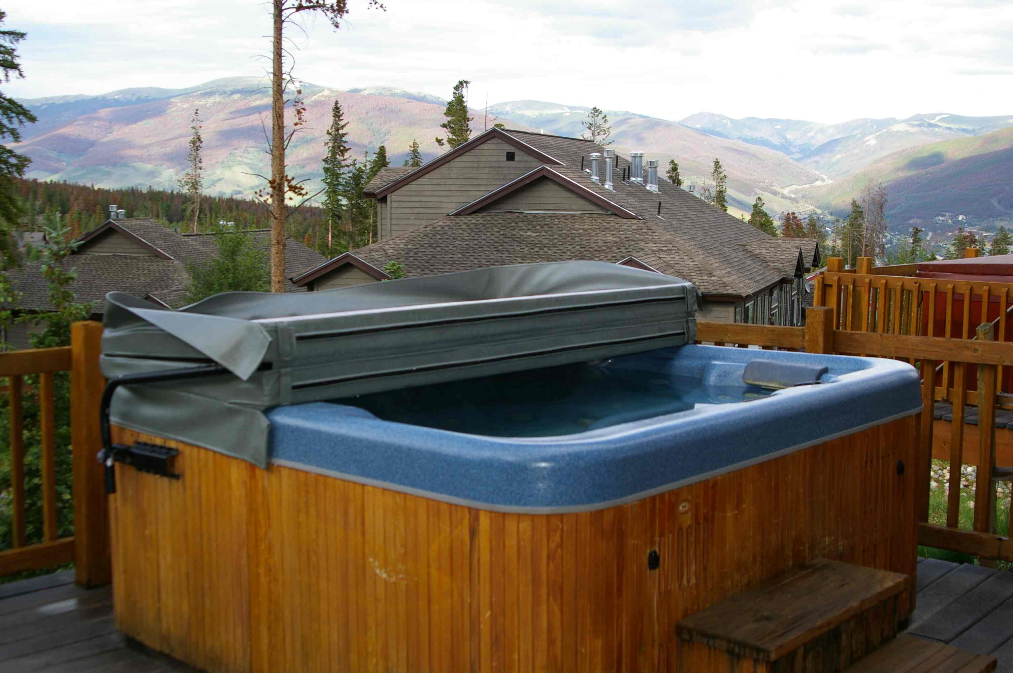

To open cover completely:
Open latches (2) on front and (2) latches on back. Lift cover up and fold over halfway onto itself.
Then use lifting bar on both sides to lift cover up and over to be stored behind tub resting on platform.

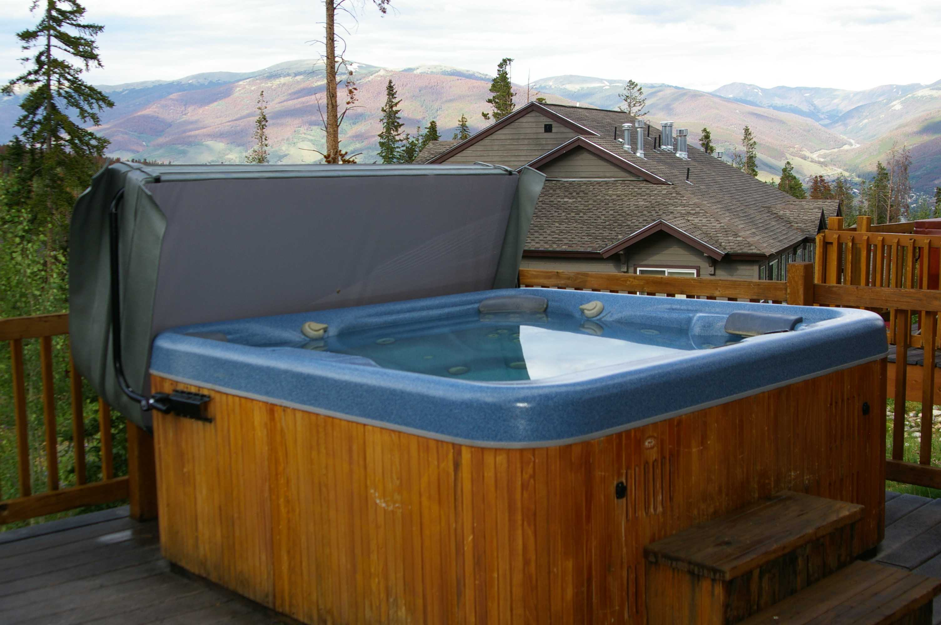

Snow must be cleared from the lid before opening, and from behind the tub to allow cover to rest freely on platform.
Only use a brush, NOT A SHOVEL. That is the #1 reason for loss of deposit (hot tub cover damage).

Temperature setting can be adjusted with up and down arrows 100-104 is comfortably warm.

Jets can be on or off by pressing those buttons (lo-hi-off)

Light can be on or off by pressing that button, Please turn light off after use.

Control panel can be LOCKED AND UNLOCKED by pressing the light and the temperature up or down buttons at the same time.
DIRECTIONS

- Interstate 70 West.
- About 75 miles west from Denver.
- After passing through Eisenhower Tunnel (~mile marker 215).
- Take 1st exit #205 - Silverthorne/Dillon.
- Make right off exit ramp.
- 1st left turn at light/7-Eleven (Wilderness Road (to left only).
- Wilderness Rd. becomes Ryan Gulch ROAD around big right curve after conoco gas station. STAY on road
- Take Wilderness/Ryan Gulch ROAD 2.9 miles up winding mountain road. Drive Carefully!
- Fire Station on right is about 1/2 mile before unit.
- Unit is on right side of road after Spy Glass Development, opposite Watch Hill Development. You will pass a red fire hydrant on the right side of the road.
- It is the middle of a three unit building.
- Park on asphalt and use driveway/garage in front of middle unit

