The Many Faces Of *star*














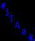
Visit

http://www.sissyfight.com

