How to receive a daily digest:

Type in the address www.yahoogroups.com
Select 5 Points South group.
Choose Members from the menu on the left
Click on Edit My Membership hyperlink.

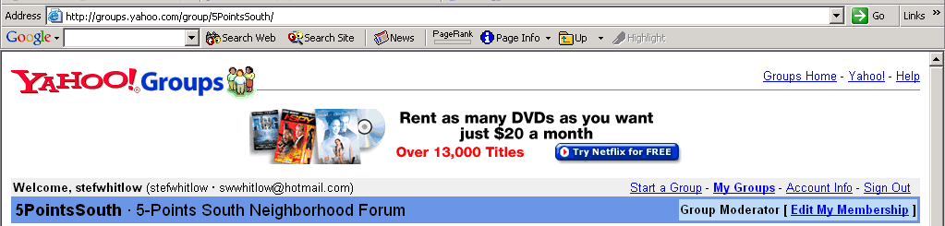

The Edit My Membership screen opens.

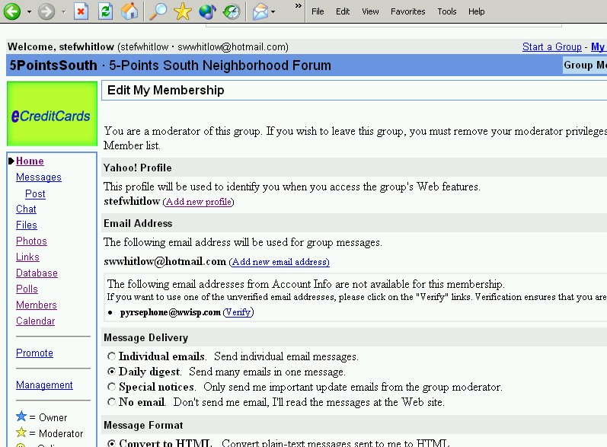

Scroll down to the Message Delivery (third blue shaded area)
Select:
- Individual emails
- Daily Digest
- Special Notices
- No Emails

Click the Save Changes button at the bottom of the screen.
A new screen opens; this screen will have the message “Your Membership has been updated.”
Click the Go to 5PointsSouth Home hyperlink to navigate to the Home page.

