How to make a profile
Type in the address www.yahoogroups.com
Select 5 Points South group.
Choose Members from the menu on the left
Click on Edit My Membership hyperlink.

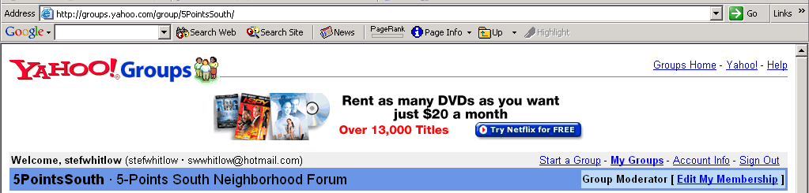

The Edit My Membership screen opens.
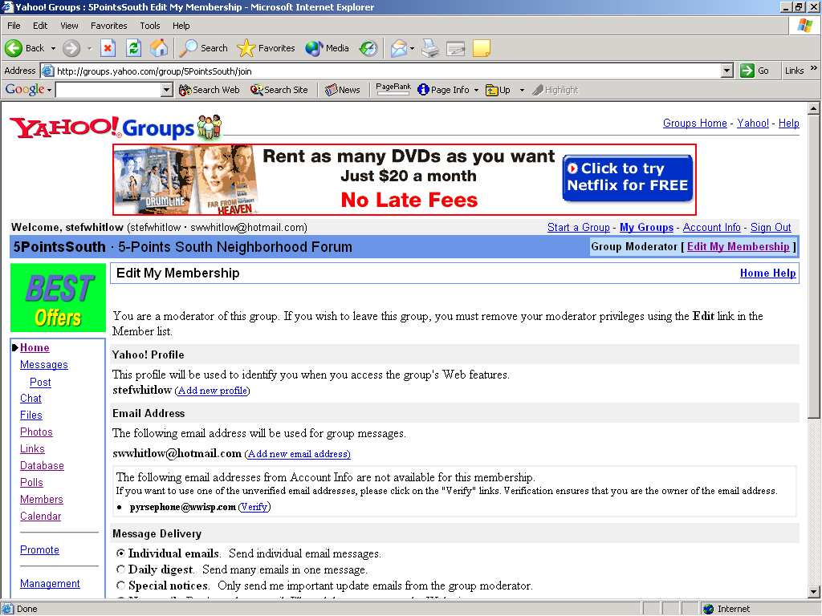

Choose your name. Double-click on your email address.

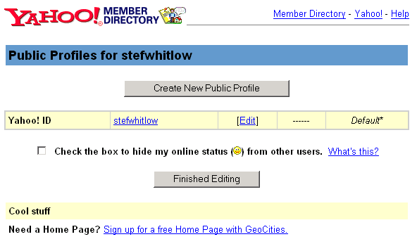
Click the [Edit] hyperlink. This action opens the Edit Profiles screen.
Change or add any information.
Note: Be sure to read and acknowledge what information, if any, you want made public. If no boxes are checked all of your information will be made public.

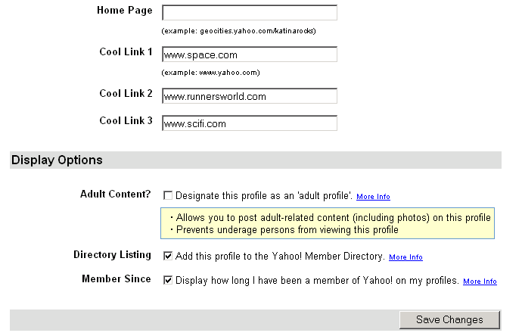

Once all changes are made, click the Save Changes button.
This action returns you to the Public Profiles page.
Click Finished Editing button. The Edit My Membership page again displays.
Select the Home hyperlink to the left of the screen to navigate to the main page.

