How to add a picture to your profile:

Type in the address www.yahoogroups.com
Select 5 Points South group.
Choose Members from the menu on the left
Click on Edit My Membership hyperlink.

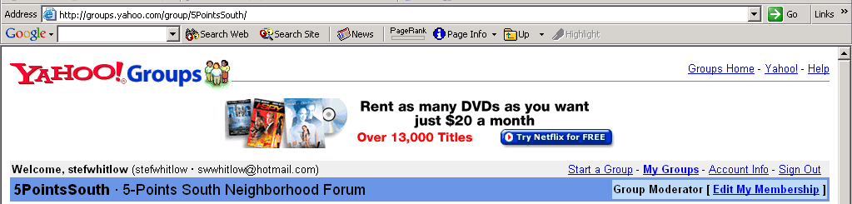

The Edit My Membership screen opens.
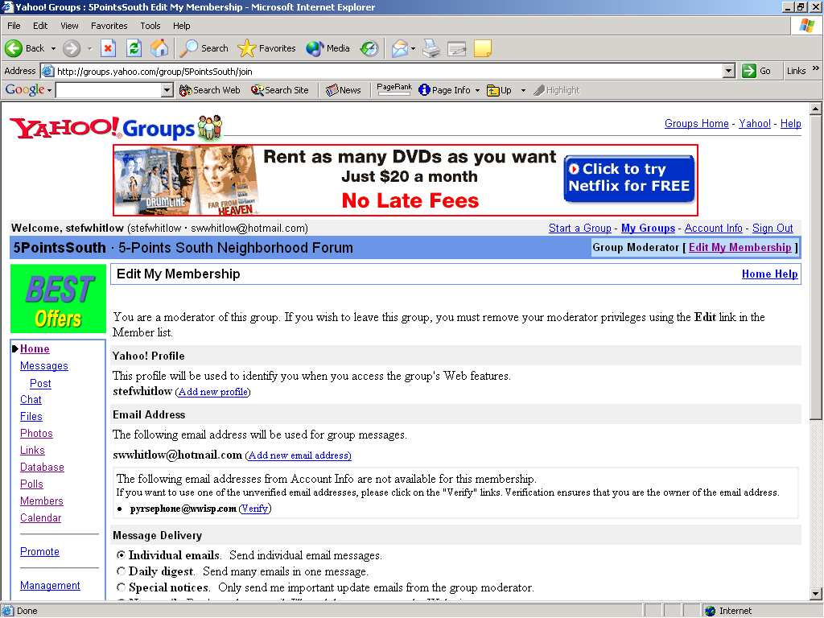

Choose your name. Double-click on your email address.

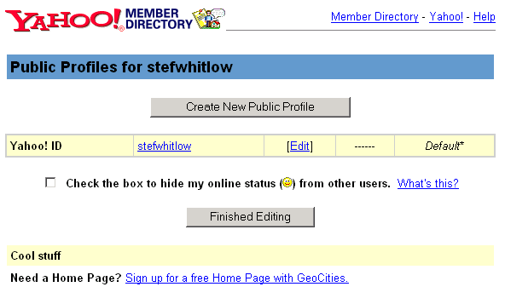
Click the [Edit] hyperlink. This action opens the Edit Profiles screen.
Select the Edit Picture hyperlink on the left inside the yellow bar.
The Verify password screen displays. Enter your password.
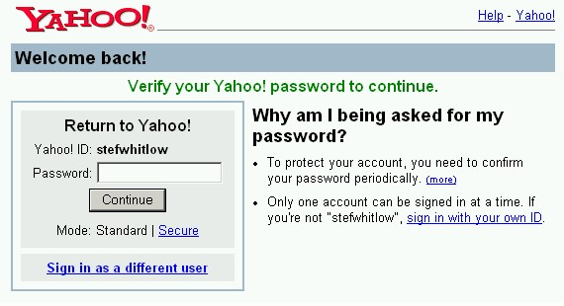

When the Picture Profile screen opens, click the hyperlink to:
- The Web
- Our Gallery
- Yahoo! Photo albums
- Delete Current Picture

Or select the Browse button to find the file on your personal computer.
Click Upload to add the photo to your profile or click Cancel to return to the previous screen.

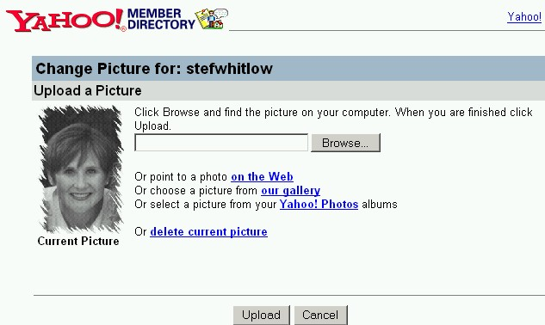

When the upload is complete, the Edit Profile page will display.
Click the X in the upper right corner to leave the Yahoo! site.

