Atomic Models

I) A little bit of history…
Democritus (400 BC)
-

- thought that matter was made of particles called ________, but we couldn’t prove this until 2000 years later!

Antoine Lavoisier (1743-1794)
- French chemist
- developed..
- his law stated that matter cannot be ___________________________ in a chemical reaction, only changes form
- therefore, matter is….

Joseph Louis Proust (1754-1826)
-
- developed law of…
- matter reacts in a _________________________________ way

For example:

John Dalton (1766-1844)
-

- studied the ratios of elements in chemical reactions and came up with a theory about atoms
Dalton’s Atomic Theory (text p. 63)
- All matter consists of atoms which are tiny, _________________ particles of an element

and cannot be ______________________________

- Atoms from one element are _______________ in ________ and other properties. The atoms of an element are different in mass and properties from those of any other element.

- Atoms of on element cannot be ________________ into atoms of another element.

- _________________ are the chemical combination of two or more elements in a specific ratio. For example:

Was Dalton completely correct? Think about statement number 1…We will come back to this later.
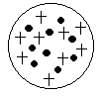

J.J. Thomson (1856-1940)
-
- discovered the ___________
- proposed the ________________ atomic model

Ernest Rutherford (1871-1937)
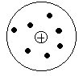
-
- his experiment proved that the atom is mostly ______________
and that the atom’s mass is concentrated in a small, central, __________ charged region called the _________

Niels Bohr (1885-1962)
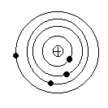
-

- proposed that electrons orbit the nucleus in ______________ and that the farther the orbit is from the nucleus, the higher its _____________.

Edwin Schrödinger (1887-1961)
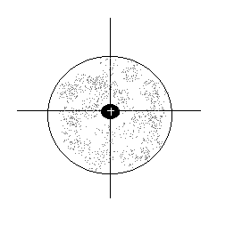
-

- used a ____________ equation to describe the location and energy of an electron:
→ electrons have _____________, but not specific orbits or paths
→ he used ____________ to describe the location of an electron…this
led to the Quantum Mechanical Model (III)

II) Subatomic particles (why Dalton didn’t have it totally correct with his atomic theory)

An atom is the smallest whole unit of an element. We are now capable of seeing atoms with a scanning tunneling ___________. We have since learned, however, that the atom itself is made up of even smaller particles called ______________________.

We have already mentioned the following terms: atom, nucleus, electron, positive charge, orbit. Now, let’s put them all together.

1. Identify the following subatomic particles on the diagram:
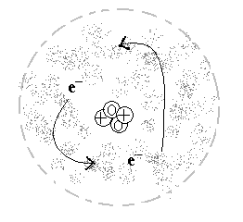
-nucleus
-neutron
-proton
-electron

2. Go back to Dalton’s Theory. On a separate piece of paper, write a paragraph that gives evidence from what you have learned so far to prove all or part of Dalton’s Theory wrong.

