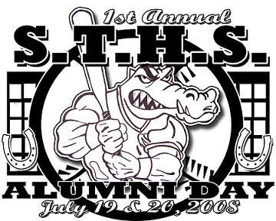
1stAnnual S.T.H.S. Gator Alumni Softball Tournament
&
** Family Fun Weekend **

July 18, 19 & 20 - 2008
Announce Bracket & Home Run Derby on The 18th

Adult Softball Complex / East Side – Hwy 24
All Alumni From 1962 to 2008
Are Encouraged to come out and Participate…
We will Have Volleyball & Horse-Shoe Games as well…
“HOME-RUN DERBY”

For More Information Call:
Kyle Lyons ’96 (232-1752)
Brandon Savoie ’96 (232-6247)
Mitsy Ledet ’84 (709-6447)
Dusty Dupre ’99 (856-3780)
Tony Authement ’82 (853-0210)
Jay Duplantis ’78 (991-3309)

