Documentation and report.

E1)

The Menu should contain buttons that link to each of the 3 games individually, as well as a button to quit the program and password protection for the Program.
Game 1 should have a text box to enter a number for player 1 and another to enter a number for player 2. It should also have a button to quit the game and return to the menu.
Game 2 should have one text box to input a number that will be calculated into its times tables in a label below it.
Game 3 should have a text box to enter the names

A clear and accurate specification that’s meets and defines the input of the processing and output requirements.

Input | Processing | Output
Number between 1 and 10 | Program stores number | Command button and text box hidden
Number between 1 and 10 (Users guess) | Program compares number with the first number | “Correct” is matches  “too low” if needs to be higher  “too high” if needs to be lower

E2

E3

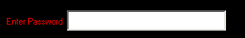
Above is an example of how I have used text boxes in my menu.

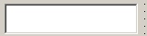
Here is another text box, this time in Game 3.

E4
E5
E6
E7
Menu code
Private Sub Command1_Click()
Game1.Visible = True
Menu.Visible = False
End Sub

Private Sub Command2_Click()
Game2.Visible = True
Menu.Visible = False
End Sub

Private Sub Command3_Click()
Game3.Visible = True
Menu.Visible = False
End Sub

Private Sub Command4_Click()
Unload Me
End Sub

Private Sub Text1_Change()
If Text1.Text = "monkey" Then
Command1.Visible = True
Command2.Visible = True
Command3.Visible = True
Label1.Visible = False
Text1.Visible = False
End If
End Sub

Game 1 code
Private Sub Command1_Click()
If Text1.Text >= 1 And Text1.Text <= 20 Then
Label1.Visible = False
Text1.Visible = False
Command1.Visible = False
Label2.Visible = True
Text2.Visible = True
Command2.Visible = True
Else
MsgBox "Please enter a number between 1 and 20"
End If
End Sub

Private Sub Command2_Click()
If Text2.Text < Text1.Text Then
MsgBox "Too Low"
If Shape2.Visible = True Then
Shape3.Visible = True
End If
If Shape1.Visible = True Then
Shape2.Visible = True
End If
If Shape3.Visible = True Then
MsgBox "You Lose!"
End If
If Shape1.Visible = False Then
Shape1.Visible = True
End If

If Text2.Text > Text1.Text Then
MsgBox "Too High"
End If
If Text1 = Text2 Then
MsgBox "You Win!"
End If
If Shape2.Visible = True Then
Shape3.Visible = True
End If
If Shape1.Visible = True Then
Shape2.Visible = True
End If
If Shape3.Visible = True Then
MsgBox "You Lose!"
End If
Shape1.Visible = True
End If
End Sub

Private Sub Command3_Click()
Game1.Visible = False
Menu.Visible = True
Unload Me
End Sub

Game 2 code
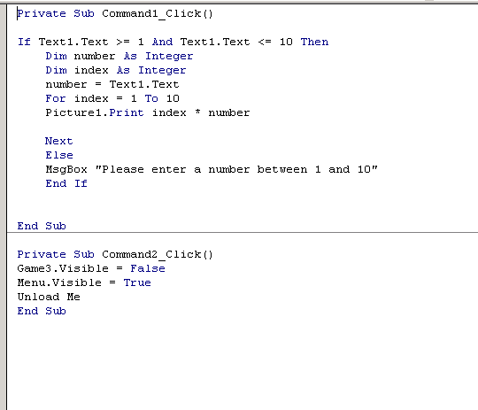

Game 3 code

Private Sub Command1_Click()
Dim counter As Integer
For counter = 1 To 12
If UCase(Text1.Text) = weeks(counter, 1) Then
Label1.Caption = weeks(counter, 1)
Label2.Caption = weeks(counter, 2)
Label3.Caption = weeks(counter, 3)
Exit For
End If
Next counter

End Sub

Private Sub Command2_Click()
Menu.Visible = True
Game2.Visible = False
Unload Me
End Sub

Private Sub Form_Load()
weeks(1, 1) = "JAN"
weeks(1, 2) = "43.2"
weeks(1, 3) = "4.1"

weeks(2, 1) = "FEB"
weeks(2, 2) = "45.2"
weeks(2, 3) = "4.2"

weeks(3, 1) = "MAR"
weeks(3, 2) = "50.6"
weeks(3, 3) = "4.5"

weeks(4, 1) = "APR"
weeks(4, 2) = "56.4"
weeks(4, 3) = "3.8"

weeks(5, 1) = "MAY"
weeks(5, 2) = "62.6"
weeks(5, 3) = "2.9"

weeks(6, 1) = "JUN"
weeks(6, 2) = "69.7"
weeks(6, 3) = "2.3"

weeks(7, 1) = "JUL"
weeks(7, 2) = "71.8"
weeks(7, 3) = "2.1"

weeks(8, 1) = "AUG"
weeks(8, 2) = "70.1"
weeks(8, 3) = "2.5"

weeks(9, 1) = "SEP"
weeks(9, 2) = "65.0"
weeks(9, 3) = "2.9"

weeks(10, 1) = "OCT"
weeks(10, 2) = "58.4"
weeks(10, 3) = "3.6"

weeks(11, 1) = "NOV"
weeks(11, 2) = "50.2"
weeks(11, 3) = "3.8"

weeks(12, 1) = "DEC"
weeks(12, 2) = "45.3"
weeks(12, 3) = "4.2"
End Sub

