Andrew Meagher
Mrs. Cebula
Environmental Science
February 22, 2008
Carbon Footprint
Everyday I do things that affect the earth in a little way. But we all do little things that are not good for the earth. Out of the all the things I do all day, I can think of 5 that are the worst.
One thing I do the worst out of all my habits is drinking bottled water. I live off drinking it. I can go through a whole case in a matter of days. This leaves my recyclable bin filled with dozens of bottles and my trash cans littered with caps. Just making the bottles alone uses a lot of non-renewable sources. Also the emissions from making the bottles leave pollution that harms our air and water. Making bottles also uses oil, which we already know the US is lacking in. Plastic bottles also do not disintegrate, which allows them to pile up and make for more garbage lying around (Fisk). Even though I am aware of the problems and waste that using plastic bottles make I still continue to use them.
My second biggest vice of all is smoking. Aside from the health factors, I never stopped to think about where my cigarette butts are going. I flick them into my yard and forget about them. But I know they do not disintegrate. Through studies done in New York by the CDC, they found that the chemicals in the cigarettes alone are bad enough for the environment. Also, the filter, which is made of acetate, is non-biodegradable, while the paper and tobacco are (Reuters). They also found that many of the butts end up in sewers and drains and go into our waterways and oceans ("Cigarettes: Toxic Trash”). It has also been reported that kids and animals are known to have eaten cigarette butts. Just thinking about this makes me disgusted.
Everyday I come home to a kitchen that is filled with plastic bags. We come home from the grocery store and are left with tons of them. We rarely reuse them and they just sit around and are later thrown away, not recycled. First, plastic bags take over 300 years to disintegrate. Even when they do, the particles they break down into are bad for the water and for the ground. The bags also make their way onto our coastlines where they are a hazard for our ocean life (Jacobsen).
When I wake up in the morning and am ready to go to school, I always brush my teeth. When I brush my teeth, I tend to leave the faucet on as well. I never thought about how much water really comes out of the faucet. From the public water system alone, we use 43 billion gallons of water a day. For each house, that is 4 billion gallons a day. That is a staggering amount of water used. Using more water can also affect our water. Water can be drawn across the ground picking up pollutants along the way. It also affects our natural aquifers (“Water Sense”).
One last thing that I do is that I leave lights on whenever I leave a room or hallway. I have been doing this since I was a little kid and I could never kick the habit. I know I’m wasting electricity but I continue to do it. Lighting itself is 25% of our home’s electricity use. 90% of the energy used for lights produces heat, not light ("Saving Electricity at Home"). I would also be saving emissions from the power plant and lowering the price we have to pay for all the light bulbs that I go through.

Proof
Plastic Bottles
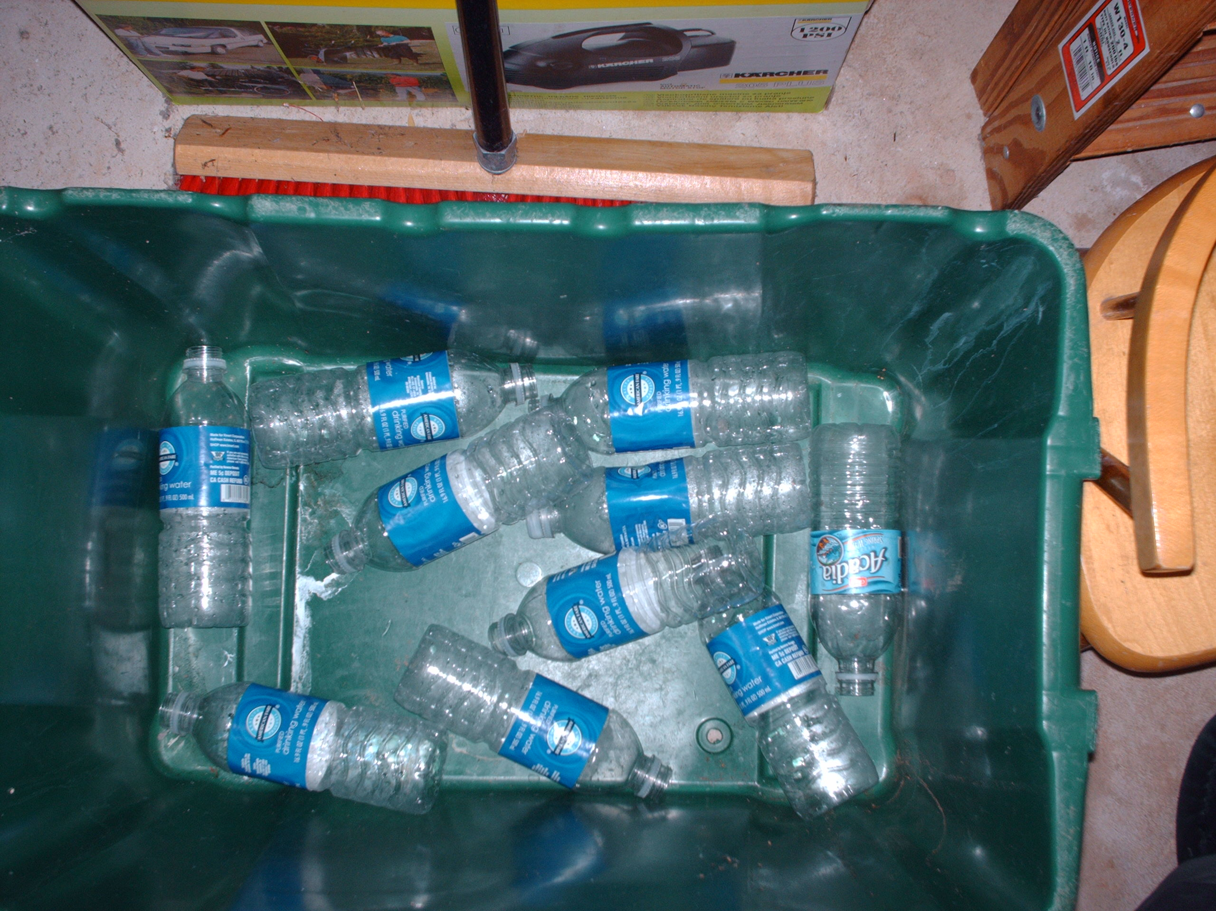
This is a picture of my recycling bin. This is probably about a quarter of the amount of bottles that we have after a week.
Cigarette Butts
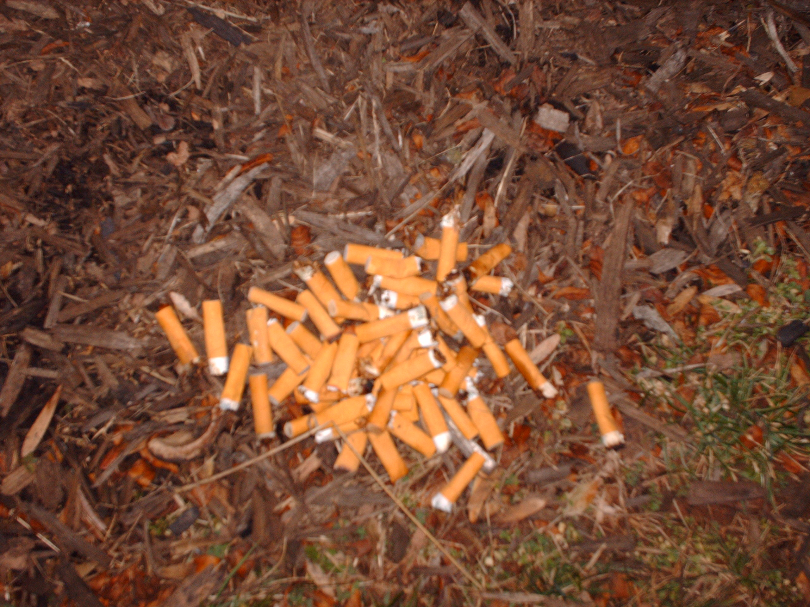
These are only the butts I found only a couple of feet away from my porch. I was astonished by how many I found in that little distance.

Plastic Bags
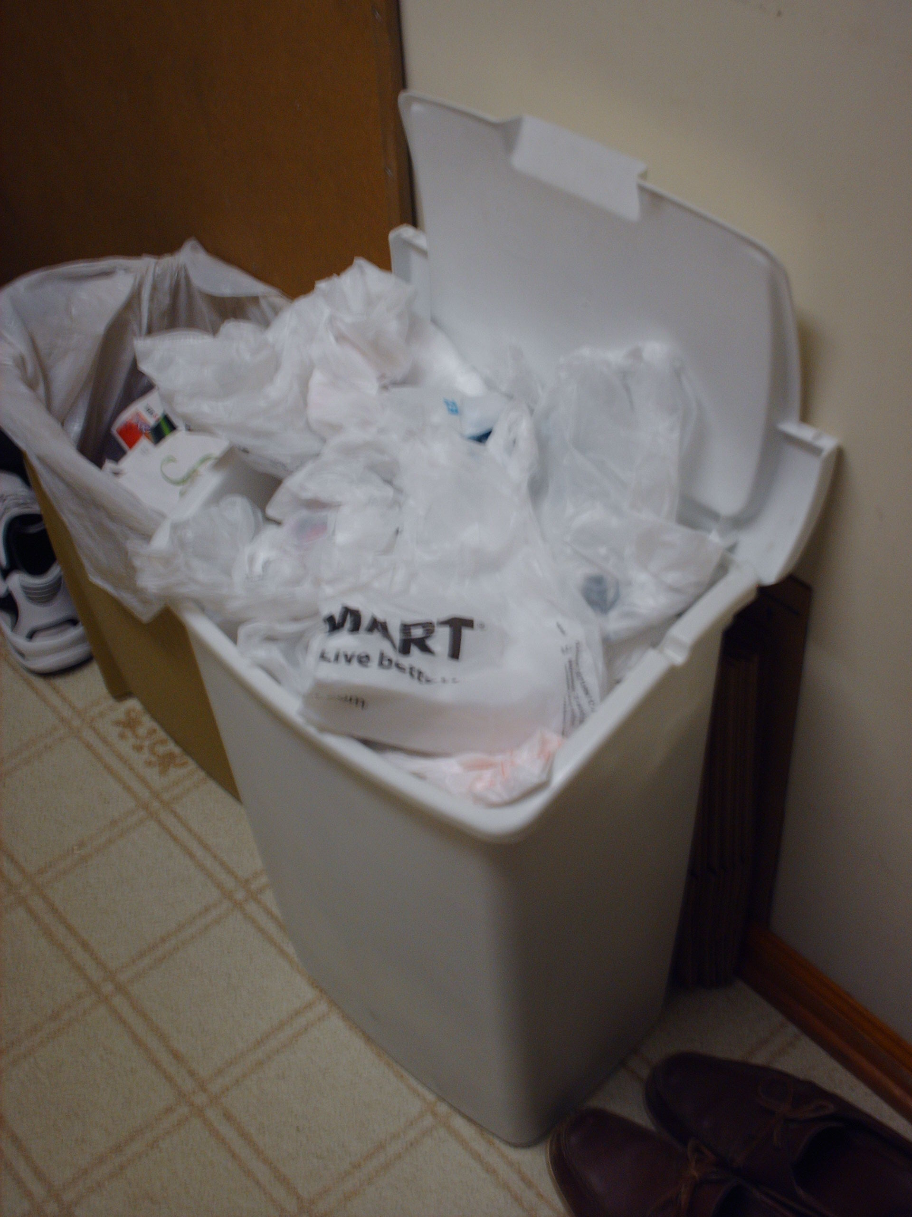

This trash can I filled top to bottom with plastic bags filled with plastic bags filled with plastic bags. I couldn’t even dig down farther than a couple inches.

Lights
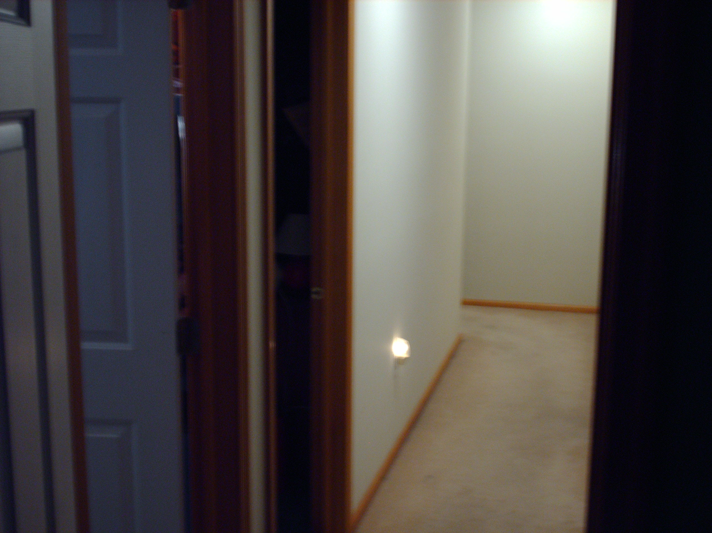

You can’t tell, by the room on the left has its lights on, the hallway lights are on, and the night light are on. The room on the left is my room, and I leave that light on all the time, except when I leave the house.
Water
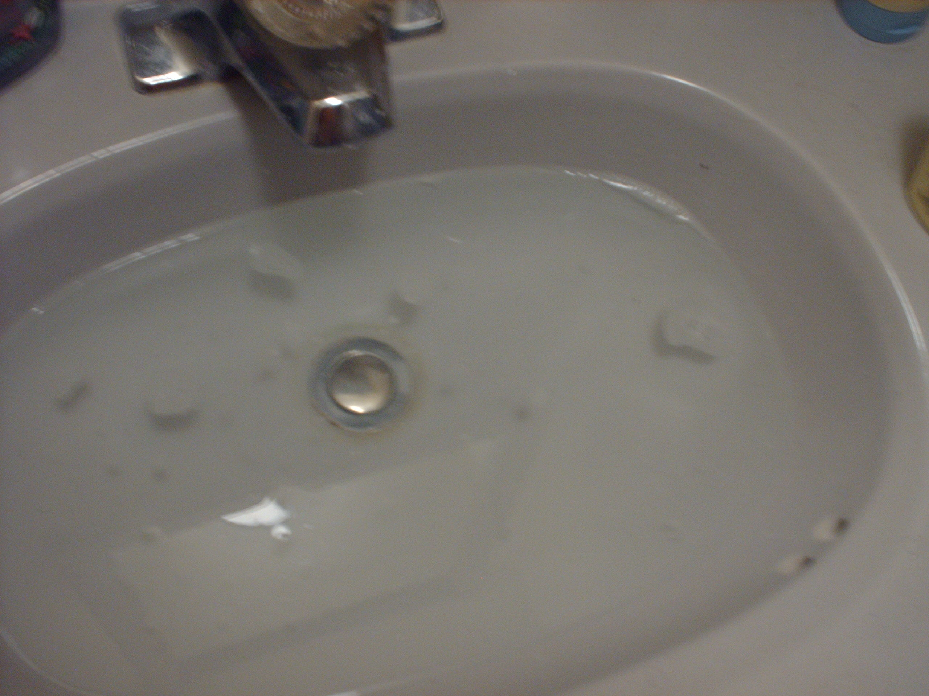
This is the amount of water I use when brushing my teeth. To the deepest point the sink is 3 and a half inches deep. The picture doesn’t do the amount of water in that sink any justice.

There are 3 things that I can say I’m going to change right after I save this paper. First, I’m going to stop putting my cigarette butts in the yard. I was absolutely astonished by how many I found. I am going to start to put them in a tin can right next to my porch so no one can see them, but I know that they aren’t going all over my yard. I am going to start drinking water from the tap a lot more. Having a bottle is a lot more convenient, but using a glass is a lot more eco-friendly. Lastly, whenever I leave a room I’m going to turn the light off. I hate having to change my light bulb every other week because it’s on all the time.
So in conclusion, just by doing this project, I was amazed at how much of an effect I have on the earth. By turning off the lights and using glasses more, I think I will really change my effect on the environment.

Sources
Fisk, Umbra. "Bottle Racket." Grist 02 Aug 2004 14 Feb 20 <http://www.grist.org/advice/ask/2004/08/02/umbra-bottles/>.

"Cigarettes: Toxic Trash." Californias Against Waste 14 Feb 2008 <http://www.cawrecycles.org/issues/cigarettes/toxic_trash>.

Reuters, "Cigarette butts cause environmental pollution." Yahoo News 14 Feb 2008 <http://web.vtc.edu/mt/102/Projects/ElectronicNotebooks/SectionA/JoshCross/cig4_1.html>.

Jacobsen, Sharon. "Plastic Bag Pollution ." 25 July 2005 14 Feb 2008 <http://www.googobits.com/articles/p0-1604-plastic-bag-pollution.html >.

"Water Sense." Environmental Protection Agency 4 Feb 2008
<http://www.epa.gov/owm/water-efficiency/index.htm>.

"Saving Electricity at Home." Green Sangha 14 Feb 2008 <http://www.greensangha.org/action5.html>.

