MICROPROCESSOR

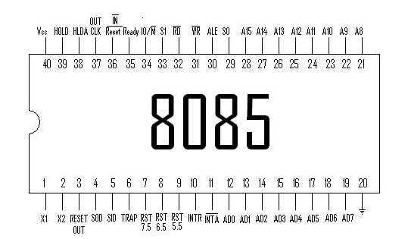

We attach a 4Mhz to 6Mhz crystal oscillator to X1 & X2, the internal circuitry of the 8085 IC is such that it divides the frequency in two equal parts and provides a frequency of 2Mhz to 3Mhz to each of X1 & X2.

AD0 – AD7 = Multiplexing Address and Data BUS

A8 – A1 = Address BUS

ALE = Address Latch Enable.
If ALE = 1 then AD0 – AD7 acts as address BUS
If ALE = 0 then AD0 – AD7 acts as data BUS

RD bar , WR bar = active when value 0, and inactive when value 1, but simultaneously both 0 or 1 is impossible as RD is for Read and WR is for Write.
IO/M = If value 1 then IO Function is active & if value is 0 then Memory Function active

SOD = Serial Output
SID = Serial Input

= Power Fail
TRAP
RST 7.5
RST 6.5
RST 5.5
INTR
INTA

Vector Interrupts

CLK OUT = provides clock pulse for other chips in the system

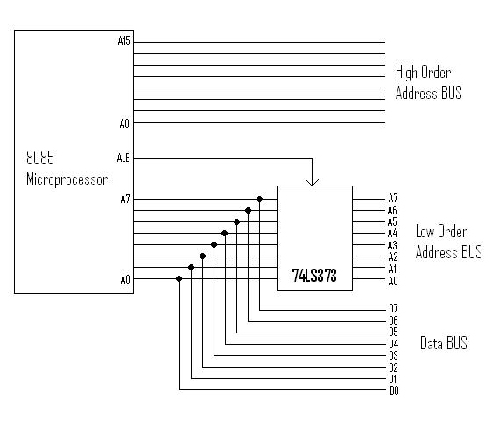
Schematic of Latching Low Order Address BUS

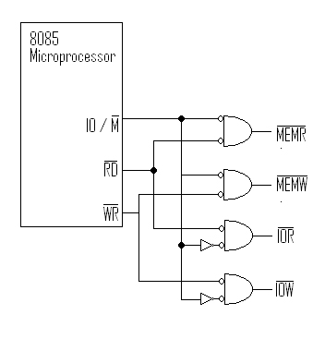

Schematic to generate Read / Write Control Signals for Memory and I/O

