University of Calcutta
Model Questions Computer Science (Hons) Part 1

Operating System

- Define Operating system

AN OS is a system software that acts as an interface between a user and the computer hardware & as well as a resource manager for the entire system. The purpose of an OS is to provide an environment in which user can develop, edit, compile & execute programs. The objectives of an OS are to make the computer system convenient to use and to use the computer hardware in an efficient manner.

OS is a resource manager, it manages resources like – memory, CPU, I/O devices, etc. It is a collection of programs that provides the following services –

  - Program Execution (Load & run, normal/ abnormal termination)
  - I/O Operation (File & Device)
  - File Management system
  - Error Detection reporting
  - Resource Allocation
  - Accounting
  - Command Language Support

- Explain
  - Batch Processing – In order to reduce the setup time between jobs, a continuous series of jobs to be loaded automatically from an input device, this is a batch. In batch processing jobs were submitted in batches to the computer.

  - Multiprogramming – In a multiprogramming system several programs are run on a uniprocessor system. In a Multiprogrammed OS all jobs that enter the system are kept in a common job pool. This pool consists of all processes residing on mass storage awaiting allocation of main memory. IF several jobs are ready to be brought into the memory and there is not enough room for all of them, then the system must choose among them. There can be no true simultaneous execution of different programs. Instead, the operating system executes part of one program, then part of another, and so on. To the user it appears that all programs are executing at the same time.

  - Multiprocessing – Multiprocessing is the coordinated processing of program / s by more than one processor.

  - Time Sharing – Through a timesharing system we can efficiently, cost effectively share a single computer among many users. The OS provides a small share of the CPU time to each time-shared user. Since each command or action in a time-sharing system tends to be short, only a little CPU time is needed for each user. As the system rapidly switches from one time-shared user to another the users get the impression that the he has his own computer whereas actually one computer is being shared by all of them.

  - Spooling – In Spooling (Simultaneous Peripheral Operations On Line), a high-speed device like a disk is interposed between a running program and a low speed device involved with the input/ output of the program. This technique is known as spooling. Through this process we can create synchronization between the high speed and low speed device.

For Example – When a job requests the printer to print, the line is copied into a system buffer and is written to the disk. When the job is complete, the output is actually printed. In the meanwhile other processes utilize the CPU for the time taken by the printer to print.

- How can users be authenticated in a multi user system? (NOT SURE)

A Multi user system is a computer system, which is shared by several users. Usually permissions are required to access a multi user system. This is achieved by assigning username and password to each user. The permissions of the user are associated with the username and thus users are authenticated in a multi user system.

- What is a process? Draw the process state diagram and mention the events that lead to transition from one state to another. What is a Process Control Block (PCB)?

A process is an active program, which executes in a sequential fashion.
It includes –

- Current activity as PC & general purpose registers.
- Process Stack (contains temporary data, return address)

As a process executes, it changes state.
- New: The process is being created.
- Running: Instructions are being executed.
- Waiting: The process is waiting for some event to occur (such as an I/O completion or reception of a signal).
- Ready: The process is waiting to be assigned to a processor.
- Terminated: The process has finished execution.

Each process is represented in the OS by its own Process Control Block (PCB).

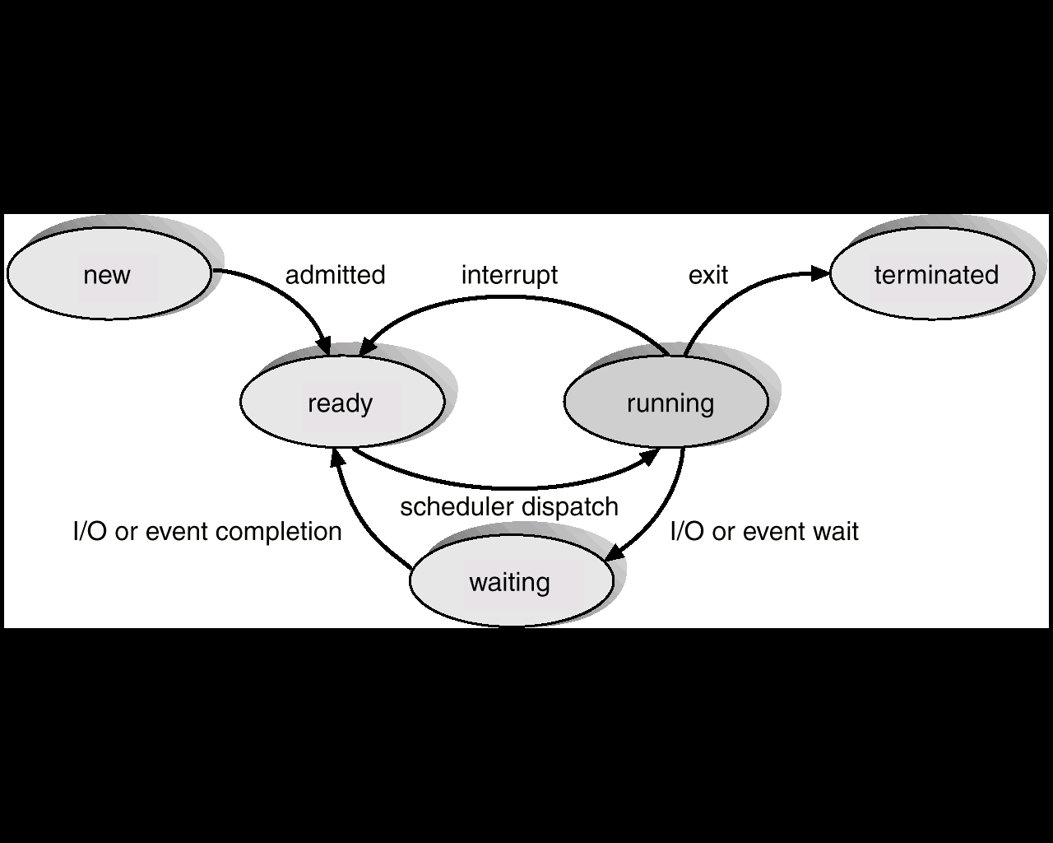

Each process is represented in the OS by its own Process Control Block (Task Control Block). It includes the following attributes (Process Attributes) –

- Process State: New/Ready/Running/Waiting/Terminated.
- Program Counter: Holds address of next executable instruction.
- CPU Registers: They are ACC, SP, PC, IR, GPR, which holds data & intermediate state information.
- CPU Scheduling information: Includes process priority scheduling information.
- Memory management information: Holds information on base registers, page tables, segment tables etc.
- Accounting information: Holds information on CPU time, process numbers etc.
- I/O status information: Holds information on available I/O devices.

- Explain difference between virtual and physical address?

An address generated by the CPU is commonly referred to as a logical address, where as an address seen by the memory unit (MAR) is commonly referred to as a physical address. We usually refer the logical address as a virtual address. The set of all logical addresses generated by a program is referred to as a logical address space. The set of all physical address corresponding to their logical address is referred to as a physical address space.
An address used by the programmer is called Virtual Address and a set of virtual address is called Address Space. An address in main memory is called Physical Address and a set of physical address is called Memory Space.

- Mention necessary condition for Deadlock. How can circular waiting be prevented, by using claim usage count approach?

A process is said to be deadlocked when it is waiting for an event, which will never occur. Associated with the problem of resource allocation and resource scheduling, there is the probability of two (or more) processes waiting on each other (or in a circular chain) for requested sources that will never be released. Such a situation is called Deadlock.

e.g. City traffic jam, Airline booking system.

Necessary Conditions :

- Mutual Exclusion: Only one process can use a resource at a time.
- Resource Holding: Processes hold some resources while requesting, more which are, hold by another process.
- No Preemption: Resources cannot be forcible removed from a process.
- Circular wait: A closed circle of processes exists, where each process requires a resource held by the next.

Resource-Request Algorithm : (Claim Usage Count Approach)

- If Request[i] ≤ Need[i], go to step 2. Otherwise raise an error condition, since the process has exceeded its maximum claim.
- If Request[i] ≤ Available, go to step 3. Otherwise P[i] must wait, since the resources are not available.
- Have the system pretend to have allocated the request resources to process P[i], by modifying the state as follows
Available := Available – Request[i]
Allocation[i] := Allocation[i] + Request[i]
Need[i] := Need[i] – Request[i]
- If the resultant resource allocation state is safe then make the allocation, otherwise restore the system and request the process to wait.

- Distinguish between preemptive and non-preemptive processes. Can a processor handle and interrupt while a non-preemptive process is running? Give an example of a process that would probably be preemptive? What kind of processes would be non preemptive?

Nonpreemptive CPU scheduling :

When CPU scheduling occurs -

- for I/O request
- when an interrupt occurs
- for completion of I/O
- when a process terminates

then this scheduling scheme is called Non preemptive.

Under non preemptive scheduling, once the CPU has been allocated to a process, the process keeps the CPU until it releases the CPU either by terminating or by switching to the waiting state. E.g., MS WINDOWS environment.

Preemptive CPU scheduling :

The strategy of allowing processes that are logically run able to be temporarily suspended is called preemptive scheduling. Once a process has been given the CPU then CPU can be taken away from that process. Preemption has an effect on the design of the operating system kernel. This process is useful in systems in which high-priority processes require rapid attention.

Example:

- non preemptive
- preemptive

- What is semaphore and why is it used? Distinguish between a general semaphore and a binary semaphore. How do you implement a general semaphore as binary semaphore? How can it solve the producer consumer problem?

A semaphore is a simple integer variable which can accessed only through two standard atomic operations – wait & signal. Entry to critical regions of active processes is controlled by the wait operation and exit from a critical region is signaled by the signal operation.

A synchronization variable that takes on positive integer values, invented by Dijkstra.

- What is mutual exclusion? Explain with an algorithm, a simple technique for mutual exclusion.

Mutual Excution: Only one process can use a resource at a time.

The Banker’s algorithm is used for deadlock avoidance.

- Work := Available
If Allocation[i]≠0 then Finish[i] := false ∀ i=1,2,…,n else Finish[i] := true
- Find an index i such that both Finish[i] = false & Request[i] ≤ Work
If no such i exists, go to step 4.
- Work := Work + Allocation[i], Finish[i] := true
Go to Step 2.
- If Finish[i] = false for some i, 1 ≤ i ≤ n, then the system is in a deadlock state.

- Explain internal & External fragmentation. Which one occurs in paging and why? Which one is pure segmentation and why?

Internal fragmentation :

Let us consider the hole is of 18464 bytes. If we allocate exactly the requested block, we are left with a hole of 2 bytes. The overhead to keep track of this hole will be substantially larger than the hole itself. The general approach is to allocate very small as part of the larger request. Thus, the allocated memory may be slightly larger than the requested memory. So, here memory is internal to a partition, but is not being used.

- Fixed Partitions suffer from inefficient memory use - any process, no matter how small, occupies an entire partition.
- This waste is called Internal Fragmentation.
- Unequal size partitions are better in terms of internal fragmentation.

External fragmentation :

As processes are loaded and removed from memory, the free memory space is broken into little pieces. External fragmentation exists when enough total memory space exists to satisfy a request, but it is not contiguous, storage is fragmented into a large number of small holes. This problem can be solved b compaction. The objective is to shuffle the memory contents to place all free memory together in one large block.
- Eventually, main memory forms holes too small to hold any process. This is external fragmentation.
- Total memory space may exist to satisfy a request but it is not contiguous.
- Compaction reduces external fragmentation by shuffling memory contents to place all free memory together in one large block.

External fragmentation is pure segmentation.

- Contiguous allocation of files lead to disk fragmentation, is it internal or external? Justify.

It is external fragmentation. Since contiguous memory allocation generally leads to a point where there is enough space available but they are not contiguous.

- Why are output files of printers usually spooled on disk before printing?

The printer is a much slower device than the CPU. So the rate at which CPU generates instructions the printer cannot complete those instructions at the same rate. So the CPU remains engaged for the entire time of the printing without maximum utilization. For this the instructions are loaded on to a disk by the CPU & the CPU continues its other work, no longer bothered about the printing. In the mean while the printer prints at its normal speed slowly receiving instructions from the disk. So output files of printers are usually spooled on disk before printing.

- An OS A, can run one process at a time. Another one B can run many processes at a time. Discuss the organizational differences between the systems A & B with regard to support of processes.

- OS A is uniprocessing but the OS B is multiprocessing.

- Context switching will not take pace in the OS A. since it can run only one process at a time. But it will take place in OS B.

- Explain the basic concept of client server model. Can it be used with a single computer system?

In this system the machine containing the file is the server and the machine seeking information is the client. Usually this model is used in network Operating System. First the server declares the available resources to the client, then the client requests those resources and accesses them. A client can access several servers or several clients can be served by a single server according to the implementation details of the client server model.

A client server model can never be implemented on a single machine. This is because the client and the server must be two separate machines, which can never be possible.

- What is indefinite postponement? How does it differ from deadlock? Give example.

Indefinite postponement is a phenomenon in multiprogramming environment. In this situation a low priority process is never given the CPU because high priority processes arrive one after another. So the CPU is given to the newly arrived high priority process but the old low priority process never gets the CPU. This is called indefinite postponement in case of old process.

A process is said to be deadlocked when it is waiting for an event, which will never occur. Associated with the problem of resource allocation and resource scheduling, there is the probability of two (or more) processes waiting on each other (or in a circular chain) for requested sources that will never be released. Such a situation is called Deadlock.

In case of indefinite postponement there is a remote chance that the process may be executed. But in case of Deadlock the process will never be executed.

- State the advantages of Peterson’s method over Dekker’s method for achieving mutual exclusion. State and explain Peterson’s algorithm.

Peterson method is applicable for 2 processes only, whereas the Dekker’s method is applicable for multiple processes.

- What are the different types of interrupt available? Mention each of them in brief.

Interrupts are of two types:-

- Maskable
- Non Maskable

- Maskable – In this kind when the interrupt arrives the process is not interrupted, the process in allowed to be executed & to terminate. Then the interrupt is handled by the CPU.

- Non Maskable - In this kind when the interrupt arrives the process is interrupted, the process is kept waiting and the interrupt is served by the CPU then the process is allowed to be executed & to terminate.

- Distinguish between paging and demand paging. Explain the address mapping strategy for paged memory management.

Paging is a memory management scheme that permits the physical address space of a process to be non contiguous. The basic method for implementing paging involves breaking physical memory into fixed sized blocks called frames and breaking logical memory into blocks of same size called pages. When a process is to be executed, its pages are loaded into any available memory from the backing store. The backing store is divided into fixed size blocks of same size as the pages.

In case of demand paging, when a process is to be swapped in, the pager guesses which pages will be used before the process is swapped out again. Instead of swapping whole process, the pager brings only those necessary pages into the memory. Thus it avoids reading into memory pages that won’t be used anyway, decreasing swap time and physical memory needed.

- What is shell in OS? Why it is not a part of the OS itself?
- Distinguish between storage allocation in file system and that of main memory allocation.
- What are the differences between pure procedure and impure procedure? Explain with examples.
- What is storage interleaving?
- Why storage protection is needed in a multiprogramming system? Why privileged instructions are often provided in a multiprogramming system? Explain concept of multiprogramming with variable partitions.
- How multiprogramming is supported using fixed partition memory allocation scheme? What are the problems associated with this? Name a memory allocation scheme that removes these problems.
- What is the disadvantage of the classical definition of Semaphore? Give a modified definition of the Semaphore where the disadvantage has been avoided.
- What are the primitives used in message passing?
- Can a system be in a state that is neither nor safe? If so give an example. If not give reasons.
- Mention different scheduling objectives.
- Explain why two level scheduling is commonly used for process scheduling.
- Explain the FIFO Page replacement technique.
- Explain the garbage collection with reference to memory management systems. What are its drawbacks?
- In a hierarchical storage system, a certain amount of overhead is involved in moving programs and data between the various levels of the hierarchy. Discuss the benefits from such systems and justify the overhead involved.
- What do you mean by segmentation? Explain why we need Segment Table Base Register (STBR) and Segment Table Length Register (STLR) for implementing Segmentation.
- What is a working set strategy? What is its physical significance? How does inter fault time vary with page segments? What is thrashing?
- Briefly explain the working of a typical virus.
- Explain Device Drivers, Interrupt Handler
- Explain the basic principle of operation of a memory-mapped terminal.
- Why RS132 terminals are interrupt driven but memory mapped terminals are not
- Mention two main advantages of RAM Disk
- ‘Memory mapped terminals write directly into the video RAM’ Explain
- What is device independence
- Why do we need clocks? List some important duties of a clock driver.
- Normally we use extensions like .com to name a file. What kind of help such conventions can provide for an OS.
- What is FAT? Why are they uses?

FAT stands for File Allocation Table. It is a kind of file system usually used with Operating System from Microsoft like Windows XP, Windows 98, MS Dos. In this file system a table is maintained of all the locations in the Secondary Memory (hard disk) along with their physical addresses. The status of the location (used or free) is also maintained. When a process wants to access a file it consults the FAT Table and obtains the address of the file on the Secondary Memory. Then through a system call accesses the contents of the file. Similarly when a file is written the program consults the FAT table, obtains the addresses of the free spaces and modifies the table.

- What is I node? In UNIX, file can be shared by having two directories point to the same I node. MS DOS does not have I nodes. How can we link a file to two directories at the same time? How is it implemented?

In Linux Virtual File System (VFS) an inode object represents an individual file. For each object the VFS defines a set of operations. An inode object is an data structure containing pointers to the disk blocks that contain the actual file contents.

- Explain the basic principle of storing files as a linked list. Is there an advantage of link allocation using index?

An index block is normally one disk block. Thus it can be read and written directly by itself. To allow for large files, we can link together several index blocks. This is the basic principle of storing files as a linked list.

Advantages – for any type of access contiguous allocation requires only one address to get a disk block. For linked allocation we can also keep the address of the next blocking memory and read it directly.

- Explain the function and details of the following in relation to MS DOS

- BIOS - Acronym for basic input/output system, the built-in software that determines what a computer can do without accessing programs from a disk. On PCs, the BIOS contain, all the code required to control the keyboard, display screen, disk drives, serial communications, and a number of miscellaneous functions.
The BIOS is typically placed in a ROM chip that comes with the computer (it is often called a ROM BIOS). This ensures that the BIOS will always be available and will not be damaged by disk failures. It also makes it possible for a computer to boot itself.
- Config.SYS - The configuration file for MS DOS systems. Whenever a DOS computer boots up, it reads the CONFIG.SYS file (if it exists) and executes any commands in it. In addition, you can enter commands that install drivers for devices.

- “The network operating System and Distributed OS are the names of the same OS” Justify.

A distributed system is a collection of physically separate, possibly heterogeneous computer systems that are networked to provide users with access to various resources that the system maintains. Access to a shared resource increases speed, functionality, economy, and reliablility and data availability. A network is the simplest term used in communication path between two or more physically separate computer system. So a network operating System and a Distributed OS are the names of the same OS.

- What are system calls? Give an over view of system calls in UNIX.

In computing, a system call is the mechanism used by an application program to request service from the operating system, or more specifically, the operating system kernel.
In Unix the following system calls are available

- Fork ()
- exec ( )

- What are the distinguishing characteristics of the UNIX shell?

It is a modified C program that serves as a shell interface. It accepts commands and executes them as a separate process. A shell interface then provides the user with a prompt after which the next command is entered.

- What is an archive in UNIX file system? What are special files in UNIX? Explain:
  - Fork – fork( ), in unix process management a new process is created by the fork ( ) system call. A new process may be created by the fork ( ) without a new program being run. The new sub process continues to execute the exactly the same program that the first, parent proess was running.

  - Execve – exec ( ), in unix process management a new program is run after a call to the exec ( ) system call. Running a new program does not require a new program to be created first. Any process may call exec ( ) at any time. The currently running program is immediately terminated, and the new program starts executing in the context of the existing process.

  - Zombie – Such systems are previously compromised, independent systems that are serving their owners while being used by nefarious purposes including denial-of-service attacks and spam relay.

- Explain the different types of non-contiguous allocation in brief.
- Explain the concept of TSR programs in MS DOS. Why no such program is there in UNIX?
- Describe basic structure of directory entry in MS DOS.

