An Operating System (OS) is a system software that acts as an interface between a user and computer hardware & as well as a resource manager for the entire system. The purpose of an OS is to provide an environment in which a user can develop, edit, compile and execute programs. The objectives of an OS are to make the computer system convenient to use and to use the computer hardware in an efficient manner.

OS is a resource manager; it manages resources like – memory, CPU, I/O devices etc. It is a collection of programs. It provides following services –
- Program execution (load & run, normal / abnormal termination)
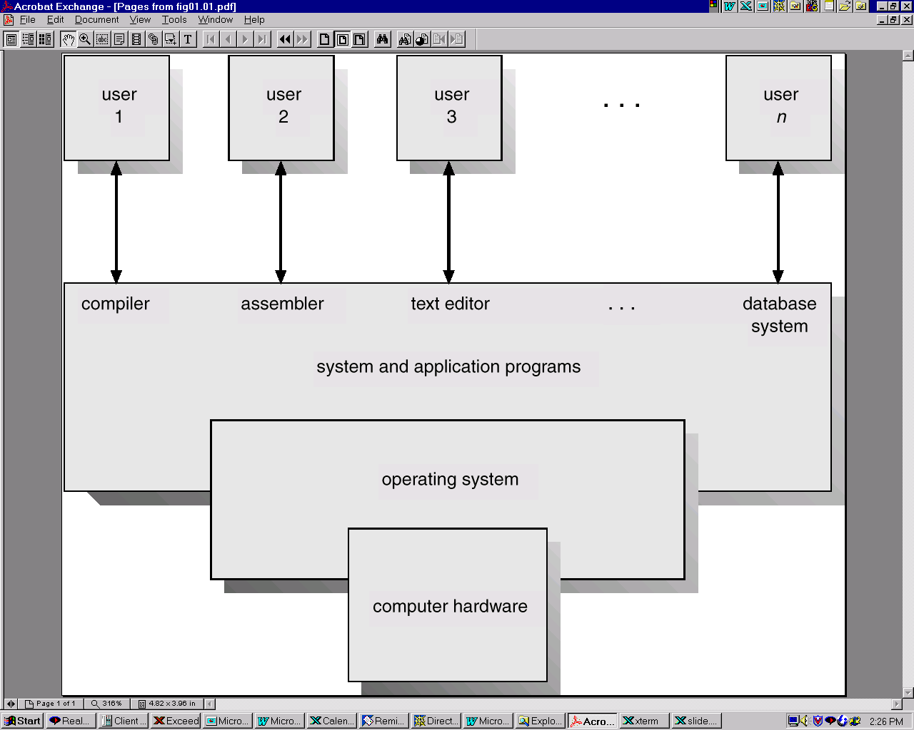
- I/O operation (file & device)
- File management system
- Error detection reporting
- Resource allocation
- Protection mechanism
- Accounting
- Command Language Support

Application programs

System programs (Compiler, Assembler, Linker etc.)

User Interface
Process Management
Memory Management
I/O
Control
File Management

OS
S/W

CPU
Main
Memory
Secondary
Storage
H/W
I/O
Devices

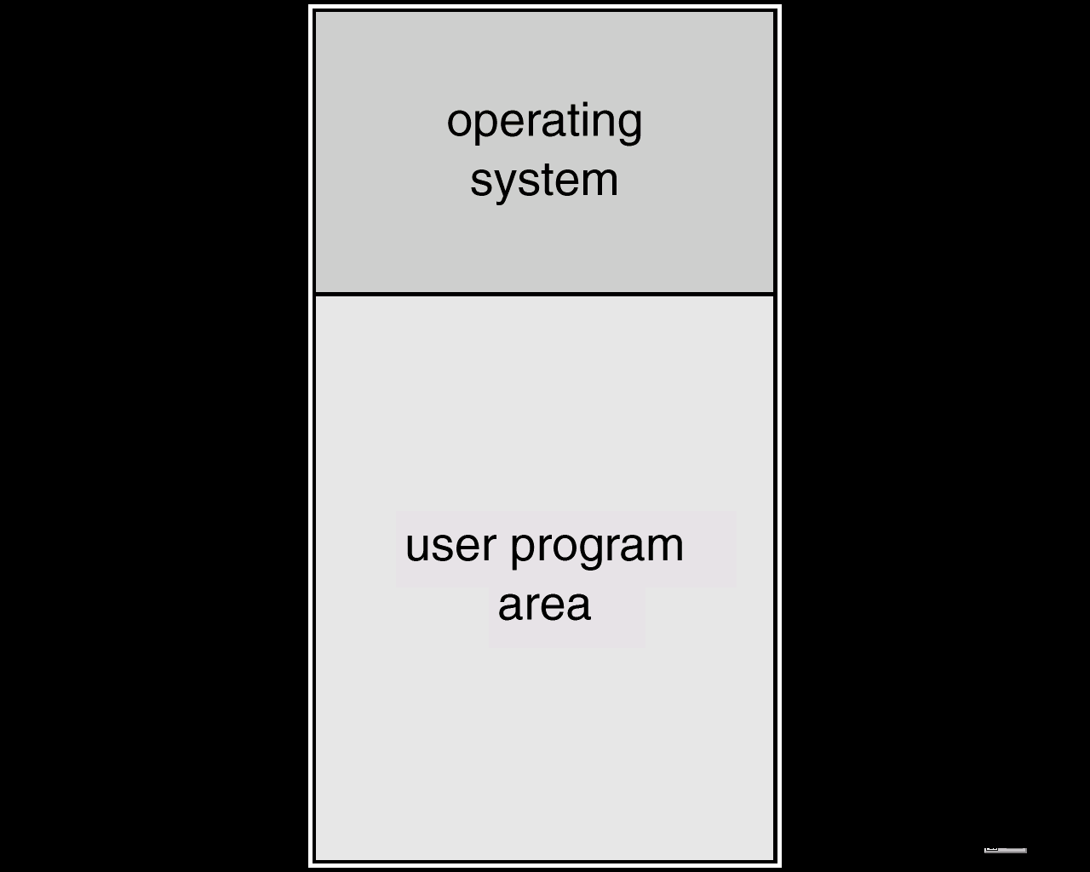
Single stream batch processing :
In order to reduce the setup time between jobs, a continuous series of jobs to be loaded automatically from an input device. In batch processing jobs were submitted in batches to the computer.

Spooling : In Spooling (Simultaneous Peripheral Operations On Line), a high-speed device like a disk is interposed between a running program and a low speed device involved with the program in input/output.
E.g., When a job requests the printer to output a line, that line is copied into a system buffer and is written to the disk. When the job is complete, the output is actually printed.
Disk

I/O

Card reader

CPU
Line
Printer

Multiprocessing : The OS keeps several jobs in memory at a time. This set of jobs is a subset of the jobs kept in the job pool. The OS picks & begins to execute one of the jobs in the memory. Eventually, the job may have to wait for some task, such as a tape to be mounted a command to be typed on a keyboard or an I/O operation to complete. In a multiprogramming system, the CPU is switched to another job. A job was selected on the basis of an operator assigned priority number. As long as there is some job to execute, the CPU will never be idle.

In Multiprogrammed operating system all jobs that enter the system are kept in the job pool. This pool consists of all processes residing on mass storage awaiting allocation of main memory. If several jobs are ready to be brought into memory and there is not enough room for all of them, then the system must choose among them. This is called job scheduling. When the operating system selects a job from the job pool, it loads that job into memory for execution. In addition, if several jobs are ready to run at the same time, the system must choose among them. This is called CPU scheduling. Finally, multiple jobs running concurrently require that their ability to affect one another be limited in all phases of the operating system, including process scheduling, disk storage and memory management.

Advantage :
- Throughput : The speed-up ratio with n processors is not n, but less than n. When multiple processors cooperate on a task, a certain amount of overhead is incurred in keeping all the parts working correctly.
- Resource Sharing : Multiprocessor can also save money compared to multiple single systems. If several programs are to operate on the same set of data, it is cheaper to store those data on one disk and to have all the processors share them, rather than to have many computers with local disks and many copies of the data.
- Reliability : If functions can be distributed properly among several processors, then the failure of one processor will not halt the system, but rather will only slow it down. If we have 10 processors and one fails, then each of the remaining nine processors must pick up a share of the work of the failed processor. Thus the entire system runs 10% slower, rather than failing altogether. This ability to continue providing service proportional to the level of surviving hardware is called graceful degradation. Systems that are designed for graceful degradation are also called fault-tolerant.
- Continued operation in the presence of failures requires a mechanism to allow the failure to be detected, diagnosed and corrected(if possible).

Time sharing system : Time sharing system were developed to provide interactive use of a computer system at a reasonable cost. A time-shared OS uses CPU scheduling and multiprogramming to provide each user with a small portion of a time-shared computer. A time-shared OS allows the many users to share the computer simultaneously. Since each action or command in a time-shared system tends to be short, only a little CPU time is needed for each user. As the system switches rapidly from one user to the next, each user is given the impression that he has his own computer, where as actually one computer is being shared among many users.

Real Time System : A real time system is used when there are rigid time requirements on the operation of a processor or the flow of data and thus is often used as a control device in a dedicated application.
A hard real time system has well-defined, fixed time constraints. Processing must be done within the defined constraints, or the system will fail. e.g. Air traffic control system.
Soft real time systems have less stringent timing constraints and do not support deadline scheduling. e.g. Multimedia system.

Distributed System : Distributed system is a collection of processors where each processor has its own local memory, and the processors communicate with one another through various communication lines.
- Resource sharing : If a number of different sites with different capabilities are connected to one another, then a user at site may be able to use the resources available at another.
- Computation speedup : If a particular computation can be partitioned into a number of subcomputations that can run concurrently, then a distributed system may allow us to distribute the computation among the various sites to run that computation concurrently. In addition, if a particular site is currently overload with jobs, some of them may be moved to other sites. This movement of jobs is called load sharing.
- Reliability : If one site fails in a distributed system, the remaining sites can potentially continue operating.
- Communication : When many sites are connected to one another by a communication network, the processes at different sites have the opportunity to exchange information.

System Programs : System Programs provide a convenient environment for program development and execution.

- File Manipulation – These programs create, delete, copy, rename, print, dump, list and generally manipulate files and directories.
- Status Information – Some programs simply ask the system for the date, time, amount of available memory or disk space, number of users or similar status information.
- File Modification – Several text editors may be available to create and modify the content of files stored on disk or tape.
- Programming Language Support – Compilers, Assemblers, Interpreters for common programming languages are often provided to the user with the operating system.
- Program Loading & Execution – Once a program is assembled or compiled, it must be loaded into memory to be executed.
- Communication – These programs provide the mechanism for creating virtual connections among processes, users and different computer systems.
- Application Programs – Most operating systems are supplied with programs that are useful to solve common problems or to perform common operations.

System Call : System Calls provide the interface between a process and the operating system. Whenever a user program requires some service from operating system it requests operating system to offer that service in the form of a system call.
To implement a system call, parameters are put in the registers or stack and then a special trap instruction is executed by the user program. As a result of trap instruction - (i) the execution mode of CPU switches from user mode to kernel mode or supervisor mode (ii) the control is transferred to operating system.
The operating system then determines which particular service is requested for. It locates that service with the help of a dispatch table and transfers control to the appropriate routine and upon completion of that routine gives the control back to the user. Obviously the execution mode of CPU also goes to the user mode simultaneously.

User program

Kernel User
Call (4) prog.

Main
Memory

(1) service
routine Operating System

(2)
Dispatch table

- User program traps kernel.
- Operating System determines the service number required with the help of a dispatch table.
- The Operating System locates the service routine and executes it.
- The control is transferred to the user processes.

System call can be grouped into five major categories :
- Process Control
- end, abort
- load, execute
- create process, terminate process
- get process attributes, set process attributes
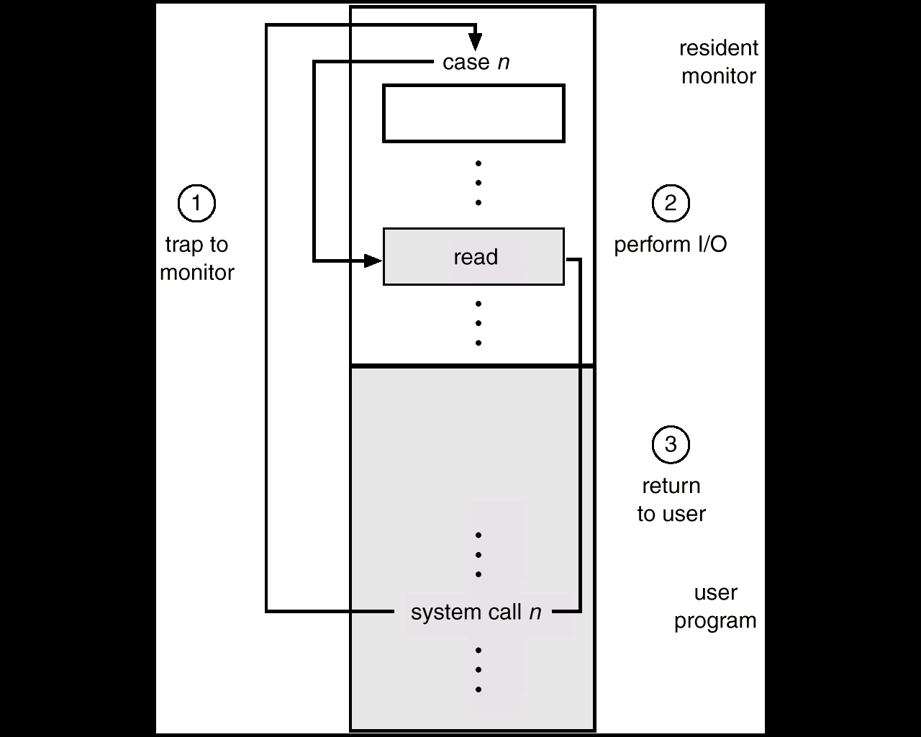
- wait for time
- wait for event, signal event
- allocate and free memory
- File Manipulation
- create file, delete file
- open, close
- read, write, reposition
- get file attributes, set file attributes
- Device Manipulation
- request device, release device
- read, write, reposition
- get device attributes, set device attributes
- logically attach or detach devices
- Information Maintenance
- get time or date, set time or date
- get system data, set system data
- get process, file, or device attributes
- set process, file, or device attributes
- Communication
- create, delete communication connection
- send, receive messages
- transfer status information
- attach or detach remote devices

System Structure :
- Simple Structure (Monolithic System) : It has no well defined partition of system structure. e.g. MSDOS.
Advantage : Simple
Better performance due to simple interface design
Disadvantage : Hard to understand
Hard to modify
Hard to maintain
Bugs hard to trace may causes crashes
- Layered Structure : Operating System is broken into some layers (levels) such that modularity is increased. Each layer is a virtual machine to the layer below. E.g. OS/2. Under top-down approach the overall functionality & features can be determined and separated into components.
Disadvantage : Complex
Poor performance due to layer crossings or bad interface design
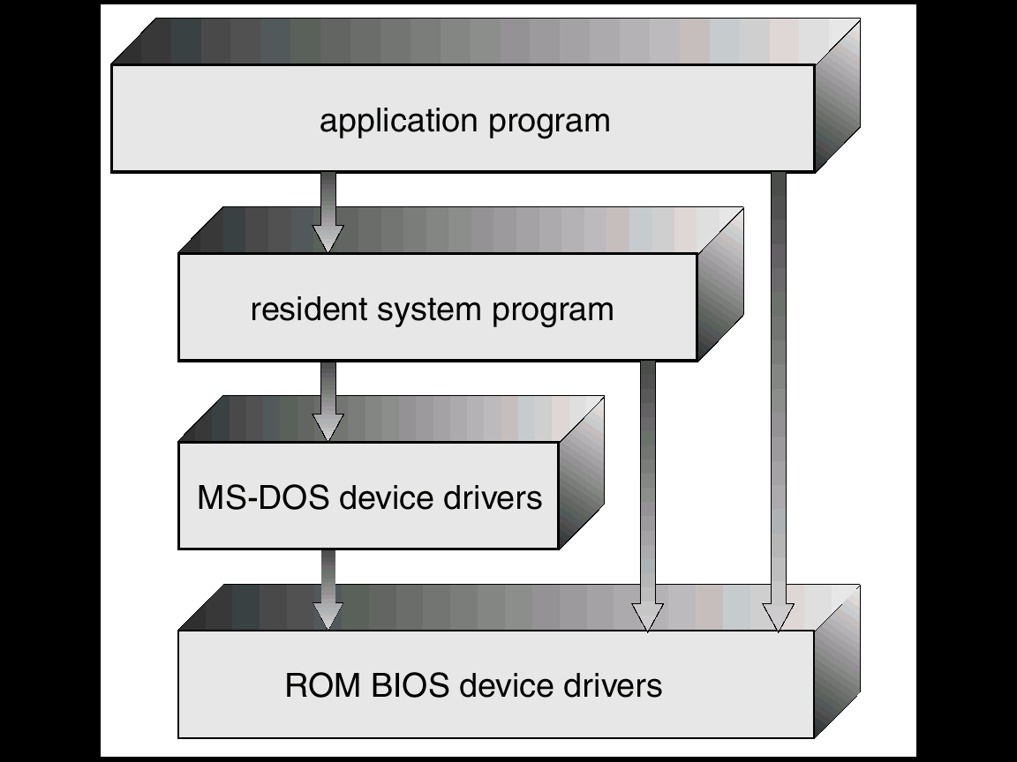

MS-DOS Layered Structure

Operating System Shell : Many commands are given to the operating system by control statements. When a new job is started in a batch system or when a user logon to a time shared system, a program that reads and interprets control statements is executed automatically. This program is called command line interpreter or shell. e.g. MSDOS shell.

Process : A process is an active program which executes in a sequential fashion.
It includes –
- Current activity as PC & general purpose registers.
- Process Stack (contains temporary data, return address)
Data section (contains global variables)
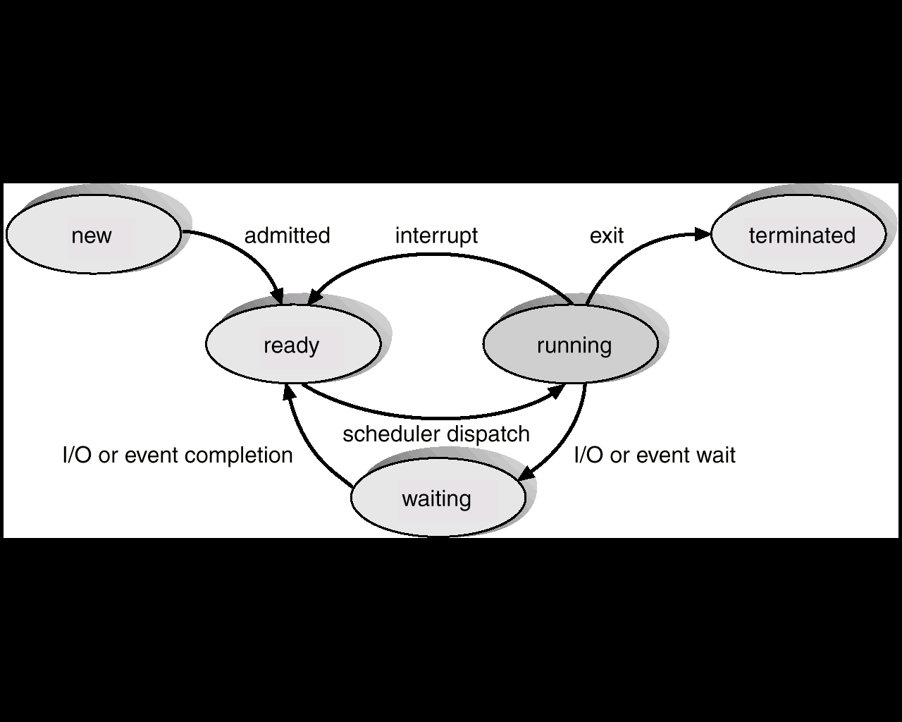

As a process executes, it changes state.
- New : The process is being created.
- Running : Instructions are being executed.
- Waiting : The process is waiting for some event to occur (such as an I/O completion or reception of a signal).
- Ready : The process is waiting to be assigned to a processor.
- Terminated : The process has finished execution.
Each process is represented in the OS by its own Process Control Block (PCB).

Process Image :
As memory image, condition with respect to pages for that process, the instruction & data contain in that page.
As CPU image, current status of execution as reflected by the registers of CPU so that this information can be stored in corresponding activation record for that process. This activation record is stored in activation stack or runtime system stack to be used later during return from the process which was executing earlier.

Process Control Block :
Each process is represented in the OS by its own Process Control Block (Task Control Block). It includes the following attributes (Process Attributes) –
- Process State : New/Ready/Running/Waiting/Terminated.
- Program Counter : Holds address of next executable instruction.
- CPU Registers : They are ACC, SP, PC, IR, GPR which holds data & intermediate state information.
- CPU Scheduling information : Includes process priority scheduling information.
- Memory management information : Holds information on base registers, page tables, segment tables etc.
- Accounting information : Holds information on CPU time, process numbers etc.
- I/O status information : Holds information on available I/O devices.
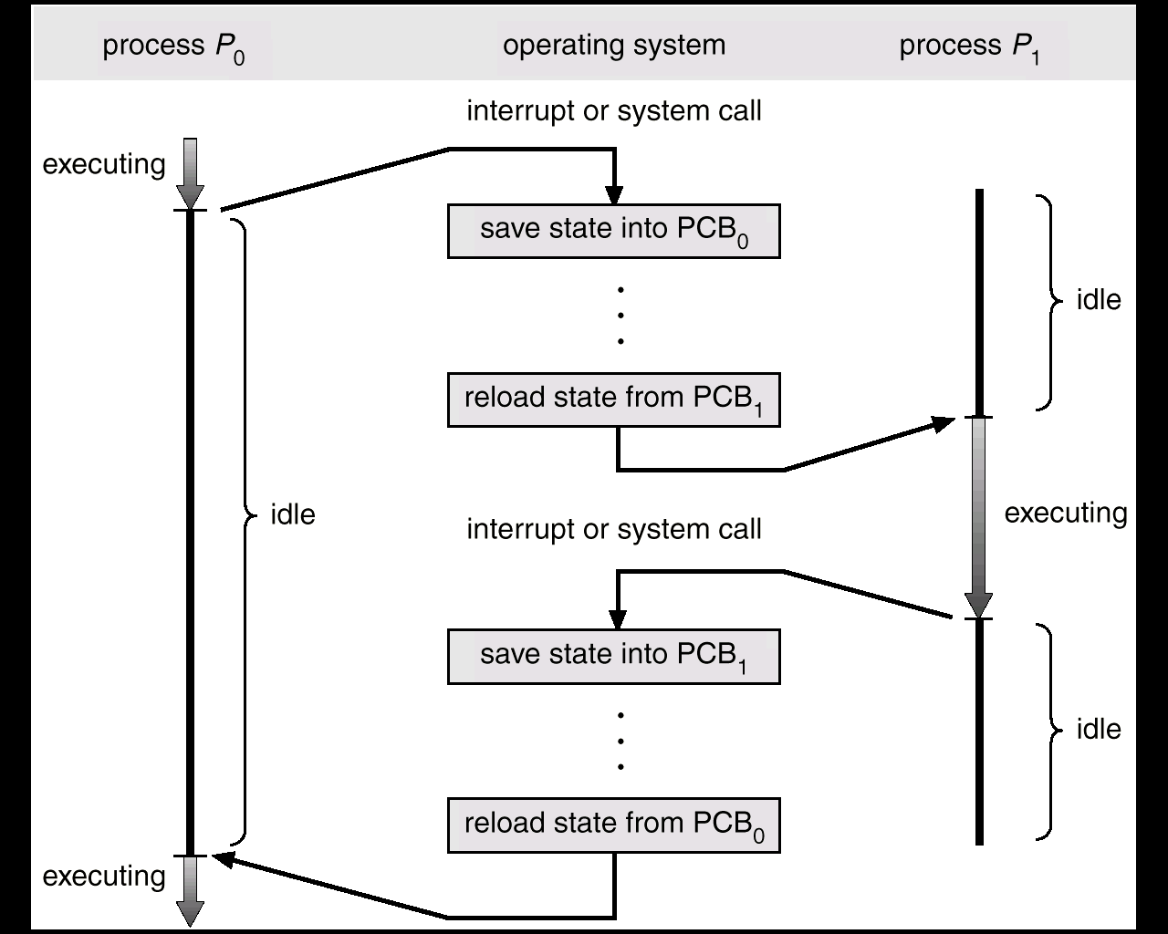

Context switch or Process switch

Process Entry Table : It is a table in which information about all newly submitted processes are kept. This table is checked by long time scheduler whenever the system resources permit entry of newer processes.

Schedulers :
A process migrates between the various scheduling queues throughout its lifetime. The operating system must select for scheduling purposes, processes from these queues in some fashion. The selection process is carried out by the appropriate scheduler.
- Short time scheduler (CPU scheduler) selects the processes which are ready and allocate them in CPU. The short time scheduler is very fast.
- Long time scheduler (Job scheduler) selects processes from the job pool and loads them into memory for execution. Long time scheduler executes less frequently. It controls degree of multiprogramming (number of processes in memory). CPU scheduling occurs for I/O request, when an interrupt occurs, for completion of I/O, when a process terminates.
- Medium time scheduler is the intermediate level of scheduling. It reduces degree of multiprogramming and provides swapping between processes.
CPU
Ready queue

Short time
scheduler
I/O I/O queue I/O request

Time slice expired
Long time
scheduler
Child terminates child executes fork a child

Interrupts occurs wait for an interrupt

swap in Partially executed swap out
swapped-out processes

ready queue CPU end Middle time
scheduler

I/O I/O waiting queues

Concurrency : Concurrency is the phenomenon where multiple processes executes simultaneously. Hence multiple processes can be there in the ready queue as well as in the device queues. To control the allocation of resources between several concurrent processes the issues like synchronization, deadlock detection & avoidance and atomicity are basically involved.

Cooperating processes :
The concurrent processes executing in the operating system may be either independent processes or cooperating processes.

A process is independent if it cannot affect or be affected by the other processes executing in the system. It does not share any data with other process executing in the system.
A process is cooperating if it can affect or be affected by the other processes executing in the system. It shares data with other process.
E.g. Producer-Consumer problem.
The reasons for providing an environment that allows cooperation process –
- Information sharing
- Computation speedup
- Modularity
- Convenience

Nonpreemptive CPU scheduling :
When CPU scheduling occurs -
- for I/O request
- when an interrupt occurs
- for completion of I/O
- when a process terminates
then this scheduling scheme is called Nonpreemptive.
Under nonpreemptive scheduling, once the CPU has been allocated to a process, the process keeps the CPU until it releases the CPU either by terminating or by switching to the waiting state. E.g., MS WINDOWS environment.

Preemptive CPU scheduling :
The strategy of allowing processes that are logically runnable to be temporarily suspended is called preemptive scheduling. Once a process has been given the CPU then CPU can be taken away from that process. Preemption has an effect on the design of the operating system kernel. This process is useful in systems in which high-priority processes require rapid attention.

Dispatcher :
The dispatcher is the module that gives control of the CPU to the process selected by the short-term scheduler. This function includes –
- Switching context
- Switching to user mode
- Jumping to the proper location in the user program to restart program
- Helps in paging activity.
The time required to stop a process and start another process by the dispatcher is called dispatch latency.

Scheduling Criteria :
- CPU Utilization : CPU utilization may range from 0% to 100%. In a real system, it should range from 40% (lightly used system) to 90% (heavily used system).
- Throughput : Throughput defines by the number of completed process per unit time.
- Turnaround time : The interval from the time of submission of a process to the time of completion is the turnaround time.
- Waiting time : Waiting time is the sum of the periods spent waiting in the ready queue.
- Response time : Response time is the amount of time required to start responding.

CPU scheduling algorithms :
(1) First-Come First-Serve Scheduling :
First-Come First-Serve CPU Scheduling is the simplest scheduling algorithm. The process that requests the CPU first is allocated the CPU first. The implementation of FCFS policy is done by FIFO method. When a process enters in the ready queue its PCB is linked onto the tail of the queue. When the CPU is free it is allocated to the process at the head of the queue.

E.g., Process Burst Time
P₁ 24ms
P₂ 3ms
P₃ 3ms
If the processes arrive in the order P₁, P₂, P₃ then the Gantt chart is,
P₂

P₁
P₃

0 24 27 30
Average waiting time = (0+24+27)ms/3 = 17ms
Turn around time = (24+27+30)ms/3 = 27ms

The FCFS scheduling algorithm s nonpreemptive. Once the CPU has been allocated to a process, that process keeps the CPU until it releases the CPU either by terminating or by requesting I/O. This algorithm is not suitable in case of time sharing system.

(2) Shortest-Job-First Scheduling :
This algorithm associates with each process the length of the latter’s next CPU burst. When the CPU is available, it is assigned to the process that has the smallest next CPU burst. If two process have same length next CPU burst, FCFS scheduling is used to break the tie.

E.g., Process Burst Time
P₁ 6ms
P₂ 8ms
P₃ 7ms
P₄ 3ms
The Gantt chart is,

P₄

P₁

P₃

P₂

0 3 9 16 24
Average waiting time = (0+3+9+16)ms/4 = 7ms
Turn around time = (3+9+16+24)ms/4 = 13ms

SJF can minimizes the average waiting time.
SJF algorithm may be either preemptive or non preemptive.

(3) Priority Scheduling :
The SJF algorithm is a special case of the general priority scheduling algorithm. A priority is associated with each process and the CPU is allocated to the process with the highest priority. Equal priority processes are scheduled in FCFS order.

E.g., Process Burst Time Priority
P₁ 10ms 3
P₂ 1ms 1
P₃ 2ms 3
P₄ 1ms 4
P₅ 5ms 2

The Gantt chart is,

P₂
P₅
P₁
P₃
P₄

0 1 6 16 18 19
Average waiting time = (0+1+6+16+18)ms/5 = 8.2ms
Turn around time = (1+6+16+18+19)ms/5 = 12ms

Priorities can be defined either internally or externally.
Priority scheduling can be either preemptive or nonpreemptive.

The major problem in this algorithm is starvation. A process of low priority that is ready to run but lacking the CPU can be considered blocked, waiting for the CPU. In a heavily loaded computer system a steady stream of higher priority processes can prevent low priority process to get the CPU. Under this circumstances the computer system may be crash and loose all unfinished low priority processes. The solution of this problem is aging. Aging is a technique of gradually increasing the priority of processes that wait in the system for a long time.

(4) Round-Robin Scheduling :
Round-Robin scheduling algorithm is designed especially for time-sharing system. It provides a small unit if time (time quantum/time slice) and a circular queue. To implement RR scheduling the ready queue is used as a FIFO queue of processes. New processes are added to the tail of the ready queue. The CPU scheduler picks the first process from the ready queue, sets a timer to interrupt after a 1 time quantum and dispatches the process.

E.g., Process Burst Time
P₁ 24ms
P₂ 3ms
P₃ 3ms
Then the Gantt chart is,

P₁ P₂ P₃ P₁ P₁ P₁ P₁ P₁ P₁ P₁

0 3 6 9 12 15 18 21 24 27 30

Average waiting time = (0+3+6)ms/3 = 3ms
Turn around time = (30+6+9)ms/3 = 15ms

RR scheduling is preemptive.
The performance of RR algorithm depends on time quantum.

Multilevel Queue Scheduling :
Processes can be divided into two groups – foreground process (interactive) and background process (batch). They have different response time and foreground process has more priority than background process.
In a multilevel queue scheduling algorithm, processes are permanently assigned to a queue on entry to the system.
A multilevel queue scheduling algorithm partitions the ready queue into several separate queues. Each queue has its own scheduling algorithm. For example, separate queues are used for foreground process and background process and the foreground queue uses RR algorithm where background queue uses FCFS algorithm. There must be scheduling between the queues.
Each queue has absolute priority over lower priority queues. No process in the batch queue could run unless system processes, interactive processes and interactive editing processes are all empty.

Highest priority
System Processes

Batch Processes
Interactive Processes

Interactive Editing Processes

Lowest priority

Multilevel Feedback Queue Scheduling :
Multilevel Feedback queue scheduling, allows a process to move between queues. If a process uses too much CPU time, it will be moved to a lower priority queue. This scheme leaves I/O bound and interactive processes in the higher priority queues. Similarly a process that waits too long in a lower priority queue may be moved to a higher priority queue. This form of aging prevents starvation.
It is also called Preemptive Priority Scheduling.
E.g., Let us suppose a multilevel feedback queue scheduler with three queues numbered from 0 to 2. The scheduler first executes all processes in queue0. Only when queue0 is empty then the processes of queue1 will execute. Processes of queue2 will be execute only when queue0 and queue1 are empty. A process entering the ready queue is put in queue0. A process in queue0 is given a time quantum of 8ms. If it does not finish within this time it is moved to the tail of queue1. If queue0 is empty, the process at the head of queue1 is given a quantum of 16ms. If it does not complete, it is preempted and is put into queue2.
The main characteristic of multilevel feedback queue scheduling are –
- The number of queues
- The scheduling algorithm for each queue
- The method used to determine when to upgrade a process to a higher priority queue
- The method used to determine when to demote a process to a lower – priority queue
- The method used to determine which queue a process will enter when that process needs service
Interprocess Communication :
The function of a message system is to allow processes to communicate with each other without the need to resort to shared variables. An IPC facility provides at least the two operations : send (message) & receive (message). Messages sent by a process can be of either fixed or variable size.
If process P & Q want to communicate, they must send messages to and receive messages from each other, a communication link must exist between them.

There are several methods for logically implementing a link and the send/receive operations.
- Direct or Indirect communication
- Symmetric or Asymmetric communication
- Automatic or Explicit buffering
- Send by copy or send by reference
- Fixed sized or variable sized message

Direct Communication : In a direct communication discipline, each process that wants to communicate must explicitly name the recipient or sender of the communication.

Send(p,message) send a message to process p.
Receive(q,message) receive a message from process q.
- Link is established automatically between every pair of processes that want to communicate.
- Between each pair of process, there exist exactly one link.
- The link may be unidirectional, but is usually bidirectional.

Indirect Communication : With indirect communication, the messages are sent to and receive from mailboxes.

Send(A,message) send a message to mailbox A
Receive(A,message) receive a message from mailbox A

- A link is established between a pair of processes only if they have a shared mailbox.
- A link may be associated with more than two processes.
- Between each pair of communicating processes, there may be a number of different links, each link corresponding to one mailbox.
- A link may be either unidirectional or bidirectional.

Critical Section Problem :
The overlapping portion of each process, where the shared variables are being accessed and manipulate is called Critical Section.
Let us consider a system consisting of n processes {P₀,P₁,…,P_{n-1}}. Each process has a segment of code, called a critical section. Each process must request permission to enter its critical section. This section of code implementing this request is the entry section. The critical section may be followed by an exit section.
A solution to the critical section problem must satisfy the following three requirements.
- Mutual Exclusion : If process P_{i} is exactly in its critical section, then no other processes can be executing in their critical sections.
- Progress : A process operating outside of its critical section cannot prevent other processes from entering theirs; processes attempting to enter their critical sections simultaneously must decide which process enters eventually. On other words, if no process is executing in its critical section and there exist some processes that wish to enter their critical sections, then only those processes that are not executing in their remainder section can participate in the decision of which will enter its critical section next, and this selection can not be postponed indefinitely. A process operating outside the critical section means either it is in entry section or in remainder section. Those who are in entry section, will compete very soon and they can easily prevent the others who are requesting the entry to critical section at that time. Only those cannot participate, who have just used the critical section, i.e. those who are in their remainder section.
- Bounded Waiting : A process attempting to enter its critical region will be able to do so eventually. There must exist a bound on the number of times that other processes are allowed to enter their critical sections after a process has made a request o enter its critical section and before that request is granted.

repeat
entry section
critical section
exit section
remainder section
until false;

Critical Regions :
Types of error generated due to incorrect use of semaphores to solve critical section problem.
- Suppose that a process interchanges the order in which the wait and signal operations on the semaphore mutex are executed.
signal(mutex);
……….
critical section
……….
wait(mutex);
- Suppose that a process replaces signal(mutex) with wait(mutex).
wait(mutex);
……….
critical section
……….
signal(mutex);
In this case deadlock will occur.
- If a process omits wait(mutex) and/or the signal(mutex) then mutual exclusion is violated or deadlock will occur.

The critical region high level synchronization construct requires that a variable v of type T, which is to be shared among many processes be declared as,
var v : shared T;
The variable v can be accessed only inside a region statement of the following form, Region v when B do S;
This construct means that, while statement S is being executed, no other process can access the variable v. The expression B is a boolean expression that governs the access to the critical region. When a process tries to enter the critical section region, the boolean expression B is evaluated. If the expression is true statement S is executed. If it is false, the process relinquishes the mutual exclusion and is delayed until B becomes true and no other process is in the region associated with v. thus if the two statements,
region v when true do S1;
region v when true do S2;
are executed concurrently is distinct sequential process, the result will be equivalent to the sequential execution S1 followed by S2 or vice versa.

The critical region construct can be effectively used to solve certain general synchronization problems.

Explain that if PV operations are not executed atomically then mutual exclusion is violated.
The operations P & V denote waiting and signal operations of semaphore respectively. Also their pseudo codes are as follows,
wait(S) signal(S)
{ {
while(S<=0) S++;
; // no op }
S--;
}
So, if these actions are not taken atomically i.e. testing of variable S or its increment or decrement is not atomically then race condition may occur again.

E.g., suppose two procedures are executing in the following manner,

P Q
wait(S); wait(S);
…….. ……..
signal(S); signal(S);

Let the value of S be initially 1. Next suppose P executes its wait instruction in which it tests the value of S. Before the modification is complete (S--), its time slice finishes. Now Q executes wait(S). The value of S stills 1. Hence it exists from while loop. Again let the control come back to P. Now for both the processes, the value of S is 1. Hence both of them produce to decrement the value of S and enter into the critical section. This violates the mutual exclusion property. So the instruction wait and signal should atomic.

Describe mutual exclusion problem and discuss how Dekker’s algorithm handles this problem for two processes.
Mutual exclusion implies the alternation of two or more processes, accessing a particular resource in such a manner that no two of them access the resource concurrently.
Dekker’s solution provides a software solution to the critical section problem for two processes P₀ and P₁. This involves two shared variables boolean flag[2] and int turn.
Dekker’s algorithm is as follows,
do
{
flag[i]=true;
turn=j;
while(flag[j] && turn==j)
; // no op
…………. Critical Section ………………
flag[i]=false;
…………. Non Critical Section ………………
} while(1);

Semaphore :
A semaphore is a simple integer variable which can accessed only through two standard atomic operations – wait & signal. Entry to critical regions of active processes is controlled by the wait operation and exit from a critical region is signaled by the signal operation.
A synchronization variable that takes on positive integer values, invented by Dijkstra.

P(semaphore): an atomic operation that waits for semaphore to become positive, then decrements it by 1.
V(semaphore): an atomic operation that increments semaphore by 1.

The definitions of these operations, using a semaphore S are,
wait (S) : if S>0
then S:=S-1
else block the calling process (i.e. wait on S)
endif

signal (S) : if any processes are waiting on S
then start one of these processes
else S:=S+1
endif
wait & signal are sometimes called P(to test) and V(to increment) respectively.

If we assume S initially set to value 1 (= resource is available), the first process to execute the wait will set S to S- 1 then will enter its critical region. If another process reaches its critical region, the wait now finds S set to 0 and process is blocked. When the first process exits from its critical region, it executes the signal. Since another process is waiting, this process is started, in the absence of this waiting process, S would be set to 1 to indicate that the resource was now available. For each semaphore, the system must maintain a queue of processes which are waiting for that semaphore to become non-zero.

wait (S)
<critical region>
signal (S)
The magnitude of negative S value is the number of waiting or blocked process.

Use – We can use semaphores to deal with the n-process critical section problem and it is also use to solve various synchronization problem.

Implementation –
repeat
wait (mutex);
critical section
signal(mutex);
remainder section
until false;

Producer – Consumer Problem :
The PRODUCER process generates units of data (characters, records etc.) and storing them in the next available position in a buffer consisting of an array of stores. The CONSUMER process removes items from this buffer and processing them.

Since both processes can potentially access the buffer simultaneously, we require –
- To prevent both the producer and the consumer from manipulating the buffer simultaneously (mutual exclusion).
- Data is written in the buffer when it is empty (empty space).
- Consumer read data from buffer when it is full (data available).

To provide for each of these three conditions. We require to employ the following semaphores.

Semaphore Purpose Initial value

free mutual exclusion for buffer access 1
space space available in buffer N
data data available in buffer 0

The outline structures of the Producer and the Consumer are given below,

Producer Explanation
produce item Application produces data item
wait(space) If buffer full, wait for space signal
wait(free) If buffer being used, wait for free signal
add item to buffer All clear, put item in next buffer slot
signal(free) Signal that buffer no longer in use
signal(data) Signal that data has been put in buffer

Consumer Explanation
wait(data) Wait until atleast one item in buffer
wait(free) If buffer being used, wait for free signal
get item from buffer All clear, get item from buffer
signal(free) Signal that buffer no longer in use
signal(space) Signal that at least one space exists in buffer
consume item Application specific processing of item

Producer’s signal(data) will increment the count of the number of data items while the consumer’s wait(data) will decrement the count of data items.
We allow the producer & consumer process to run concurrently, we allow the producer to produce one item while the consumer is consuming another item. When the producer finishes generating an item, it sends that item to the consumer. The consumer gets that item via the receive operation. If an item has not been produced yet, the consumer process must wait until an item is produced.

The producer process is defined as,
The consumer process is defined as,
repeat
………….
receive (producer, nextc);
………….
consume the item in nextc

until false;

repeat
………….
produce an item in nextp
………….
send (consumer,nextp)

until false;

In case of multiprocess communication,
send(p,message) send a message to process p
receive(id,message) receive a message from any process, the variable id is set
to the name of the process with which communication has taken place

The disadvantage is the limited modularity of the resulting process definition. If a process (which received) changed name, all its reference must found & modified.

Readers - Writers Problem :
A data object is to be shared among several concurrent processes. Some of these processes may want only to read the content of the shared object whereas others may want to update (i.e. to read and write) the shared object. When two readers access the shared data object simultaneously there is no conflict occur. But when a reader and a writer both access the same data object simultaneously then a conflict may occur.
To avoid this problem, an exclusive access on the shared object is given to the writers.

There are two cases may arise in this synchronization problem –
- No reader will be kept waiting unless a writer has already obtained permission to use the shared object.
- If a writer is waiting to access the data, no new readers may start reading.

A solution to either problem may result in starvation. In the first case writers may starve and in the second case readers may starve.
wait(wrt);

Writer process …
…….
writing is permitted
…….
signal(wrt);

wait(mutex);
readcount:=readcount+1;
if readcount=1 then wait(wrt);
signal(mutex);
…………..

Reader process …
reading is performed
…………..
wait(mutex);
readcount:=readcount-1;
if readcount=0 then signal(wrt);
signal(mutex);

Through Monitor …..

monitor rw
{
int readcount;
condition mutex,wrt;

void start_read( )
{
mutex.wait( );
readcount++;
if readcount==1
wrt.wait( );
mutex.signal();
}

void end_read( )
{
mutex.wait( );
readcount--;
if readcount==0
wrt.signal( );
mutex.signal();
}

void start_write( )
{
wrt.wait( );
}

void end_write( )
{
wrt.signal( );
}

void init( )
{
readcount=0;
}
}

When a reader starts reading, it calls rw.start_read( ) and calls rw.end_read( ) when completes. Within this function the shared variable readcount is accessed through mutex and the writer process is signaled appropriately.

Dining Philosophers Problem :
Consider five philosophers who spend their lives thinking and eating. The philosophers share a common circular table surrounded by five chairs, each belongs to one philosopher. In the center of the table there is a bowl of rice, and the table is laid with five single chopsticks. When a philosopher thinks, she does not interact with her colleagues. From time to time, a philosopher gets hungry and tries to pick up the two chopsticks that are closest to her. A philosopher may pick up only one chopstick at a time. Obviously, she cannot pickup a chopstick that is already in the hand of a neighbor. When a hungry philosopher has both her chopsticks at the same time, she eats without releasing her chopsticks. When she is finished eating, she puts down both of her chopsticks and starts thinking again.
Using semaphore this problem can be solved. A philosopher tries to grab the chopstick by executing a wait operation on that semaphore, she releases her chopsticks by executing the signal operation on the appropriate semaphore. No two neighbors are eating simultaneously.

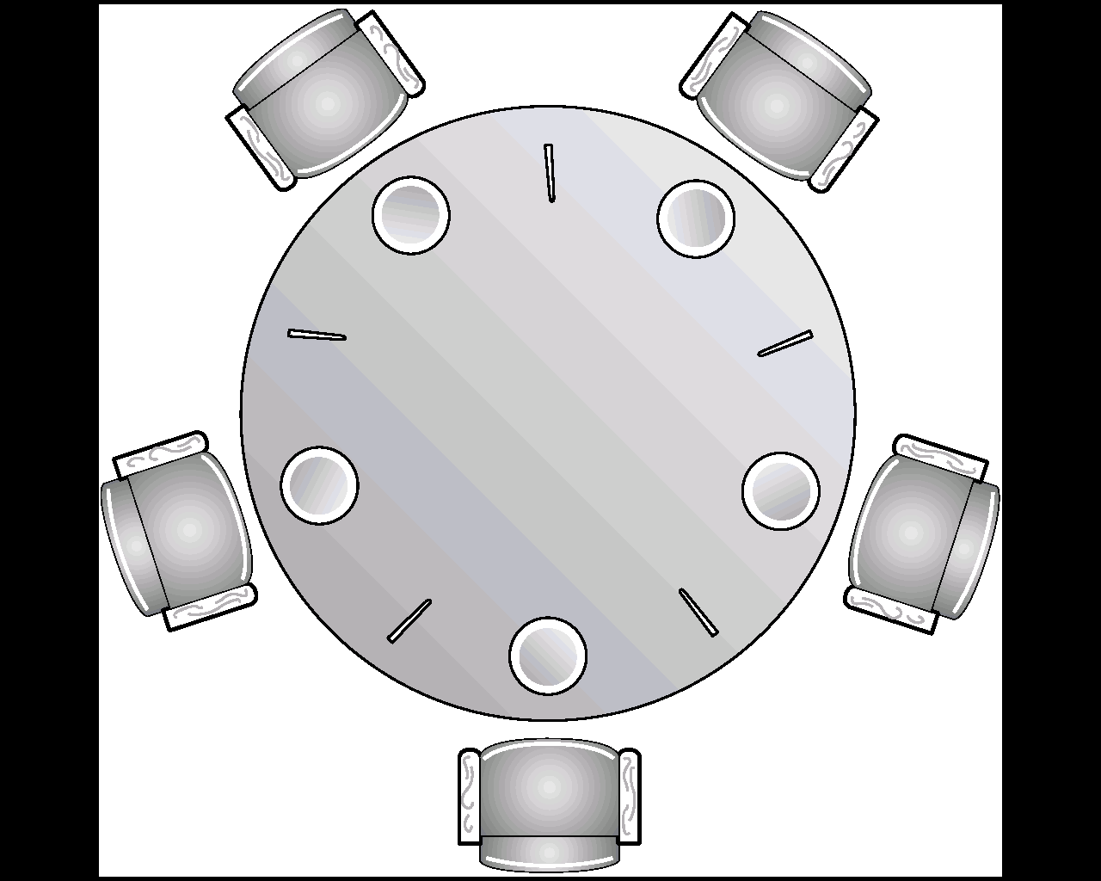
repeat
wait(chopstick[i]);
wait(chopstick[i+1 mod 5]);
……..
eat
……..
signal(chopstick[i]);
signal(chopstick[i+1 mod 5]);
……..
think
……..
Philosopher i
until false;

Sleeping Barber Problem :
A barbershop consists of a waiting room with n chairs and a barber room with one barber chair. If there are no customers to be served, the barber goes to sleep. If a customer enters the barbershop and all chairs are occupied then the customer leaves the shop. If barber is busy but chairs are available then the customer sits in one of the free chairs. If the barber is asleep, the customer wakes up the barber.
Entry
Exit

Barber process…
while(true)
{
signal(customers); // go to sleep if there is no customer
Hair Cut
signal(mutex); // acquire access to waiting
waiting=waiting-1; // decrement count of waiting customers
Waiting
wait(mutex); // release waiting
cut_hair( ); // cut hair (outside critical region)
}

Customer process…
signal(mutex); // enter critical region
if waiting<chairs // if there are free chairs
{
waiting=waiting+1; // increment count of waiting customers
wait(customers); // wake up barber if necessary
wait(mutex); // release access to waiting
get_haircut( ); // be seated and be serviced
}
else wait(mutex); // shop is full, do not wait

Dead lock :
A process is said to be deadlocked when it is waiting for an event which will never occur. Associated with the problem of resource allocation and resource scheduling, there is the probability of two (or more) processes waiting on each other (or in a circular chain) for requested sources that will never be released. Such a situation is called Deadlock.
e.g. City traffic jam, Air line booking system.

Conditions :
- Mutual Exclusion : Only one process can use a resource at a time.
- Resource Holding : Processes hold some resources while requesting more which are hold by another process.
- No Preemption : Resources can not be forcible removed from a process.
- Circular wait : A closed circle of processes exists, where each process requires a resource held by the next.

Prevention : To prevent deadlocks, we ensure that at least one of the necessary condition never holds.
- Denying Mutual Exclusion : It is not possible to prevent deadlocks by denying the mutual exclusion condition – some resources are intrinsically non-sharable.
- Denying Resource Holding : Disallowing this condition implies that a process must allocate all its resources at one time, so called one shot allocation. This means either allocating all resources it requires as soon as the process starts, or if a new resource is required during execution, all currently held resources must be relinquished before allocating everything again. The main disadvantages are resource utilization may be low and starvation is possible.
- Allow Preemption : If a process already holding some resources requests an additional resource which is held by another process, the requesting process can be forced to give up the resources currently held. It would then need to wait for all the necessary resources. A second possibility is that a resource required by one process and held by a second, could be forcibly removed from the second on the basis of the relative process priorities.
- Denying Circular wait : The circular wait condition can be prevented if resources (or resource types) are organized into a particular order, and to require that resource requests have to follow the order.

Avoidance : To avoid deadlock, we ensure that at least one of the necessary conditions never holds. Another method for avoiding deadlocks is to require additional information on how each process will be utilizing the resources.
A state is safe if the system can allocate resources to each process in some order. A safe state is not a deadlock state. If no such sequence exists then the system state is said to be unsafe. An unsafe state may lead to a deadlock.

The Banker’s algorithm is used for deadlock avoidance.
- Work := Available
If Allocation[i]≠0 then Finish[i] := false ∀ i=1,2,…,n else Finish[i] := true
- Find an index i such that both Finish[i] = false & Request[i] ≤ Work
If no such i exists, go to step 4.
- Work := Work + Allocation[i], Finish[i] := true
Go to Step 2.
- If Finish[i] = false for some i, 1 ≤ i ≤ n, then the system is in a deadlock state.

Detection : If a system does not employ deadlock detection and deadlock recovery algorithm then a deadlock situation may occur. If a deadlock is detected, the system must terminate of one or more processes in order to release their resources. Usually this is not practical.

Recovery : If a system has become deadlock, then the deadlock must be broken automatically or manually. There are two options to break a deadlock – either abort one or more processes to break the circular wait or to preempt some resources from one or more of the deadlock processes.

Banker’s algorithm :
This algorithm requires the following information –
Available – Number of available resources of each type.
Max – Maximum demand of each process.
Allocation – Number of resources of each type currently allocated to each process.
Need – Remaining resource need of each process.

Safety Algorithm :
1. Work := Available, Finish[i] := false ∀ i=1,2,…,n.
2. Find an i such that both Finish[i] = false & Need[i] ≤ Work
If no such i exists, go to step 4.
3. Work := Work + Allocation[i], Finish[i] := true
Go to Step 2.
4. If Finish[i] = true ∀ i, then the system is in a safe state.

Resource-Request Algorithm :
- If Request[i] ≤ Need[i], go to step 2. Otherwise raise an error condition, since the process has exceeded its maximum claim.
- If Request[i] ≤ Available, go to step 3. Otherwise P[i] must wait, since the resources are not available.
- Have the system pretend to have allocated the request resources to process P[i], by modifying the state as follows
Available := Available – Request[i]
Allocation[i] := Allocation[i] + Request[i]
Need[i] := Need[i] – Request[i]
- If the resultant resource allocation state is safe then make the allocation, otherwise restore the system and request the process to wait.

Logical address space & Physical address space :
An address generated by the CPU is commonly referred to as a logical address, where as an address seen by the memory unit (MAR) is commonly referred to as a physical address. We usually refer the logical address as a virtual address. The set of all logical addresses generated by a program is referred to as a logical address space. The set of all physical address corresponding to their logical address is referred to as a physical address space.
An address used by the programmer is called Virtual Address and a set of virtual address is called Address Space. An address in main memory is called Physical Address and a set of physical address is called Memory Space.
…
program 1
…
data 1,1
…
…
program 1
data 1,1
data 1,2
…
program 2
data 2,1
…

Process Loading : In order to execute a process, the program code has to be transferred from secondary storage to main memory, this activity is called process loading.

Memory allocation method (single process system) :
Unused

User process

OS
In a computer which is only interred to run one process at a time memory management is simple. The process to be executed is loaded into the free space area of the memory.

Swapping :
It is a process which swapped temporarily out of memory to a locking store and then brought back into memory for continued execution. This process requires too much swapping time and provides too little execution time to be a reasonable memory management solution.

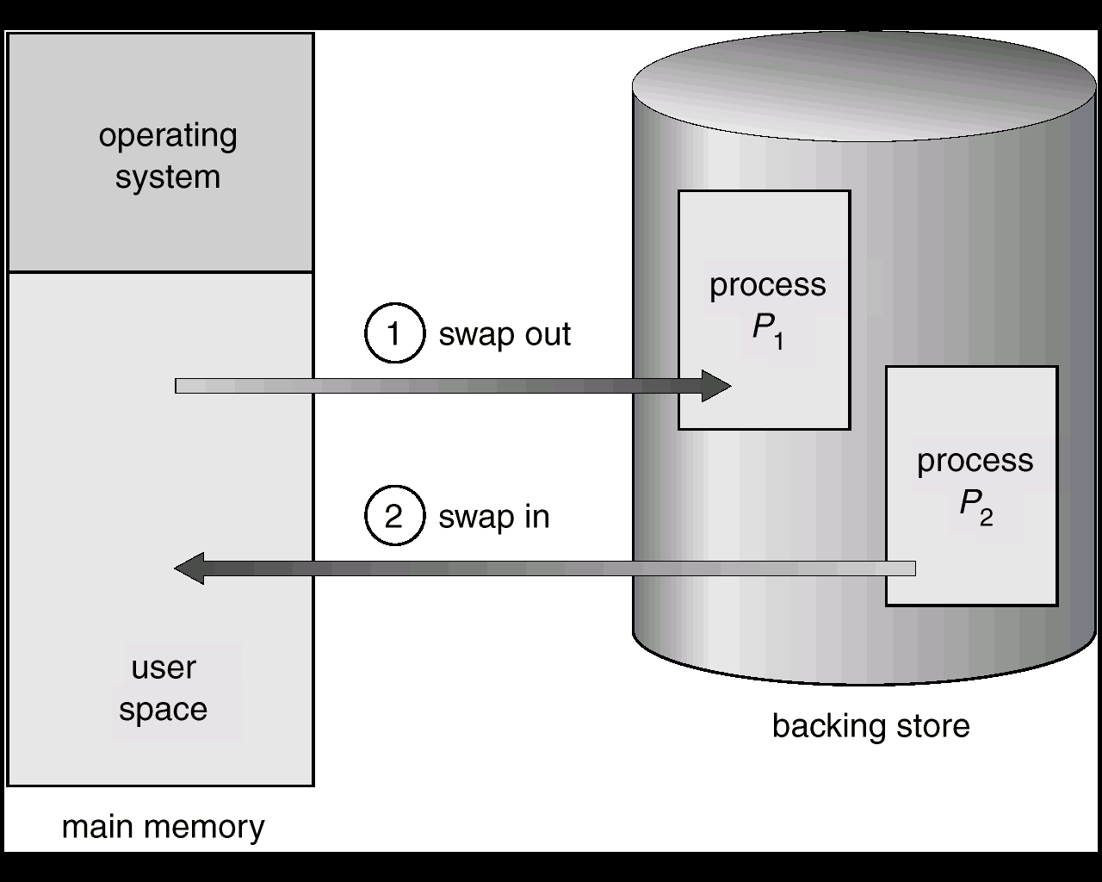

Multiple partition Allocation :
1. Fixed partition memory ---
OS can support simultaneous execution of processes number of partitions in a practical system would be controllable. One partition would have to be large enough to hold the largest process which might be run. Each partition will typically contain unused space .The occurrence of wasted space in this way is referred to as internal fragmentation.
Disadvantages :
- The fixed partition sizes can prevent a process being run due to the unavailability of a partition of sufficient size.
- Internal fragmentation wastes space which collectively, could accommodate another process.

2. Variable partition memory :

Job Queue
Process | Memory | Time
P1 | 600K | 10s
P2 | 1000K | 5s
P3 | 300K | 20s
P4 | 700K | 8s
P5 | 500K | 15s
0k 0k 0k

OS

OS

OS

400k 400k 400k

P1

P1

P1

1000k 1000k 1000k

P2

P4

1700k
2000k 2000k 2000k

P3

P3

P3
2300k 2300k 2300k

2560k 2560k 2560k
0k 0k

OS

OS

400k 400k

1000k 1000k

P4

1700k 1700k
2000k 2000k

P3

P3

2300k 2300k

2560k 2560k
To allocate to the process the exact amount of memory it requires. Processes are loaded into consecutive areas until the memory is filled, or remaining space is too small to accommodate another process. When a process terminates, the space it occupied is freed and becomes available for the loading of a new process. It can often happen that a new process can not be started because none of the holes is space is more than the required size. This situation is termed external fragmentation. It is frequently happen that a process adjacent to one or more holes will terminate and free its space allocation. This results in two a three adjacent holes, which can then be viewed and utilized as a single hole. The effect is referred to as coalescing of holes and is a significant to it or is maintaining fragmentation within usable limits. First fit, best fit, worst fit are the most common strategies used to select a free hole from the set of available holes.

Internal fragmentation :
Let us consider the hole is of 18464 bytes. If we allocate exactly the requested block, we are left with a hole of 2 bytes. The overhead to keep track of this hole will be substantially larger than the hole itself. The general approach is to allocate very small as part of the larger request. Thus, the allocated memory may be slightly larger than the requested memory. So, here memory is internal to a partition, but is not being used.
- Fixed Partitions suffer from inefficient memory use - any process, no matter how small, occupies an entire partition.
- This waste is called Internal Fragmentation.
- Unequal size partitions are better in terms of internal fragmentation.

External fragmentation :
As processes are loaded and removed from memory, the free memory space is broken into little pieces. External fragmentation exists when enough total memory space exists to satisfy a request, but it is not contiguous, storage is fragmented into a large number of small holes. This problem can be solved b compaction. The objective is to shuffle the memory contents to place all free memory together in one large block.
- Eventually, main memory forms holes too small to hold any process. This is external fragmentation.
- Total memory space may exist to satisfy a request but it is not contiguous.
- Compaction reduces external fragmentation by shuffling memory contents to place all free memory together in one large block.

Paging : The main memory (physical memory) is divided into blocks and the auxiliary memory (virtual memory) is divided into pages. The programs also consider to be split into pages of fixed size. The pages are moved from auxiliary memory to main memory.
The address generated by CPU, called virtual address, has two parts – page number & offset. The page number is used as an index for page table. The page table contains the block address. The combination of block address and offset value generates the physical address in main memory address register. The presence bit in the page table indicates whether the page is transferred from auxiliary memory to main memory or not. If the presence bit is 1 then the contents of main memory of the corresponding physical address is transferred into MBR. If the presence bit is 0 i.e. data is absent in main memory then page replacement occurs.

CPU virtual address
p d
generated
address
table presence bit
address main memory
… physical address
… …

f 1
… ...
…
f d
M
B
R
p
… main memory
page table address register

When the page reference by CPU is not available in the main memory the page fault occurs. When page fault occurs the execution of the present program is suspended until the required age is brought into the main memory from auxiliary memory, it generates demand paging. Then the OS finds the location of the desired page in virtual memory and finds a free block in main memory. If there is a free block, use it. Otherwise use a page replacement policy (FIFO, LRU) to select a victim block. Write the victim block in the virtual memory and then the desired page is transferred to the free block in main memory.

Problems:
- Internal fragmentation: Page size does not match up with information size. The larger the page, the worse this is.
- Table space: If pages are small, the table space could be substantial. In fact, this is a problem even for normal page sizes.
- Efficiency of access: It may take one overhead reference for every real memory reference (page table is so big it has to be kept in memory).

Page selection Algorithms:
- Demand paging: Start up process with no pages loaded, load a page when a page fault for it occurs, i.e. until it absolutely MUST be in memory. Almost all paging systems are like this.
- Request paging: Let user say which pages are needed. The trouble is, users do not always know best, and are not always impartial. They will overestimate needs.
- Prepaging: Bring a page into memory before it is referenced (e.g. when one page is referenced, bring in the next one, just in case). Hard to do effectively without a prophet, may spend a lot of time doing wasted work.

Page Replacement Algorithms:
- FIFO: Throw out the oldest page and the new page is inserted at the tail of the FIFO queue.
- LRU: We will replace the page that has not been used for the longest period of time.
- Optimal: Replace the page that will not be used for the longest period of time.
- Random: Pick any page at random.
- MIN: Naturally, the best algorithm arises if we can predict the future.
- LFU: Use the frequency of past references to predict the future.

Page fault : Process references a logical address the code for which is not in real memory, necessitating loading of a page.
If not all of process is loaded when it is running,
- First, extend the page tables with an extra bit "present". If present is not set then a reference to the page results in a trap. This trap is given a special name, page fault.
- Any page not in main memory right now has the "present" bit cleared in its page table entry.

When page fault occurs,
- Operating system brings page into memory.
- Page table is updated, "present" bit is set.
- The process is continued.

Demand Paging : It is a technique where by pages are not loaded into memory until accessed by a process.
Pure demand paging never brings in a page until that page is actually referenced. The first reference causes a page fault to the OS resident monitor. The OS consults an internal table to determine where the page is located on the backing store. The page table is updated to reflect this change, and the instruction that caused the page fault is restarted. This approach allows a process to run even though its entire memory image is not in main memory at once. As long as the page fault rate is reasonably low performance is acceptable.
Demand paging can be used to reduce the number of frames allowed to a process. This arrangement can raise the degree of multiprogramming and the CPU utilization of the system.

Consider the following page reference string : 1,2,3,2,4,5,2,4,3,4,5,4,3,2,5,3,4,5,3,2,3.
How many page faults would occur for the following replacement algorithms, assuming that there are 3 page frames in the machine? Assume that none of the process’s pages are loaded in memory when the above trace starts. (i) FIFO (ii) LRU (iii) Optimal Solution
(i) FIFO :
1 , 2, 3, 2 ,4, 5, 2, 4, 3, 4, 5, 4, 3, 2, 5, 3, 4, 5, 3, 2, 3
1 | 1 | 1 | 1 | 4 | 4 | 4 | 4 | 3 | 3 | 3 | 3 | 3 | 2 | 2 | 2 | 2 | 5 | 5 | 5 | 5
 | 2 | 2 | 2 | 2 | 5 | 5 | 5 | 5 | 4 | 4 | 4 | 4 | 4 | 4 | 3 | 3 | 3 | 3 | 2 | 2
 |  | 3 | 3 | 3 | 3 | 2 | 2 | 2 | 2 | 5 | 5 | 5 | 5 | 5 | 5 | 4 | 4 | 4 | 4 | 3
Page fault = 19

(ii) LRU :
1, 2, 3, 2, 4, 5, 2, 4, 3, 4, 5, 4, 3, 2 , 5, 3 , 4, 5, 3, 2, 3
1 | 1 | 1 | 1 | 4 | 4 | 4 | 4 | 3 | 3 | 3 | 3 | 3 | 2 | 2 | 2 | 2 | 5 | 5 | 5 | 5
 | 2 | 2 | 2 | 2 | 5 | 5 | 5 | 5 | 4 | 4 | 4 | 4 | 4 | 4 | 3 | 3 | 3 | 3 | 2 | 2
 |  | 3 | 3 | 3 | 3 | 2 | 2 | 2 | 2 | 5 | 5 | 5 | 5 | 5 | 5 | 4 | 4 | 4 | 4 | 3
Page fault = 11

(iii) Optimal :
1,2,3,2,4,5,2,4,3,4,5,4,3,2,5,3,4,5,3,2,3
1 | 1 | 1 | 1 | 4 | 4 | 4 | 4 | 4 | 4 | 4 | 4 | 4 | 4 | 5 | 5 | 5 | 5 | 5 | 5
 | 2 | 2 | 2 | 2 | 2 | 2 | 2 | 2 | 2 | 5 | 5 | 5 | 2 | 2 | 2 | 4 | 4 | 2 | 2
 |  | 3 | 3 | 3 | 5 | 5 | 5 | 3 | 3 | 3 | 3 | 3 | 3 | 3 | 3 | 3 | 3 | 3 | 3
Page fault = 9

Page table register : A hardware register, which contains the memory address of the page table of the currently active process. When a process switch occurs, the page table register is set to point to the appropriate page table.

Segmentation : Here programs & data are divided into logical parts called segments. Segments may be generated by the programmer or by the OS. e.g. subroutine, array of data, table of symbols, user program etc.

Logical

Segment Page Word

address

…

…
…

…
+
physical address
Block Word
segment table page table
The logical address is partitioned into 3 fields – Segment field specifies the segment number, Page field specifies the page within the segment, Word field specifies the word within the page. The segment number of logical address specifies the address of the segment table. The combination of the entry in the segment table and the page field of the logical address is a pointer address for page table. Page table contains the block number of physical memory. Finally the combination of the block value and the word field produces the physical address for main memory.

Distinguish between Paging & Segmentation :
Paging Segmentation
1. Programs are divided into fixed 1. Programs are divided into variable
size partitions called pages. size partitions called segments.
2. Each logical address is in the 2. Each logical address is in the term
term of page number & offset of segment number & offset
within the page. within the page.
3. Physical memory is divided into 3. Physical memory can not divided
fixed size blocks. fixed size blocks.
4. No external fragmentation occur. 4. External fragmentation occurs.
5. Due to page fault, page 5. Due to segment fault, segment
replacement occurs. replacement occurs.

Advantages of Partition allocation :
- It facilitates multiprogramming hence, more efficient utilization of the processor and I/O devices.
- It requires no special costly hardware.
- The algorithms used are simple and easy to implement.

Disadvantage of Partition allocation :
- Due to fragmentation memory utilization is reduced.
- Even if memory is require is not fragmented, the single free area may not be large enough for a partition.
- It does require more memory than a single contiguous allocation system in order to hold more than one job.
- A job’s partition size is limited to the size of physical memory.

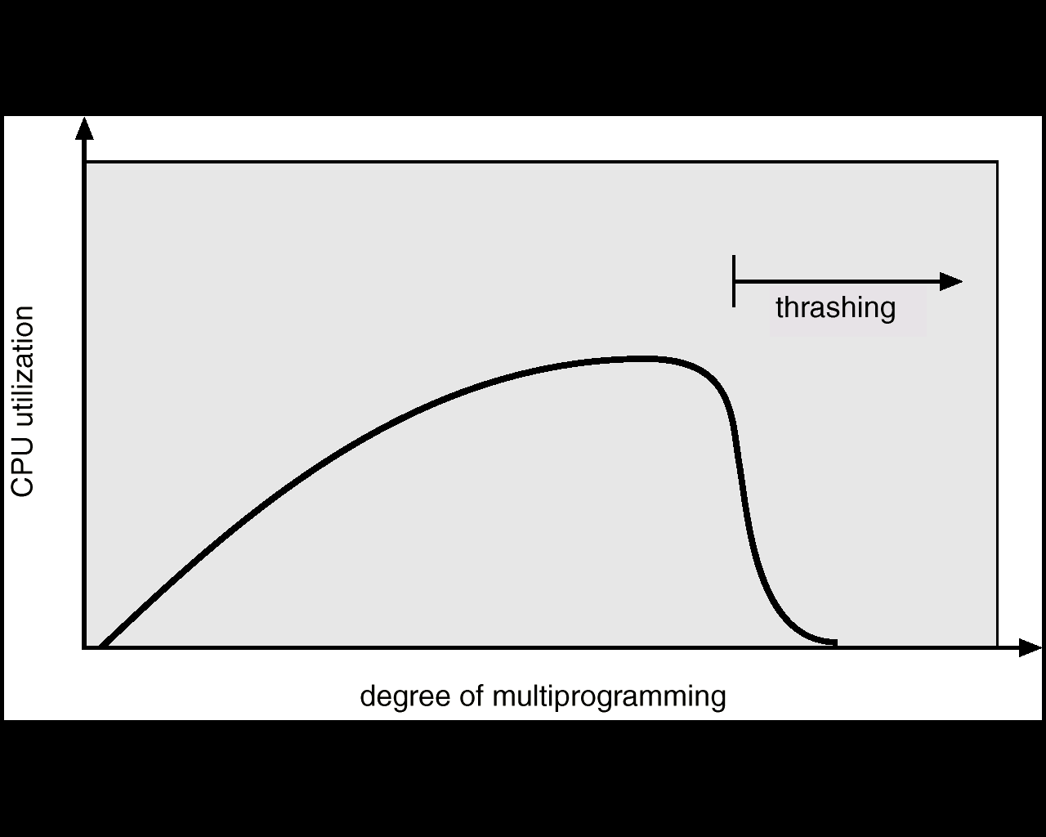
Thrashing : If too many process are running, their resident sets will be restricted, which will came frequent occurrence of page faults. This is happened due to spending a lot of time by swapping page and doing a little productive work. This situation is called thrashing.
- If a single process is too large for memory,
there is nothing the OS can do. That process will simply thrash.
- If the problem arises because of the sum of several processes then figure out how much memory each process needs and change scheduling priorities to run processes in groups whose memory needs can be satisfied.
Thrashing can be solved by – (i) increasing RAM size (ii) to terminate/block one or more processes which are causing maximum page fault, till more memory is available.

With reference to virtual memory explain the importance of page map table. Explain how virtual address translation is performed with combined associative/direct mapping in a paged and segmented system.
Virtual memory is a technique that allows the execution of process that may not be completely in memory. This technique frees programmers from concern over memory storage limitations.

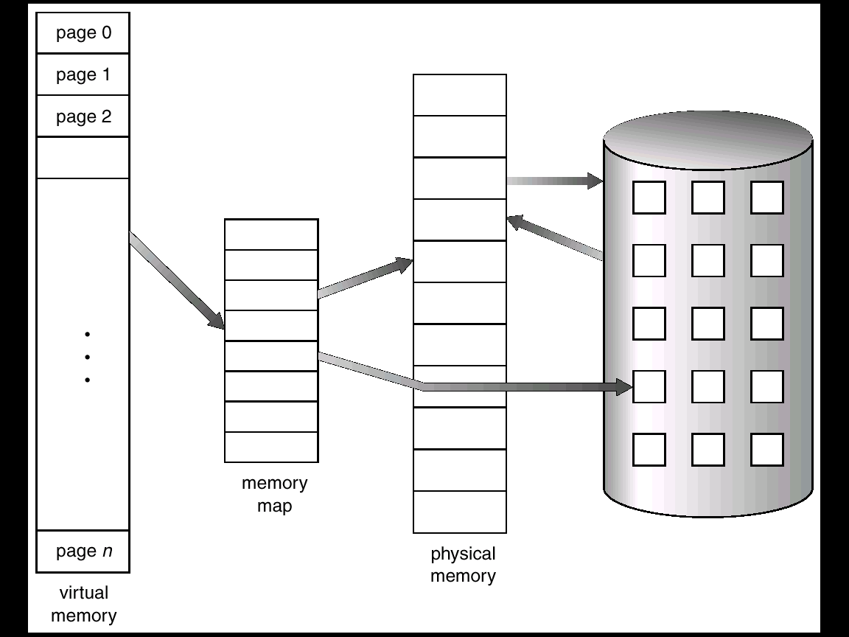

Virtual memory is implemented by demand paging or in a segmentation system.
A demand paging is similar to a paging system with swapping. When we want to execute a process, we swap it into memory. Instead of swapping in a whole process, the pager brings only those necessary pages into memory. It decreases swap time and amount of physical memory needed.
With this scheme we need some hardware support between pages that are in memory and that are in the disk. The valid-invalid bit scheme can be used for this purpose. ‘Valid’ indicates that the associated page is legal and in memory. ‘Invalid’ indicates that the page is invalid or currently in the disk.
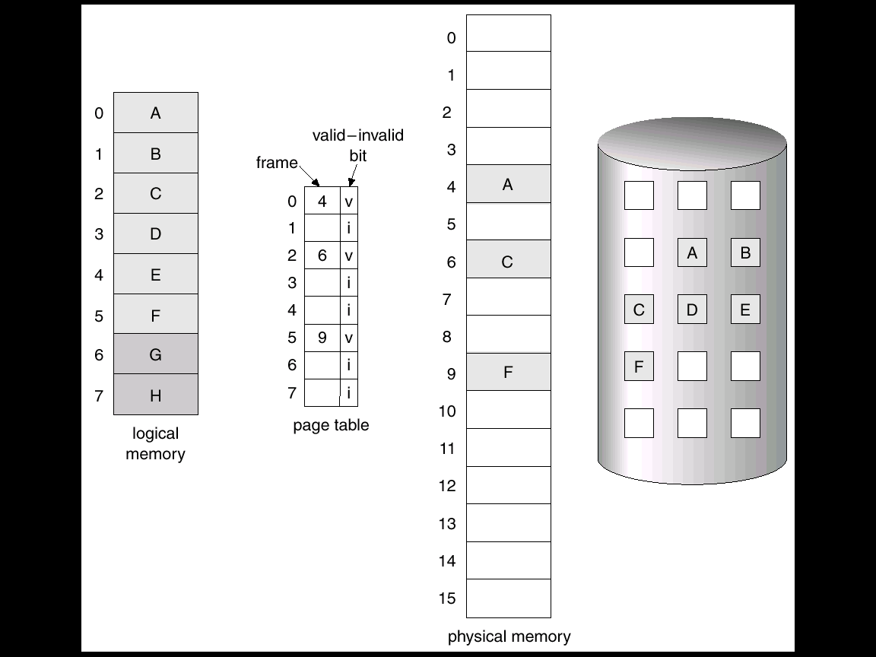

The transformation of data from virtual memory to main memory is referred by a mapping process.

Associative Mapping : The fastest and most flexible cache memory organization uses an associative memory. CPU generated address is first stored in Argument Register.
CPU address Main memory contains address and data of each word. If the address in argument register is matched (hit) with the address in main memory then the corresponding data of main memory is send to CPU. But, if the address in argument register is not matched (miss) with the address in main memory then the virtual memory is access for the word. The address-data pair is then transferred from virtual memory to an empty space in the main memory.
Main Memory
Argument Register

Address Data

01000 3450
02777 6710
22345 1234
… …
If there is no empty space in the main memory then a address-data pair which is not currently used is transferred (round-robin order) from main memory to virtual memory and the desired address-data pair is bring into the empty space in main memory from virtual memory. This event is called page replacement.

Direct Mapping : In this method the CPU address has two parts – Tag & Index. In general case there are 2^{N} words in virtual memory and 2^{K} words in main memory, where N>K. In Direct Mapping process, N bits are required to address virtual memory and K bits are required to address main memory. Index field is referred by K bits and Tag field is referred by N-K bits. In main memory each word contains tag & data field against each index address.
CPU address

- 000 000
Tag Index

Virtual
Memory

Main
Memory
… … …
… … …
77 777 777
Memory Address Memory Data Index

Tag Data

- 1220
… …
… …
… …
02 6710
Address
00 000 1220
… … … 000
00 777 2340
01 000 3450
… … …
01 777 4560 777
02 000 5670
… … … Main Memory
02 777 9710
… … …
Virtual Memory
When CPU generates memory request, then the index field is used for the address to access the main. The tag field of CPU address is compare with the tag field of the word in the main memory. If the two tags match then there is a hit and the desired data is read from the main memory. If there is no match occurs (miss) then the required word is fetched from virtual memory to main memory by updating the tag value. If main memory is full then page replacement technique is used.

File Attribute :
- Name : Name of the file for identification.
- Type : Supporting type of the file system.
- Location : Location of the file on the device.
- Size : Size of the file.
- Protection : Provides access control information regarding reading / writing / execution.
- Time, date and user identification : Provides information on creation, last modification and last use of the file. This information is used for protection, security and monitoring.

Access Methods : It deals with how data is accessed from files.
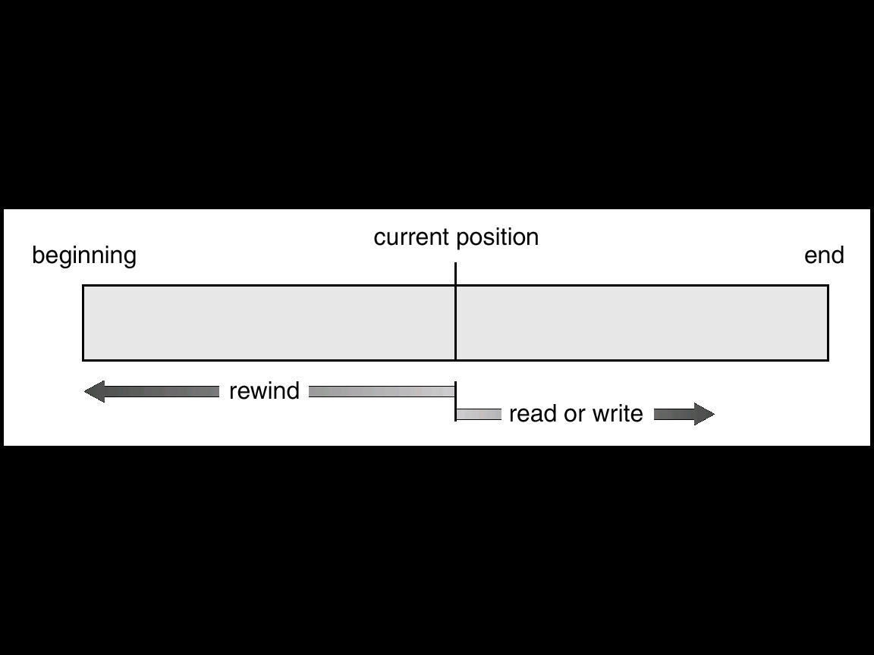
- Sequential Access : In this system, a process could read all the bytes or records in a file in order, starting at beginning, but could not skip around and read them out of order. E.g. Magnetic Tape.

- Direct Access : Here records are directly (randomly) accessed by their physical addresses. Hashing techniques are useful in locating data in direct access files. E.g. Database system.
- Indexed Sequential : Records are arranged in logical sequence according to a key contained in each record. Indexed sequential records may be accessed sequentially in key order or they may be accessed directly.
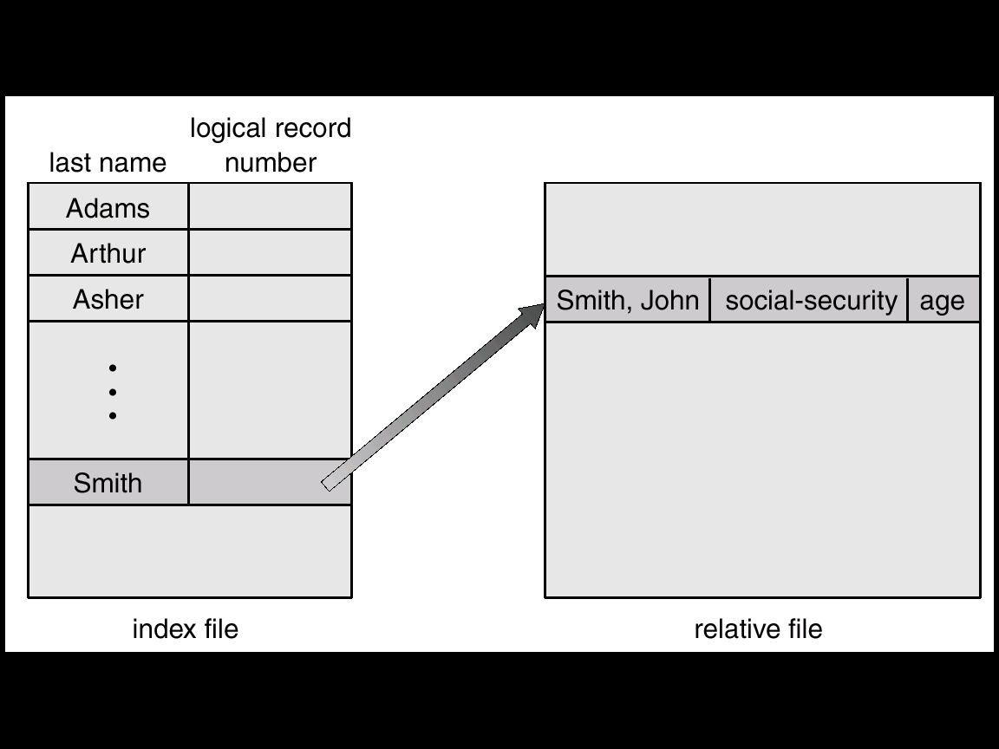

- Partitioned : Each sequential subfile of a main file is called a member. The starting address of each member is stored in the file’s directory. Partitioned files are used to store macro libraries.

File System & Directory Structure :
File system contains,
- Access methods – It deals with how data is accessed from files.
- File management – It deals with the mechanism for files to be stored, referenced, shared and secured.
- Auxiliary storage management – It deals with the file space in secondary memory.
- File integrity mechanisms – It checks the information integrity of a file.

To keep track of files, the file system normally provides directories. The directory can be viewed as a symbol table that translates file names into their directory entries. The following operation can be performed on directory –
- Searching – Searching a file entry in a directory structure.
- Creation – New files are created and added into directory.
- Deletion – Old files are removed from directory.
- Listing – listing of files along with contents in a directory.
- Renaming – Renaming of a file and its position in the directory structure.
- Traversing – Access each and every file within directory structure.

- Single-Level Directory : All files are contained in the same directory. The disadvantage is that the confusion of file names between different users.
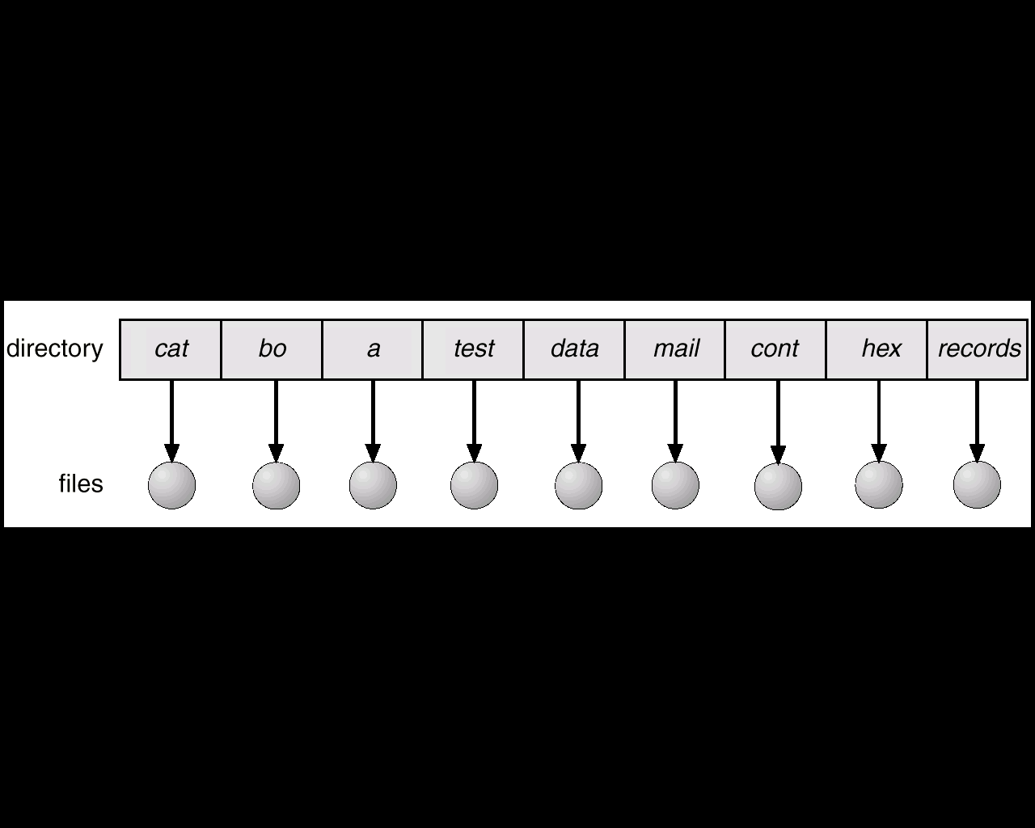

- Two- Level Directory : Each user has own file User File Directory (UFD). When a user job starts or user logs in, the system’s Master File Directory (MFD) is searched. The MFD is indexed by user name or account number. When a user refers to a particular file, only his own UFD is searched. Thus different users may have files with the same name, as long as all the file names within each UFD are unique. This structure isolates one user from another. This is advantageous when the users are completely independent. But it generates problem when one user needs to access a file of another user.
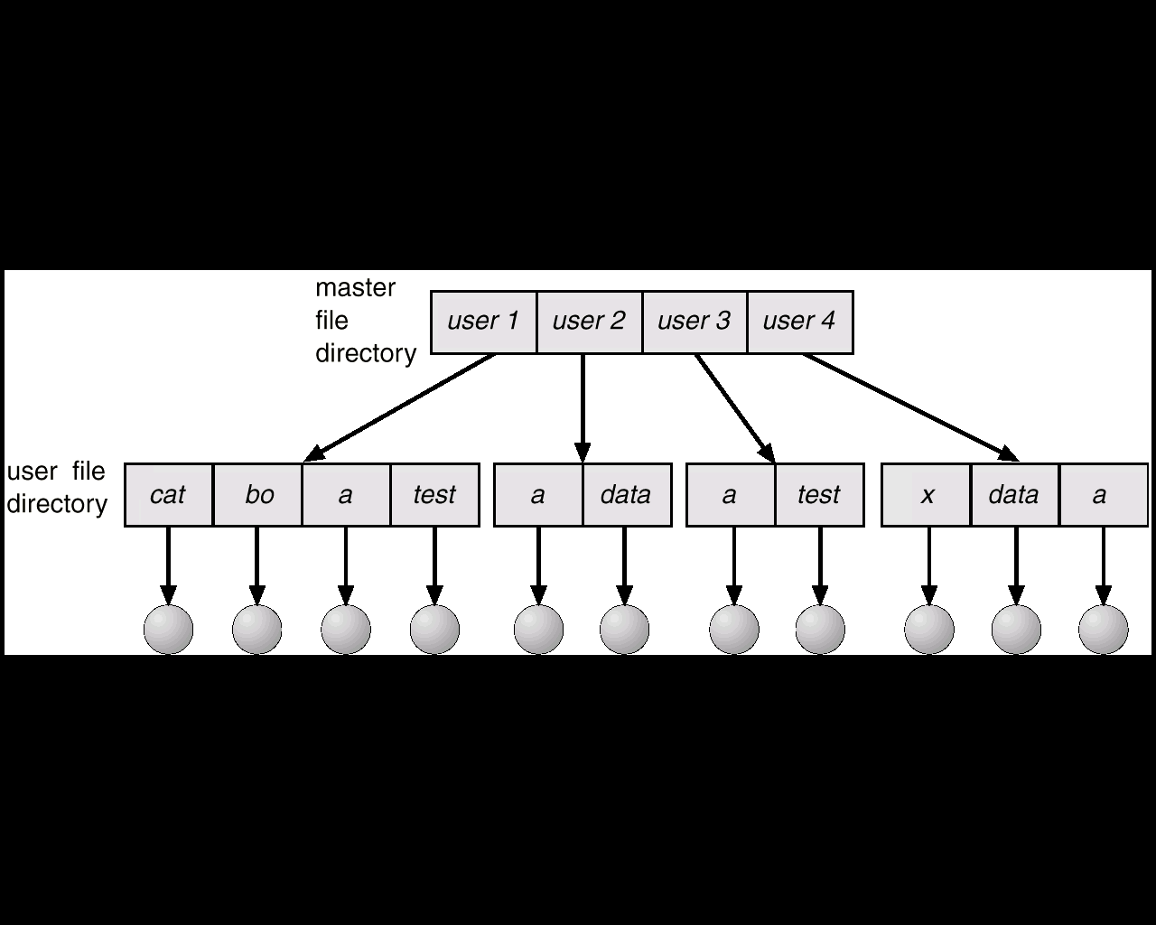

- Tree-Level Directory : The tree has a root directory. Every file in the system has a unique path name. A path name is the path from the root, through all the subdirectories to a specified file. A directory contains a set of files or subdirectories. When a reference is made for a file, initially the current directory of the user is checked, if the file is found in that current directory then it is served. Otherwise a system call is provided to locate the file through the actual path name.

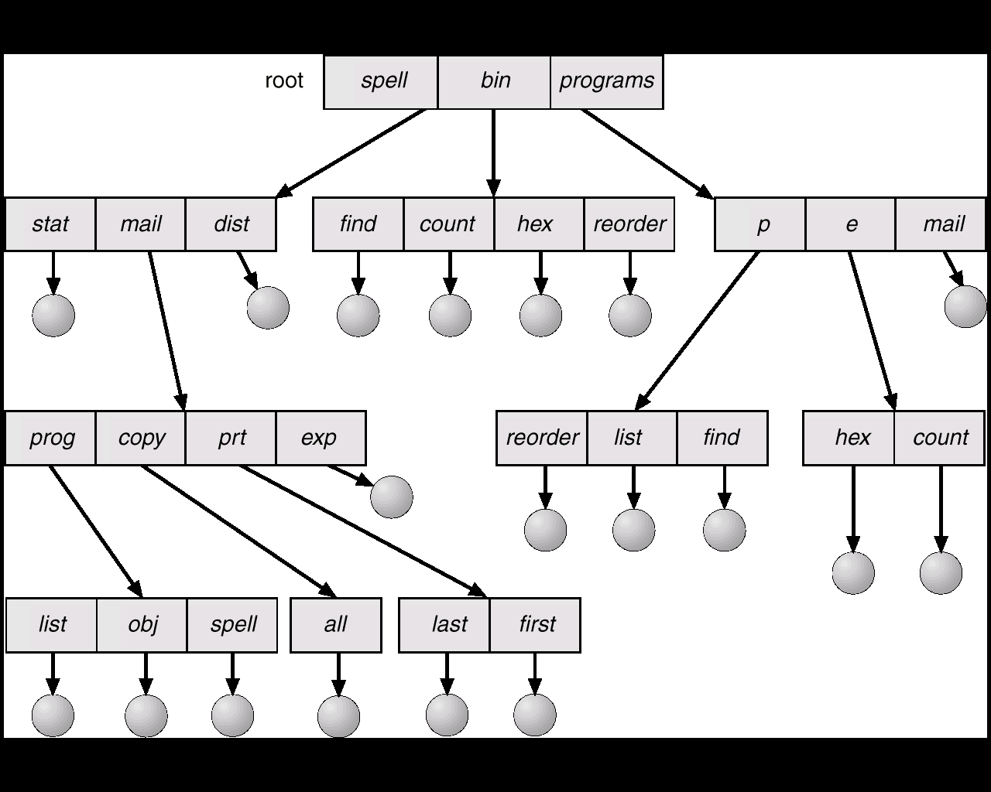

- Cyclic-Graph Directory : It allows subdirectories and files to be shared, but complicate searching and deletion.

- General Graph Directory : It allows complete flexibility in the sharing of files and directories, but sometimes requires garbage collection to recover unused disk space.

File Protection :
When information is kept as file in a computer system then one major concern is its protection from both physical damage (reliability) and improper access (protection).
Reliability is generally provided by duplicate copies of files. File system may be damages by power failures, head crashes, temperature fluctuation, vandalism etc.
Protection is provided by controlled access on files. Different file operations like read, write, execute, append, delete, list, rename, copy, edit etc. may also be controlled. File protection can be provided by passwords, by access list, or by special adhoc techniques.

Storage Placement Strategies (Allocation Methods) :
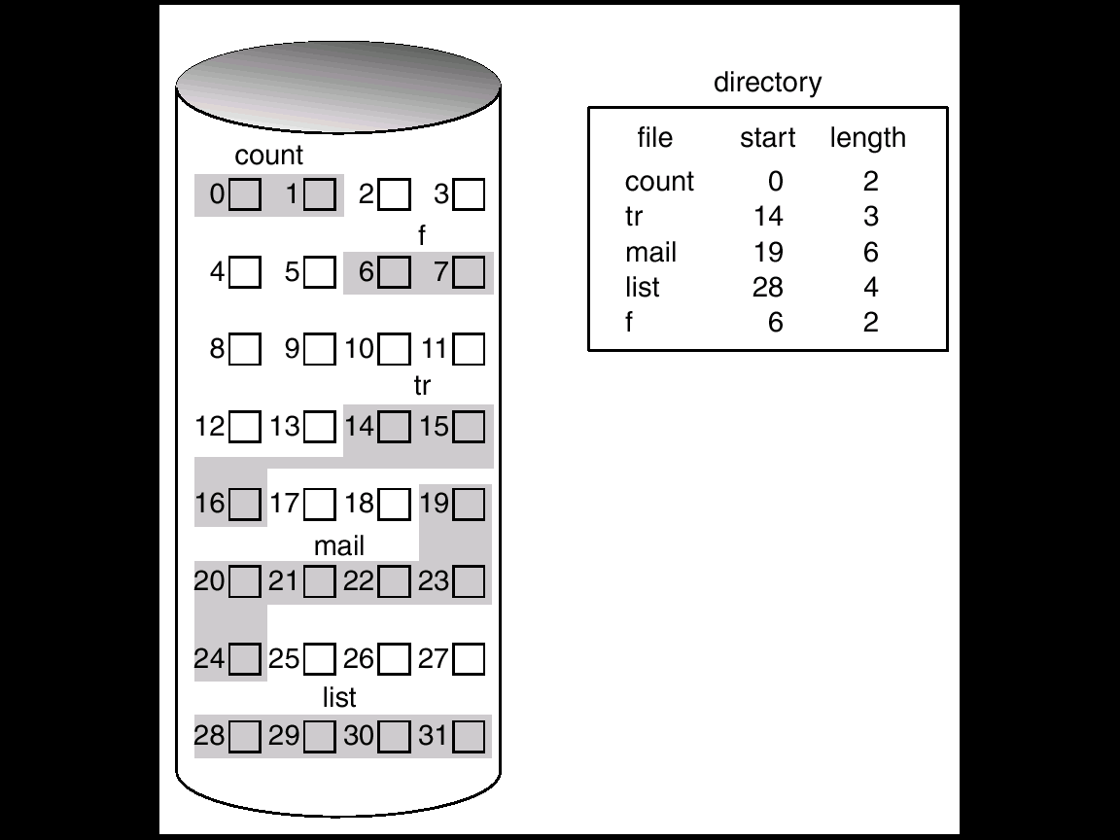
- Contiguous Allocation : In contiguous allocation, files are assigned to contiguous areas of secondary storage. A user specifies in advance the size of the area needed to hold a file to be created. If the desired amount of contiguous space is not available, the file can not be created. The directory entry for each file indicates the address of the starting block and the length of the area allocated for the file.
As files are deleted, the space they occupied on secondary storage is reclaimed. This space becomes available for reuse but may not be sufficient to allocate new flies. Hence external fragmentation occurs.

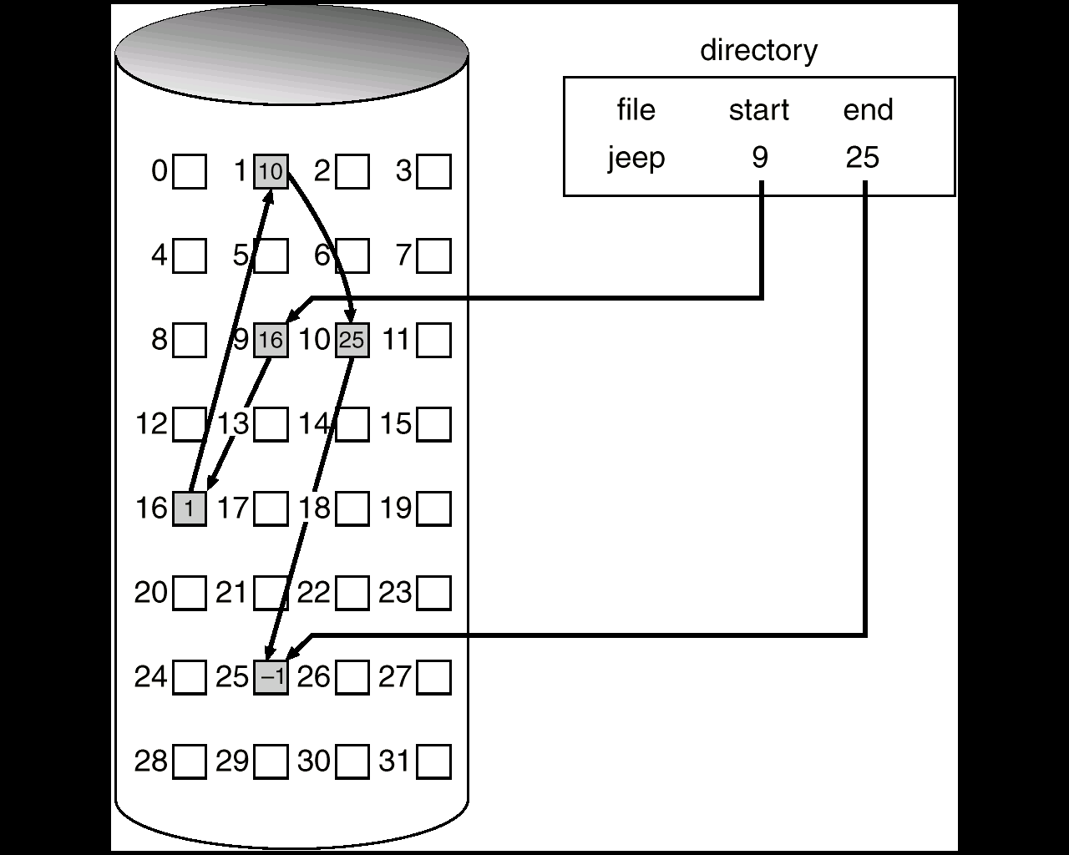
- Linked Allocation : With linked allocation, each file is a linked list of disk blocks, the disk blocks may be scattered anywhere on the disk. The directory contains a pointer to the first and last blocks of the file.
There is no external fragmentation occurs and no compaction is needed.
The major problem is that it can be used effectively for only sequential access files. Some space is wastage also due to use of pointers. Since the files are linked together by pointers scattered all over the disk then it may happen to lost a link, then data loss occurs (reliability problem).
- Indexed Allocation : each file has its own index block, which is an array of disk block addresses. The directory contains the address of the index block. To read the ith block, we use the pointer in the ith index block entry to find and read the desired block.
Indexed allocation supports direct access, without suffering from external fragmentation. It does not suffer from wasted space. The disadvantage of this scheme is that insertions can require the complete reconstruction of the index blocks.

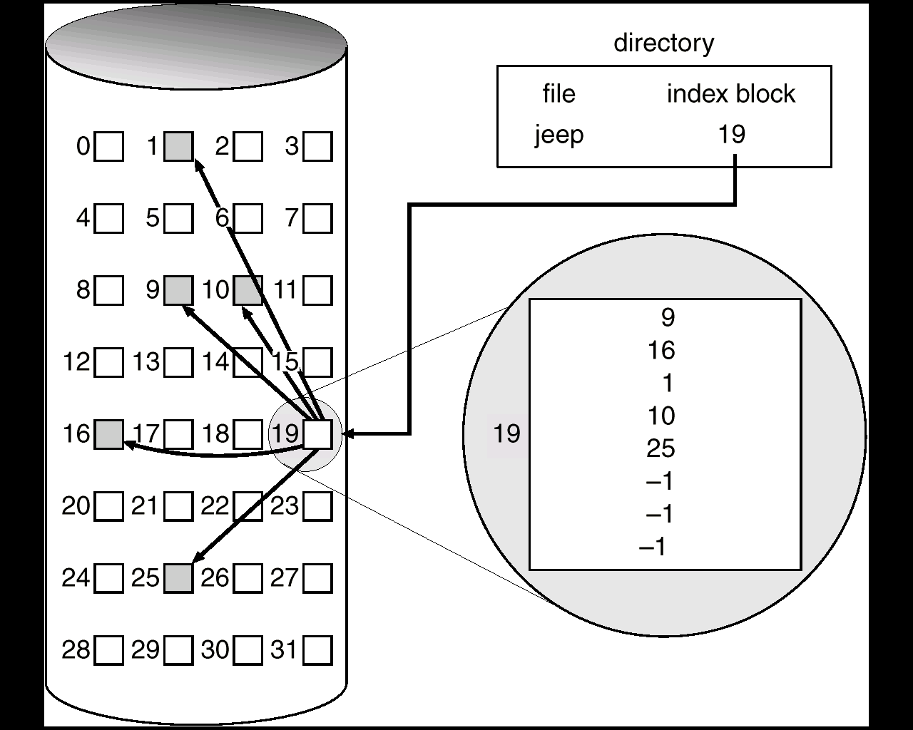

Free Space Management : Free space allocation method influences the efficiency of use of disk space, the performance of the file system and the reliability of secondary storage. The free space list records all disk blocks that are free. To create a new file, we search the free space list for the required amount of free space and removed them from free space list and utilize for the creation of the file. When a file is deleted, its disk space is added to the free space list.

- Bit Vector : The free space list is implemented by a bit map or bit vector. Each block is represented by a single bit. If the block is free the bit is 1, if the block is allocated the bit is 0. The main advantage is that it is simple and efficient to find the first free block or n consecutive free blocks on the disk.
For example, consider a disk where blocks 2,3,4,5,8,9,10,11,12,13,17,18,25,26 & 27 are free and rest are allocated. The free space bit map would be 0011110011111100011000000111.
- Linked List : The free blocks are linked together and a pointer points to the first block. For traversing this approach is not efficient.
- Grouping : The address of first n free blocks are stored in the first free block. The first n-1 of these blocks are actually free. The last block contains the addresses of another n free blocks, and so on.
- Counting : Several contiguous blocks may be allocated or freed simultaneously. Thus rather than keeping a list of n free disk addresses, we can keep the address of the first free block and the number n of free contiguous blocks that follow the first block.
Functions of I/O system
- To interface the operating system with the peripheral devices attached to the system.
- To manage access to these peripheral resources by various user level programs.
- To share resources in efficient manner.
- To manage and control I/O operations & I/O devices.
- To improve the efficiency of I/O.

Two level Device Driver
A printer device processes documents much slowly then the CPU can transmit them. Hence a printer spooler is a special program which holds the data sent by the CPU in a file or a directory which is then send to the printer as and when it is free. By doing so the user level programs can fire prints commands and can carry out other activities while the printing taken place in the background.

Printer SPOOLER
Polling : In this method the CPU polls for device status constantly as long as the device is required.
Interrupt driven method : The CPU interfaces are setup such that the CPU is interrupted only when a device is ready. Hence when the device is busy the system is free to service other request.

Briefly outline the Shortest Seek Time First disk scheduling with aging.
The shortest seek time first scheduling schedulers sets the next request to the served according to the minimum distance required for disk head movement. This may lead to starvation if requests come in near the current position of disk head while there are already existing requests which are far away from the current head position.
To overcome this aging is used. Here a function of the shortest seek time along with the sending time of request is taken into account. Hence even if a request is at a sector faraway from the current disk head its edge will make the operating system service it within a suitable time bound.

Disk Caching :
Cache is a region of fast memory that holds copies of data. It improves the I/O efficiency for files that are shared by applications. When the kernel receives a file I/O request, the kernel first access the buffer cache to check whether that region of the file is already available in main memory. If so, a physical disk I/O can be avoided or deferred.

Direct Memory Access : When relatively large amount of data transfer is needed then DMA technique is preferred. The speed at which the μp transfer the data is much higher than that of peripheral devices like HD or FD. In such a case the CPU has to wait for a longer time for two consecutive data transfer, to overcome this difficulty the data transfer between peripheral devices and memory takes place via DMA controller, where the CPU relinquishes the control of DB & AB to the DMA controller.

- Burst mode transfer : When data is transferred between memory and I/O devices using DMA then the μp is idle and is said to be in the HOLD state. The μp exists from this state only after an interrupt is received or after a DMA request is withdrawn by the peripheral devices. The duration of the HOLD state depends on the speed of the I/O devices, speed of the memory and the number of bytes to be transferred.

- Cycle Stealing transfer : An I/O device using the cycle stealing concept, requests the processor for a DMA cycle, transfer a byte or a word and withdraws the DMA request. After sometime when the device is again ready for data transfer it repeats the above process. Finally when the last data byte has been transferred the device interrupts the processor indicating the end of the delays its operation for one memory cycle to allow the direct memory I/O transfer to steal one memory cycle.

In Programmed I/O, I/O device access the memory via CPU. I/O instructions transfer data from source to CPU and then another special instruction transfer data from CPU to destination. CPU also must check periodically for the readiness of the I/O device. Thus CPU keeps idle or busy without any processing for majority of the time, hence it is a time consuming process.
In DMA, data are directly transferred from an I/O device to the memory or vice-versa without going through the CPU. The memory buses are time shared by the CPU & peripherals. It results faster data transfer.

Device Driver :
Device Driver is a program which interfaces the kernel with hardware. It is specific to the underline hardware i.e. different hardware resources have different device drivers. Its function is to provide an interface to the hardware for operating system and application programs.
They are usually of two types –
(1) Statically Linked : Statically linked drivers are those which are already present in the kernel.
(2) Dynamically Loaded : Dynamically loaded models are those which are loaded in the kernel where there is a request for interfacing with the particular hardware device.
A disk device is a block device and hence the device driver is responsible for managing blocks of data transfer from and to the harddisk. The controller also must take into consideration that various applications may simultaneously try to access the disk device. This may lead to certain scheduling criteria. The various scheduling algorithms that the disk driver used as FCFS,…. The disk driver program is usually statically linked to the kernel image & is responsible to mounting root file system of the device.

Double Buffering
Double buffering is used by a system in which on one hand there is comparatively a slower communication link. Two buffers are maintained in the following manner. The first CPU reads/ writes to one buffer. The slower link writes/reads to the other one. When one of the buffers sets full the device exchanges the data amongst the devices so that the CPU can continue to read / write to a buffer which has previously already been written or read from by the communication link. In this way double buffering helps to interface a fast link with a slower one.

Device Independence :
Device independence means implementation or coding which is not specific to any particular device usually the operating system has this kind of interface for device drivers for same class of hardware devices.

Block Device and Character Device :
Block Device Character Device
- Concept of linear array of blocks. 1. Concept of linear stream of byte.
- Provides file system interface. 2. Provides character stream interface.
- Basic commands are read, write, seek. 3. Basic commands are put, get.
e.g. memory mapped file access. e.g. data access through keyboard.
Disk scheduling algorithms : One of the responsibility of the operating system is to use the hardware efficiently. For disk drives, this means having a fast access time and disk bandwidth. The access time and the bandwidth can be improved by disk scheduling. If the desired disk drive and controller are available, the request can be serviced immediately. If the drive or controller is busy, any new requests for service will need to be placed on the queue of pending requests for that drive. For a multiprogramming system with many processes, the disk queue may often have several pending requests. Thus, when one request is completed, the operating system has an opportunity to choose which pending request to service next.

(1) First-Come First-Serve Scheduling :
First-Come First-Serve CPU Scheduling is the simplest scheduling algorithm.
E.g. a disk queue with requests for I/O to blocks on cylinders 98, 183, 37, 122, 14, 124, 65, 67 in that order. If the disk head is initially at cylinder 53, it will first move from 53 to 98, then to 183, 37, 122, 14, 124, 65 and finally to 67, for a total head movement of 640 cylinders.
Advantage : Simple
Disadvantage : Large head movement, hence slow

(2) Shortest-Seek-Time-First Scheduling :
SSTF algorithm selects the request with the minimum seek time from the current head position. Since seek time increases with the number of cylinders traversed by the head, SSTF chooses the pending request closest to the current head position.
E.g. a disk queue with requests for I/O to blocks on cylinders 98, 183, 37, 122, 14, 124, 65, 67 in that order. If the disk head is initially at cylinder 53. The closest request to the initial head position is at cylinder 65. The next closest request is at cylinder 67. From there, the request at cylinder 37 is closer than 98, so 37 is served next. Continuing we service the request at cylinder 14, then 98, 122, 124 and finally at 183. This scheduling method results in a total head movement of 236 cylinders.
Advantage : Improvement of performance, Lesser head movement than FCFS.
Disadvantage : May cause starvation.

(3) Scan Scheduling :
In the SCAN algorithm, the disk arm starts at one end of the disk, and moves toward the other end, servicing requests as it reaches each cylinder, until it gets to the other end of the disk. At the other end, the direction of head movement is reversed and servicing continues. The head continuity scans back and forth across the disk.
E.g. a disk queue with requests for I/O to blocks on cylinders 98, 183, 37, 122, 14, 124, 65, 67 in that order. The disk head is initially at cylinder 53. If the disk arm is moving toward 0, the head will service 37 and then 14. At cylinder 0, the arm will reverse and will move toward the other end of the disk, servicing the requests at 65, 67, 98, 122, 124 and 183.
The SCAN algorithm is sometimes called the elevator algorithm, since the disk arm behaves just like an elevator in a building, first servicing all the requests going up, and then reversing to service requests the other way.

(4) C-Scan Scheduling :
Circular-Scan is a variant of SCAN that is designed to provide a more uniform wait time. C-SCAN moves the head from one end of the disk to the other, servicing requests along the way. When the head reaches the other end, however, it immediately returns to the beginning of the disk, without servicing any requests on the return trip. The C-SCAN scheduling algorithm essentially treats the cylinders as a circular list that wraps around from the final cylinder to the first one.

Give a neat diagram showing the various layers of the I/O system, showing their main functions alongside. Also indicate how a ‘read’ command is processed through each layer.
Read request is generated by the application which is then trapped by the operating system. The operating system would then calculate the number of blocks required to satisfy the read command. This could be send to the I/O sub system for servicing. The I/O sub system would check whether the whole/part of the request is available in its cache. The blocks to be read would be translated to track sector head format and send to the scheduler. The scheduler would call the device driver to process each of the request. The device driver would then write the appropriate command to the device registers.

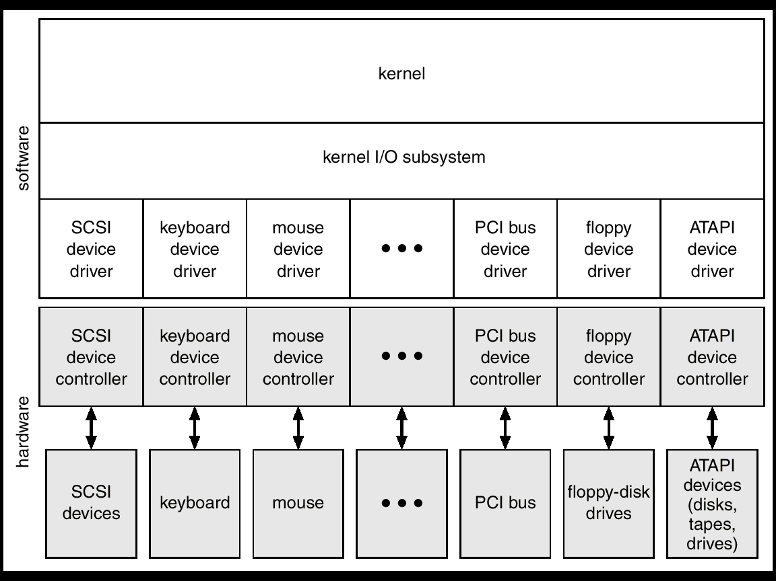

Protection Policies & Mechanisms :
Protection refers to a mechanism for controlling the access of programs, processes, or users to the resources (files, memory segments, CPU) defined by a computer system. This mechanism must provide a means for specification of the controls to be imposed, together with some means of enforcement.
The role of protection in a computer system is to provide a mechanism for the enforcement of the policies governing resource use. Some policies are fixed in the design of the system & others are formulated by the management of a system. Mechanism determines how something will be done. Policies decide what will be done.
There are three aspects to a protection mechanism:
- User identification (authentication) : Make sure we know who is doing what.
User identification is most often done with passwords. This is a relatively weak form of protection.
- A password is a secret piece of information used to establish the identity of a user.
- Passwords should not be stored in a readable form. One-way transformations should be used.
Passwords should be relatively long and obscure.
- Authorization determination : Must figure out what the user is and is not allowed to do. Need a simple database for this.
Must indicate who is allowed to do what with what. Draw the general form as an access matrix with one row per user, one column per file. Each entry indicates the privileges of that user on that object. There are two general ways of storing this information - access list and capability list.
Access Lists : Each column of the access matrix can be implemented as an access list for each file. With each file, indicate which users are allowed to perform which operations.
- In the most general form, each file has a list of pairs.
- It would be tedious to have a separate listing for every user, so they are usually grouped into classes. For example, in Unix there are three classes: self, group, anybody else (nine bits per file).
- Access lists are simple, and are used in almost all file systems.
Capabilitiy list : Each row of the access matrix can be implemented as a capability list for each user. With each user, indicate which files may be accessed, and in what ways.
- Store a list of pairs with each user. This is called a capability list.
- Typically, capability systems use a different naming arrangement, where the capabilities are the only names of objects. We cannot even name objects not referred to in our capability list.
- In access-list systems, the default is usually for everyone to be able to access a file. In capability-based systems, the default is for no one to be able to access a file unless they have been given a capability. There is no way of even naming an object without a capability.
- Capabilities are usually used in systems that need to be very secure. However, capabilities can make it difficult to share information. Nobody can get access to our stuff unless we explicitly give it to them.
- Access enforcement : Must make sure there are no loopholes in the system.
Some part of the system must be responsible for enforcing access controls and protecting the authorization and identification information.
- Some portion of the system must run unprotected. Thus it should be as small and simple as possible. E.g. the portion of the system that sets up memory mapping tables.
- The portion of the system that provides and enforces protection is called the security kernel. Most systems, like Unix, do not have a security kernel. As a consequence, the systems are not very secure.
- A hierarchy of levels of protection is needed, with each level getting the minimum privilege necessary to do its job. However, this is likely to be slow (crossing levels takes time).

Domain of Protection :
Computer systems contain many objects. These objects need to be protected from misuse. Objects may be hardware (memory, CPU time, I/O devices) or software (files, programs, semaphores). An access right is the permission to perform an operation on an object. A domain is a set of access rights. Processes execute in domains and may use any of the access rights in the domain to access & manipulate objects.

Hardware Protection :
To improve system utilization, the operating system shares system resources among several programs simultaneously. With spooling one program might have been executing while I/O occurred for other processes, the disk simultaneously held data for many processes. Multiprogramming put several programs in memory at the same time.
This sharing created both improved utilization and increased problems. When the system was run without sharing, an error in a program could cause problems for only the one program that was running. With sharing, many processes could be adversely affected by a bug in one program.
Without protection against these sorts of errors, either the computer must execute only one process at a time, or all output must be suspect. A properly designed
operating system must ensure that an incorrect program cannot cause other programs to execute incorrectly.
Many programming errors are detected by the hardware. These errors are normally handled by the operating system. If a user program fails in some way then the hardware will trap to the operating system as an interrupt. Whenever a program error occurs, the operating system must abnormally terminate the program. This situation is handled by the same code as is a user-requested abnormal termination. An appropriate error message is given and the memory of the program is dumped. The memory dump is usually written to a file so that the user can examine it, and perhaps can correct and restart the program.

Dual-Mode Protection : The dual mode of operation provides a protection for operating system from errant users, and errant users from one another. The hardware allows privileged instructions to be executed in only monitor mode. If an attempt is made to execute a privileged instruction in user mode, the hardware does not execute the instruction, but rather treats the instruction as illegal and traps to the operating system.

Access Matrix :
The Access Matrix is a general model of protection. The access matrix provides a mechanism for protection without imposing a particular protection policy on the system or its users.
The rows of the access matrix represent domains, and the columns represent objects. Each entry in the matrix consists of a set of access rights. Because objects are defined explicitly by the column, we can omit the object name from the access right. The entry access (i,j) defines the set of operations that a process, executing in domain D_{i}, can invoke on object O_{j}.
It is normally implemented either as access lists associated with each object, or as capability lists associated with each domain. We can include dynamic protection in the access matrix model by considering domains and the access matrix itself as objects.
It is implemented in (i) Global Table (ii) Access Lists for objects (iii) Capability lists for domains.

File System Protection :
File system protection is done on basis of –
- Operations that can be performed on file : The various operations that can be performed on file are reading or writing or file may be executable. This is done by writing or the file may be executable. This is done by keeping certain protection bits which are only modification only by owner of the file or the super user.
(2) Access restriction on file depending on user : Usually there are three categories of user for a particular file - the creator, the group of the creator and other users. Access write is maintained for each category by the user or super user.

