Process Control Block – Each process is represented in the OS by a process control block or PCB. It contains many pieces of information associated with a specific process

- Process State
- Program Counter
- CPU registers
- CPU scheduling information
- Memory Management information
- Accounting information
- I/O status Information

Threads – The process model discussed so far has implied that a process is a program that performs a single thread of execution. For example when a process is running a word processor, a single thread of instruction is being executed. The single thread of control allows the process to perform only one thread at a time. For example you can’t type in characters and run the spell checker simultaneously. Many modern OS have extended the process concept to have multiple thread execution.

Process Scheduling

The objective of multiprogramming is to have some process running at all time to maximise CPU utilization. The objective of time-sharing is to switch the CPU among processes so frequently that users can interact with each program while it is running. To obtain this goal the process scheduler selects an available process from a process pool for program execution on the CPU.

Scheduling Queues

As a process enters the system, they are put into a job queue, which consists of all the processes in the system. This queue is generally stored as a linked list. A ready queue header contains the pointer to the first and final PCBs in the list. Once the process is allocated the CPU and is executing, one of several events could occur.
- The process could issue an IO request & then be placed in an IO queue
- The process could create a new sub process and wait for the subprocess’s termination.
- The process could be removed forcibly from the CPU, as a result of an interrupt, and be put back in the ready queue.

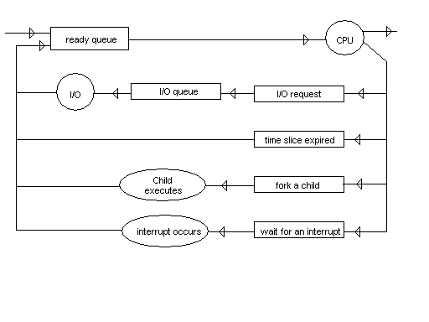
Multithreading

Benefits
- Responsiveness – it may allow a program to continue even if part of it is blocked or is performing a lengthy operation. So it increases responsiveness to the user.
- Resource Sharing – the benefit of sharing code and data is that it allows an application to have several different threads of activities within the same address space.
- Economy – Allocating memory and resources for process creation is costly. Since threads share the resources so it is economical.
- Utilization of Multiprocessing architecture – the multiple threads run in the multiple processors and thus increases efficiency.

Multithreading Models

- Many-to-one Model – maps many user level threads to one kernel thread
- One-to-one Model – maps each user thread to a kernel thread.
- Many-to-many Model – multiplexes many user level thread to a comparatively small number of kernel threads

Process Scheduling

CPU scheduling is the basis of multiprogrammed OS. By switching the CPU among processes, the OS can make the computer more productive.

CPU Scheduling – Whenever the CPU becomes idle; the OS must select one of the processes in the ready queue to be executed. The selection process is carried out by the short-term scheduler (or CPU scheduler). The scheduler selects the process from the list of processes that are ready to be executed and allocates the CPU to that process. The ready queue must not be a FIFO queue. It can be priority queue, tree or an unordered linked list.

Preemptive Scheduling

CPU scheduling my take place under the four circumstances

- When a process switches from the running state to the waiting state
- When a process switches from the running state to the ready state
- When a process switches from the waiting state to the ready state
- When a process terminates

When scheduling occurs under the conditions 1-4 then it is called nonpreemptive scheduling or cooperative scheduling.

- Dispatcher – The dispatcher is the module that gives control of the CPU to the processes selected by the short-term scheduler. The dispatcher should be as fast as possible, since it is invoked during every process switch. The time it takes for the dispatcher to stop one process and start another running is known as dispatch latency.

Scheduling Criteria

Different CPU scheduling algos have different properties. In choosing the algos we should consider the following points.

- CPU Utilization – We want to keep the CPU as busy as possible
- Throughput – It is a measure of work for CPU, measured as number of processes completed per unit time.
- Turnaround time – the time from the point of submission to the point of completion is called turnaround time.
- Waiting Time – It is the time that a process waits waiting in the ready queue.
- Response Time – The time until which a response is produced.

Scheduling Algorithms

- First Come, First Served Scheduling – the implimentation is by a FIFO queue. However the average waiting time is long. There is also a defect called a convoy effect. As all the other processes wait for one big process to get off the CPU. This effect results in lower CPU and device utilization than might be possible if the small processes were allowed to go first. This algorithm is a nonpreemptive, once the CPU has been allocated to a process, the process keeps the CPU until it terminates or requests I/O. So this algo is particularly troublesome for time-sharing systems.

- Priority Scheduling – A priority is associated with each process and the CPU is allocated to the process with the highest priority. Equal priority are scheduled is the FCFS system. Priority scheduling can be either preemptive or nonpreemptive. A major problem is indefinite blocking or starvation. A process that is ready to run but waiting for the CPU can be considered blocked. A priority scheduling can leave some low priority processes blocked indefinitely. Two things can happen, either the process will eventually be run after a long wait when the system is finally lightly loaded or the system will crash loosing all the low priority processes.
A Solution to this problem is ageing. It gradually increases the priority of a process as it waits. So priority increases proportionally with the wait time.

- Shorted Job first Scheduling – The SKF algo is a special case of priority scheduling, where the priority is the inverse of the next CPU burst, larger the CPU burst lower is the priority. When CPU is available is assigned to the process with the shortest next CPU burst. When the next CPU burst of two processes are same FCFS algo is used to break the tie. The SJF scheduling can both be preemptive or non preemptive. In a preemptive situation if a process arrives with a shorter next CPU burst than the running process the running process will be preempted and the new process will be allocated the CPU. In the nonpreemptive situation the running process is allowed to be completed.

- Round Robin Scheduling – It is specially designed for time-sharing system. Here is a concept of time quantum, which is generally 10 to 100 milliseconds. The ready queue is treated as a circular queue. The CPU schedule goes round the circular queue and allocates the CPU to each program for 1 time quantum.

Critical Section Problem – Galvin Pg 189
Deadlock & starvation – Galvin Pg 200
The Dining Philosophers Problem – Galvin Pg 203
Deadlock Characterization – Galvin Pg 240
Methods for Handling Deadlocks – Galvin Pg 243
Bankers Algorithm – Galvin Pg 251

