October 07, 2002

INTEREST RATES (%)
CCY | 3M LIBOR | 6M LIBOR | 3Y IRS | 5Y IRS
USD | 1.76000 | 1.67000 | 2.65 | 3.33
GBP | 3.93000 | 3.92500 | 4.44 | 4.69
JPY | 0.07125 | 0.07688 | 0.18 | 0.35
EUR | 3.25138 | 3.12863 | 3.56 | 3.97

12 month Libor – 5 Year History
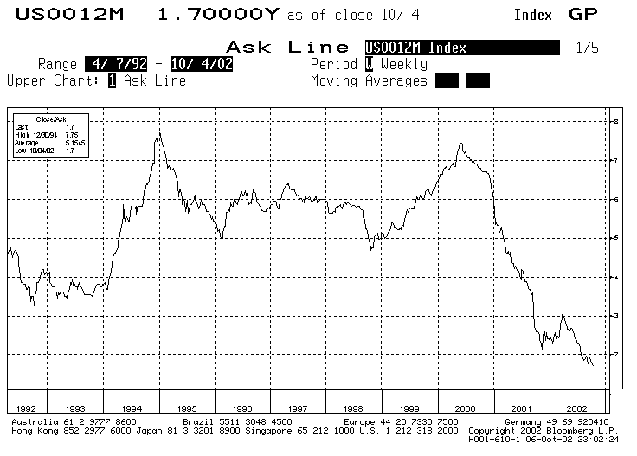

NEWS and VIEWS
Last Week’s Hot News:
- U.S. Stocks Tumble, Ending 6th Losing Week; Dow Near 5-Year Low
- U.S. Ports Stay Shut as Groups Seek White House Help
- US Airways' Bankruptcy Grounds Airport Muni Bonds
- Philip Morris Must Pay Smoker $28 Billion, Jury Says
- CEOs Say They're Concerned U.S. Recovery Is Stalling

We’re sorry if we sound as defensive as Billy Joel in “We didn’t start the fire” (for those of us who grew up with gems from the Piano Man). But the above were just the weekend headlines! Clearly, despite the better unemployment figures revealed last week, the U.S. economy continues to be in the grip of slowdown fever. While the unemployment figures have caused intra-meeting rate cut fears to subside, clearly we will continue to see soft rates for the foreseeable future. Given that expectation, we give below an idea that would seem to serve the hedging needs of a lot of our clients give the feedback we have received from a number of you in the last couple of weeks.

IDEA FOR THE WEEK –5 Year Zero-Cost Cap
Notional Amount USD 25,000,000
Client Pays 12MLIA + 50 bps (Annual,A/360) with a Coupon Cap @ 4.50%
Alternatively 12MLIA (Annual,A/360) with a Cap @ 5.25%
Client Receives 6 month USD Libor(Semi-Annual,A/360)
Opportunity for the Client This swap is based on the view that most of us remain unconvinced about U.S. economic recovery, but unfortunately, the need to hedge some of the floating rate portfolio remains. The client receives 6 month Libor to pay the underlying debt, and moves the liability through this swap to 12 month Libor-in-arrears paid annually. On top of this, the client buys a cap on 12 month LIA to quantify the maximum interest expense. With rates not expected to move up anytime in the near future (rate cut fears still persist) this swap reduces the negative carry (if any) that the client faces while providing an absolute cap on interest expense. We provide two alternative prices to suit the needs of different risk classes. Current 12ML is @ 1.70%.and the average for the last 5 years was 5.15%.

CURRENCY AND INTEREST RATE FORECASTS
CCY | Sep 30,02 |  | Dec 31,02 |  | Sep 30,02 |  | Dec 31,02
USD |  |  |  |  |  | 1.75% |  | 1.75%
GBP |  | 1.5600 |  | 1.5000 |  | 3.50% |  | 3.50%
JPY |  | 120.00 |  | 130.00 |  | 0.10% |  | 0.10%
EUR |  | 0.9900 |  | 1.0500 |  | 2.75% |  | 2.75%

