Josh Hamilton Rumblings
By Jayson Stark
ESPN.com

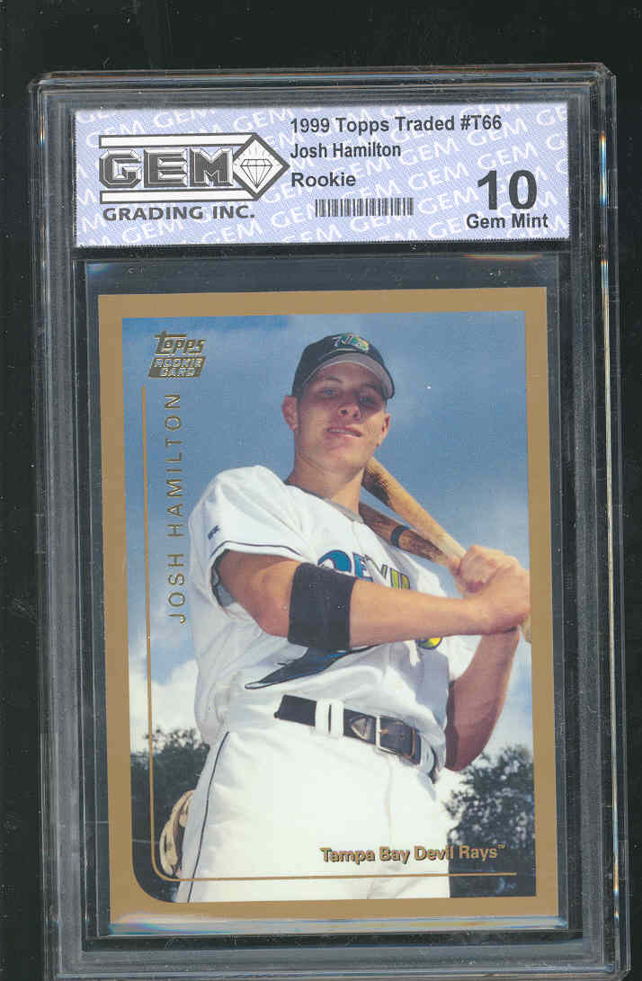

The saddest stories in sports are the stories of players who waste their talents and lives. So how do we measure how sad the story is of Josh Hamilton, suspended for the season by Major League Baseball for a violation of its non-steroid drug policy?

Five years ago, when the Devil Rays held the No. 1 pick in the June draft, they had a nearly impossible choice -- Josh Hamilton or Josh Beckett. Now, even though Beckett has won a World Series MVP award and Hamilton has dropped off the planet, the man who made the decision to take Hamilton says: "I'd still do it again."

"It was a win-win situation," said Dan Jennings, then the scouting director of the Devil Rays, now (ironically) an assistant GM for the Marlins. "You had a No. 3-or-4 hole hitter or a No. 1 starter. You couldn't go wrong. It was just which you preferred, the pitcher or the hitter."

Obviously, that choice did go wrong. But we've never found anyone who saw Hamilton play in high school and foresaw a kid who would have two dozen tattoos and at least two drug suspensions five years later.
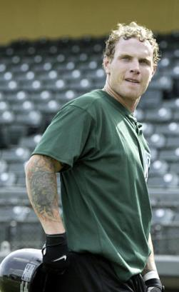

"That kid reeked of baseball," Jennings said. "He'd come out, kiss grandma and go play. I remember one game, he hit a home run and then came back and he was the bat boy. So I don't want him to become another Brien Taylor (No. 1 overall in 1991) or Mark Merchant (No. 2, after Junior Griffey, in '87), who never became what he should have been."

But that, of course, is where Hamilton is heading, unless he undergoes a miraculous transformation in the next 12 months. By next spring, it will have been 2½ years since he played a professional game.

"There was nothing he couldn't do," said Hal McRae, who has been a hitting coach, manager and special advisor for the Rays. "But once he comes back, it won't be ability that determines whether he makes it. It will be attitude. The two years he lost, he can still make up, because he's still young. But he'll have to bust his butt to get back.

"I've seen enough stories like this to know that when a guy like this comes back, he's not even the same person. He looks the same, but he's not. He won't even think you view what he does the same. You hope you get the same person back, but you don't. You've lost that guy. You just hope the guy who comes back still wants to play bad enough. If he wants it bad enough, he can still get it. But he's got to want it."

So in a year, will Josh Hamilton have enough awareness of how much he's lost to finally get back on the path to fulfilling his potential, as a player and a human being? That's a question no one can answer yet -- even him.

