The Tramp is an Artist
By Melanie Jones
Word Count:
Art 1030 section 15

The Tramp is an Artist

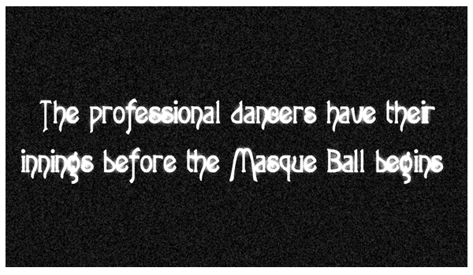
The picture jumps a little bit as the scene starts, showing a man and woman, both obviously well trained dancers, taking the center of the floor in a large room. They prance and twirl, reminding one of ballet if it had been designed for a ballroom, until our attention is pulled elsewhere.

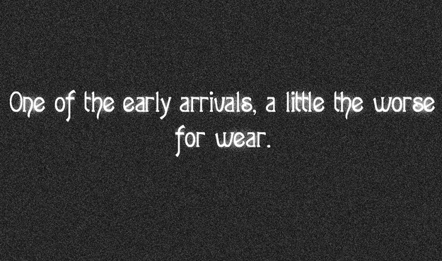
For a complete change of mood, we now see two girls in knee length ruffled dresses, very stylish for the 1910 era, long hair in curls, and they’re hand in hand doing a simplistic form of the cancan to the side of the dance floor. Behind them, a man in his early twenties who is probably already drunk even though the party has not yet started, staggers in and spots the two girls. Smiling, and thinking nothing of it, he walks up and takes one of the girls by the arm and starts to kick, imitating their dance. But he’s the girls are taken by surprise and jump away, leaving him to lose his balance and fall on his rear. A man comes up to him and tells him to leave the girls alone and to check his hat. Once he leaves, the young man says goodbye to the girls but they only wave at him to leave quickly. When he finally starts to walk away, they begin to dance again as if he had never shown up.
At hat check, without even looking, he places his hat on the head of the girl manning the desk. She, not very pleased, takes the hat off and takes it and his cane to a shelf. When she comes back with the claim ticket, he makes eye contact with her and sparks start to fly … at least for him. He tries to hold her hand while taking the ticket, but she pulls it away. He winks and nods towards the dance floor, but she snubs him.¹
This is a crude sketch at best of what the young man would eventually become. Often loveable, always down on his luck, Charlie Chaplin was definitely one of a kind. He took advantage of nearly every angle of human existence and poked fun at it: taught us to laugh at the hard times without hiding the pathos that often accompanied the scene. It was this ability that kept him making movies for over fifty years.

Charles Spencer Chaplin was born on April 16th, 1889 in England to poor stage actors. His father left the household early in his childhood and died soon after that, leaving Charlie, his mother and his half brother to support themselves. After Mrs. Chaplin became ill and lost her ability to sing, and therefore, her ability to perform, she and the children had to get jobs in a local workhouse, where at around age five, Charlie was the youngest worker.
At six years old he made his stage debut, which provided his family with only a few cents, but it sparked something that would remain with him for the rest of his life. As times got harder for the family and Mrs. Chaplin’s mental health deteriorated enough to admit her to a psychiatric hospital, the two boys supported themselves with acting jobs. With no child labor laws at that time, they were able to keep themselves going with little or no adult supervision. When Charlie reached his mid teens, he joined Fred Carno’s Pantomime Company, which was a stage show that toured England and France, and eventually America.
The frequent trips to the United States were essential to the shaping of the young man’s future. In 1912 he met Mack Sennett, a comedy film producer with Keystone, and before long, Charlie quit the touring stage show and started making short silent films. The films were far from polished: the acting styles of all the actors were very stylized and not at all realistic. There was little or no play to emotion other than humor, and the main actions were “the chase”, falling down, and kicking other people in the rear.
His characters in the beginning were varied. He was everything from a reporter to a villain until 1915, where the character of the tramp began to evolve. This is perhaps the most famous persona ever imagined, one that is easily recognizable even in silhouette.

Sources

1. “Charlie’s Recreation” produced by Mack Sennett
© 1914
My Autobiography by Charles Chaplin
Simon and Schuster © 1964
Gilbert’s Living with Art 6th Edition by Mark Getlein
McGraw Hill © 2002 pp. 230-231
Classics of the Silent Screen by Joe Franklin
Citadel © 1959 pp. 144-146
100 Years of Hollywood – A Century of Movie Magic by Carol Krenz
Metrobooks © 2000 pp. 58-61
A History of Films by John L. Fell
Holt, Rinehart & Winston © 1979 pp. 97-99
Film by Andrea Gronemeyer
Barron’s © 1998
“Modern Times” written and directed by Charlie Chaplin
© 1936

