2002 Sponsorship
Proposal

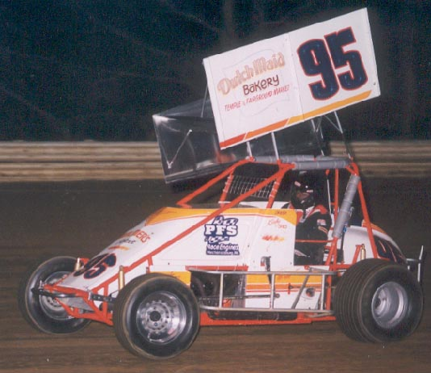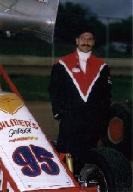

To our Potential Sponsor

As we finish one season and begin to look forward to another we also must evaluate our goals for the upcoming season. As part of this process we would like to offer an opportunity to you to be part of the racing experience by sponsoring our team in the upcoming season set to begin in March of 2002. As part of the sponsorship relation ship you will receive the opportunity to advertise at one of Americas fastest growing spectator sports. Auto racing has always been a positive venue to reach potential consumers with various products from household cleaners to auto parts and supplies.
The Dirt Track Racing Fan:
Average age 31
64% are married
52% have two or more children
91% own one, 52% own two automobiles
89% own variety of audio and video equipment
15% travel more then 75 miles to attend the races
54% are home owners
54% attend more then half of the season’s events
Large percentages have and use credit cards on a regular basis
69% read the weekly track program
Some of the sponsors that are seen at local events such as Pepsi, Land’O Lakes, Restaurants, Home Appliance Companies and Auto dealers have seen the advantages of advertising within the local auto racing circuits. With a wide range of fans attending each event the opportunities are wide and reach a very diverse group of people from housewives to children.
The division that we are a part of receives attention in several local and regional news papers as well as TV and radio. As well as a very cooperative Racing facility and management who work with the teams and sponsors to enhance the advertising opportunities by allowing sponsorship of race nights, individual races and special events. At these events there can be promotional stands, the car on display and or driver autograph sessions to help promote you product or service.
The Winged Super Sportsman class at Silver Springs is the featured class along with Late Models and Street Stock class. The night starts with hot laps giving the teams an opportunity to get some heat in the motors and get a feel for the car. The Wing Sportsman class then will normally run 5 qualifying events with up to 12 cars per event. The top 4 finishers in the qualifying events will advance to the feature event. Those that do not qualify will be split into two consolation races to attempt to reach the main event in the last opportunity to qualify for the night. The consolation races will place the top 3 finishing cars into he feature event. The feature events are generally 25 laps with several larger shows through out the season.

The Winged Super Sportsman class we are participating in is very competitive and exciting and the featured class every week at Silver Springs Speedway. The class attracts over 55 cars a week. With multiple winners of qualifying events and Feature events the list of drivers over the course of the season in these two categories is long which is a testament to the level of competition and that on any given night someone different may win.
Class: Super Sportsman
Chassis: LPS
Engine: 358 cubic inch Small Block Chevrolet
Owner/Crew Chief: Harry Nunemacher, Cressona Pa
Driver: Kirby Sites, Hamburg, PA
The car is maintained in Cressona Pa., which is approximately 1 hour from the speedway, which is located just outside of the Harrisburg area on the Carlisle Pike highway in Mechanicsburg, Pa.
Silver Springs Speedway has been offering some of the best racing entertainment for over forty-five years. The track offers three weekly classes that average over thirty cars a night each. The track is very fan friendly and offers affordable entry fees and children under twelve are free. The racetrack is very helpful in helping the car owners in their attempts to gain added exposure for their sponsors. The racetrack its self is a 3/8-clay oval racetrack, and is always in good race condition. This is always an exciting night and is a great place to treat family, friends, and business associates to a great night out. Be part of one of this countries fastest growing spectator sport. We hope you would take advantage of this opportunity to advertise your product and become part of the excitement.
Car owner Harry Nunemacher has been actively involved in the Super Sportsman class as Crew Chief and Crew Chief/Owner for over 15 years and has had much success in the division posting Rookie of the Year honors with a previous driver, as well as multiple win seasons accounting for numerous victories while working with several different drivers. His involvement in racing has been in several classes of racing as a Crew Chief including Small Block Modified, and URC Sprint cars, posting wins in both classes.
There are several reasons for sponsoring a race team that can improve on your public relations and build consumer support from some of the most loyal fans.
- Build a winning image among your targeted audience.
- Build sales opportunities for your company before, during, and after each race.
- Build employee morale.
- Earn publicity exposure in the local regional print and broadcast media.
- Increase visibility through trade show appearances and vendor/supplier media relations.
- Create a high excitement-merchandising vehicle for cross promotional and tie in opportunities
- Enhance client and supplier loyalty and interest.
- Distinguish your company from your competition.
- Is an alternative too conventional advertising media.
- Broaden the group that sees your product name on a normal basis.

Rookie Season

Silver Springs Speedway
Qualified for 10 Races
1 top ten
1 top 15
8 top 20
1 Heat win
Sportsman Tour

1 Top 5 at Big Diamond Speedway

Past Accomplishments:

“Rookie of the Year”
1987 Street Stock Division Big Diamond

“Sportsman Award”
1989 Street Stock Division Big Diamond

“Track Championship”
1998 NASCAR Pro Truck Big Diamond

“Track Champion”
1999 Street Stock Division Silver Springs

Hard Charger Award Winner
1999 Street Stock Division Silver Springs

Hard Charger Award Winner
2000 Street Stock Division Silver Springs

1999 Street Stock 40 Winner

2001 Sportsman Tour Rookie of the Year Award

Race Tracks
Home Track:
Silver Springs Speedway, Mechanicsburg Pa
Tour Tracks:
Williams Grove Speedway, Mechanicsburg PA,
Port Royal Speedway, Port Royal Pa
Lincoln Speedway, Abbottstown Pa, Selinsgrove Speedway, Selinsgrove PA, Big Diamond Speedway, Minersville PA

Big Diamond 2001 Web Site
On August 3, West Side Wood Products and Hamburg's Dark 'n Go Tanning
Salon will bring the Super Sportsman cars to Big Diamond on a card with the
NASCAR Modifieds and Roadrunners. The winged sportsman field is seeing a
clash of the veterans versus the young newcomers trying to wrestle the
spotlight. Among the leading competitors on the Sportsman Tour are Carmen
Perigo, Frankie Herr, Ken Carberry, Howie Locke, Smokey Snellbaker, Rich
Eichelberger, Russ Mitten, Danny Hager, Craig Morrow, Pat Cannon, and Donnie
Beaver as well as local favorites like Bill Schoffstall, Pat Kelly, Chris
Reed, Kirby Sites and recent Lincoln Speedway winner Keith Prutzman.
Regarding the Super Sportsman at Big Diamond, the track has announced that,
due to the fact that the Big Diamond back gate pit fee of $25 is higher that
the super sportsman teams usually pay, all position including non-qualifiers
money will be increased $20 over the usual Super Sportsman Tour payoff. It is
hoped that this will be seen as a good faith effort by the track to listen to
the concerns of the sportsman drivers and partially cover some of their added
expenses.

Sponsorship Program: Return on Investment
Your company’s name on the car in a viewable location
The traveling billboard effect of your company’s name on the car as it travels to and from the races each week. Most of the tracks require approximately 40 miles both ways on major highways majority of which being on Interstate 81.
The display of the car with your name on the car at marketing areas, which can be agreed to.
The distribution of printed materials that you could provide for us to distribute at the track.
We would invite you to do product samplings and research at the track. We would be willing to work out the arrangements with the racetrack.
The use of your company’s name in any media releases or any merchandise involving the team.
We invite you to share any ideas you may have on how we could better help and promote your company. These are just some ideas to help you see the opportunities out there. We welcome your suggestions and hope to be able to help each other reach both our goals.
Auto racing is one of the fastest growing sports in the country and we would like to give you the opportunity to benefit from the many opportunities to promote your company. We are confident in the fact that we can together help each other reach our goals in our separate areas of interest. We invite you to join us in this up coming racing season and be part of all the excitement.

- The race team is fully aware of the risks and hazards inherent in the racing business and in the participation of the activities contemplated by this draft. Accordingly the team will enter into any agreement and assume all risks of loss, damage, or injury to property or person that may be sustained by the team. The team here by releases your company and any affiliated companies and their officers, directors, and employees from any and all claims, demands, actions, causes of actions or liabilities arising out of or related to any loss, damage, or injury to property or person that in any way be sustained by the team, driver, or crew while performing under this agreement.

Terms of Final Agreement________________________________________________________________________

Sponsor Representative________________________ Date___________

Team Representative__________________________ Date___________

Contacts: Harry Nunemacher, 570-385-2745 Kirby Sites, 610-562-5811
David Schumacher, 570-544-4359
319 Laurel St. Minersville Pa. 17954 usfour@losch.net

