

An Official Publication of the Shenandoah Valley Paralegal Association
Member of the Virginia Alliance of Paralegal Associations
March 2005 Volume 15, Issue 1

SVPA 2005 Officers

President – Alex M. Wilmer

(540) 434-5353
amw@littensipe.com

President-Elect – Charles R. Chenault

(540) 434-5353
crc@littensipe.com

Secretary – Elizabeth B. Knicely

(540) 434-5353
ebk@littensipe.com

Treasurer – Nancy Hodges

(540) 434-0337
nlhodgesla04@yahoo.com
PRESIDENT’S MESSAGE

Alex M. Wilmer

Happy 2005! I hope everyone had a joyful and festive holiday. With the start of a new year, it’s time to get organized for another great year of SVPA programs. We had some very interesting guest speakers and programs in 2004, and I know that our board will continue to plan thought-provoking and educational programs this year. It is also important for us to expand our membership base in 2005. We have a lot to offer to paralegals in the Harrisonburg community – we must continue to work hard to get as many paralegals to join or rejoin our association.

Our first meeting in January was an organizational meeting where we formed our committees for 2005. I want to thank all of our members for their hard work in 2004, especially the members who served on the executive committee. Your efforts made 2004 a very successful year for SVPA. If you have not renewed your membership, please use the membership renewal form attached to this newsletter.

I truly enjoyed serving as your president-elect, and I appreciate the opportunity to serve as president in 2005. If you have any suggestions, comments, or new ideas for improving SVPA, please e-mail me at amw@littensipe.com, or feel free to contact any of the executive committee members. Best wishes in 2005!

HARRISONBURG-ROCKINGHAM BAR ASSOCIATION CALLED TO ASSIST NEEDY FAMILIES BY THE CHIEF JUSTICE OF THE VIRGINIA SUPREME COURT

Alex M. Wilmer

The Honorable Leroy Rountree Hassell, Sr., Chief Justice of the Virginia Supreme Court, came to Harrisonburg to request that the Harrisonburg-Rockingham Bar Association support a new legal aid initiative to assist needy families in child custody cases. Chief Justice Hassell discussed the need for improved legal aid for individuals unable to afford legal representation, particularly in juvenile and domestic relations courts. Each year, about 550,000 cases are filed in these courts, many of which deal with disputes over child custody and visitation. In these cases, it is not uncommon to find one parent represented by counsel while the other parent is unable to afford a lawyer. There are other occasions where neither parent can afford to hire a lawyer.

“A court’s decision regarding custody of a child is perhaps one of the most important decisions that a court can ever make,” noted Chief Justice Hassell. To help solve this problem, Chief Justice Hassell, John Whitfield, executive director of Blue Ridge Legal Services, Inc., the Virginia Bar Association, and the Virginia Trial Lawyers Association, among others, have worked to create a pilot program called “Virginia’s Lawyers Helping Families.” The purpose of this program, according to Chief Justice Hassell, is to “provide lawyers, at no charge, who will assist truly poor litigants in custody and child visitation disputes.” Participating lawyers will receive continuing legal education credits for their service in the program. Free training for lawyers interested in participating in the program is also available.

Two pilot programs will be implemented in Virginia: one serving the greater Richmond area and one in the Shenandoah Valley. Chief Justice Hassell noted that the Shenandoah Valley was chosen as the rural area pilot because of the “outstanding work that has been performed by this bar association and the exemplary work and strong commitments exhibited by John Whitfield.” Chief Justice Hassell commended the Harrisonburg-Rockingham Bar Association and Blue Ridge Legal Services for their pro bono work throughout the Shenandoah Valley. The Harrisonburg-Rockingham Bar Association has been nationally recognized for its pro bono work, being a recipient of the American Bar Association's prestigious Harrison Tweed Award for its pro bono program operated in conjunction with Blue Ridge Legal Services

SVPA Community Service Projects

SVPA members participated in two community service projects during the holiday season: a canned food drive for the Blue Ridge Area Food Bank and the Salvation Army Kettle Program.



SVPA would like to thank all members that gave items at our November & December business meetings and those that “rang the bell” in December at the Valley Mall!

For more information about these charities, visit them on the Internet at:

Blue Ridge Area Food Bank: http://www.brafb.org
Salvation Army: http://www.salvationarmyharrisonburg.org/index.htm

We look forward to working with these and other charitable groups in 2005!

2005 Bowl for Kids’ Sake Bowlathon

Big Brothers Big Sisters of Harrisonburg-Rockingham County sponsored the 2005 Bowl for Kids’ Sake. This year’s bowlathon was held on Saturday, February 26 at Valley Lanes. Last year, 5 SVPA members formed a team and raised $435 for the annual event, which raised over $72,000 to support BBBS programs. This year, SVPA sponsored two teams with seven members participating. SVPA would like to thank all members who participated this year as donors or bowling participants!

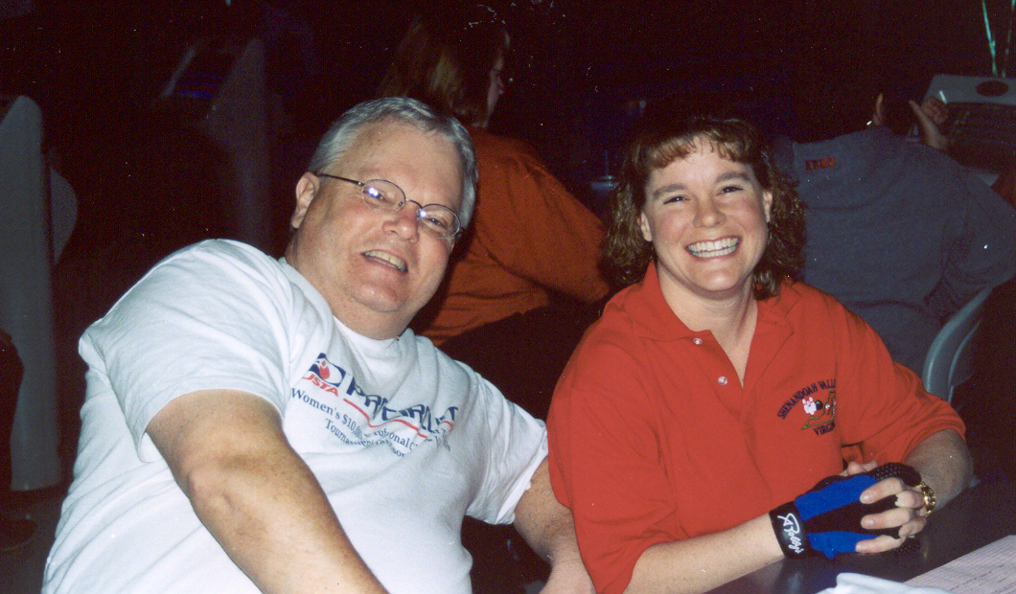

THE VALUE OF ONE MEMBER!
Reprinted With Permission From “On Point” – A Publication of NCAPA

Ten little members standing in a line.
One disliked the president, then there were nine.

Nine ambitious members offered to work late.
One forgot a promise, then there were eight.

Eight creative members had ideas good as heaven.
One lost enthusiasm, then there were seven.

Seven loyal members got into a fix.
They quarreled over programs, and then there were six.

Six members remained with spirit and drive.
One moved away, then there were five.

Five steadfast members wished there were more.
One became indifferent, then there were four.

Four cheerful members who never disagree—
‘Til one complained of meeting, then there were three.

Three eager members! What do they do?
One got discouraged, then there were two.

Two lonely members, our rhyme is nearly done.
One joined the bridge club, then there was one.

One faithful member was feeling rather blue—
Met with a neighbor, then there were two.

Two earnest members, each recruited one more—
Doubling their number, and then there were four.

Four determined members just couldn’t wait—
‘Til each won another, and then there were eight!

Eight excited members signed up 16 more.
In another six verses, there’ll be a thousand twenty-four!
COMMITTEE REPORTS

Treasurer’s Report – There is a balance of $2,114.86 in our treasury as of March 2, 2005.

Membership Committee Report – We currently have 21 paid members and there are no applications pending at this time.
Nancy Hodges
Treasurer and Chairperson of the Membership Committee

Program/Social Committee – SVPA celebrated the holiday season with the annual Christmas Luncheon, held at L’Italia on December 8, 2004. Alex Wilmer, Charlie Chenault, Nancy Hodges, and Karen Texiere were installed as the new officers for 2005. Several members also participated in an ornament exchange. Poinsettias were also given as gifts to all members and guests.

Our first meeting of 2005 was held at Litten & Sipe on January 12, 2005 at noon. Plans for guest speakers, meeting locations, and other events were planned at this meeting. Ways to market SVPA and increase membership were also discussed.

In February, Stacey Turner, Director of the Department of Planning and Community Development for the City of Harrisonburg was our guest speaker at China Inn. Ms. Turner discussed several real estate issues including site plan reviews and variances completed by the planning department. Samples of reports issued by the department were also distributed by Ms. Turner as she described these issues at the meeting.

Our March meeting will be an open house meeting for all paralegals in the Harrisonburg community. It will be held at Wharton Aldhizer & Weaver on March 9 at noon. All members are encouraged to bring guests who might be interested in learning more about the goals of our association.

I’d like to thank everyone on the Program/Social Committee for their help and assistance throughout 2004, and I look forward to working with the new chairperson, Charlie Chenault, in 2005.

Alex M. Wilmer
Chairperson of the Program/Social Committee

Alliance Committee - The Virginia Alliance of Paralegal Associations met on Saturday, February 19, 2005 in Charlottesville. Deborah Elkins, Assistant Editor of Virginia Lawyers Weekly, attended the meeting to give input regarding a new bi-monthly insert on Legal Professionals. VLW requested reports featuring paralegals and events for paralegals. (See the February 14th edition for the first insert publication.)
In addition, the Alliance agenda included follow-up matters from the 2004 statewide conference, planning for the 2006 conference, and discussions about the VAPA website. The next statewide conference will be held in Richmond October 5, 6, and 7, 2006. The conference will be held in conjunction with the Local Government Paralegal Association’s annual conference. Thursday, October 5, will be dedicated to local government issues and speakers, Friday, will be a mix of speakers of interest to all paralegals and Saturday, October 7, will primarily comprise private firm paralegal issues. Believe it or not, it is time to set the agenda and begin engaging speakers for the upcoming conference. Please contact June Nabers, CLA or Martha Munson, CLA, your VAPA Delegates, with your suggestions for speakers.
The next meeting of the Alliance will be hosted by SVPA at the Charlottesville office of Keeler Obenshain_{PC} on Saturday, May 7th. Hosting involves funding and coordinating the delegate’s breakfast and making lunch arrangements. Please contact your Delegates if you have questions or desire information about the Alliance.
Martha M. Munson, CLA
Chairperson of the Alliance Committee

CALENDAR AT A GLANCE

Mar 9th Open House Mtg – Noon - WAW

Apr 6th Executive Committee Mtg. - Noon – Jalisco’s

Apr 13th Joint Mtg. with H’burg/R’ham Bar Association
Noon – Location TBA
Speaker – L. Wayne Harper

May Regular Mtg. – Noon – Location & Time TBA
Speaker – Marsha Garst, Commonwealth Atty.

July 13-16th 30th Annual NALA Convention-Kansas City, MO

Shenandoah Valley Paralegal Association
P.O. Box 88
Harrisonburg, Virginia 22803

TO:

