

An Official Publication of the Shenandoah Valley Paralegal Association
Member of the Virginia Alliance of Paralegal Associations
October 2004 Volume 14, Issue 3

SVPA 2004 Officers

President-Elect – Alex M. Wilmer

(540) 434-5353
amw@littensipe.com

Secretary – Karen R. Wilkins

(540) 437-3130
kwilkins@kolawfirm.com

Treasurer – Nancy Hodges

(540) 434-0337
nlhodgesla04@yahoo.com
A SPECIAL PRESIDENT’S MESSAGE
OUT WITH THE OLD. . .

Patricia C. DeRamus, CP

“And now the end is near, I’ve paid my dues, and it’s time for the final curtain call – but I did it my way!” A singer I’m not, but I have enjoyed serving as your 2003 - 2004 SVPA President. Not only have I enjoyed being President, it has been an honor and privilege to serve my fellow colleagues. Yes, there have been some trials and tribulations, but nothing that could not be taken care of with a little determination and cooperation from the great team that served with me on the Executive Committee.

We had a great start to the first part of my term with the Virginia Alliance of Paralegal Associations’ Seminar in Leesburg. We have had informative and interesting speakers for our monthly meetings. I will miss our own week declared by the Governor of Virginia – Paralegals’ Week.

Yes, we have had a busy first part of the year with 2005 just around the corner. I would like to take this time to thank all of you for a great year and a half. I have many memories to share with my new colleagues in Florida. I ask that you give your support to our new President and the Executive Board Members for a continued great organization serving our profession, the Shenandoah Valley, and our great state. I would like to take this opportunity to once again thank all of my friends in SVPA for their support and fond wishes upon my departure for success in my new career quest in Florida.

PRESIDENT-ELECT’S MESSAGE
By Alex Wilmer

Welcome back! Now that summer vacations are over, it’s back to the grind. Fear not, it also marks the return of our monthly meetings! We’ve had some very interesting programs this year, continuing with our September meeting featuring William Stables. Paralegals’ Day will mark our next meeting in October, and our Christmas luncheon is just around the corner.

As we look back on the first half of the year, I would like to take a moment to thank two members who left SVPA over the summer. Our President, Pat DeRamus, resigned in June when she and her husband Derrill moved to Florida. Jo Ann Bilbrey, our Treasurer, retired in August to help care for her mother. Both Pat and Jo Ann gave much of their time and energy to help make SVPA a stronger organization. Their impact on SVPA will not soon be forgotten, and we wish the very best for them both.
I also want to thank Nancy Hodges and Martha Munson for helping out on the Executive Committee. We all appreciate Nancy’s willingness to step up into the office of Treasurer and Martha’s willingness to step up as Chairperson of the Alliance Committee.

I know that Pat and Jo Ann both felt very strongly about SVPA, and I do as well. We have some outstanding members who, in one way or another, have helped throughout the year. I hope that all of you will continue to support SVPA as we complete 2004 and head into 2005, our fifteenth year as an Association!

SVPA would like to thank the following businesses that donated food and door prizes for Law Day 2004:

Mr. J’s Bagels



Dave’s Downtown Taverna

Kline’s Dairy Bar

THANKS TO . . . WILLIAM L. STABLES, JR., ESQUIRE
By Nancy L. Hodges

The September 8, 2004, meeting of the Association was held at L'Italia in Harrisonburg. Our guest was Attorney William L. Stables, Jr., who spoke to us about bankruptcy law and how it could affect practice areas such as real estate and civil litigation.

Mr. Stables and his wife, Margaret, live near Mt. Solon and are the proud parents of two sons and grandparents of one grandson. Mr. Stables graduated from Bridgewater College in 1967 and taught school for four years. In 1974 he graduated from South Texas College of Law in Houston, Texas, where he served on the editorial staff of the Law Journal, and in his third year also served as a clerk in a Houston law firm assisting in (among other things) corporate reorganization (Bankruptcy Chapter 11).

Mr. Stables was admitted to practice in Virginia in 1974 and has been practicing law in Harrisonburg for the last 30 years. In the early years, he had a general practice, including criminal, domestic relations, real estate, and civil litigation, but had an emphasis on bankruptcy law. In more recent years, his practice has been increasingly focused on bankruptcy. Mr. Stables has also served several times as Adjunct Professor at James Madison University in various law courses.

BANKRUPTCY LAW
By John Murnane, Student Member

Bankruptcy is a branch of law that is critical to any debtor that is unable to pay his or her creditors. This type of litigation allows for a supervised plan to resolve debt by the division of assets. While there are some cases in which a debtor may be allowed to stay in business and use incoming revenue to pay off the debt, there are other cases where the debtor may be completely discharged of his debt, even if all of his financial obligations have not been met. In the interest of the creditors, the intent of bankruptcy law is to develop a plan so the debt can be addressed and paid off equally.

The law regarding bankruptcy is uniform throughout the United States under Title 11 of the United States Code. Individual states may pass other laws that affect the debtor-creditor relationship; however, they cannot directly regulate bankruptcy. As stated previously, some debtors are allowed rehabilitation and have the opportunity to pay off debt with future earnings. This type of bankruptcy files under Chapters 11, 12, and 13 of Title 11. When the debtor’s assets are sold and distributed to the creditors by a person known as a trustee, this is known as liquidation. Chapter 7 liquidation is the most common form of filing for bankruptcy. As with liquidation, filings for bankruptcy under Chapters 11, 12, and 13 also involve the appointment of a trustee to supervise the debtor’s assets.

In the Western District of Virginia for the year 2003, 82.3% of the bankruptcy cases were filed under Chapter 7 - liquidation. The second highest percentage was under Chapter 13 with 17.5%. The small remaining percentage of 0.23% was related to Chapters 9, 11, and 12. Over the last 20 years, the number of filings for bankruptcy in the Western District of Virginia has steadily increased with 12,945 cases last year. This is a drastic difference in comparison to the 3,099 cases filed in 1980. If both history and the economy repeat themselves, one should expect the filings for bankruptcy to continue to rise.

Links for more bankruptcy information:

U.S. Bankruptcy Court http://www.vawb.uscourts.gov
Official site for Western District of Virginia, 4th Circuit.

PACER: http://pacer.psc.uscourts.gov
Official electronic record retrieval site.
*Must register and arrange payment to access documents.

Cornell University: http://www.law.cornell.edu/topics/bankruptcy.html

American Bankruptcy Institute: http://www.abiworld.org

QUOTES ON LAW

"Even when laws have been written down, they ought not always to remain unaltered." Aristotle

" Let me not be understood as saying that there are no bad laws, nor that grievances may not arise for the redress of which no legal provisions have been made. I mean to say no such thing. But I do mean to say that although bad laws, if they exist, should be repealed as soon as possible, still, while they continue in force, for the sake of example they should be religiously observed."
Abraham Lincoln

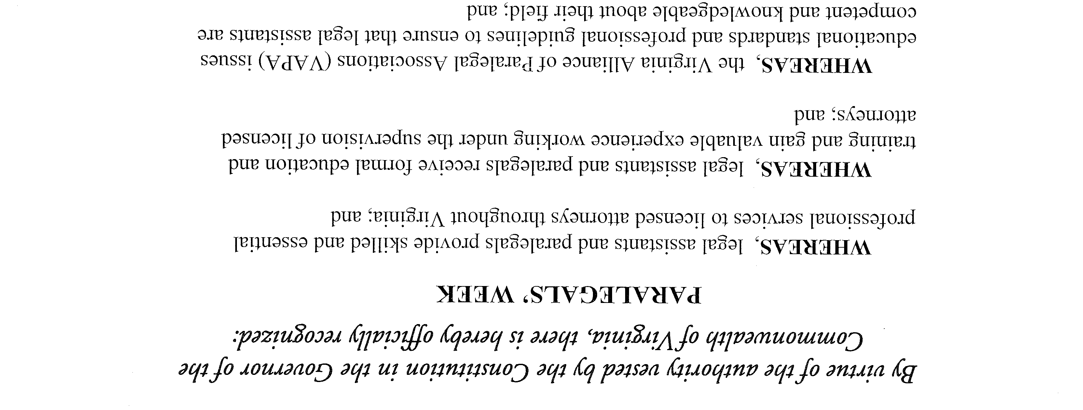
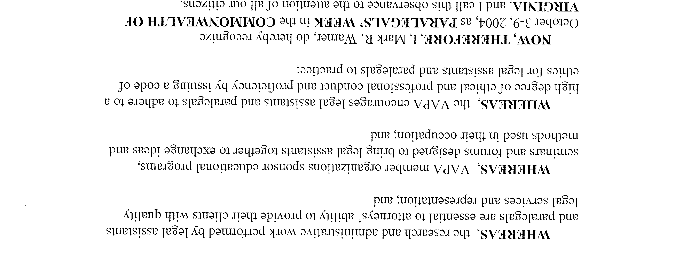

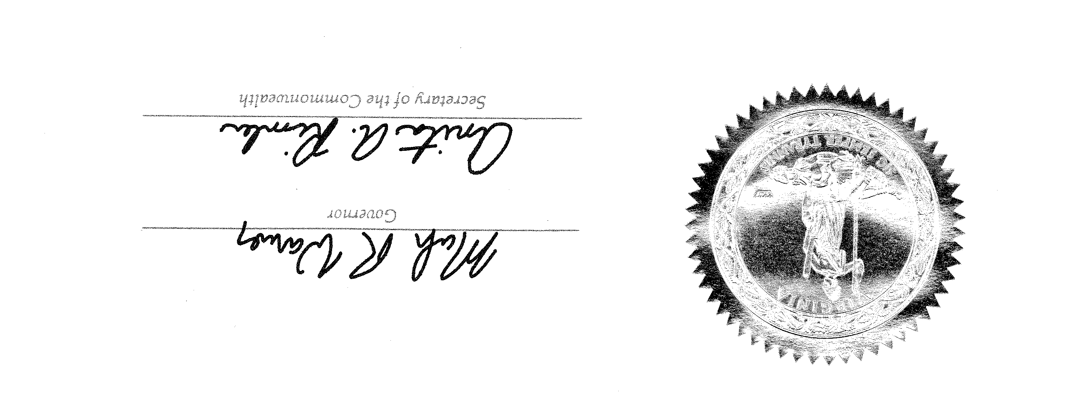

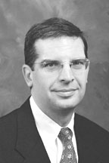
WELCOME SENATOR OBENSHAIN
By Karen Wilkins

In celebration of Paralegals’ Week 2004, our Association has invited The Honorable Mark D. Obenshain to be our special guest speaker. Senator Obenshain will discuss past, present, and future legislation of interest to our group.

Mr. Obenshain holds a Bachelor of Arts degree from Virginia Tech. In 1987, he received his Juris Doctorate degree from Washington and Lee University School of Law and was admitted to the Virginia State Bar that same year.

Mr. Obenshain practices in areas such as commercial and civil litigation, employee rights, employment discrimination, harassment, will contests, alternative dispute resolution, local government law, constitutional law, and personal injury. His specialty lies in civil litigation where he has more than 15 years of litigation experience and approximately 75 jury trials to his credit.

As a member of the Virginia State Senate, Senator Obenshain serves on the following Committees: Agriculture, Conservation and Natural Resources, Courts of Justice, Privileges and Elections, Local Government, and Charters Subcommittee in Local Governments. He represents the 26th District of Virginia, which includes the City of Harrisonburg, Page County, Rappahannock County, Shenandoah County, Warren County, and part of Rockingham County.

Mr. Obenshain is one of the founding partners of Keeler Obenshain PC. He and his wife, Suzanne, live in Harrisonburg, with their two children, Tucker and Sam.

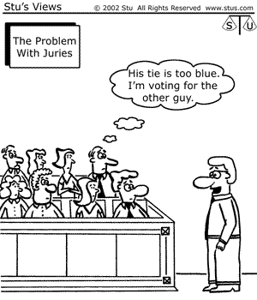

COMMITTEE REPORTS

Treasurer’s Report – There is a balance of $1,851.05 in our treasury as of September 26, 2004.

Membership Committee Report – We currently have 23 paid members and there are no applications pending at this time.
Nancy Hodges
Treasurer and Chairperson of the Membership Committee

Public Relations Committee – There is nothing new to report at this time. If you have ideas on how to make our newsletter better, please do not hesitate to let me know.
Karen R. Wilkins
Chairperson of the Public Relations Committee/Editor of The Paralegal Times

Program/Social Committee – Law Day was held on Thursday, May 13. Turnout was strong at the Clerk’s Office and at the luncheon, hosted by Wharton, Aldhizer, & Weaver. Over 40 attorneys and paralegals attended the luncheon, which featured our guest speaker, Dr. Robert N. Roberts of James Madison University. Numerous businesses and members donated refreshments and 25 door prizes were given away.

Two events were also sponsored by SVPA over the summer. SVPA’s “Spring Fling” was held on May 20 at Jo Ann Bilbrey’s home. Also, a special luncheon was held to honor President Pat DeRamus on June 30. There were 16 members present. Pat was presented with a historical book on Harrisonburg and a writing set.

The web site for SVPA was launched on June 23. An announcement was made at our special luncheon for Pat. Since then, additional information has been added, including a list of our officers, application for membership, and the quarterly newsletter. Our homepage is http://www.geocities.com/svparalegal.

Our September meeting featured local attorney William Stables at L’Italia. His presentation was on bankruptcy law.

The October meeting will commemorate Paralegals’ Week. It will be on Monday, October 11 at Simple Pleasures. Our guest will be Senator Mark Obenshain. All members are invited to bring their supervising attorney to the luncheon. Invitations were sent to all members in mid-September. Please let me know if you need an invitation.

Our next business meeting will be at Litten & Sipe on November 10. We will vote on our budget and elect officers for 2005. The Christmas luncheon is set for Wednesday, December 8, 2004 at L’Italia. More details will be announced for these two meetings following Paralegals’ Day.

Alex M. Wilmer
Chairperson of the Program/Social Committee

Alliance Committee - We were represented at the 2004 Statewide Conference by Jo Ann Bilbrey, Pam Wolford, Pat DeRamus, and Martha Munson. All who attended had a positive experience. The fall VAPA meeting was postponed until October 9, 2004 and will be held in Charlottesville. The agenda includes review of Bylaws revisions, review of the 2004 conference, and planning for the 2006 conference. All SVPA members are encouraged to attend this meeting. Please contact Martha Munson if you are interested.

Martha M. Munson, CLA
Chairperson of the Alliance Committee

Real Estate Committee – The use of the plat cabinets in the Clerk’s Office has been discontinued. All new recorded plats will be scanned into the system and accessible as attached to the original recorded document. The County has agreed to reprogram the printer to accommodate 11X17 paper for printing of the larger plats with fine details.

Copies of the new Rockingham County Subdivision Ordinance (effective August 23, 2004) are available from the Community Development Office.
Pam Wolford, CLA
Chairperson of the Real Estate Committee

Nominating Committee – A big thank you goes out to the following members who have agreed to run for these respective offices of the Shenandoah Valley Paralegal Association:

President Alex Wilmer
President-Elect Charles Chenault
Secretary Karen Texiere
Treasurer Nancy Hodges

Elections will be held at the November Business meeting, with officer installation at the December meeting. We look forward to another exciting year in 2005.
Pam Wolford, Liz Knicely,
June Nabers, and Martha Munson
Members, Nominating Committee

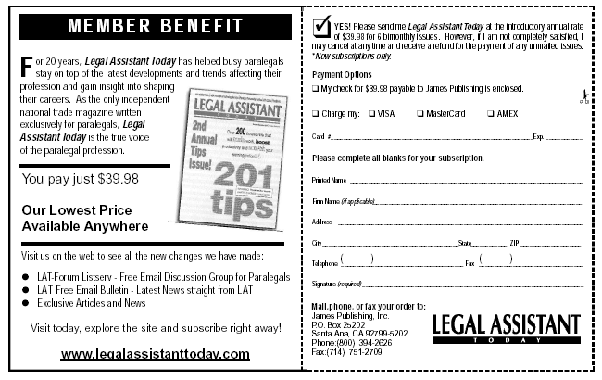

CALENDAR AT A GLANCE

Oct 6th Executive Committee Mtg. at Daily Grind

Oct 11th Paralegal’s Day Luncheon at Simple Pleasures
(Monday) Guest Speaker – Senator Mark D. Obenshain

Nov 2nd Election Day – VOTE!!

Nov 3rd Executive Committee Mtg. – Location TBA

Nov 10th Membership Mtg. at Litten & Sipe
Elect Officers and Vote on Budget for 2005

Dec 1st Executive Committee Mtg.– Location TBA

Dec 8th Christmas Luncheon at L’Italia

Dec 9th Salvation Army Kettle Program
Valley Mall Food Court – 5 – 7 p.m.

Shenandoah Valley Paralegal Association
P.O. Box 88
Harrisonburg, Virginia 22803

TO:

