HMS Software Implementation Description

Prepared by Team One
Sandra Busik
Susan Le
Peter Lockwood
Pradeep Miglani
Reita Sikka
Kai Zhang
SWE 626
Spring 2002

for
Professor Ye Wu
April 24, 2002
Table of Contents

HMS Software Implementation Description 1
Overview 1
Mapping UML Design to Java 1
Data Mappings 17
Data Relationships for the HMS 18

Table of Figures

Figure 1: Checkin 2
Figure 2: Checkout 3
Figure 3: Client 4
Figure 4: Discount 4
Figure 5: Customer 5
Figure 6: CustRecord 6
Figure 7: GenerateReport 7
Figure 8: HMS Control 8
Figure 9: HMSInterface 8
Figure 10: jdbcConnection 8
Figure 11: Payment 9
Figure 12: Report 9
Figure 13: Reservation 10
Figure 14: ReservationControl 11
Figure 15: Room 12
Figure 16: RoomAdmin 13
Figure 17: RoomAvailability 14
Figure 18: Scheduler 14
Figure 19: SearchResults 15
Figure 20: User 15
Figure 21: UserAdmin 16
Figure 22: Data Relationships 18

Overview

The Java implementation of the distributed software architecture for each subsystem, task, and class follows the design. There are packages defined for each of the subsystems. The classes are local to the subsystem and are used by classes of other packages using defined interfaces. There will be two Java packages: Management Package and Room Service Package. These packages will contain the relevant classes. CLIENT class (which will contain the database class) is a utility class, which is not a part of any package and can be called by classes in each of the packages. The Database class will be the API providing all the centralized database functions for retrieving and updating data. All of the classes methods and variables in the class diagram will be developed. Additional temporary methods and variables will be added to the CLIENT and other classes on an ad-hoc basis. Each Java screen will have its own class and the HMS Interface will be a parent class, instantiating methods in each of the classes.

This document contains two sections. The first section contains the mapping of the classes from the UML design to real Java code. The second section contains a mapping of the entity classes to their related tables in the database.

Mapping UML Design to Java

Mapping UML classes to Java classes is a one to one mapping. Below is a table that describes the mapping process.

UML | Java
Package | package myPackage;  public class MyClass { }
Class | public class MyClass { }
Attribute | private type attribute1 = initialValue;
Operation | public void operation1 (type1 arg1, type2 arg2) { }

The detailed mapping of the HMS UML classes to Java code is shown on pages 2 through 16.
Figure 1: Checkin
Figure 2: Checkout
Figure 3: Client

Figure 4: Discount
Figure 5: Customer
Figure 6: CustRecord
Figure 7: GenerateReport
Figure 8: HMS Control

Figure 9: HMSInterface

Figure 10: jdbcConnection
Figure 11: Payment

Figure 12: Report
Figure 13: Reservation
Figure 14: ReservationControl
Figure 15: Room

Figure 16: RoomAdmin
Figure 17: RoomAvailability

Figure 18: Scheduler

Figure 19: SearchResults
Figure 20: User

Figure 21: UserAdmin

Data Mappings

The following table illustrates the mapping of the entity classes from the HMS UML design to their representative data entities in the HMS database. The data relationship table is on the following page.

Entity Class | Table(s) Mapped to in the HMS Database
Bill | Bill; BillItem; BillItemType
Customer | Customer
Discount | Discount
Payment | Payment; PaymentType
Room | Room; RoomType; RoomStatus; RoomAvailable
User | User; Role
Reservation | Reservation; Checkin; Checkout
Report | Report

Data Relationships for the HMS

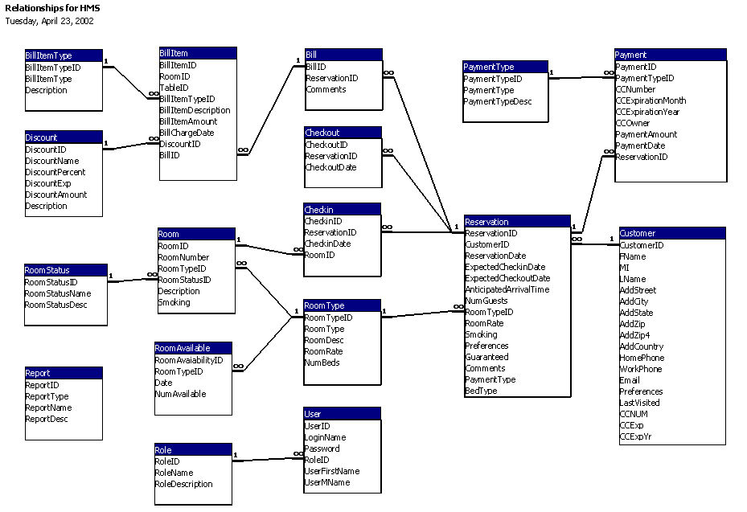
Figure 22: Data Relationships

