SWE 632: User Interface Design
And Development

Individual Term Project

Anurag Dwivedi

Student Admissions and Tracking System

Disclaimer: This project is built upon an existing project that I did for SWE 626. I loved working on this project and there were some pieces of code where I felt I can do a better job, but due to time constraints I was not able to do it. Thanks to SWE632 and Professor Bechtold, I got a chance to get back to this project and modify / fix those parts.
Hope you enjoy reading it as much as I did working on it.

Problem Definition
Currently the Department of Information Systems and Software Engineering maintains hardcopies of all documents that are required for Students’ Admissions and tracking, which requires a lot of paperwork and is cumbersome.

This project is intended to automate the student admission process into the graduate Masters, Certificate, and non-degree programs of the ISE Department.

This systems needs to be able to track the students admissions process starting from when the students’ application arrives in the Department. Some information may be scanned into the computer (such as student transcripts and references, which are read only documents) while other information, such as forms that need faculty approval) will be entered via forms so that the information can be stored in a database.

Forms that need to be automated include:
- Student self-evaluation form
- Academic status form
- Change of Degree form
- Change in Degree requirements form
- Student plan of study form
- Permission to take course elsewhere form
- Transfer of credit form
- Application Evaluation form

- Where information is already available in the system, certain fields should automatically be populated in the forms.
- Users of the system may not access the database directly.
- Notification of certain events should be transmitted via email.
- Certain letter should be automatically generated.

Software Development Plan

Software Planning:
Software will be developed on the windows XP environment. ISE department, which is the customer of the software, also uses Tomcat server, which is the java based web sever, and access/ oracle as the backend database. Based on the experience and knowledge of the developer, and the requirements of the customer, following technologies will be used in the software development.

Software | Version
Rational Rose | 2000
Access | 2000
JDK | 1.4
ODBC
Visio | 2000
Tomcat | 4.2
Dreamweaver | MX
Homesite | MX

Software Design:
Analysis model and the design model will be developed for SATS using Rational Rose and Visio. Object - Oriented principles will be used to design the system.

System Development:
Java Based web technologies will be used to develop the online SATS. Tomcat will be server on which the system will be deployed and web pages will be JSPs communicating with Servlets which would act as the controller. So java will be the language used in the coding the web pages. Forte, Dreamweaver and Homesite will be used to code the Servlets and JSP pages. Access will be the backend database server. ODBC will be used to connect to the database.

User Functions

Users of the System:
- Students
- Staff
  - Faculty Member
  - Department Coordinator
  - Department Chair
  - Associate Dean
- System Administrators

Student – Major Functions

- Students can request the change in degree requirement courses
- Students can request for change of degree
- Students can request for transfer of credits from another institution or GMU non degree courses.
- Students can request a plan of study for his/her Master’s degree program. (in this case SWE and IS).
- Students can change his/her personal contact information
- Students can fill in the self evaluation form online and store in their records for all the available master and certificate programs that the student is enrolled in. ( in this case SWE, IS, EC certificate, Information security certificate, SWE certificate, information engineering certificate.)
- Students can request for a change in change his/ her academic status.
- Students can request to take courses elsewhere outside GMU

Faculty – Major Functions

- Faculty member can Accept or reject change in degree requirement courses requested by a student.
- Department Coordinator can accept or reject Change of degree requested by a student
- Faculty member can accept or reject the students request to transfer credits from another institution or GMU non degree.
- Department coordinator can verify the decision taken by the faculty member on student’s request to transfer credits and accept or reject it.
- Department Dean can verify the decision taken by the faculty member and the department coordinator on student’s request to transfer credits and accept or reject it.
- Faculty member (student advisor) can accept or reject the plan of studies requested by the student.
- Department Coordinator can accept or reject student’s self evaluation for a program and suggest any required courses to be taken.
- Faculty member can accept or reject change in academic status (drop any course after the last day to drop courses is over) requested by a student.
- Faculty member (Student’s Advisor) can accept or reject the student’s request to allow him/her to take courses elsewhere outside GMU.
- Department Coordinator can verify the decision taken on Student’s request to take courses elsewhere by faculty member and accept or reject it.
- Department Dean can verify the decision taken on the Student’s request to take courses elsewhere by faculty and department coordinator and accept or reject it
- Faculty member can review the student’s application for admission into a program and comment on it.
- Department coordinator can review the comments made by the faculty member on an applicant’s application and accept or reject him/her into the program requested.
- Faculty member and department coordinator can view the applicant’s image files such as the transcripts and recommendation letters etc.

System Administrator – Major Functions

- System Administrator can create student’s application by entering the information given by the student in the admission application into the database
- System Administrator can create a student user.
- System Administrator can create a staff user (including faculty member, department coordinator and a Department chair and associate dean)
- System Administrator can store applicant’s image files consisting of the applicant’s transcripts, recommendation letters etc.
- System Administrator can find a particular user in the SATS database.
- System Administrator can update user information or deactivate a user from SATS database.
- System Administrator can update/modify student’s information.
- System Administrator can update foundation courses for a program
- System Administrator can create a new degree program in the department
- System Administrator can update the existing degree program in the department.
- System Administrator can create or update guidelines for standardized tests such as GRE, TOEFL

Screen captures with description of the screens

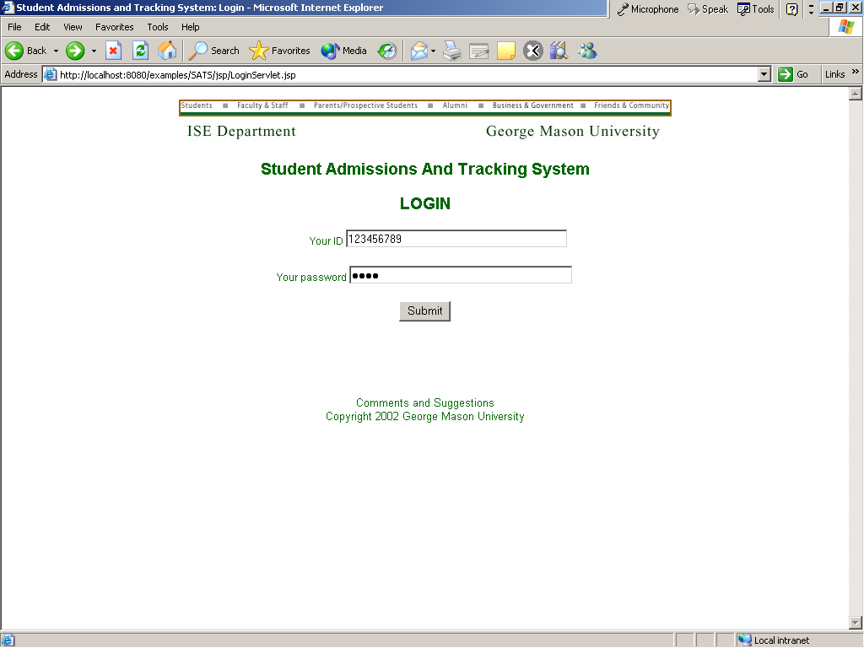

Start page is the login page. It will pass the information entered by the user to a servlet which will verify the information from the database. Then based on the user type the servlet will pass on the control to the appropriate JSP to display that user’s menu options.

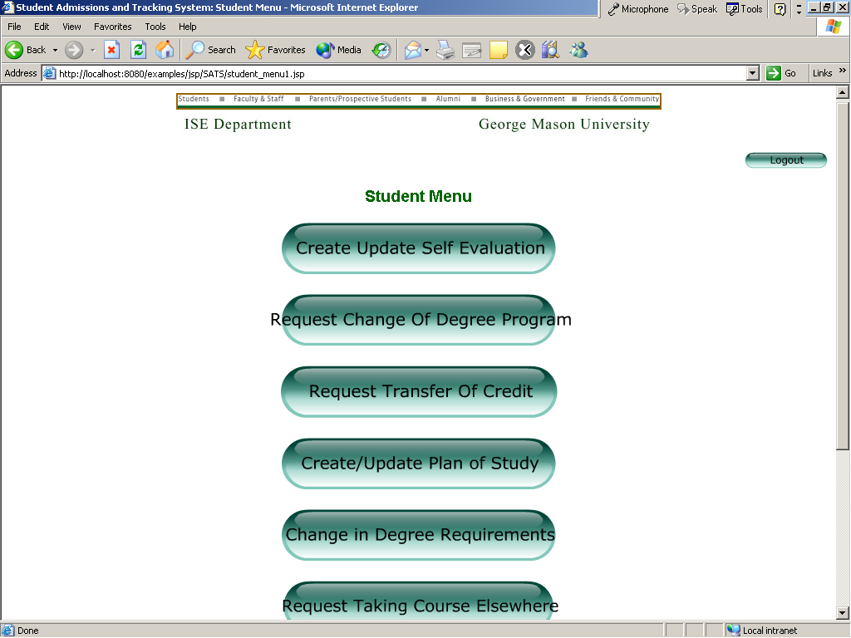

The menus are self explanatory which on being clicked takes the user to the appropriate form.

I will go over the flow of student applying for permission to take course elsewhere.
The student clicks on the Taking Course Elsewhere option which takes him to the appropriate form with his basic information pre-filled.
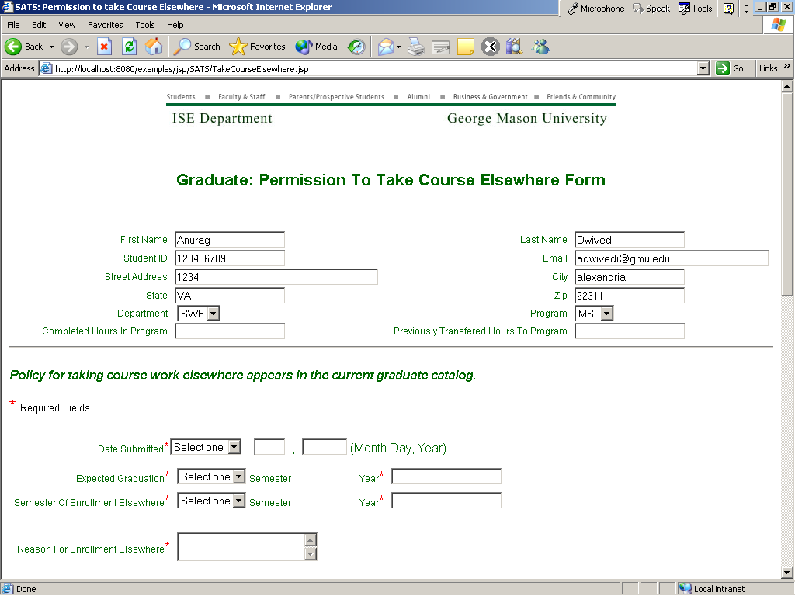
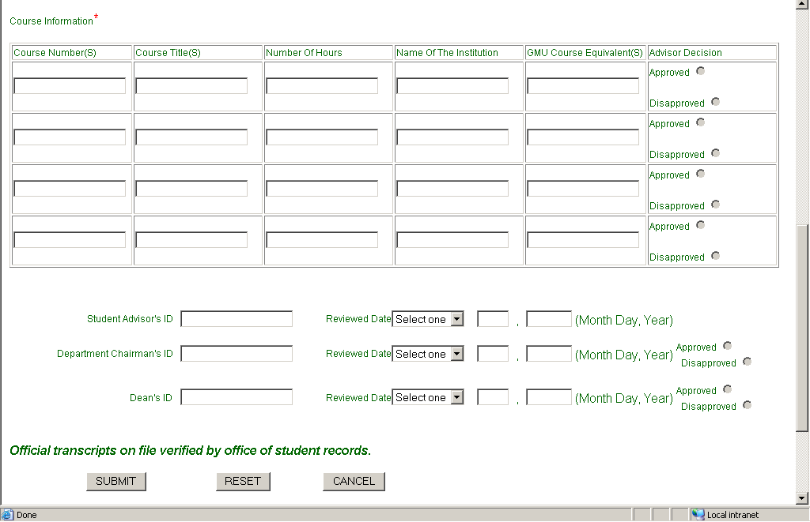

The student just needs to enter the required information. The parts of the form which are not intended to be filled by the student user are disabled.

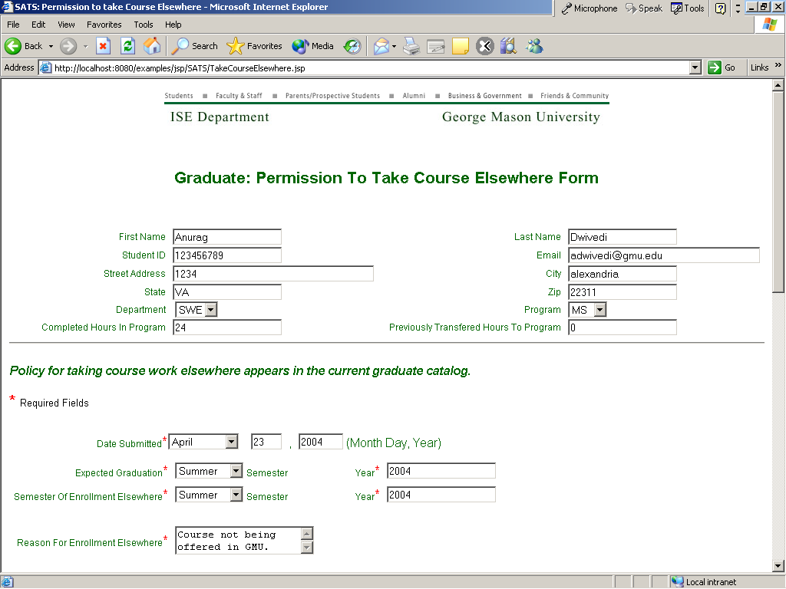
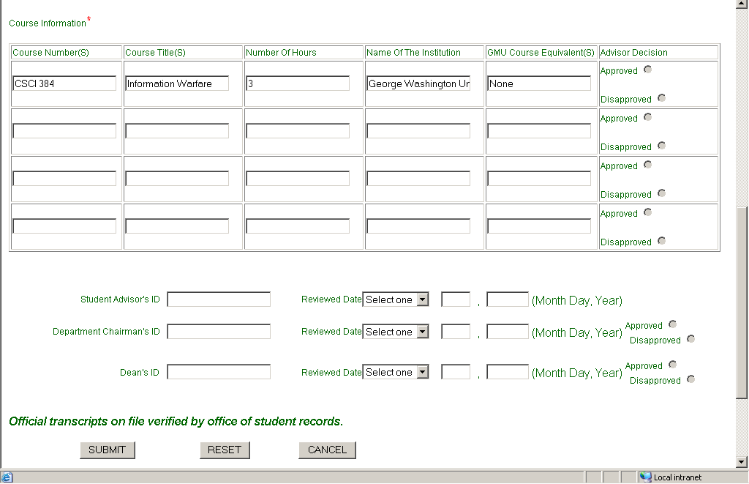

The student fills up the required information and hits Submit. Reset will delete all the filled information and cancel will take him back to the main menu.
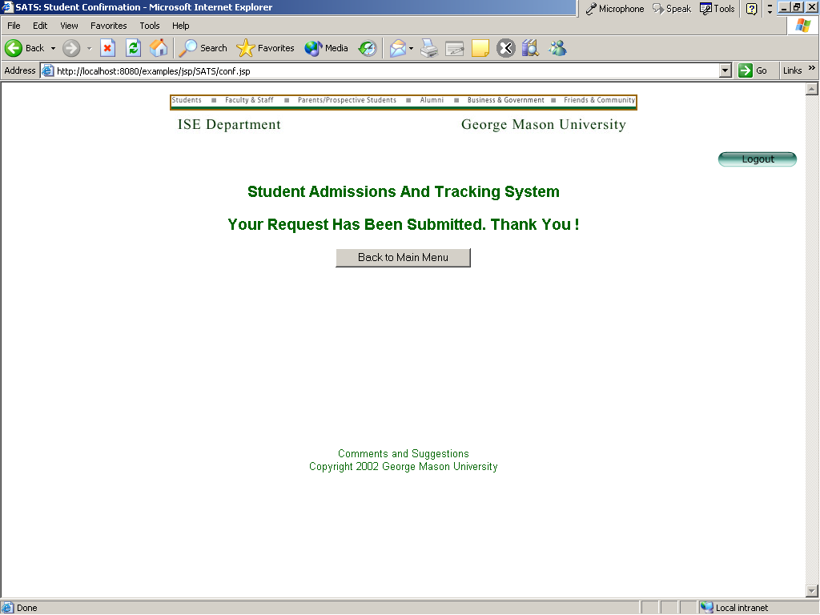

The student can then go back to the Main Menu or Logout. In this case he chooses to log out.

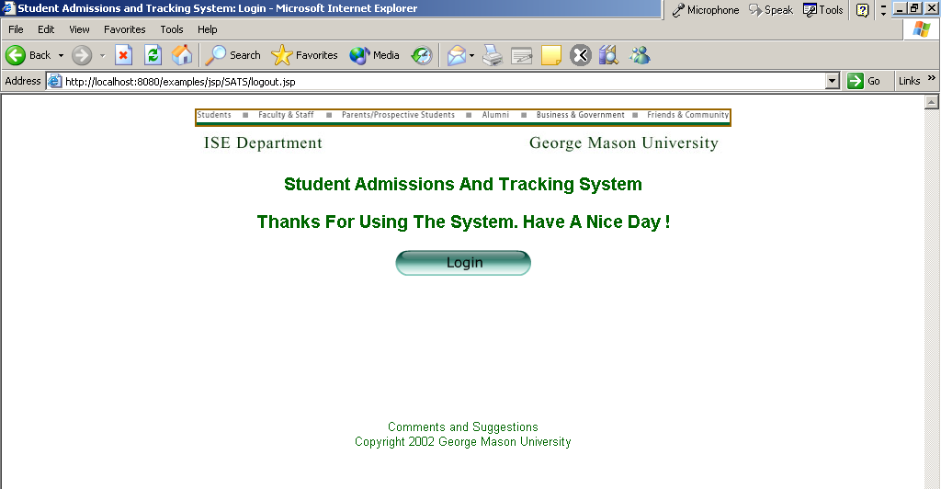

Student’s advisor will get an e-mail informing him that there is a pending request submitted by a student. He can then log in to the system in order to process the request.

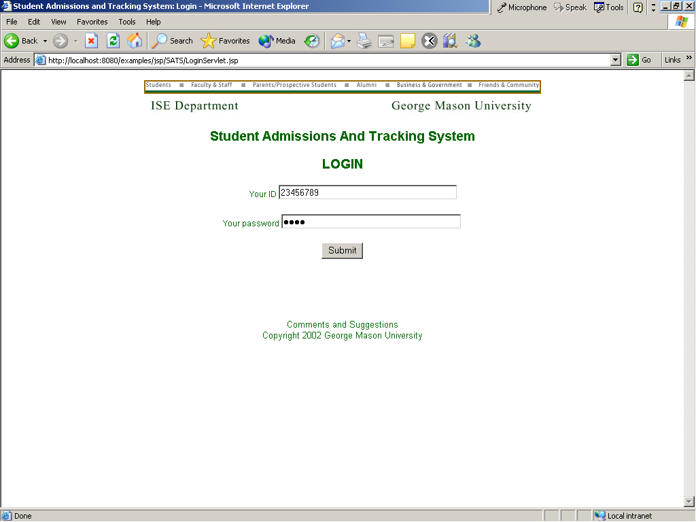

Once the faculty member enters his login information he is redirected to the menu options that are available to him.

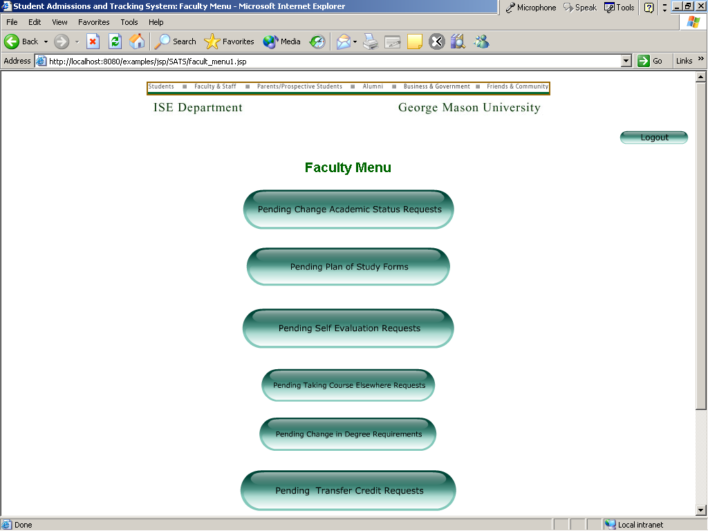

He can then click on the appropriate menu option (Pending Taking Course Elsewhere Requests) which shows him the requests that are pending for him to process.

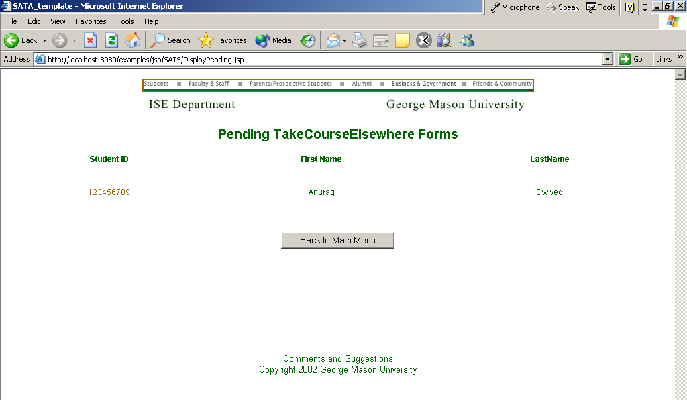

The student ID has a link which on being clicked populates the appropriate form with the information that the student has filled.

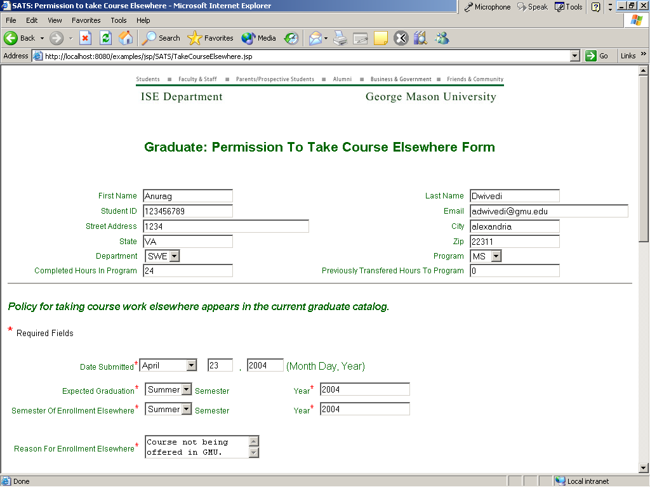
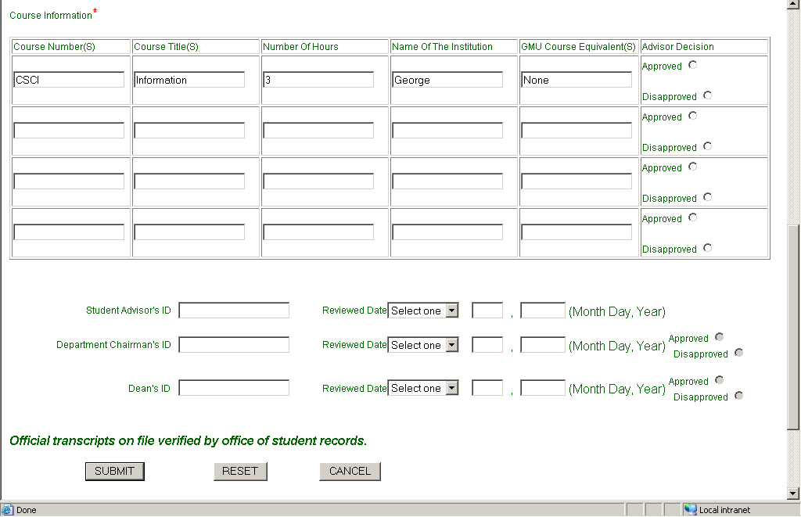

The Student’s Advisor can then either approve or disapprove the request and will need to enter his / her ID and the review date. Again, the parts of the form that he is not entitled to fill are disabled.

In this case the advisor approves the request, enters his ID and date and hits Submit.

The advisor can then either go back to the main menu if they have any more pending requests or logout.

Once the Advisor submits their decision, an e-mail notification is sent to the next reviewer (Department Chair in this case).

The Department Chair then logs in to the system to review the forms that are pending for him.

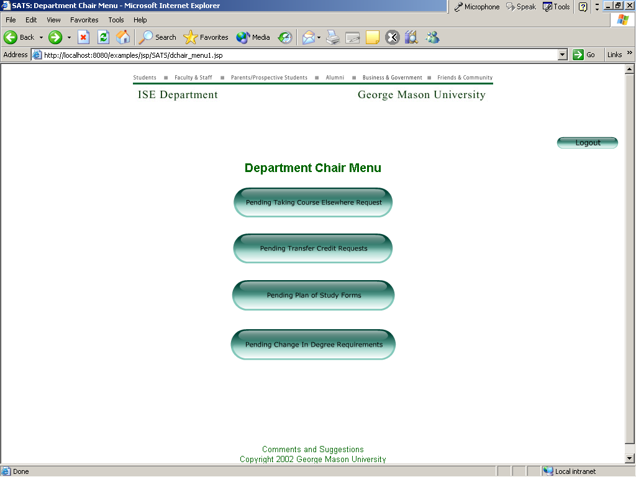

Once the chair selects the Pending Taking Course Elsewhere menu option, the system displays a list of all the students that have submitted this form on which the students’ advisors have made a decision.

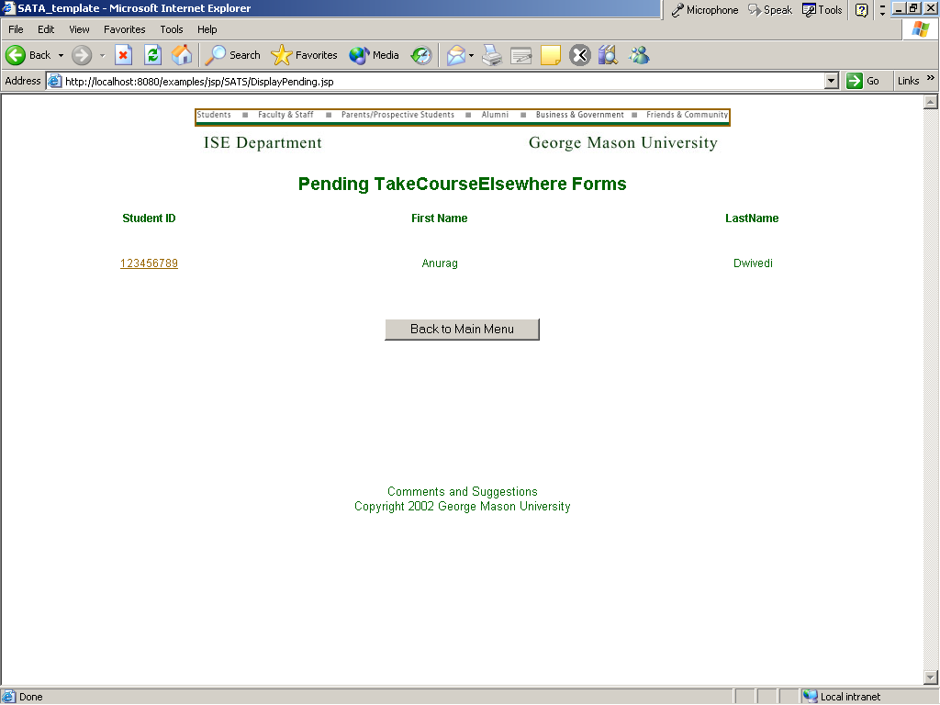

The Department Chair can then click on the Student ID to get to the form in order to make a decision.

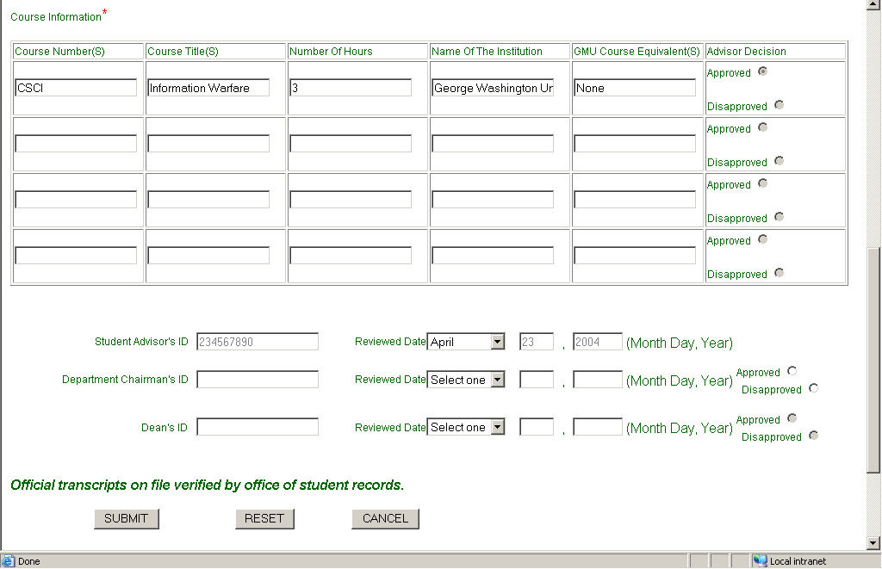

The Chair can then approve or disapprove the request, enter his ID and date reviewed and submit the form at which point a confirmation page will be displayed from where they can either go to the Main Menu or log out.

Once the Department Chair submits their decision, an e-mail notification is sent to the next reviewer (Associate Dean in this case).

The Associate Dean then logs in to the system to review the forms that are pending for him.

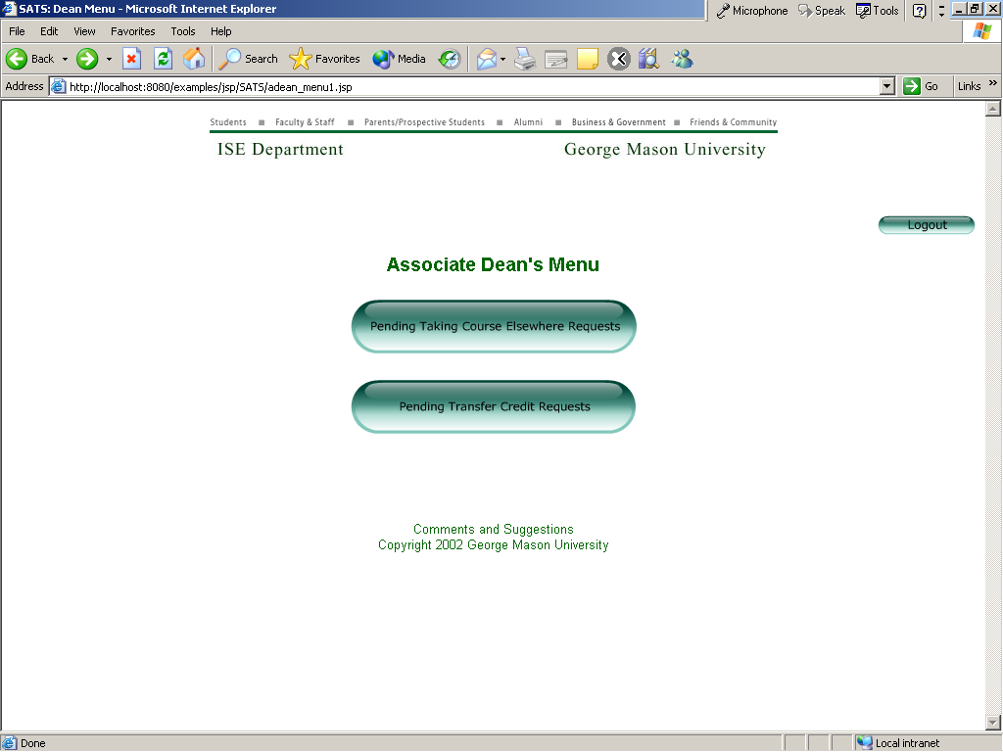

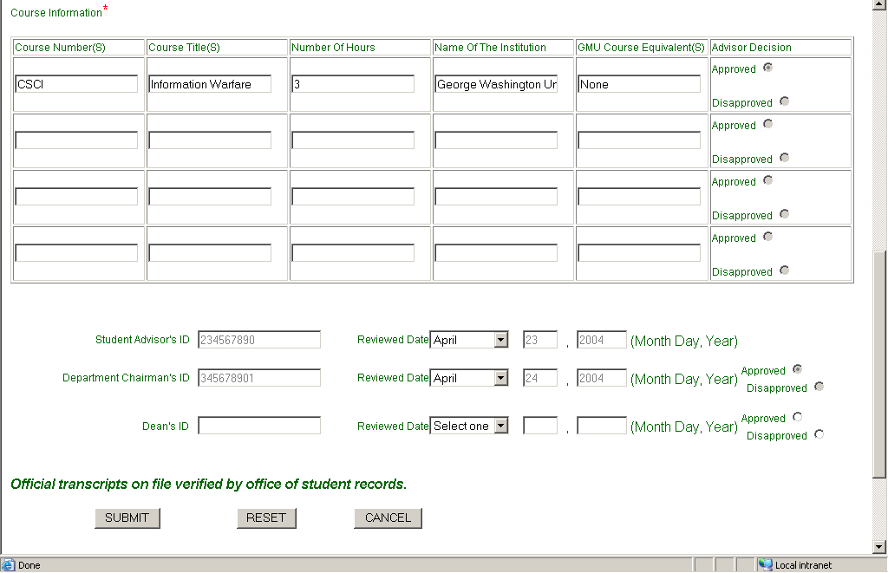

Associate Dean can then make a final decision on the students’ request. Once he submits his decision, an email is sent to the student informing him about the status of his application.

All the other students’ forms work the same way as described above.
The System Administrator’s functions are described next.

Once the System Administrator logs in to the system he is provided with the set of options he is entitled to person. He can then choose any of the options, which will take him to the appropriate form.

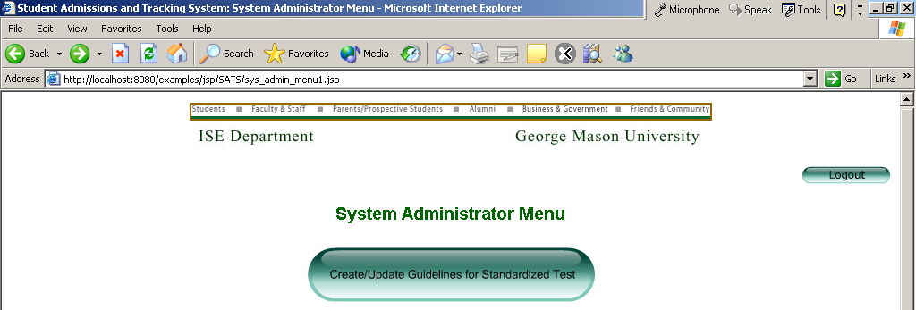
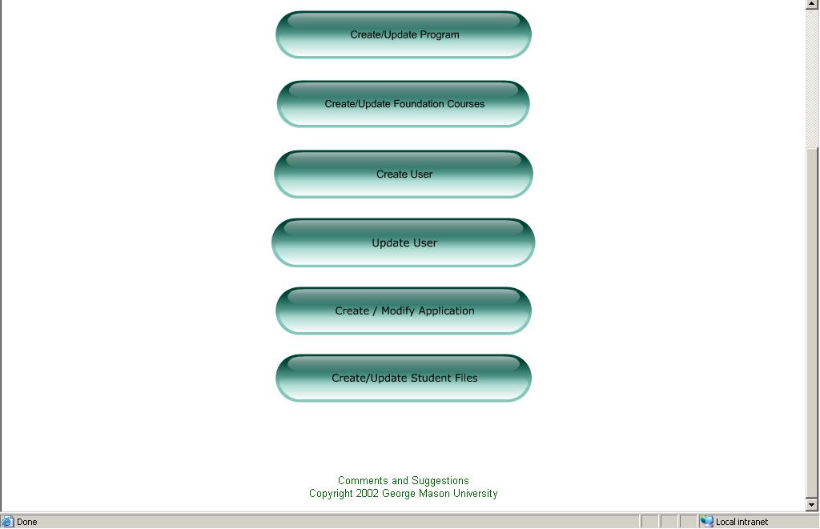

If the System Administrator chooses the Create or Update Program option, he is taken to a form where he can enter information about the new program that needs to be created, or enter the program ID of the existing program and hit submit in case he needs to update any of the existing program’s information. If the program’s ID is in the database the form will be populated with the information of the existing program.

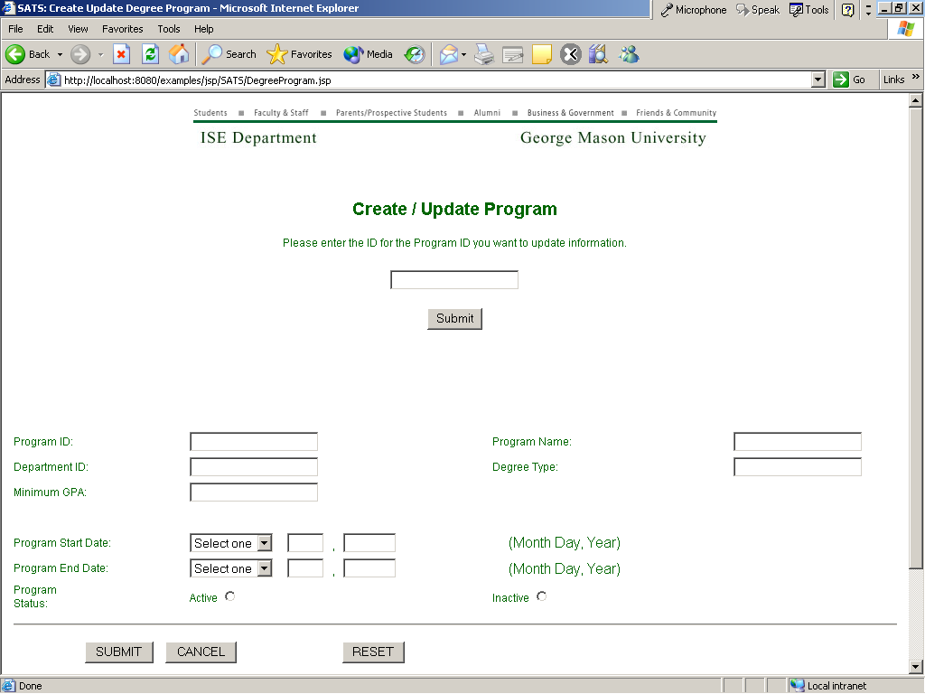

The System Administrator has the option of making a program active or inactive so that the program does not need to be deleted from the database if the Department doesn’t want to continue it any more. If there is a program end date specified then the program automatically becomes inactive after that date and can be reactivated at a later date.

The System Administrator also has the option of creating a new user of the system once a student or faculty member joins the Department or updating an existing user’s information.
The users can update their contact information but only the System Administrator can change other information like userId, Name and user type.
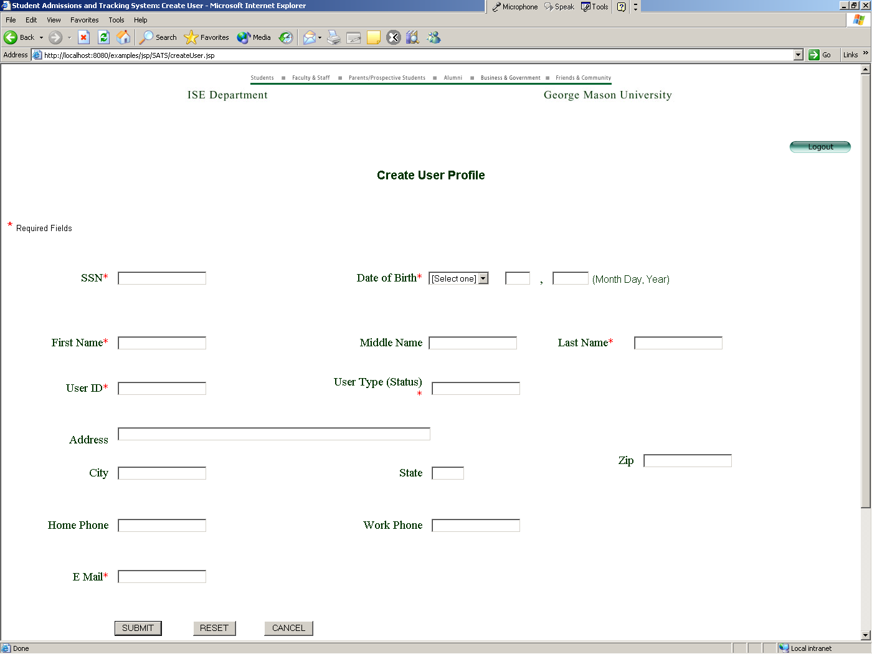

It is the System Administrator who will be entering information from the admission application that a prospective student has submitted. He can also pull up an existing student’s information and update records.

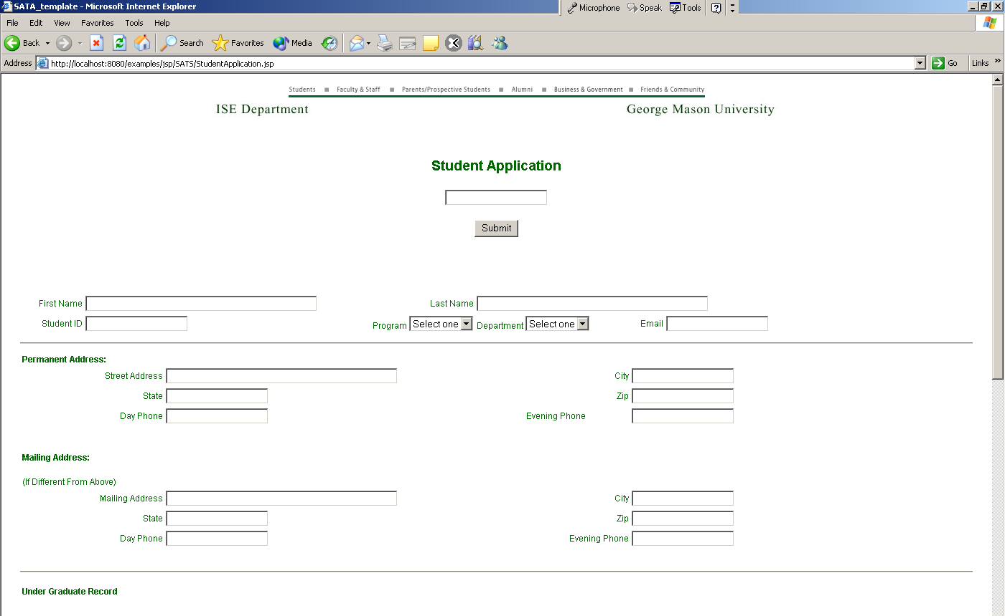
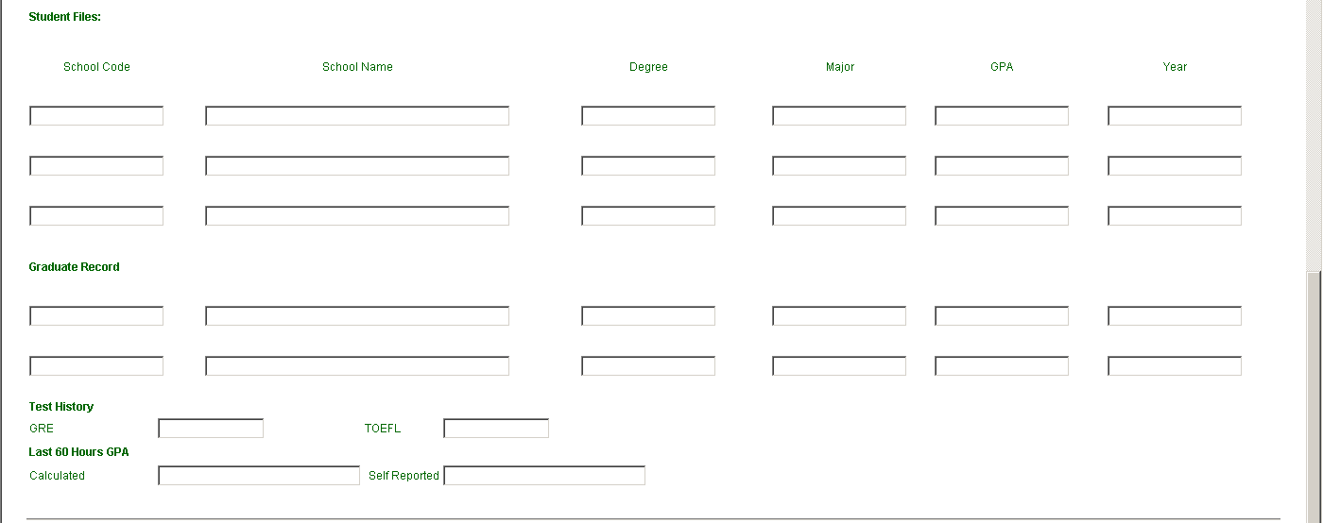
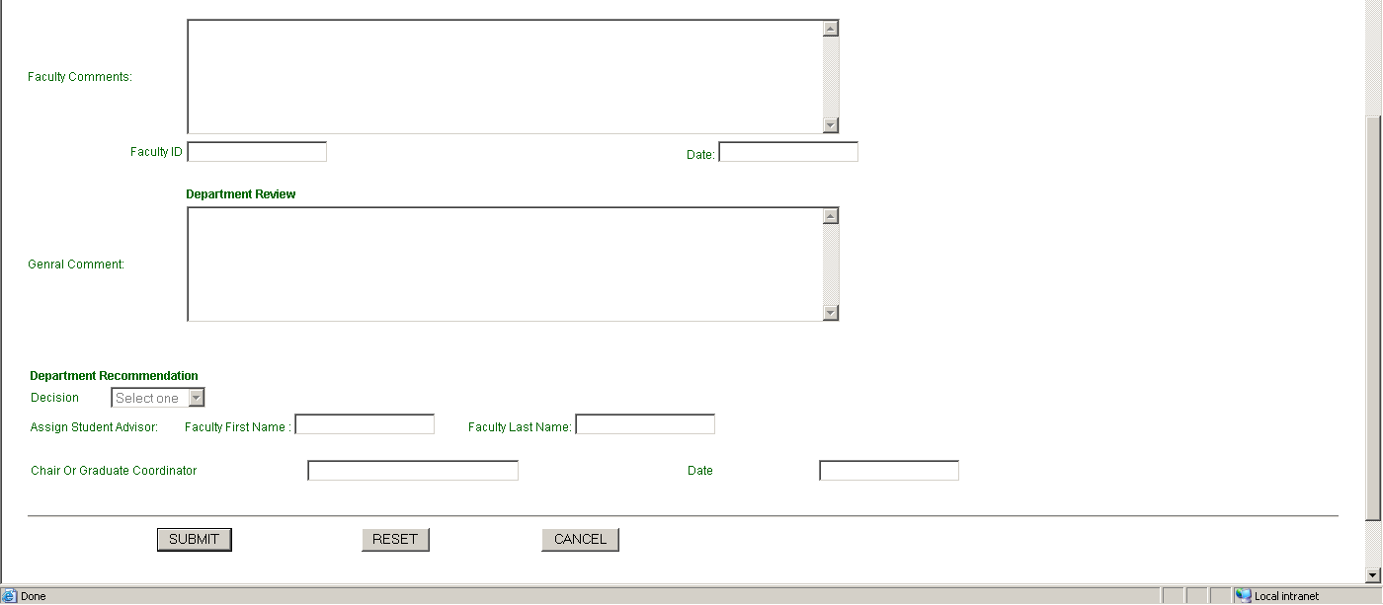

Once the student application is created the System Administrator can use the Student Files menu option in order to enter the path for the student transcripts and references etc. which have been scanned and stored on the computer in PDF format.

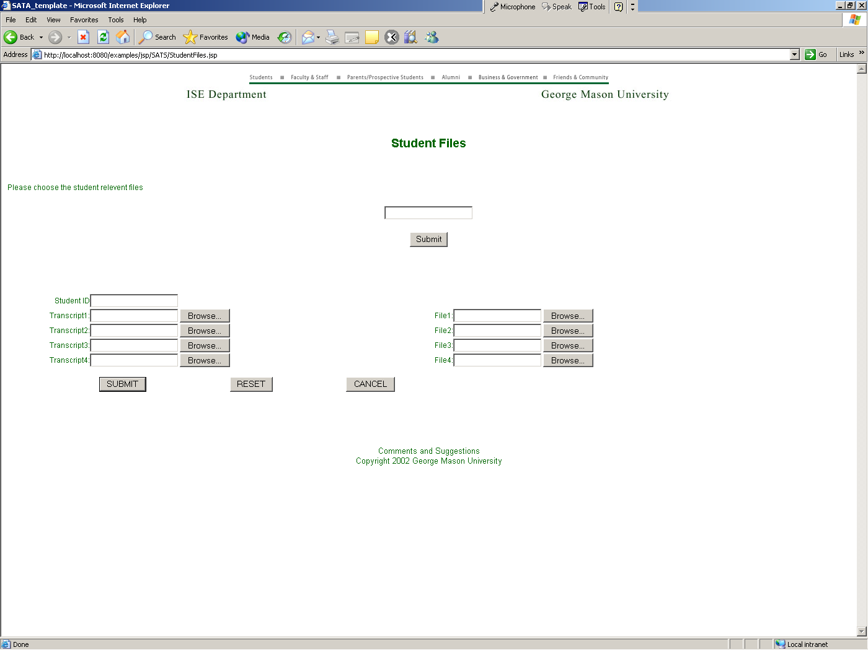

After a new student application is created in the system by the System Administrator, the faculty members are notified and they can make a decision on the application and finally assign an advisor in case the student is accepted in the program.
Once a decision has been made the applicant is sent en email about the decision with further information.

Conclusions:
1. This project was intended to automate the process of Student’s Admission and tracking.

