Create a table with the fields used in the given data
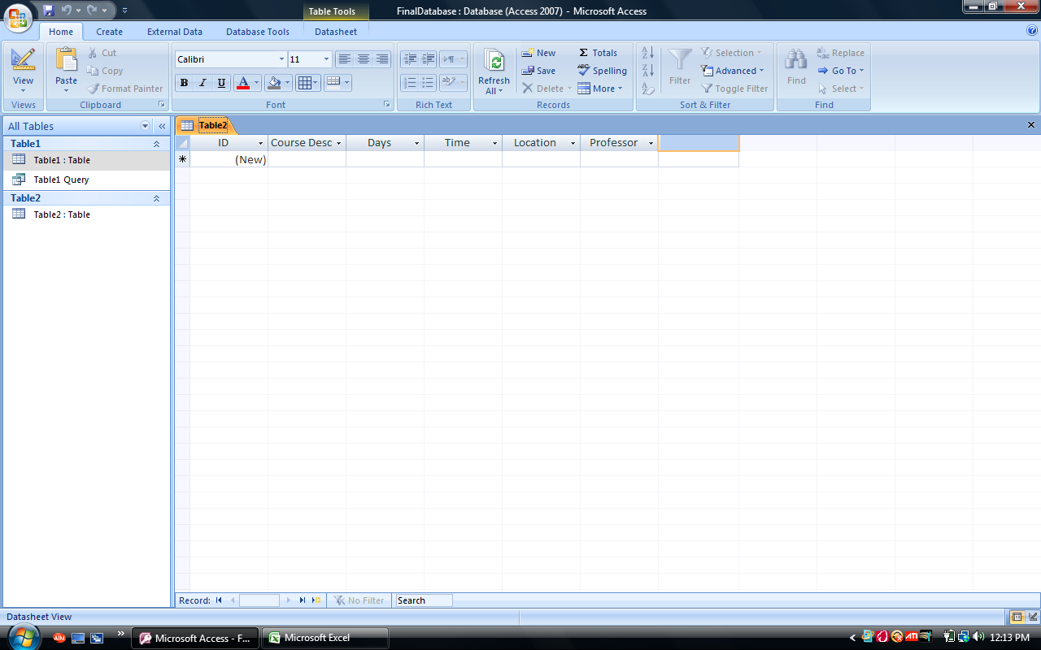
Create a Data entry form: 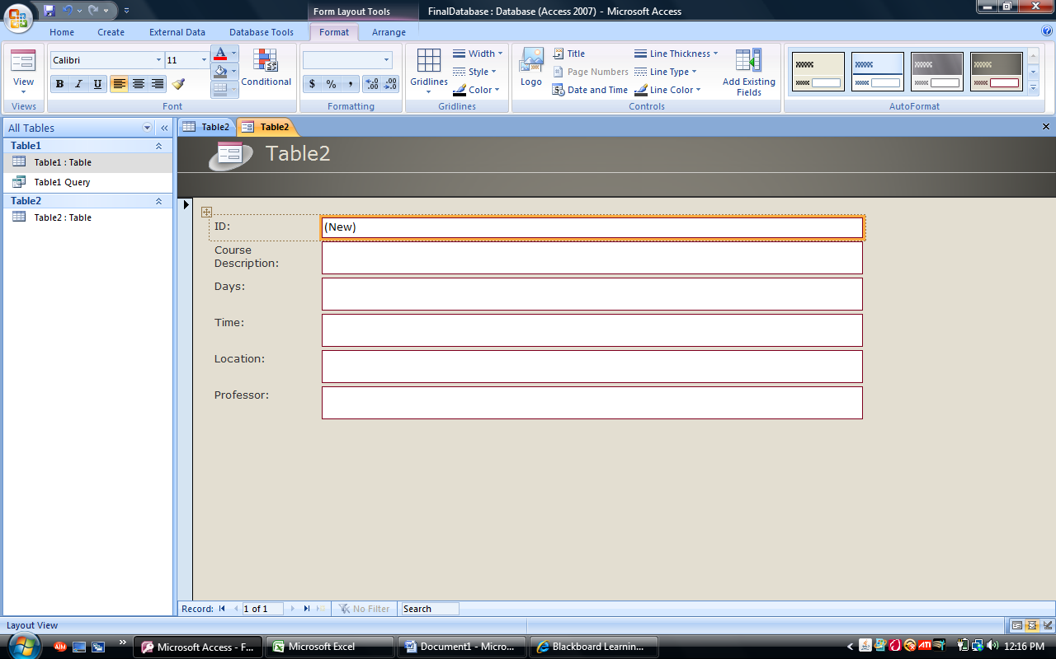
Create a Report Form, Import the data and create a report
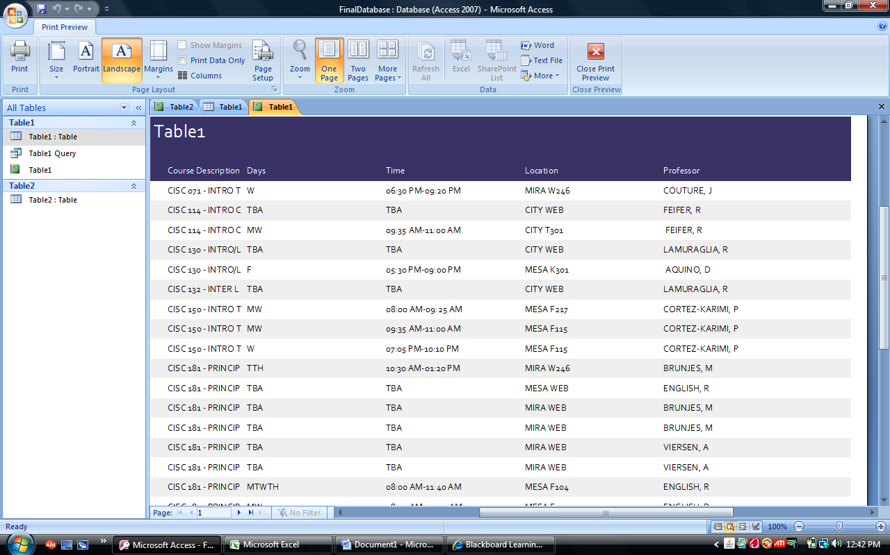
Sort data by location and make a report
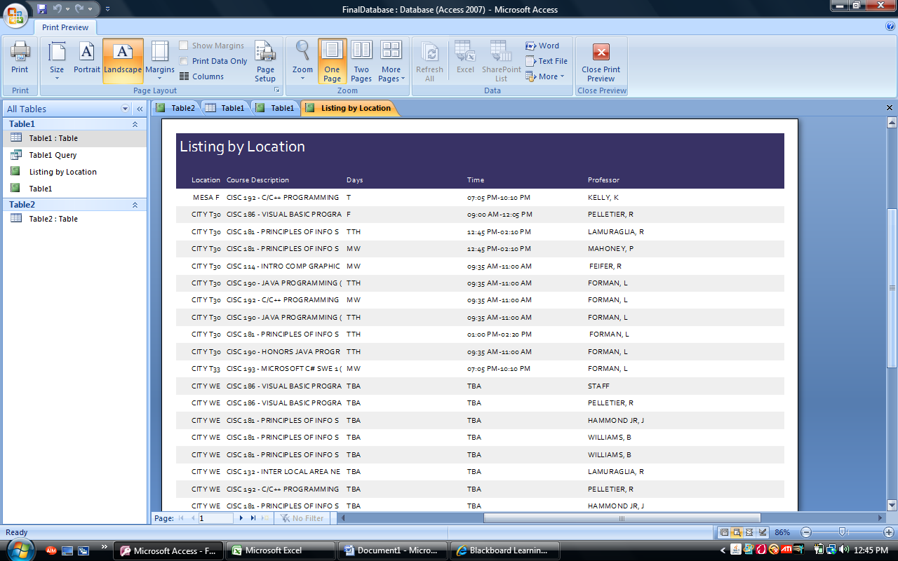
Query for only classes taught at City College, create a report
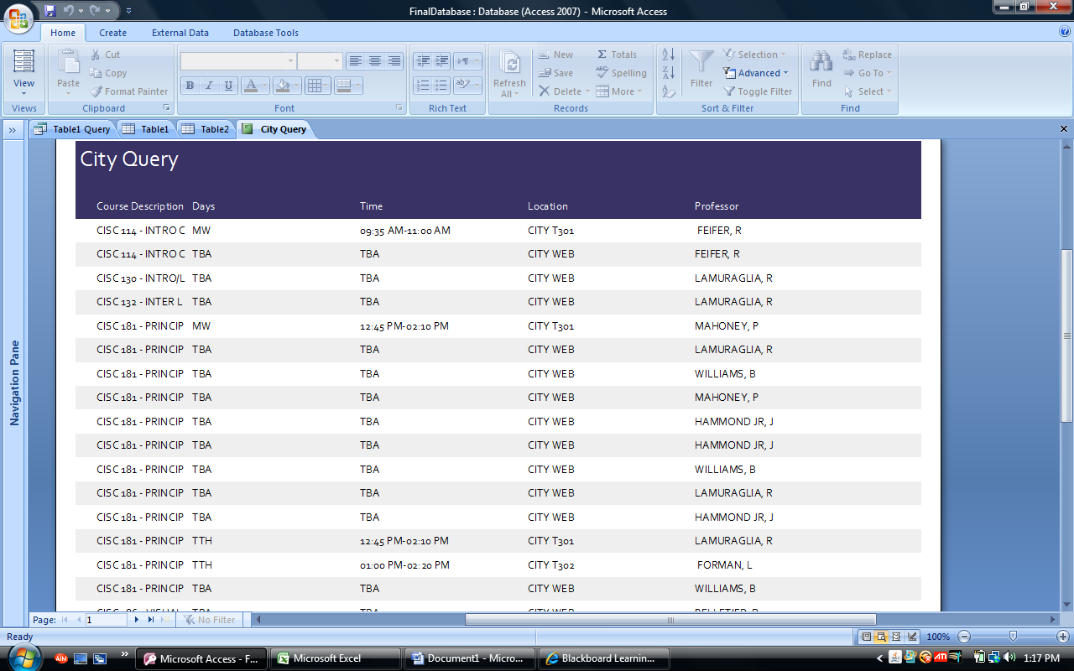
Query for classes taught by Prof. Mahoney and create a report
