STROKE: Remember The 1st Three Letters.... S.T.R.
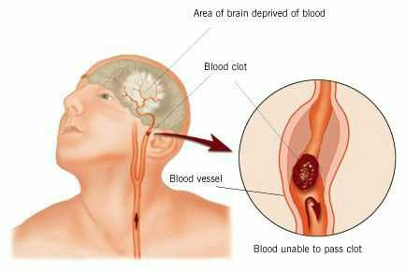
STROKE IDENTI FICATION:
During a BBQ, a friend stumbled and took a little fall,
she assured everyone that she was fine (they offered
to call paramedics) .....she said she had just tripped
over a brick because of her new shoes.
They got her cleaned up and got her a new plate of
food. While she appeared a bit shaken up, Ingrid went
about enjoying herself the rest of the evening.
Ingrid's husband called later telling everyone that his
wife had been taken to the hospital - (at 6:00 pm Ingrid
passed away.) She had suffered a stroke at the BBQ.
Had they known how to identify the signs of a stroke,
perhaps Ingrid would be with us today. Some don't die,
they end up in a helpless, hopeless condition instead.
It only takes a minute to read this...
A neurologist says that if he can get to a stroke victim
within 3 hours he can totally reverse the effects of a
stroke... totally . He said the trick was getting a stroke
recognized, diagnosed, and then getting the patient
medically cared for within 3 hours, which is tough.
RECOGNIZING A STROKE
Thank God for the sense to remember the
'3' steps, STR . Read and Learn!
Sometimes symptoms of a stroke are difficult t o identify.
Unfortunately, the lack of awareness spells disaster The
stroke victim may suffer severe brain damage when
people nearby fail to recognize the symptoms of a stroke .

Now doctors say a bystander can recognize a stroke
by asking three simple questions:
S * Ask the individual to SMILE.
T * Ask the person to TALK and SPEAK A SIMPLE SENTENCE
(Coherently) i.e. It is sunny out today)
R * Ask him or her to RAISE BOTH ARMS.
If he or she has trouble with ANY ONE of these tasks,
get medical help immediately and describe the
symptoms to the dispatcher.
New Sign of a Stroke ------- Stick out Your Tongue
NOTE: Another 'sign' of a stroke is this: Ask the person
to 'stick' out his tongue.. If the tongue is 'crooked',
if it goes to one side or the other , that is also an
indication of a stroke.

